1971-1972

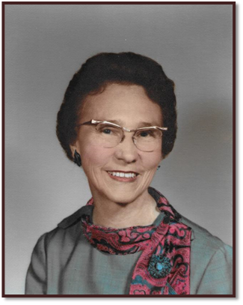

Mrs. Joe E. Brown
Dustin, OK

1972-1973

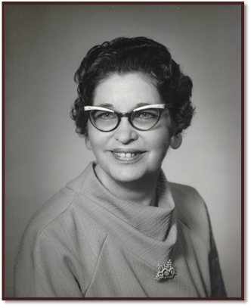

Mrs. Ottie Morgan
Duncan, OK

1973-1974

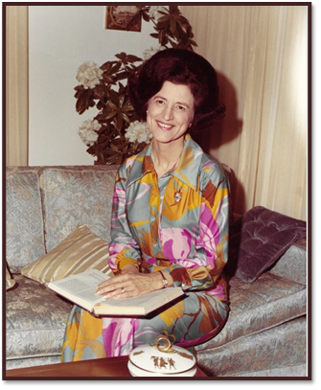

Mrs. Glen E. Laughlin
Stillwater, OK

1974-1975

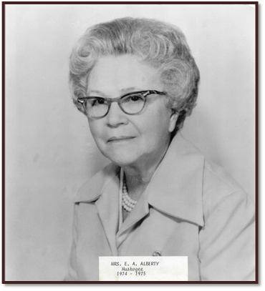

Mrs. E. A. Alberty
Muskogee, OK

1975-1976

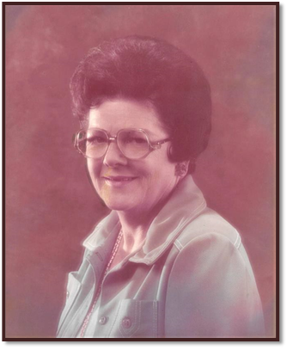

Mrs. A. H. (Betty) Karr
Altus, OK

1976-1977

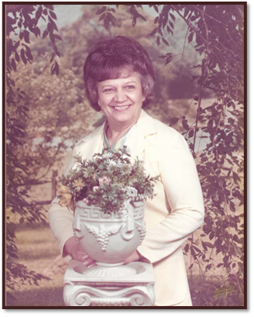

Mrs. Lemo (Cecelia) Easky
Ponca City, OK

1977-1978

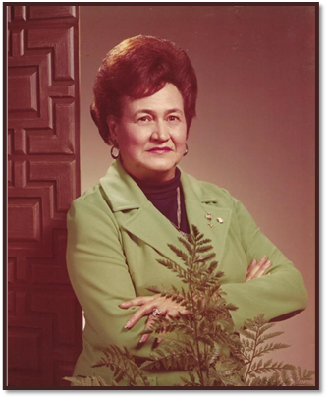

Mrs. Dale (Sybil) Franklin
Heavener, OK

1978-1979

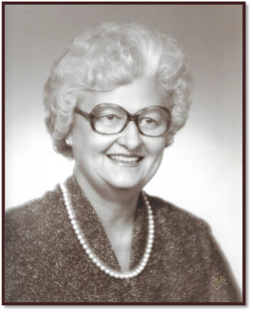

Mrs. Elmore (Dorothy) Meshew
Oklahoma City, OK

1979-1980

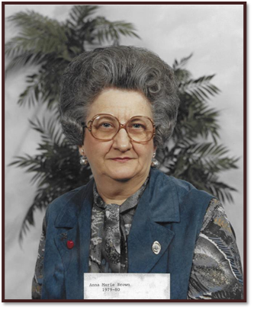

Mrs. Anne Marie Brown
Tecumseh, OK

1980-1981

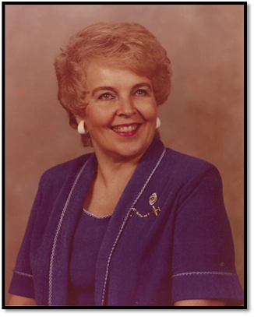

Jerri Hollis
Tuttle, OK

