1981-1982

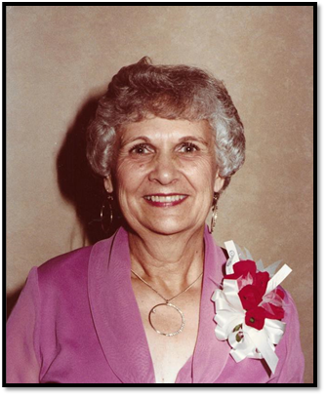

Geneva Younger
Tulsa, OK

1982-1983

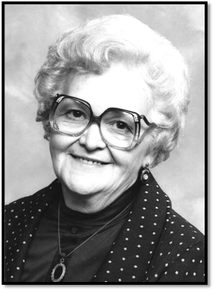

Elaine Smith
Norman, OK

1983-1984

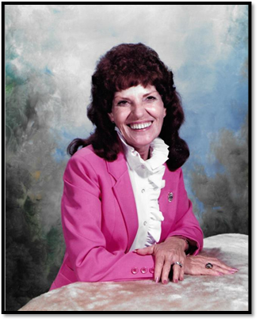

Velma Reinhart
Welling, OK

1984-1985

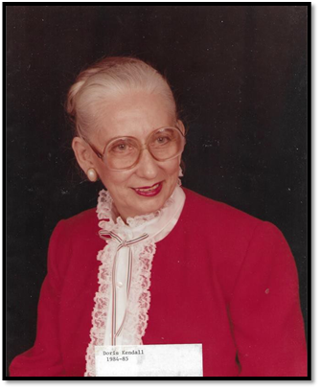

Doris Kendall
Erick, OK

1985-1986

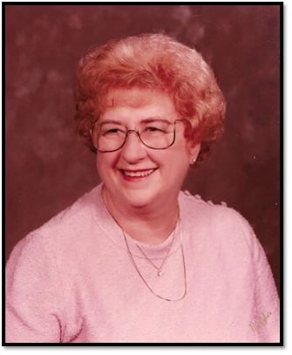

Pauline Bonham
Bethany/Warr Acres. OK

1986-1987

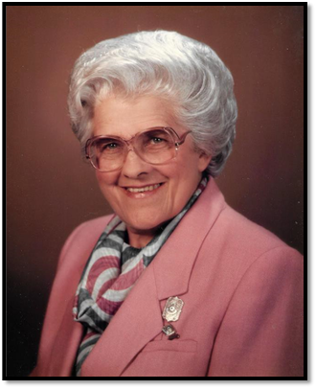

Anne Faye Parrott
Chandler, OK

1987-1988

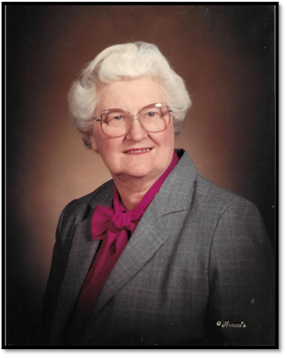

Mrs. Virginia Bowman
Norman, OK

1988-1989

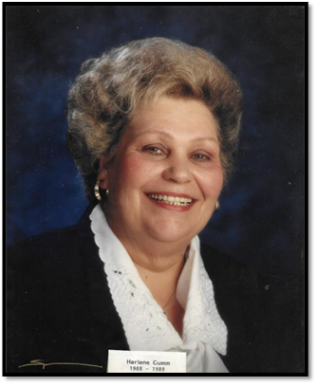

Harlene Gumm
Durant, OK

1989-1990

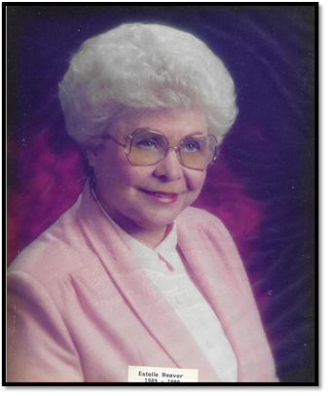

Estelle Weaver
Mangum, OK

1990-1991

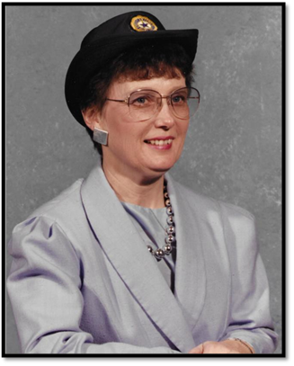

Charlene Marshall
Beaver, OK

