2001-2002

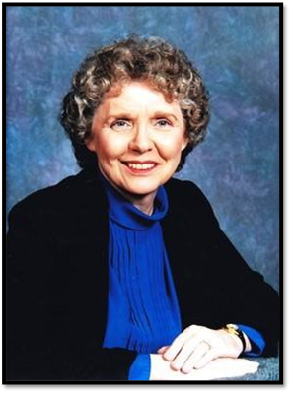

Mrs. Neil (Betty) McElderry
Purcell, OK

2002-2003

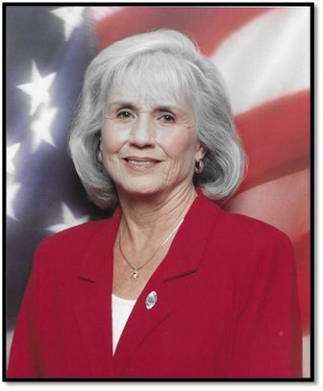

Mrs. Paul (Priscilla) Walker
Lawton, OK

2003-2004

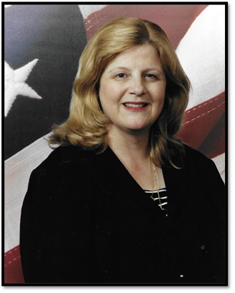

Mrs. Darrell (Ronna) Johnston
Porter, OK

2004-2005

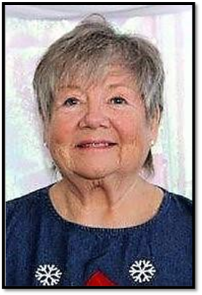

Mrs. Diana Garman-Lonkerd
Oologah, OK

2005-2006

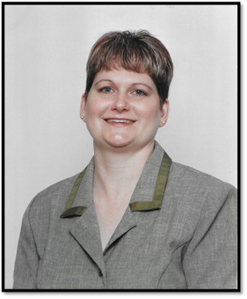

Cindy Fain Hamilton
Tecumseh, OK

2006-2007

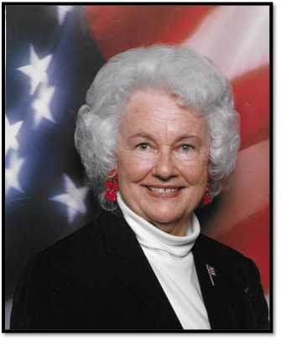

Mrs. Rabbit (Virginia) Hare
Grove, OK

2007-2008

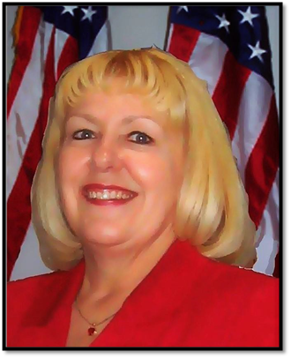

Mrs. Michael (Sue) Heil
Morrison, OK

2008-2009

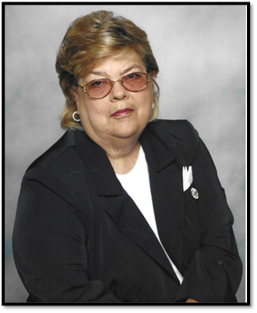
Gwenell Knight
Harrah, OK

2009-2010

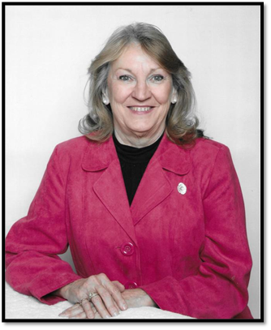

Linda K. Deuster
Tulsa, OK

2010-2011

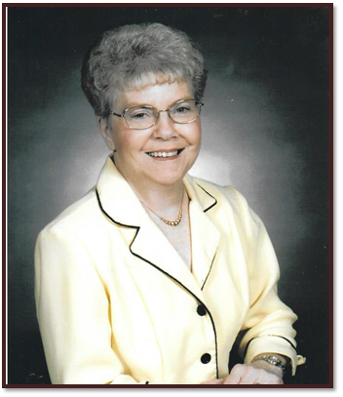

Mrs. Chesta (Ann) Willits
Fairview, OK

