2011-2012

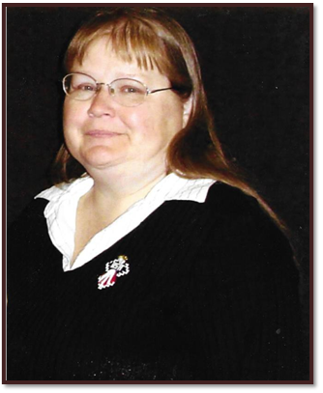

Mrs. Charles (Linda) Erwin
Midwest City, OK

2012-2013

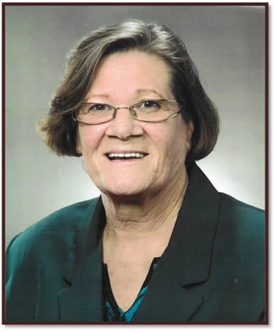

Dorothy I. Clingenpeel
Ryan, OK

2013-2014

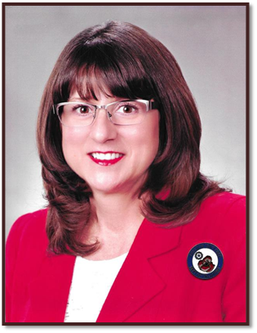

Debra Densmore
Bethany/Warr Acres, OK

2014-2015

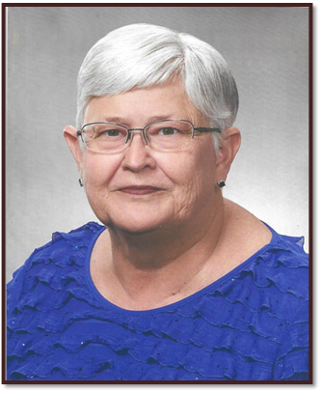

Linda Keister
Granite, OK

2015-2016

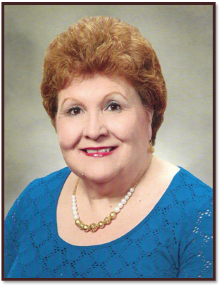

Carol Blocsh
Stillwater, OK

2016-2017

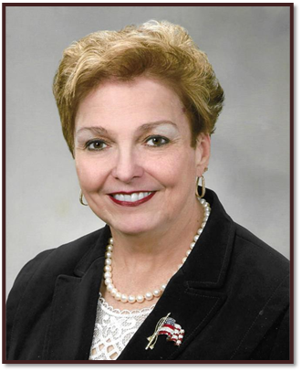

Patsy Chinn
Sand Springs, OK

2017-2018

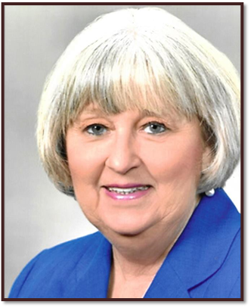

Brenda Harvey
Muskogee, OK

2018-2019

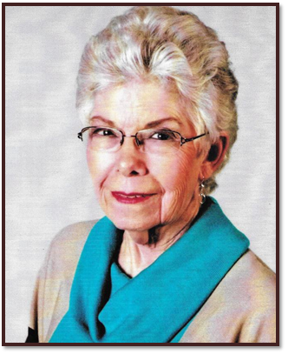

Nancy J. O’Leary
Hominy, OK

2019-2020

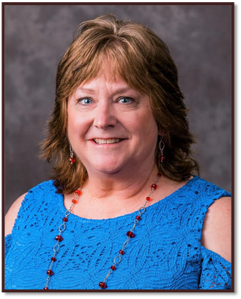

Jody Chisolm
Wilburton, OK

2020-2021

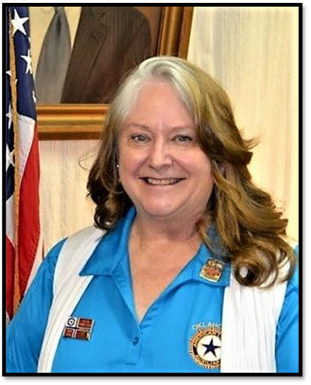

Jody Chisolm
Wilburton, OK

