**2021-2022**

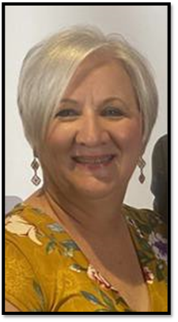

Tracey Smith

Fort Gibson, OK

**2022-2023**

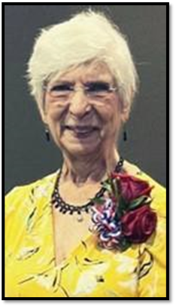

Rowena “Gayle” Keene

Chandler, OK