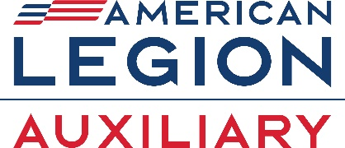

LEGISLATIVE PLAN OF ACTION 2026-2027

Purpose: The purpose of the Legislative Committee is to provide information and assistance to American Legion Auxiliary members to advocate for the legislative agenda of The American Legion. Standing Rule #5, National Committees – Mission Outreach
- Utilize The American Legion’s Legislative Website at www.legion.org/legislativeto obtain information on legislative priorities, call for immediate action, and connect with representatives.
  - Grassroots Action Center
  - Sign up for alerts.
  - Locate pending legislation.
  - Contact your representatives.
  - Report on meetings with representatives.
- Host a Meet the Candidates Night. Invite all candidates involved in a specific election for a question-and-answer session, not a debate with a townhall format with no Legion Family signage.
https://www.legion-aux.org/Member/Committees/Legislative/How-to-Host-a-Meet-the-Candidate-Night
- Promote the ALA Legislative Advocacy Guide to develop a plan to increase legislative awareness in your community.
https://www.legion-aux.org/Member/Guides/Advocacy-Guide
- If you are interested in joining the Legislative Council to advocate for The American Legion Family’s legislative priorities with members of Congress with whom you have personal relationships, reach out to your Department’s Legion Legislative Council Vice Chair.

Deadlines/Important Dates:
- Department Chair Narrative Report due to National Committee: May 15.
- Unit Award: Most Outstanding Unit Legislative Program (per division) — submitted by 5 p.m. ET on June 1.
- Department Award: Best Department Legislative Program (per division) — submitted by 5 p.m. ET on June 1.

SUSAN ENGSTROM
Legislative Chair 2025-2027
chikagirlo2@gmail.com
918-791-8523, 918-791-3259

