**1951-1952**

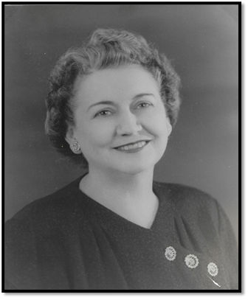

Mrs. Bertie Wilson Drake

Hominy, OK

**1952-1953**

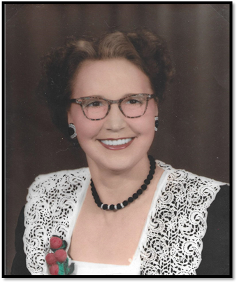

Mrs. Clarence Hunnicutt

Muskogee, OK

**1953-1954**

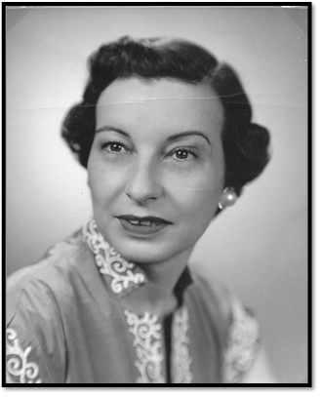

Mrs. Alfred Rice

Ponca City, OK

**1954-1955**

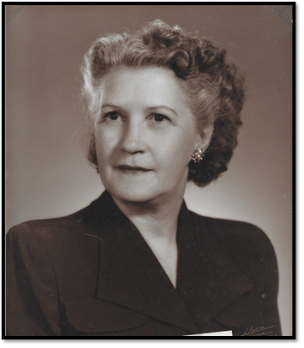

Mrs. Ralph Lillard

Shawnee, OK

**1955-1956**

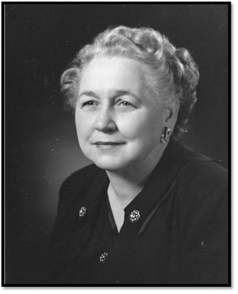

Mrs. John D. Brown

Chickasaw, OK

**1956-1957**

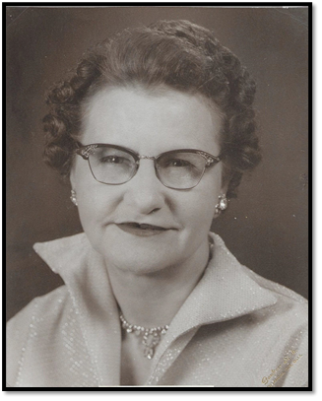

Mrs. Hazel Ballerd Custer

Oklahoma City, OK

**1957-1958**

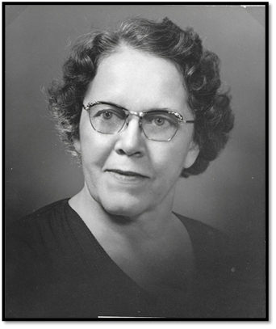

Mrs. W. E. Phillips

Weatherford, OK

**1958-1959**

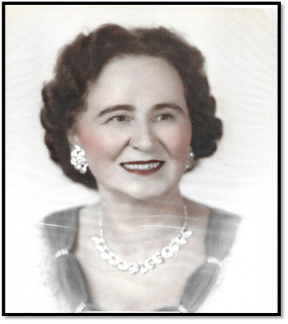

Mrs. Roy (Hazel) McAlister

Ardmore, OK

**1959-1960**

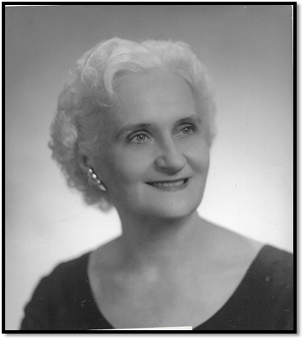

Mrs. A. V. Buck

Tonkawa, OK

**1960-1961**

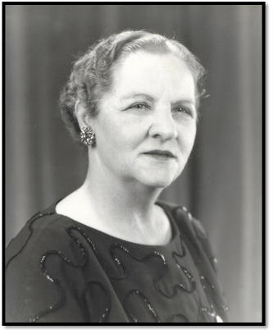

Mrs. L. B. Scudder

Chelsea, OK