Tobacco Mosaic & Potato Virus X (Double Streak) on Tomato Fruit

Firm dark blotches appearing on most of fruit surface.

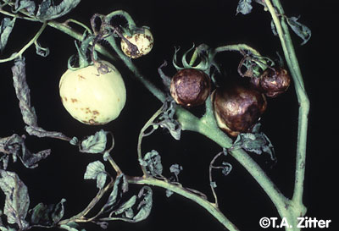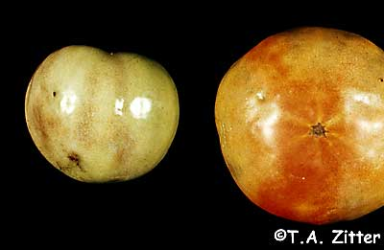
Viral infections can reduce plant vigor by disrupting cellular functioning, but do not commonly kill plants. Tobacco mosaic is one of the most highly persistent tomato diseases because it can remain viable without a host for many years and it is able to withstand high heat. The virus is spread primarily by mechanical methods. Gardeners can contaminate their hands when they touch tobacco products or infected plants and weeds and spread the virus to healthy plants.
Symptoms and Diagnosis
Tobacco mosaic virus is not as distinct as other viruses, but yellow-green mottling on leaves is the most characteristic symptom of the disease. Infected plants have stunted growth, and flowers and leaflets may be curled, distorted, and smaller than normal in size. Open blooms may have brown streaks through them. Yellow, chlorotic spotting is characteristic of pepper plants that are infected.
Integrated Pest Management Strategies
1. Remove and destroy infected plants. Pull plants with mosaic symptoms immediately. Remove the debris from the garden area and bury them if possible.
2. Keep your garden weed-free. Some weed may be harboring the virus. These represent sources of inoculum.
3. Always wash your hands thoroughly and disinfect tools. Before handling plants, wash with soap and water, especially if you're a smoker.
4. Plant resistant varieties of tomato. Suggested varieties include: ‘Big Pick’, ‘Celebrity’, ‘President’, and ‘Park's Extra Early Hybrid’. Other resistant varieties will be labeled TMV resistant.

Catfacing on Tomato Fruit
Catface is a condition involving malformation and scarring of fruits, particularly at the blossom end. Affected fruit are often somewhat flat with a corky brown scar covering the base of the fruit. Catfaced fruit can have cavities extending deep into the flesh.
The deformity is caused by something (internal or external) that occurs during the formation of the flower that results in the fruit not developing normally.
The causes of catfacing are not definitely known, but it is generally agreed that any disturbance to flowers or flower buds can lead to abnormally shaped fruits. Cold temperatures temperatures that occur about 3 weeks before bloom and contact with Drifts of herbicides such as 2,4-D commonly believed to be responsible for catface. . Heavy pruning in indeterminate varieties has been shown to increase catfacing, but this has not been shown to happen in our short-stake varieties. Heavy thrips feeding on young fruit can. There is not much that can be done for control
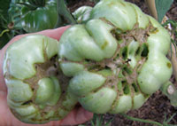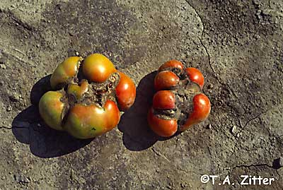

Late Blight of Tomato

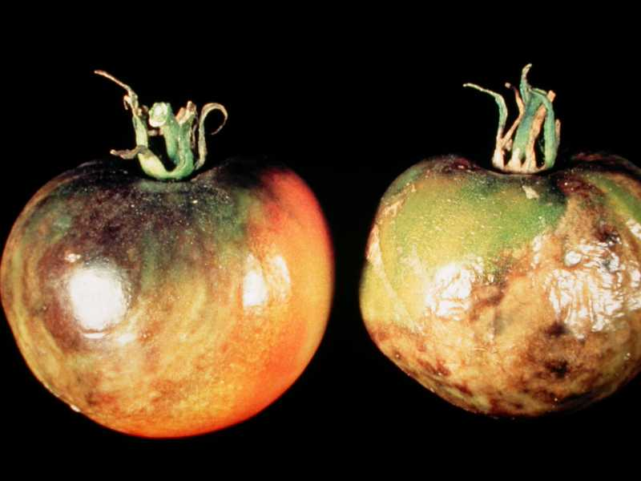
A strain of fungus causes late blight in tomatoes. As the name implies it is prevalent on tomato hosts in late summer, after the plants have bloomed. Late blight usually appears in mid- or late August as is more common when the humidity is high and temperatures are around 68 degrees F late in the growing season(cool, rainy weather). Watch for the disease when cool, moist nights are followed by warm, humid days.
Symptoms and Diagnosis
One of the first symptoms of late blight is watersoaked patches on older leaves. Late blight attacks the older leaves first, then spreads to the fruit. Green-black watery patches develop on the upper surfaces of older leaves. These patches will enlarge quickly, and in moist weather, a downy growth may develop on the underside of the leaf. On the fruit, you will see rough, firm, dark-colored spots.
Life Cycle
The fungus overwinters on tomato and potato plant debris, including potato tubers. The fungus can produce spores over a broad range of temperatures although spores are most infective at temperatures of 68 degrees F with high humidity. The spores are transmitted by water or are wind blown and may be introduced from diseased plants in nearby gardens.
Integrated Pest Management Strategies
1. Plant resistant varieties. Several tomato varieties are designated as resistant to late blight.
2. Avoid overhead watering. Avoid working around plants when they are wet. Both of these practices can spread the fungal spores from plant to plant.
3. Clean up all garden debris in the fall. Remove and destroy any affected plants as soon as they are observed.
4. Practice crop rotation. Do not plant tomatoes, potatoes, and celery in succession. All of these crops are susceptible.
5. Use a copper-based fungicide. Apply when symptoms are first identified. Reapply at 7–10 day

