163 Spring St., Windsor Locks, CT. 06096
Ph: 860-706-9083
Fax: 860-370-9031
www.actionfreightservicesnow.com
www.globaltranz.com
www.adcomworldwide.com
USA CANADA MEXICO

On the Road
LTL – Outbound / Inbound
Expedited – Guaranteed
GlobalTranz agent
T/L – Outbound / Inbound
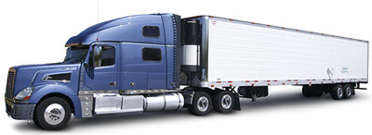
Van or On the Rail
Refrigerated T/L
LTL -T/L – Flat Bed
Heavy Haul
Trade Show – Exhibition
Pier Pick Up & Deliveries

In the Air – OTR Expedited
Overnight – Domestic - International
Adcom Worldwide agent
First Flight out
1-2 Day Expedited
International Air
Ocean Containers
Courier Service
White Glove Service
Trade Show Experts

*Asset & Non Asset based

