**AJ FAST Inc.**

**AJ Fast Inc.** is a **federally regulated company** registered and operated under Canada Business Corporations Act (CBCA). We are an **international trading company** focusing on import and export of fasteners and industrial supplies globally and specializing in importing to North American market.

We are able to supply wide range of top-quality products that complied with international standards & certifications, made by extremely reputable manufacturers and offered at highly competitive price.

Take a look into information about one of our products. **Need more details**? Contact us at [sales@ajfast.com](mailto:sales@ajfast.com)

--------------------------------------------------------------------------------------------------------------------------------------

**CLIPPED HEAD WIRE WELD COLLATING**

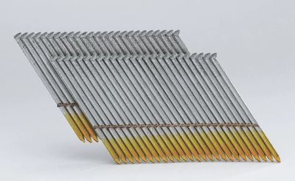

The clipped head and the tight collation mean that more nails can be loaded in the tools, the wire weld collation is not affected by wetness, storage time or temperature. The grooved shank increases the shear capacity.

To keep each nail in proper alignment, some manufacturers tack-weld strips of thin wire to the side of each nail. A piece of wire weld has been tacked to each row of these nails, making them extremely durable. They do a great job when framing outside and can withstand the ruggedness of a typical jobsite. Additionally, these sleeves generally come with more nails per sleeve, meaning less reloads of the gun.

**Details**

Primary applications include framing, sheathing, subfloors, roof decking and exterior decks. For use with most 28 Deg (degree) wire weld framing nailers.

|  |  |  |  |
| --- | --- | --- | --- |
| **CLIPPED HEAD WIRE WELD COLLATING** | | | |
| **LENGTH (Inches)** | **DIA (Inches)** | **LENGTH (mm)** | **DIA (mm)** |
| 2" – 3" | 0.113" | 50 - 76 | 2.87 |
| 2¼" – 4" | 0.120" | 57 - 101 | 3.05 |
| 2½" – 3½" | 0.131" | 64 - 89 | 3.33 |
| 2½" – 3½" | 0.135" | 64 - 89 | 3.43 |

|  |  |  |  |
| --- | --- | --- | --- |
| **FINISH** | **SHANK TYPE** | **POINT TYPE** | **HEAD TYPE** |
| Brite, Hot Dip Galvanized, Electro Galvanized | Smooth, Ring, Screw | Diamond, Blunt Chisel | Plain Clipped head (D Head) |