TEXOMA SAILING CLUB and CANEY CREEK YACHT CLUB
2022 ASBURY SMITH CUP
SAILING INSTRUCTIONS

- RULES:
  - This regatta will be governed by the Racing Rules of Sailing.
  - RRS Rule 26 and A5 are changed to allow for a starting window.
  - RRS Rule 32.2 is changed concerning shortening a course.
  - RSS Rule 33 is changed concerning notification of course changes.

- CHANGES IN SAILING INSTRUCTIONS:
  - Any change to the sailing instructions will be posted on the Regatta Notice Board by 1200 hrs. on day notice is to take effect.
  - Oral changes may be made by the Race Committee on the water prior to the time of the warning signal of any race. Oral changes will be broadcast on VHF Channel 69. This changes Rule 33.

- COMMUNICATIONS:
  - All boats shall carry a working VHF radio. The Race Committee will broadcast and monitor Channel 69.

- NOTICES TO COMPETITORS:
  - Notices to competitors will be displayed on the TSC Notice Board located at the TSC Clubhouse.
  - On the water, the Race Committee intends to monitor and communicate with competitors on VHF Channel 69.

- SIGNALS MADE ASHORE:
  - Signals made ashore will be displayed from the deck railing at the TSC Clubhouse.
  - Code Flag "L" means Notices to Competitors and/or changes to sailing instructions have been posted on the Regatta Notice Board.
  - Code Flag “AP” with two sound signals means the race is postponed. DO NOT leave the clubhouse area. The warning signal will not be made sooner than 30 minutes from the lowering of “AP”, accompanied by one signal. This modifies “Race Signals”.

- RACING SCHEDULE:
  - This race will be held on May 14, 2022. Postponed or abandoned races may be re-scheduled.
  - Daily Schedule:
1200-1230 Registration and Check-In at TSC Clubhouse
1230 Mandatory Skipper’s Meeting
1355 First Warning Signal
1400 First Start
No warning signal after 1530
1800 Dinner and Awards Ceremony at CCYC Clubhouse

- RACING AREA:
  - The races will be held on Lake Texoma. Courses will start in the Little Mineral Arm and finish outside Caney Creek Yacht Club.

- COURSES:
  - The specific courses to be sailed will be announced at the Skippers Meeting.
  - Courses are diagrammed in Attachment A to these sailing instructions. The diagram shows the order in which marks are to be rounded.
  - Mark WF to be rounded to Port. Mark IS to be rounded to Starboard.
  - No later than the warning signal, the race committee signal vessel will display the course to be sailed.
  - The length of the courses determined by the Race Committee will be final.
  - Competitors will be notified of course changes by VHF radio channel 69. This changes Rule 33.
  - In the event that a race must be stopped due to foul weather or other reasons before the race can be shortened per Rule 32, the Race Committee may utilize the rounding times of the last mark rounded by all boats of a Fleet to score their race. This changes RRS Rule 32.2

- THE START:
  - A Five Minute Starting Sequence will be used to start the race.
  - Starting Flags for each Fleet are:
Cruising Fleet Numeric Pennant 1
Leisure Fleet Numeric Pennant 2
Novice Fleet Numeric Pennant 3
All Fleets Start Together Numeric Pennant 9
  - The start will open a 10 minute window for a boat to cross the starting line. The actual time the boat crosses the starting line will be used to calculate results. However, a boat starting after the 10-minute starting window has closed will be scored as the Start Time of her Fleet plus 10 minutes. This changes Rules 26 and A5.
  - The Start Line will be between a staff displaying an orange flag on the race committee signal boat and the starting pin.
  - Boats whose Warning Signal has not been made shall avoid the starting area during the starting sequence for other fleets.
  - A boat or mark tied to the committee boat will be considered a part of the committee boat. Any boat that makes contact with this boat or mark will be considered as hitting the committee boat.

- MARKS:
  - Marks of the course will be yellow cylinders.

- THE FINISH
  - The Finish line will be between the staff displaying a blue flag on the race committee signal boat and the finishing pin.

- PROTESTS:
  - A protesting boat will inform the Race Committee signal boat of their intent to protest upon finishing a race, identifying the boat being protested
  - A written protest must be filed with the TSC Race Captain or designee at the CCYC Clubhouse within 30 minutes of the protesting boat docking after the race. A Protest Committee will hear and rule on protests as soon as possible. Protest forms are available from the TSC Race Captain.
- SCORING
  - The Low-Point Scoring System of RRS Appendix A will apply.
  - PHRF Handicaps established by TSC will be used to calculate a boat’s corrected time using a Time on Distance method to determine a boat’s finishing place.

- AWARDS
  - FLEET WINNER AWARDS - Boats in first, second or third place in the final standings of a Fleet shall receive an award. If 4 or less boats are entered in a Fleet only two awards will be given. If 2 boats are entered in a Fleet only 1 award will be given.

APPENDIX A

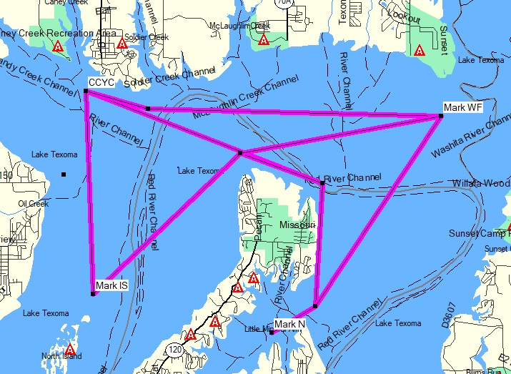

Marks |  | Coordinates
Mark CCYC |  | N33° 55.079’ W096° 41.765’
Mark IS |  | N33° 52.244’ W096° 41.647’
Mark N |  | N33° 51.700’ W096° 38.630’
Mark WF |  | N33° 54.723’ W096° 35.790’
SIGNAL | MARK ROUNDING ORDER | Distance (nm)
1 | N - CCYC | 6.0
2 | N – WF – CCYC  Round Mark WF to Port | 8.9
3 | N – IS – CCYC  Round Mark IS to Starboard | 9.4
4 | N – WF – IS – CCYC  Round Mark WF to Port  Round Mark IS to Starboard | 12.4

