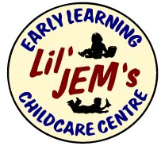

**Video Footage Contract**

From time to time we may record children and educator interactions for educational purposes. These recordings may be used to demonstrate positive child guidance in professional development workshop settings and shared with our staff and other educators in the Early Childhood Education sector. This content will also be shared on social media for positive parenting and public information purposes.

I, _________________________________ give permission for videos of my child, ______________________________ to be used for educational purposes by Lil’ JEM’s Early Learning Childcare Centre.

Parent/Guardian Signature____________________________________ Date_______________

Director Signature­­­­­­­­­___________________________________________Date________________­