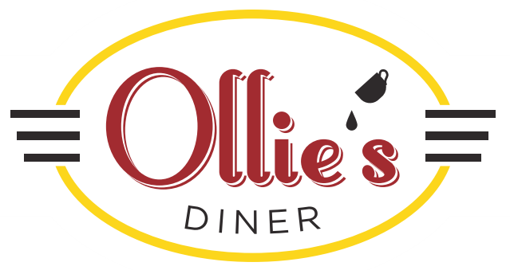

802 High Street

Cumberland, RI 02864-6529

(401) 305-3113

EGGS

Early Riser (Tuesday – Friday, 7 am-9 am): Two eggs any style, Home Fries, Toast and Coffee $3.99

House Special: Two eggs any style, Home Fries, and Toast $4.75

Two Farm Fresh Eggs any Style, Home Fries, Homemade Corned Beef Hash, and Toast $8.05

Two Farm Fresh Eggs any Style, Home Fries, Bacon or Sausage, and Toast $6.95

Two Farm Fresh Eggs any Style, Home Fries, Ham, and Toast $6.95

Two Farm Fresh Eggs any Style, Home Fries, New England Baked Beans, and Toast $6.75

Two Farm Fresh Eggs any Style, Home Fries, Two Bacon, Two Sausage, and Toast $8.30

The Lumberjack: Two Eggs, Two Pancakes or French Toast, Two Bacon, Two Sausage, and Home Fries $8.85

The Big Ollie:

Seasoned Hash Browns topped with Ham, Swiss Cheese, Two Poached Eggs, and Hollandaise Sauce $8.90

The Little Ollie: Half the Size $6.90

Eggs Benedict with Home Fries $8.30

OMELETS: Made with 3 Eggs, Served with Home Fries and Toast

Cheese Omelet $7.25

Cheese Omelet with your choice of Ham, Bacon, or Sausage $8.30

Western Omelet with Cheese $8.30

Veggie with Cheese Omelet $8.05

Corned Beef Hash with Cheese Omelet $8.30

Spinach and Mushroom with Cheese Omelet $8.05

EGG SANDWICHES:

Egg Sandwich $2.60

With Cheese $3.15

Egg and Cheese with your choice of Ham, Bacon, or Sausage $4.70

Western with Cheese $5.20

Alyssa’s Favorite: Egg and Cheese with your choice of Ham, Bacon, or Sausage and Home Fries $6.75

WAFFLES, PANCAKES, AND FRENCH TOAST

Three Large Pancakes with Butter and Sugar $5.75

Texas French Toast with Butter and Sugar $6.25

Belgian Waffle with Butter and Sugar $6.25

Oatmeal Pancakes with Butter and Sugar $6.00

Any of the above with: Chocolate Chips, Blueberries, or Bananas Add $1.50

Whipped Cream Add $0.50

SIDES

Bacon (4) $3.75

Sausage $3.75

Country Ham $3.75

Corned Beef Hash $5.50

One Egg $1.00

Hollandaise Sauce $1.75

Toast $1.30

Bagel $1.75

with Cream Cheese $2.25

English Muffin $1.55

Home Fries $2.50

Hash Browns $2.85

New England Baked Beans $3.15

DRINKS

Fresh Brewed Hot Coffee $2.00

Hot Tea $2.00

Iced Coffee $2.75

Iced Tea $2.60

Bottled Water $2.20

Fountain Soda $2.35

Milk small $2.05

large $2.55

Chocolate or Coffee Milk small $2.25

Large $2.75

Orange, Apple, or Cranberry Juice small $2.05

large $2.60

Hot Chocolate with Whipped Cream $2.25

SANDWICHES: Choice of Hand Cut Fries or House Made Cole Slaw, and a Pickle Spear

Turkey Club: Roast Turkey, Lettuce, Tomato, Bacon and Mayonnaise on White or Wheat $8.50

The Ruben: Pastrami, Swiss Cheese, Sauerkraut and Russian Dressing on Marble Rye $8.50

The Rachel: Pastrami, Swiss Cheese, and Cole Slaw on Marble Rye $8.50

Ollie’s Roast Beef: Choice of Horseradish or Barbeque sauce on an Onion or Bulky Roll $8.50

B.L.T. $6.50

Grilled Cheese $4.95

Hot Dog on a Grilled Bun $4.50

BURGERS: 6oz Burger with Lettuce, Tomato, Onion and a Pickle Spear.

Choice of Hand Cut Fries or Cole Slaw

Hamburger $6.25

Cheeseburger $7.25

Paxton’s Favorite: Bacon and Cheese Burger $8.25

CHICKEN:

Crispy Buttermilk Chicken Fingers with Hand Cut Fries, choice of Ranch or Blue Cheese Dressing $7.50

Buffalo Chicken Fingers with Hand Cut Fries, choice of Ranch or Blue Cheese Dressing $7.80

FRIDAYS ONLY: 12pm to 7pm

Fish and Chips $9.99

Fish and Cole Slaw $9.50

Fish Sandwich with Choice of Hand Cut Fries or Cole Slaw $6.95

New England Clam Chowder Cup $3.50

Bowl $4.50

New England Clam Chowder and Three Clam Cakes Cup $4.75

Bowl $5.75

Clam Cakes Three $3.00

Six $6.00

Twelve $9.00