**A PROGRAM OF UNITED WOMEN IN FAITH**

**SPONSORED BY HOLSTON CONFERENCE UNITED WOMEN IN FAITH**

**Mission u**

**July 22-23, 2022**



This year, as we study Luke 13, we find ourselves in a period of disruption and uncertainty. In the midst of a devastating pandemic, divisive political climate, unaddressed systemic racism, ecological crises and economic turmoil, we turn to the stories of Jesus that have anchored Christian communities for two millennia.

Our hope is that we will leave Mission u with a bigger and broader vision of the community Christ is calling us to be in times of loss, grief and massive disruption. What would be possible if we tend to the needs of our communities in small yet radical ways, as Jesus did in Luke 13?

Our newly designed Mission u 2022 is more flexible and intergenerational than ever— with curricula for youth, children and adults focused on the 13th chapter of the Gospel of Luke. **BOOKS WILL NOT BE AVAILABLE FOR PURCHASE DURING THE EVENT.** You may purchase a book from [UMW: eCommerce Website (umwmissionresources.org)](https://www.umwmissionresources.org/), Amazon or your favorite online store before the event.

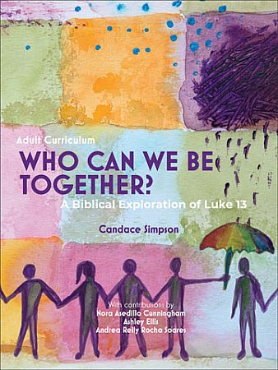 ***ADULT 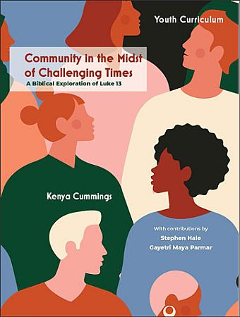 YOUTH 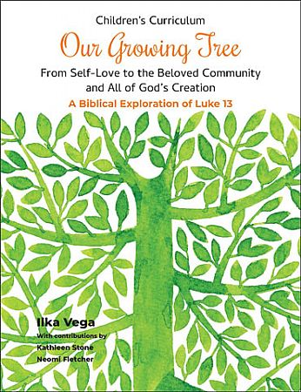 CHILDREN***

**HANDS-ON PROJECT COLLECTION**

**Wesley House Community Center, Knoxville, TN**

Wesley House Community Center was established in 1907 to provide childcare for the children of the women of Brookside Mills. Today, we focus on three areas of service: provide high-quality, affordable, and accessible childcare social connection in the senior citizen population, and the emerging needs of the Mechanicsville, Lonsdale and Beaumont communities in Knoxville, TN. Items needed are

**Snacks**

* Bottled Water
* 100% juice
* Peanut butter crackers
* Beef jerky
* String cheese
* Graham Crackers, teddy grahams, etc.
* Whole grain Cheez Its
* Small carrots

**School/Office Supplies**

* File Folders
* Copier Paper
* Pencils
* Markers of Various Size
* Index Cards
* Electric Pencil Sharpeners
* Expo Markers
* Dry Erase Board Erasers and Cleaning Spray
* Gift Cards to Walmart, Target, School Box, Dollar Tree, or Office Depot

**Susannah’s House, Knoxville, TN**

Susannah's House is an Intensive Outpatient Recovery Program for mothers in recovery. We exist to serve the spiritual, physical, and emotional needs of mothers and their children. We provide a nurturing and therapeutic environment for individuals and families to achieve sobriety, enhance mother and child relationships, and build better life skills while promoting spiritual growth. Items needed are

* Construction Paper
* Elmers Glue. Sticks (the disappearing purple kind for preschool)
* Paper Towels
* Paper plates
* 12-16 oz paper cups (not styrofoam)
* Copy paper
* Sticky Notes
* Rubber Bands
* College. Ruled spiral notebooks (single subject)
* Kleenex tissue

**OTHER MISSION INFORMATION**

**Water Mission**

In 1998, Water Mission founders George and Molly Greene were operating an environmental engineering company in Charleston, South Carolina when they heard about the devastation in Honduras caused by Hurricane Mitch. After receiving a request for multiple water treatment systems in Honduras, and being unable to find existing systems that would work, George and his team of engineers took action to design and build such a system themselves.

In the aftermath of their work in Honduras, George and Molly discovered the sad truth about the global water crisis – that billions have no other options than to drink contaminated water which results in one death every 37 seconds from a water-related illness. In 2001, the Greenes took action and founded Water Mission. Today, 21 years later, Water Mission has completed nearly 3,000 projects in 57 countries and provided safe water and sanitation solutions to an estimated 7,000,000 people.

Water Mission is a team of engineers, scientists, implementers, fundraisers, volunteers and donors, working together to solve the global water crisis. Each engineering plan, pipe fitting, and installation is a piece of a solution that God is using to give individuals the opportunity to have safe water and sanitation.

Water Mission understands that tackling the United Nations Sustainable Development Goal 6 (SDG6), to ensure access to safe water and sanitation for all, is beyond the reach of any single innovative organization or funding source. By partnering with strategic, like-minded organizations that build on each other’s strengths and share the SDG6 vision, Water Mission can collectively make a scalable impact on the crisis.

In the Spring of 2021 Water Mission established the Knoxville Area Team in an effort to raise awareness of the global water crisis. This consists of speaking to local churches and organizations, establishing prayer support and a donors’ network, and sponsoring an annual Walk for Water.

**The Bethlehem Center, Chattanooga, TN**

We are God's people empowering inner-city youth and families to lead responsible lives by providing discipleship, education, and leadership development. Our after-school program helps children continue to learn, keeps them on track in school, and provides a fun and safe environment for them Monday - Thursday from 3:00 - 6:30 p.m. from September to May. Morning Manna is a safe-haven program that allows students to participate in recreation and a morning devotional while they wait for the bus Monday - Friday from 7:30 a.m. to about 8:15 a.m. B.L.U. is a leadership development program that challenges high school students (9th - 12th grade) to come up with ways to improve their community, city, and even other parts of the country! Twice a month the Beth will host fellowship events for adults 18 and older. These events include bingo, yard sales, cooking classes, luncheons, and more.

***Cokesbury United Methodist Church, North Campus***

***9915 Kingston Pike***

***Knoxville, TN 37922***

Mission u Schedule

July 22, 2022

9 a.m. – 9:45 a.m. Registration

9:45 a.m. – 10 a.m 1st-timer orientation (in-person only)

10 a.m. – 10:30 a.m. Opening Worship (all attendees)

10:30 a.m. – 12 Noon Class Session 1

12 Noon – 1 p.m. Lunch break

1 p.m. – 3 p.m. Class Session 2

3 p.m. – 3:15 p.m. Break

3:15 p.m. – 5 p.m. Class Session 3

July 23, 2022

9:30 a.m. – 10 a.m. Closing Worship (all attendees)

10 a.m. – 12 Noon Class Session

**CEU’s are available for clergy only.**

***PLEASE TAKE NOTE OF THE FOLLOWING IMPORTANT INFORMATION!***

**BOOKS MUST BE PURCHASED ONLINE PRIOR TO THE EVENT AT** [UMW: eCommerce Website (umwmissionresources.org)](https://www.umwmissionresources.org/); [**www.amazon.com**](http://www.amazon.com)**; OR THE SITE OF YOUR CHOICE.**

We are trying to help preserve our environment and are asking participants and instructors to bring their own coffee mug and water bottle to cut down on waste. Snacks will be provided, but you will have to provide your own if you have special dietary needs.

Each district has a scholarship available for a first-timer to attend Mission u. For more information, please contact your District President.

**REGISTRATION DEADLINE: Postmarked by Friday, July 1st**

**ROOM RESERVATIONS CUT-OFF MONDAY, JUNE 20th (See below.)**

*Virtual CLASS REGISTRATION FEE is* ***$25*** *to be donated to Mission Giving.*

*In-person CLASS REGISTRATION FEE IS* ***$50*** *FOR EACH ADULT AND $10 FOR EACH YOUTH OR CHILD.*

CHILDCARE is provided for infants up through 8 years, only if the child is pre-registered prior to the deadline of July 1st. Cost is $10.00 per child.

**ATTENDEES MUST MAKE THEIR OWN HOTEL RESERVATIONS.** You may stay at any hotel of your choice; however, a block of 25 rooms is available at a special rate of $151.25 including tax per room for United Methodist Women in Faith who make reservations before **June 20th** at Hilton Garden Inn, 216 Peregrine Way, Knoxville, TN 37922. Each room has 2 Queen beds. An on-line registration link and phone number to book your room will be provided in your registration confirmation email.

Those persons eligible for reimbursement should submit expense forms **WITH RECEIPTS** to the Conference Treasurer after the event. Reimbursements will be made for hotel reservations not to exceed the rate offered at $151.25.

**Register for 2022 Mission u online at**

<https://holston-reg.brtapp.com/Missionu2022>

**OUR MISSION u LEADERS**

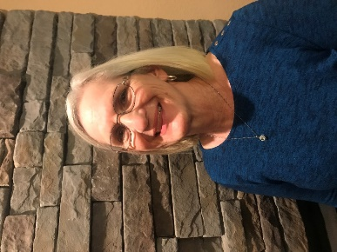**Susan Daffron, Dean of Mission u**, is now serving her second year as Dean of Mission u for the Holston Conference Women in Faith. She is also president of the Smoky Mountain District United Women in Faith. She is a member of Broadway UMC where she serves as chairperson for the Communications and Welcoming Committees, Sunday School Secretary, volunteers at the prayer table for the Brown Food Pantry and along with husband, Mark Sheridan, care for the church grounds. Susan was born and raised in Maryville, TN. After retiring in 2016, Susan now devotes her time to caring for three precious granddaughters, Katie, Eloisa and Josie and is excited to welcome another granddaughter due in June She and Mark are very active in the Blount County Master Gardeners where they partner with Sam Houston Schoolhouse to improve the grounds. She loves gardening and loves to share tips and plants with others.

**Kim Hill, Assistant Dean of Mission u** is a life-long member of Broadway United Methodist Church in Maryville, TN. She has served on several committees and as Worship Work Area Chair. She was a Member-at-Large of United Methodist Women for several years. When Square One, the evening circle, moved their meeting date from Tuesday night to Monday night, she joined them. She is also a member of the Epworth Bells handbell choir. She has been the Communications Coordinator for the Maryville/Smoky Mountain District since 2017. Her goal is to improve communications within the district. This is even more important as the district has grown. She has been married to her wonderful husband Doug for 40 years, and they have 2 daughters, Ashley and Christina. She is looking forward to serving on the Mission u team.

**Lori L. Sluder, Shadower** has been active in UMW since 1990 and has served on the local, district, and conference level in various offices in the Johnson City, Chattanooga, and Knoxville Districts. Lori lives in Louisville, Tennessee and works as the Bishop’s Assistant in the Holston Conference Episcopal Office. She has worked with Holston Conference since 2004. Her husband is the Reverend Michael Sluder, who is the Director of Connectional Ministries for Holston Conference. They have two young-adult children, Josh and Katie.



**OUR MISSION u STUDY LEADERS**

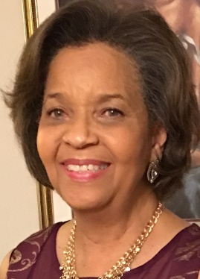**Lisa E. Black** was the first African American elected to serve as Vice-President of Holston Conference United Methodist Women. She is the past President of the Tennessee Valley District and past Vice-President of the Scenic South District. She has also served on the conference level as a member of Mission u, Spiritual Enrichment, Policy committee, and Co-Chair of the 45th and 46th Annual Meeting/Officer’s Training Event committee. While living in Clinton, TN she was a member of the local UMW unit of Rocky Top United Methodist Church. During her 2018-2020 term as Holston Conference Vice-President, she had the opportunity to worship with numerous members of United Methodist Women in various districts, as they celebrated together on annual United Methodist Women Sundays. She is more than grateful to have attended 2018 UMW Assembly with members of Holston conference and thousands of women from all over the United States and other countries. The experience of worship coupled with teaching and a learning atmosphere theme of “The Power of Bold” was life-changing. 2021 was her first time as a Study Leader for Mission u. Lisa and her husband Pastor Bobby G. Black now reside in Johnson City, TN since retiring at the 2018 Holston Annual Conference. Lisa is a mother of two adult children, Nana to three granddaughters and three grandsons and one great-grandson. She is a retiree of the City of Johnson City, TN, and the Hamilton County Department of Education Purchasing Departments. Her favorite vacation place is a beach anywhere.

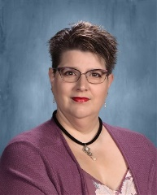**Re**v**. Nickie Fox** is a bi-vocational United Methodist Local Pastor. She is a full-time teacher and part-time local pastor for Fairgarden Circuit in Sevier County which includes Cedar Bluff UMC, Eden UMC, and Fox UMC.  Nickie answered the call to go into the ministry in 2016 when she completed her Local Pastor’s Licensing School. She was appointed to FaIrgarden Circuit in June of 2021. She has been teaching for 18 years, 12 of which has been in Sevierville Middle School. As a co-chair of the Professional Development Team at the middle school, she has had the opportunity to lead various staff development opportunities. She works with teenagers on a daily basis that come from a variety of backgrounds, struggles, and anxieties. Nickie is married to her supportive husband Tom, and they have two beautiful teenage daughters, Savannah and Briana. They also have a house full of fur babies: two dogs named Stitch and Mickey, and a cat named Figaro. Her family has been described as a little Disney crazy.

**Jim Gass (Youth Study)** is the Director of NextGeneration Ministries at Broadway United Methodist Church in Maryville, Tennessee. He has been in local church youth ministry since 2013 and spent many years in camping ministry prior to that. He has a Bachelor of Science from East Tennessee State University and a Certificate of Theology in Youth Ministry from Princeton Theological Seminary. He is also a graduate of Holston Conference’s Fuel Youth Institute, Leadership Holston, and the Youth Cartel’s Youth Ministry Coaching Program. Jim is a contributing author to *Youth Ministry In This Season of Disruption,* published by The Youth Cartel in 2020. In addition to his work at Broadway UMC, he is the District Youth Coordinator for the Smoky Mountain District, serves on the Conference Council on Youth Ministries, and was elected as a lay delegate to the 2020 Southeastern Jurisdictional Conference.

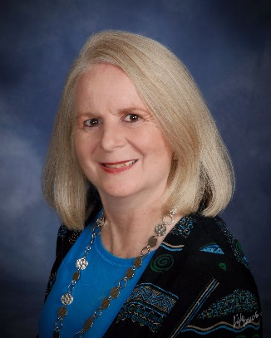**Becky Gantz Hall** is a graduate of Tennessee Tech University where she holds a B.S. in Natural Resources. She is currently the Executive Director at Christ UMC in Chattanooga, TN. She is also District Lay Leader, chair of the Conference Congregational Development Committee, on the Annual Conference Planning Team, and a Natural Church Development Coach. She has been a District United Methodist Women President and a Conference United Methodist Women Officer as well as a teacher at School of Christian Mission and Mission u. Becky has been a General Conference delegate in 2004, 2008, 2012, and 2016. She is very involved in community service which includes her efforts as a board member of the Bethlehem Center, on the board of Volunteers in Medicine, and other charitable involvement such as mission teams to Dominica, St. Martin, Liberia, Zimbabwe, Brazil, Nicaragua, Estonia, Kenya, India, Cuba, South Sudan and more. Becky is married to David; they have two grown children and two grandsons.

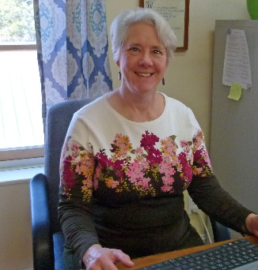**Lisa Nichols (Virtual Leader)** is a Deaconess serving as a Church and Community Worker at Jubilee Project in Sneedville, TN.  Lisa has been a CCW for over 35 years and has served in North Carolina, Alabama, Missouri, Tennessee, and Virginia. A child of Holston Conference, Lisa has a BA in Elementary Education from Emory and Henry College, and enjoys working with children and youth. She has two daughters, Sara, her husband Andrew and new baby Will live in North Carolina, and Jessica lives in Birmingham, AL. Lisa has taught Mission U classes in Missouri and for the VA and Holston Conferences. She is looking forward to leading “Who Can We Be Together?” in the virtual format.

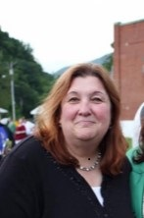**Mitzie Sadler-Thorne** **(Children’s Study)** says, “I am proud to say that I have been a United Methodist all my life. I have been involved with the United Methodist Women, it seems most of my life and attended many meetings and activities with my mother. I have made so many friends as a United Methodist Woman! I am married to Rocky and have two lovely daughters Hannah and Hali, and a nephew, Seth, living with us in Narrows, VA. We attend the First United Methodist Church of Narrows, Virginia. I am also the New River District UMW President.” Mitzi’s past service includes the Holston Conference Social Action Coordinator. She was also the Dean and Assistant Dean for Mission u and has taught the children’s study at Mission u for several years. She also served as the Program Resource Coordinator or the Tazewell District. Alongside her husband, she helps facilitate the Discipleship Bible Study at Bland Correctional Center, a multi-custody facility located in Bland VA, and operated by the**Virginia**Department**of Corrections** with a housing capacity of 650 male inmates. Mitzi became a Deaconess in May of 2020 and her ministry is as Special Education Teacher at Pikeview Middle School in Princeton, West Virginia.  She shared, “This year and last have been challenging for all we teachers, students, and families because of the pandemic!” “I so look forward to my time with you, my Smoky Mountain District UMW friends, and in sharing my path in becoming and serving as Deaconess. I hope to encourage others to become involved as well.”

**Rev. Linda Ray** grew up in the Holston Conference in Oak Ridge, Tennessee. She is a graduate of Rhodes College, Memphis, Tennessee with a B.A. in Music Education, a graduate of Scarritt College, Nashville, Tennessee with a MCM in Choral Conducting and Church Music History, she took theological study classes at Vanderbilt Divinity School, Nashville, Tennessee, a graduate of Memphis Theological Seminary with a M. Div. with an emphasis in Church History, and post-graduate studies at the University of Arkansas at Little Rock, with an emphasis in Higher Education Administration. She has served as a Diaconal Minister and Ordained Minister in the Arkansas and Virginia Annual Conferences and as an on-loan pastor in the Episcopal Diocese of Arkansas. She has served as a study leader for School of Mission for children, youth, and adults as well as serving as Dean of the School of Mission in Virginia. Linda and her husband Bruce have a blended family that includes five children and four grandchildren.

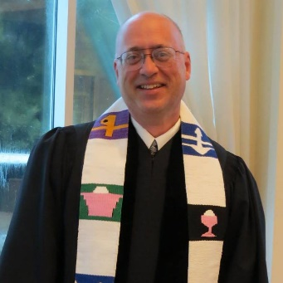**Rev. Mike Sluder** grew up in Gray, TN and attended Gray UMC.  Met his sweetheart, Lori, in the youth group at church.  They have been married 37 years and have two grown children, a son, Josh, and a daughter, Katie.  Mike graduated from Emory & Henry College in 1983 with a B.S. degree in Math and Physics and earned his M.Div. degree in 1988 at The Divinity School, Duke University.  He was ordained Elder at Holston Annual Conference in 1990.  He is currently serving his seventh appointment as Director of Connectional Ministries for Holston Conference (2015-Present) of the UMC.  Previous appointments were Asbury/Mt. Wesley UMC (1988-1992), Signal Crest UMC (1992-1996), Fairhaven UMC (1996-2002), St. Mark UMC, Knoxville (2002-2007), Bearden UMC (2007-2014), & Associate Director of Connectional Ministries for Missions (2014-2015). He has been involved with Holston Conference’s presence in South Sudan and Uganda since 2007.

**MISSION u REGISTRATION**

**July 22-23, 2022**

**Cokesbury United Methodist Church, North, Campus**

**9915 Kingston Pike**

**Knoxville, TN 37922**

**Registration Deadline is July 1, 2022**

Name: ______________________________________________________________________________________

Phone: ____________________________________________ First Time Attendee? Yes No

Address: _____________________________________________________________________________________

City: ________________________________________ State: _______________ ZIP: ______________________

ARE YOU WILLING TO SHARE DATA WITH THE NATIONAL OFFICE? All data collected by United Women in Faith will be for the sole use of United Women in Faith to promote their programs and engagement opportunities. Most communications will be by email. Please indicate if you do or do not wish to receive information from United Methodist Women on additional program opportunities.

Yes No I prefer NOT to receive phone calls

I Am A Conference Officer: Yes No I Am A District Officer: Yes No

Church: ________________________________________ District: _______________________________________

Clergy Lay

Email Address: ________________________________________________________________________________

For Clergy Only: Yes, I want CEU credit (1.5 CEUs if all classes are attended).

IN PERSON REGISTRATION: **$50**

VIRTUAL REGISTRATION: **$25** TO BE DONATED TO MISSION GIVING

Special Needs: (wheelchair, difficulty walking, etc.) Please indicate: ____________________________________

In case of emergency, contact: ____________________________________ Phone: ________________________

Names/ages of children (up to 8 years) attending with you for whom you need childcare:

Name ______________________________________________________________ Age ______________

Name ______________________________________________________________ Age ______________

Name ______________________________________________________________ Age ______________

**LUNCH MENU FOR IN-PERSON**

Friday Lunch will be ordered from Nixon’s Deli. Please mark your sandwich selection below and return with your Registration Form.

MEAT: HAM TURKEY ROAST BEEF CHICKEN SALAD*

BREAD: PLAIN/WHITE WHOLE WHEAT PUMPERNICKEL

CHEESE (UP TO 2): AMERICAN SWISS HOT PEPPER PROVOLONE

NATURAL CHEDDAR SMOKED CHEDDAR NO CHEESE

VEGGIES: LETTUCE TOMATO ONIONS MUSHROOMS

BELL PEPPERS BLACK OLIVES PICKLE SPEAR PEPPERONCINI

NO VEGGIES

STEAMED HOT COLD

CONDIMENTS: MAYONNAISE YELLOW MUSTARD SPICY BROWN MUSTARD

HORSERADISH SAUCE RANCH THOUSAND ISLAND

HONEY MUSTARD

PLEASE NOTE ANY CONDIMENTS ON THE SIDE: ____________________________________________

*Traditional Chicken Salad (no nuts or fruit.) Choosing "Steamed" will warm the bread, cheese, & any toppings. Chicken Salad will not be warmed.

A variety of chips and water, coffee, and iced tea will be available.

Remember to bring your own coffee mug/drink container.

**MAILTHE COMPLETED REGISTRATION FORM AND LUNCH MENU WITH YOUR CHECK PAYABLE TO HOLSTON CONFERENCE UNITED METHODIST WOMEN TO:**

**KIM HILL**

**1504 ABERDEEN DRIVE**

**ALCOA, TN 37701-6821**