**Mentel Memorial Golf Academy**

**2024 Junior Winter Program**

**Starter Package | Ages 6-17 | $200**

(3) 20-minute 1-1 lessons on launch monitor/putting simulator

(3) 20-minute SuperSpeed/Fitness Training sessions

(3) 20-minute solo practice sessions on EXPUTT simulator

(1) 30-minute solo practice sessions on launch monitor and/or putting simulator

(1) Round of simulator golf – 18 holes

**Advanced Package | Ages 6-17 | $300**

(5) 20-minute 1-1 lessons on launch monitor/putting simulator

(5) 20-minute SuperSpeed/Fitness Training sessions

(5) 20-minute solo practice sessions on EXPUTT simulator

(2) 30-minute solo practice sessions on launch monitor and/or putting simulator

(2) Rounds of simulator golf – 36 holes

**Elite Package | Ages 6-17 $400**

(5) 20-minute 1-1 lessons on launch monitor/putting simulator

(5) 20-minute SuperSpeed/Fitness Training sessions

(5) 20-minute solo practice sessions on EXPUTT simulator

(3) Rounds of simulator golf – 54 holes

(1) 9-hole playing lesson (scheduled in April/May)

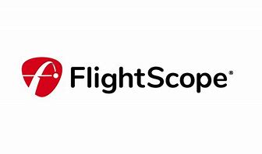



The Details - FAQ

* 1-1 lessons are available in 20-minute increments on Saturdays 8-4PM.
* The program is designed for 1 hour sessions each week and will include; 1-1 lessons, fitness & putting.
* Players CAN schedule their playing rounds 7days/wk and any time the clubhouse is open.
* Players CAN schedule their solo practice 7days/wk and any time the clubhouse is open.
* Solo practice sessions and rounds of golf do not include instruction and must be scheduled in advance.
* Players CAN schedule rounds to play together in a group of up to 4 players.
* GolfForever Program and SuperSpeed clubs are available for standalone purchase at a discounted cost to ALL program participants.
* Gift Certificates are printed on card stock, so they are presentable as gifts.
* Payment can be made remotely, and gift certificates mailed to save you a trip to the course.
* The program begins January 27 and ends March 2.