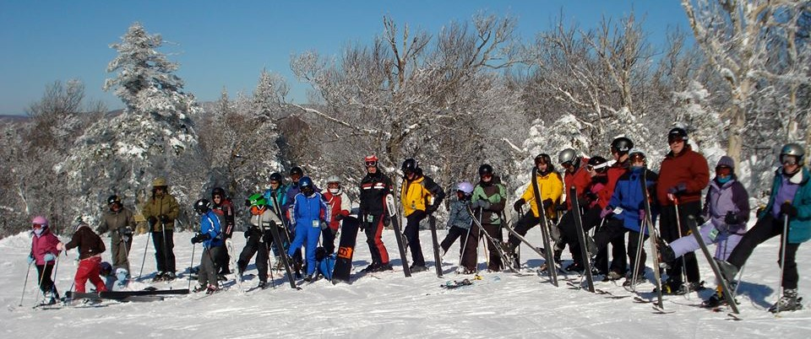

***41th Northern New England Veterinary Alpine Symposium***

***Request For Sponsorship and General Sponsor Benefits.***

We would be excited and honored to have you and your company as our meeting sponsor ! We, as the new organizers of the 2019 NNEVAS, would like to request financial support of the upcoming Omni Mount Washington CE meeting by your company.

The Mount Washington Resort, Bretton Woods, NH. is one of the last Grand Old Hotels in the USA. It is at the foot of Mount Washington which is the highest mountain peak in the eastern US. Of all the awesome peaks in the Presidential Range, Mt Washington stands tallest at 6288 feet ! The view of the mountain from this historic hotel is incredible ! A perfect venue for a meeting of the minds.

The following is some information to pass along to the appropriate powers that decide on sponsorship monies. At early stages, we can offer the opportunity for premier sponsorship. Premier sponsorship, on a first come basis, would require a commitment of $5000. There is some time sensitivity as we are already in the search for a sponsor or sponsors. We are, however, ***open to any level of sponsorship***, with levels ranging from $1000 to $5000. Sponsorships of $2000 or more and commitment prior to August 2018 will be included in the meeting announcement flyer printing distributed at promotions and to approx 4500 vets.

***We strive to provide the greatest return for our sponsor in all ways we can!!!***

***GENERAL LIST OF BENEFITS TO SPONSORS***

1. **Premier Sponsorship**: A 15 minute scheduled sponsor time will be allotted to a premium sponsor. You use this time as you wish to address the Veterinarians in attendance. In the past, these sessions have fostered much interest and questions and can highlight new products or company services. This sponsorship will include all of the following benefits.

**Premier sponsors will be highlighted during our Welcome Reception on Sunday night and on our website and mailings**.

1. A commitment of $2000, made by end of August will have that company’s name printed in our meeting flyer mailing sent to approx. 4500 practicing veterinarians on the east coast.
2. Exhibit space is included with sponsorship over $2000. If no representative from your company can attend, we will be happy to distribute your marketing information or display your product if you provide us with it..
3. Typical attendance is 40– 50 practicing veterinarians and a high percentage of decision making practice owners.
4. Representatives are included in all activities: lecture hall, dining, welcome party, skiing and/or x-country and apres-ski. You are an integral part of this conference! We want you to have a lot of one on one, shoulder-rubbing opportunities. This meeting is unique! It is laid back and full of good old New England charm and hospitality.
5. At each lecture session we verbally acknowledge our sponsors and express our gratitude.

8. We list in the AVMA Journal.

9. We send listings to all 50 State Veterinary Medical Associations, plus Canada. These listings appear in the newsletters across North America.

10. Sponsors are encouraged to participate in our banquet Raffle drawing by donating small gifts. This is another way to increase market exposure.

11. [www.vetskimeeting.com](http://www.vetskimeeting.com) is our website. Sponsor names will be listed there. We can insert links to your company’s website or your representative’s email.

12. We are flexible and open to new ideas and requests! (We want your sponsorship to benefit you!)

***WHEN:*** Sunday, Feb 24 – Thursday, Feb 28, 2019

***WHAT:*** 41th Northern New England Veterinary Alpine Symposium (NNEVAS)

(Veterinary Adventure Symposiums LLC)

***WHERE:*** Omni Mount Washington Hotel

Bretton Woods, NH. 03575

Tel: 1-603-278-1000

***WHO:*** Speaker: Christine Zewe, DVM, DACVD

Dermatologist, Mass Veterinary Referral Hospital

***SUBJECT:***  Selected Topics in Dermatology

Paul, Dianne and I and the meeting attendees look forward to your participation !

Kind Regards,

Drs Karieanne MacDonald, Paul Michaud-Nolan and Dianne Phillips

Veterinary Adventure Symposiums LLC

746 Post Road

Wells, ME USA

Cell: 207-233-8329 Dr MacDonald Email: [vetskimeeting@gmail.com](mailto:vetskimeeting@gmail.com?subject=NNEVAS)