NNEVAS Sponsorships 2026

Sun Feb 22 – Wed Feb 25, 2026 at the Omni Mount Washington Resort
Premium Sponsor $4000
Most prominent name and large logo placement on all mailers and conference notes and link on our website
Includes all benefits of exhibiting sponsor and includes a veterinary or technician CE registration fee

Speaker Sponsor $3500
1/2 hour presentation time to attending vets during Race Approved evening conference hours 5-7 pm
Special mention at Welcome Reception and Awards Ceremony Includes all benefits of exhibiting sponsor
Breakfast Sponsor $2500
10 min presentation time during our morning CE time 8 – 10:30am Includes all benefits of exhibiting sponsor
Exhibiting Sponsor $2000
Exhibit table in our conference room all 4 days
Prominent name and logo placement on all mailers and logo and link on our website Logo in printed conference notes
Introduction at Welcome Reception
Mention at Ski Race Award Ceremony and Raffle
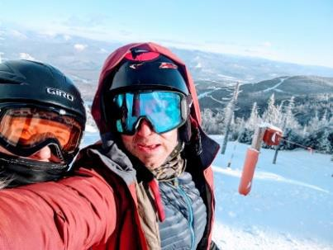
Contributing Sponsor any $
Sponsor name on website
Can contribute raffle items and promotional items

Contact Dr Karieanne MacDonald at vetskimeeting@gmail.com

