DRAFT Schedule Overview

THIS SCHEDULE IS SUBJECT TO CHANGE
WIFI Network: Hilton Honors Curio
WIFI Password: DCANO
The link to view captioning: https://www.streamtext.net/player?event=ACEDHH

Wednesday, January 29, 2025
8:00am to 5:00pm | Second Floor Foyer: Registration
1:00pm to 5:00pm | NoMa A: ACE-DHH Full Board Meeting
3:00pm to 5:00pm | Tanner Room: MLE SIG Informal Meeting
7:00pm to 9:00pm | ACEDHH Board Dinner

Thursday, January 30, 2025
7:00am – 8:00am | Second Floor Foyer: Check -in & Registration
8:00am-9:30am | Armature Room: Opening & Welcome, ACE-DHH President Dr. Ashley Greene  Keynote: Glennis Matthews, Superintendent at The Learning Center for the Deaf
9:30am-10:00am | Snack Break sponsored by The Learning Center

Breakouts | Room 1: Armature A  Strand 1: Fighting against -isms (e.g., racism, sexism) that affect all learners | Room 2: Armature B  Strand 2: Nurturing anti-ableist and anti-audist classrooms | Room 3: Tanner  Strand 3: The role of interpreters, social workers, school psychologists, and other professionals in working against -isms that affect deaf and hard of hearing individuals
10:00am-10:30am | Linguicism and P-12 and Teacher Training Programs  Presenters: Chris Kurz, Patrick Graham | The State of Deaf Education Teacher Preparation Programs: An Update to Dolman (2010)  Presenters: Janice Smith-Warsaw, Jessica Scott, Jen Kilpatrick & Claudia Pagliaro | Reading Assessments & Our Deaf Students  Presenters: Kate Kovacs, Julie Sepah & Marlon Kuntze
10:45am-11:15am | Covert ISM in Deaf Education  Presenter: Reginald Bess | Promoting Positive Self Identity and Deaf and Hard of Hearing Students through Media Representations  Presenters: Holly Pedersen, Marden Klepka, Monica Soukup, Lisa Borden-King | CED Updates on Accreditations and Advocacy  Presenters: Pam Luft, Barbara Hecht, Scott Cohen, Blane Trautwein, & Sarah Ammerman
11:30am-12:00pm | Strand 1 Spotlight presentation  Creating Connections: Overcoming Microaggressions in Deaf and HOH Education  Presenter: Shilpa Hanumantha Lacy

Lunch
12:00pm – 1:15pm | Lunch is on your own in various locations.

 | Armature A: Roundtable Session 1 Set 1 | Armature B: Roundtable Session 1 Set 2
1:15pm-2:00pm | Presentation 1: The Deaf Reading Rope Presenter: Nathan Harrison  Presentation 2: We thought it would be easy: Examining current deaf education data  Presenters: Stephanie Gardiner-Walsh, Jen Kilpatrick, Pamela Luft, Michelle Gremp, Claudia Pagliaro, Julie Delkamiller, Lindsey Kennon  Discussant: Colleen L. Smith | Presentation 3: Promoting Program Excellence through Accreditation: Council on Education of the Deaf Recognition Presenters: Scott Cohen, Jenna Voss  Presentation 4: Demystifying scholarly book and journal publishing  Presenters: Hannah Dostal, Katie Lee  Discussant: Patrick Graham

Breakouts | Room 1: Armature A  Strand 1: Fighting against -isms (e.g., racism, sexism) that affect all learners | Room 2: Armature B  Strand 2: Nurturing anti-ableist and anti-audist classrooms | Room 3: Tanner  Strand 3: The role of interpreters, social workers, school psychologists, and other professionals in working against -isms that affect deaf and hard of hearing individuals
2:15pm-2:45pm | Educating Students with “isms”  Presenters: Matthew Anderson & Alesia Allen | Implementing the Language Abilities & Approaches Wheels (LAAWs): Intentional Design of a Language Rich Environment in the Classroom  Presenters: Tammy Burns, Sarah Honigfeld | The Family Puzzle: The Inclusion of A Deaf/Hard of hearing Family Member  Presenter: Keisha Lowery
3:00pm-3:30pm | Challenging the ‘Norm’: A Critical Look at Hearing-Deaf Comparison Studies in Research  Presenters: Leala Holcomb, Jessica Scott, Stef Gardiner-Walsh, & Wyatt Hall | The Mathematical Self-Efficacy of Deaf/Hard-of-Hearing Students: A Narrative Approach  Presenter: Blake Nelson | Expert Recommendations for Inclusive SLP Services for Deaf Children Who Use Signed Language  Presenters: Dave Smith, Marie Coppola, Kristen Secora, & Brittany Lee
3:30pm-4:00 pm | BREAK
4:00-5:00 | Armature Room: ACE-DHH General Meeting

Evening Activities
6:00pm- 7:00pm | NoMa A: Graduate Students Meet and Greet | NoMa C: SIWI (for university faculty engaged in the online PD program)
5:30pm-9:00pm | Dinner On Your Own

Friday, January 31, 2025
7:00am – 8:00am | Armature Foyer: Breakfast  Sponsored by the Journal of Deaf Studies and Deaf Education

Breakouts | Room 1: Armature A  Strand 1: Fighting against -isms (e.g., racism, sexism) that affect all learners | Room 2: Armature B  Strand 2: Nurturing anti-ableist and anti-audist classrooms | Room 3: Tanner  Strand 3: The role of interpreters, social workers, school psychologists, and other professionals in working against -isms that affect deaf and hard of hearing individuals
8:00am -8:30am | Embracing Diversity: Cultivating Cultural Humility in Education  Presenter: Alesia Allen | DEIA THINK TANK DISCUSSION with Sonia Arora & Scott Cohen | Eyes on Language: Early Visual Strategies for Language-Rich Environments  Presenters: Elaine Gale, Patrice Creamer, Shane Blau
8:45am-9:15am | Public Input 2018 Survey Findings: Understanding the Barriers and Challenges of Deaf and Hard of Hearing Students and Their Families from Traditionally Underserved Groups  Presenter: Amber Marchut | Retaining Deaf College Students: Insights from COVID-19 and Ongoing Struggles with Access and Support  Presenters: Jeffrey Palmer & Carrie Lou Bloom | In Pursuit of Culturally Responsive and Sustaining Practices in Early Intervention: A Model for Professional Development  Presenters: Amanda Howerton-Fox, Islah Tauheed, & Michelle Veyvoda
9:30am-10:00am | Challenging Systemic Biases: Innovative Assessment for Multilingual Deaf Learners  Presenter: Ashley Greene | The writing of deaf secondary students  Presenters: Kimberly Wolbers, Hannah Dostal, Kelsey Spurgin, Leala Holcomb, & Elizabeth Martinez | Deaf and Hard of Hearing College Students’ Experiences With Alcohol and Related Consequences  Presenter: Christine Gannon
10:00am-10:30am | Break! | Break! | Break!
10:30am-11:00am |  | Strand 2 Spotlight Presentation  Elevating Students’ Learning Experience through Humanizing Framework  Presenters: Janaee Cobbs and Scott Cohen
11:15am-11:45am | Bimodal Bilingual Benefits Counter Audism and Linguicism  Presenters: Diane Lillo-Martin, Chui-Yi Lee, Elaine Gale, & Deborah Chen Pichler | Transformative Deaf Pedagogies: Unveiling the Power of Seeing Through New Eyes  Presenter: Paddy Ladd | The Impact of Professional Development on Early Intervention Service Providers Serving Deaf and Hard of Hearing Children  Presenters: Erin Furtado & Jennifer Catalano

Lunch
11:45pm-1:00pm | Lunch is on your own in various locations.

Breakouts, cont. | Armature A: Roundtable Session 2 Set 1 | Armature B: Roundtable Session 2 Set 2
1:00pm -1:45 pm | Presentation 1: Bridging Gaps: Supporting Deaf Education and Sign Language Recognition in Morocco Presenters: Cheryl Shahan, April Haggard, Kimberly Wolbers, David Smith  Presentation 2: World Language Learning Presenter: Terynce Butts  Discussant: Pauline Ballentine | Presentation 3: Situating ideological positivity in deaf education: A roundtable discussion toward anti-oppressive practices in deaf education Presenters: Michael Skyer, Jessica Scott, Scott Cohen  Presentation 4: Improving STEM Access and Equity for Deaf and Hard of Hearing Students: A Systematic Review of Universal Design for Learning Applications  Presenter: Jongwoo Lee  Discussant: Jennifer Catalano

 | Room 1: Armature A  Strand 1: Fighting against -isms (e.g., racism, sexism) that affect all learners | Room 2: Armature B  Strand 2: Nurturing anti-ableist and anti-audist classrooms | Room 3: Tanner  Strand 3: The role of interpreters, social workers, school psychologists, and other professionals in working against -isms that affect deaf and hard of hearing individuals
2:00 pm-2:30 pm | DEIA THINK TANK DISCUSSION with Patrick Graham and Jessica Scott | MLE-SIG Business Meeting | Evidence for ASL and Spoken Language Development in Deaf Children  Presenters: Jessica Beaty, Adele Eberwein, Karen Soza, Erich Tucker, Tabitha Venable

Afternoon break to explore DC!
Optional Gallaudet University Tour: 3:15-5:00
Evening Activities
5:30pm-8pm | Multilingual Education Special Interest Group social hour  *Must be a SIG member to attend  Location: Vesper Lounge
6pm-9pm | Dinner on your own

Saturday, February 01, 2025
7:00am – 8:00am | Armature Foyer: Breakfast  Sponsored by Lamar University

Breakouts | Room 1: Armature A  Strand 2: Nurturing anti-ableist and anti-audist classrooms | Room 2: Armature B  Strand 2: Nurturing anti-ableist and anti-audist classrooms | Room 3: Tanner  Strand 3: The role of interpreters, social workers, school psychologists, and other professionals in working against -isms that affect deaf and hard of hearing individuals
8:00am-8:30am | Intersectional Identities, Anti Bias Education, and Multilingual Deaf Education  Presenters: Kimberly Wolbers, Debbie Golos, Marlon Kuntze & Chris Kurz | Software Nonstarters, Fails and Successes according to DASS (Deaf Aesthetics Supported Software): An Evaluation Tool  Presenters: Joanne Weber, Daniel Milan, Angela Milan, Amel Benkohila, & Sarah Snively | K-12 Struggles and Strategies of Students with Mild/Moderate Hearing Losses: Case Management Issues and Empowering Solutions  Presenter: Pam Luft
8:45am-9:15am | “Involve Me, I Understand”: Teaching Misinformation Resilience  Presenter: Cindy Officer | Bridging the Gap: Enhancing transition planning and postsecondary success for deaf youth through teacher preparation  Presenters: Latoya Dixon, Karla Giese, & Carrie Lou Bloom | Parents and Language Choices: Audism at Work  Presenters: Marlon Kuntze, Elaine Gale, Julie Rems-Smario, & Laura Peterson
9:30am-10:00am |  |  | Spotlight Presentation 3  Toward a More Inclusive Classroom  Presenter: Su Isakson  HELD IN ARMATURE ROOM
10:15am-10:45am | Exploring deaf aesthetics as pedagogy and curriculum in deaf education: Findings from a trio of autoethnographic case studies about higher education  Presenters: Joanne Weber, Michael Skyer, Genie Gertz & Chris Kurz | Nationwide Survey and Focus Group: Unveiling the Current State of ASL instruction With Deaf Students  Presenters: Leala Holcomb & Adele Eberwein | Building relationships between teachers, researchers and diverse Deaf communities: Striving toward anti-bias Deaf Education  Presenters: Leah Dolezal, Cooke Brand, Brynn Kraning, Debbie Golos
11:00am-11:30am | Empowering Deaf/Hard of Hearing Learners through Self-graphing their Performance Data  Presenter: Jennifer Beal | Beyond Grammar: Deaf Students' Signed Compositions Across Personal, Informative, and Persuasive Genres  Presenter: Leala Holcomb | Cultivating partnerships for diversifying Deaf Studies students’ experiences  Presenters: Jessica Scott & Justin Malone

Lunch
11:30pm- 1:00 pm | Lunch on your own

1:15pm-2:45 pm | Armature A & B: Poster Session  Poster session: Set up 1:15-1:30  Posters 1:30-2:30  2:45 break down
Breakouts | Room 1: Armature A  Strand 1: Fighting against -isms (e.g., racism, sexism) that affect all learners | Room 2: Armature B  Strand 2: Nurturing anti-ableist and anti-audist classrooms | Room 3: Tanner  Strand 3: The role of interpreters, social workers, school psychologists, and other professionals in working against -isms that affect deaf and hard of hearing individuals
3:00-3:30 | Classism: Emerging Mental Health Challenges & Implications Among Classroom Educators and Learners  Presenters: TJ Sanger & Jennifer Gentzke | Presentation 1: Nurturing Anti-audist Classrooms: A Deaf-centric Approach to Education  Presenters: Jennifer Beal, Jamie Bencak, & M. Diane Clark | Impact of ASL translation on MAP in math test performance  Presenters: Marlon Kuntze & Brenda Call
4:00-5:00- Armature A&B: Business Meeting

Evening Activities
6:30-9:30pm | Armature A&B: Evening Banquet and Awards

Breakout Session Information

Thursday, January 30, 2025
10:00am – 10:30am

Armature Room A: Linguicism and P-12 and Teacher Training Programs
Chris Kurz & Patrick Graham
This presentation explores the impact of language oppression in teacher training programs surrounding deaf pre-service teachers through a framework of linguicism. We address the marginalization of sign languages, language imposition, linguistic deprivation, and cultural erasure, showing how societal bias affects Deaf students in P-12 and in teacher training programs.

Armature Room B: The State of Deaf Education Teacher Preparation Programs: An Update to Dolman (2010)
Janice Smith-Warsaw, Jessica Scott, Jen Kilpatrick & Claudia Pagliaro
There has long been recognition of a critical shortage in deaf education teachers, and more
recently researchers have also published calls for greater diversity among deaf education teacher
candidates. This presentation will share results of a survey that updates our knowledge of the
status of deaf education teacher preparation programs.

Tanner Room: Reading Assessments and Our Deaf Students
Kate Kovacs, Julie Sepah, & Marlon Kuntze
Deaf & Hard of Hearing students are expected to take one-on-one reading assessment in the fall to show growth on an annual basis. We want to look at data and see if students who perform well on these reading assessments also do well on the MAP test as part of the school-wide assessments.

10:45am – 11:15

Armature Room A: Covert ISM in Deaf Education
Reginald Bess
The purpose of this presentation is to examine both common and uncommon literature reviews in the field of deaf education. This review will be framed within Critical Race Theory (CRT) and Black Deaf Gain. Limitations and recommendations are discussed to guide future researchers in developing stronger research questions, particularly those addressing and investigating issues of inequity in deaf education.

Armature Room B: Promoting Positive Self Identity and Deaf and Hard of Hearing Students Through Media Representations
Holly Pedersen, Marden Klepka, Monica Soukup & Lisa Borden-King
Media is beginning to spotlight DHH characters more positively. Healthy self-identity
is a key factor in academic success. This presentation provides an overview of how
research linking self-identify with academic success was used as a foundation for
the development of a curriculum package for DHH students using contemporary
media portrayals.

Tanner Room: CED Updates on Accreditations and Advocacy
Pam Luft, Barbara Hecht, Scott Cohen, Blane Trautwein & Sarah Ammerman
Presenters will review program accreditation forms, procedures, and answer questions. The review will include examples of data for several of the standards, with narrative, and charts to show candidate outcomes. Presenters will discuss the Strategic Plan, advocacy, and developments from the recent CED Board Meeting, and answer any questions.

11:30-12:00

Armature Room A & B: Creating Connections: Overcoming Microaggressions in Deaf and HOH Education (spotlight presentation)
Shilpa Hanumantha Lacy
This presentation will cover the subtle microaggressions faced by Deaf and Hard of Hearing learners in education. We will connect these issues to broader discrimination themes and emphasize the need for inclusivity. Participants will gain practical strategies to recognize and address microaggressions, fostering a supportive and equitable environment for all students.

1:15-2:00

Armature Room A: Roundtable 1 Set 1
Roundtable Presentation 1: The Deaf Reading Rope
Nathan Harrison
As the Science of Reading (SOR) movement takes more traction, ASL/English programs find themselves at odds with the phonics-focused approach to reading required by the SOR. The Deaf Reading Rope seeks to integrate the SOR with skilled Deaf reader research and essential components of ASL/English bilingual reading.

Roundtable Presentation 2: We Thought It Would Be Easy: Examining Current Deaf Education Data
Stephanie Gardiner-Walsh, Jen Kilpatrick, Pamela Luft, Michelle Gremp, Claudia Pagliaro, Julie Delkamiller & Lindsey Kennon
Accurate data on higher education programs preparing professionals to work with DHH individuals, as well as on Birth - 21 DHH students served, is required for decision-making and advocacy. This session explores the methodological challenges of the current data available, discusses potential next steps and includes attendees in brainstorming potential strategies and solutions.

Armature Room A: Roundtable 1 Set 2

Roundtable Presentation 3: Promoting Program Excellence through Accreditation: Council on Education of the Deaf Recognition
Scott Cohen & Jenna Voss
Is your teacher preparation program looking for an opportunity to improve quality, ensure the excellence of your students and alums, and stand out amongst others? Join us to discuss the benefits of having your program accredited by the Council on Education of the Deaf to apply for the accreditation.

Roundtable Presentation 4: Demystifying Scholarly Book and Journal Publishing
Hannah Dostal & Katie Lee
The acquisitions editor at a university press and the editor-in-chief of a scholarly journal discuss the publication process for books and journal articles, offering detailed information on each
process, along with guidance on how to successfully navigate each process. Invited authors will
candidly discuss their experiences with scholarly publishing.

2:15-2:45

Armature Room A: Educating Students With “-Isms”
Matthew Anderson & Alesia Allen
This presentation discusses the lack of “isms” addressed in classrooms that affect the diverse deaf learners. Educators' understanding of diversity, equity and inclusion needs to be addressed and reduce “isms” that affect deaf learners. Tools are shared in the presentation where the educators increase their understanding of “isms” in classrooms.

Armature Room B: Implementing the Language Abilities and Approaches Wheels (LAAWs): Intentional Design of a Language Rich Environment in the Classroom
Tammy Burns & Sarah Honigfeld
How can we create more language-rich environments for deaf and hard of hearing students? Drawing on experiences, observations, and input from language planning committees and beta testing groups, the Language Abilities & Approaches Wheels (LAAWs) framework was developed to support educators in identifying language development gaps and support balanced growth in signacy, literacy, and oracy.

Tanner Room: The Family Puzzle: The Inclusion of a Deaf/Hard of Hearing Family Member
Keisha Lowery
I have a Deaf/Hard of Hearing child? Now what? How can I raise them? What will become of them when I get older? How will they fit in our family? All these questions that parents and family members ask when they discover that a child is Deaf/Hard of Hearing. This presentation will help professionals help guide parents/families through world of Deaf/Hard of Hearing. Everyone has a role to play in the development of a child that is Deaf/Hard of Hearing. Just because the child has hearing loss doesn't mean they aren't a piece of the family puzzle.

3:00-3:30

Armature Room A: Challenging the “Norm”: A Critical Look at the Hearing-Deaf Comparison Studies in Research
Leala Holcomb, Jessica Scott, Stephanie Gardiner-Walsh & Wyatte Hall
Our study critically examines the biases and methodological shortcomings found in studies comparing deaf and hearing populations. Our findings include an analysis of recurring fallacies identified in the 20 most-cited deaf-hearing comparison studies. We demonstrate how this methodology affects both the reliability and ethics of research in deaf education.

Armature Room B: The Mathematical Self-Efficacy of Deaf/Hard-of-Hearing Students: A Narrative Approach
Blake Nelson
Bandura’s ideas of self-efficacy sources and beliefs illuminate how and why d/Deaf and Hard-of-Hearing students find success in different learning environments. A qualitative example using this lens shows a HoH student finding refuge in her math classroom from ableist attitudes despite struggles with self-advocacy.

Tanner Room: Expert Recommendations for Inclusive SLP Services for Deaf Children Who Use Signed Language
Dave Smith, Marie Coppola, Kristen Secora & Brittany Lee
A Delphi questionnaire process was used to establish consensus recommendations from deaf and hearing experts in the fields of speech-language pathology (SLP), deaf education, sign language/linguistics, and child development on qualifications and culturally responsive practices for SLPs when working with Deaf and Hard-of-Hearing (DHH) students who use signed language.

Friday, January 31, 2025
8:00-8:30

Armature Room A: Embracing Diversity: Cultivating Cultural Humility in Education
Alesia Allen
Embracing diversity and practicing culturally-responsive approaches in education are important. Educators who practice cultural humility allow for greater understanding and recognize each individual’s unique cultural experiences. By acknowledging and integrating diverse cultural identities, educators can create a more equitable learning environment. A review of concepts connected with intersectionality, integrating a multicultural orientation framework, and embracing skills to practice cultural humility will be shared in hopes to create meaningful educational relationships.

Armature Room B: Creating Anti-Ableist and Anti-Audist Classrooms that Combat Language Deprivation and Prevent Related Trauma
Brittany Kaplan
This literature review seeks to understand the research in the field of language deprivation from
its origin to today as it relates to ableism, audism, and traumatic identity development. I ask
about the definition of “language deprivation” and its exploration along with a focus on its
traumatic context.

Tanner Room: Eyes on Language: Early Visual Strategies for Language-Rich Environments
Elaine Gale, Patrice Creamer & Shane Blau
This session will be valuable for current and future teachers interested in supporting families with young deaf children because they will learn about the importance of early visual strategies,
list visual strategies used by deaf adults, and teach mini-lessons on visual strategies when working with families with young deaf children.

8:45-9:15

Armature Room A: Public Input 2018 Survey Findings: Understanding the Barriers and Challenges of Deaf and Hard of Hearing Students and Their Families from Traditionally Underserved Groups
Amber Marchut
The Clerc Center’s nationwide public input survey, with feedback from 1,400 respondents, presents findings on barriers and challenges experienced by deaf and hard of hearing students (birth through high school) and their families of diverse backgrounds that prevent these children from achieving their fullest academic, linguistic, and socio-emotional potential.

Armature Room B: Retaining Deaf College Students: Insights from COVID-19 and Ongoing Struggles with Access and Support
Jeffrey Palmer & Carrie Lou Bloom
This study evaluates the impact of COVID-19 from a public secondary dataset and ongoing challenges for deaf college students using the Deaf Postsecondary Access & Inclusion Scale. It reveals critical factors affecting retention and presents evidence-based strategies to enhance institutional support and retention for deaf students.

Tanner Room: In Pursuit of Culturally Responsive and Sustaining Practices in Early Intervention: A Model for Professional Development
Amanda Howerton-Fox, Islah Tauheed & Michelle Veyvoda
Participants in this session will learn the Five Pursuits of the Cultivating Genius Equity Framework, discuss ways of incorporating them into EI goal setting, and explore the many and
varied ways to use different types of texts through early intervention to affirm the intersecting
identities of children and families.

9:30-10:00

Armature Room A: Challenging Systemic Biases: Innovating Assessment for Multilingual Deaf Learners
Ashley Greene
This presentation will explore the need to develop strategies for assessing multilingual deaf children beyond the traditional approach of simply evaluating English, which will be argued to
be an approach rooted in linguicism. This presentation highlights the limitations of normed assessments.

Armature Room B: The Writing of Deaf Secondary Students
Kimberly Wolbers, Hannah Dostal, Kelsey Spurgin, Leala Holcomb & Elizabeth Martinez
The purpose of this study is to investigate the current state of deaf high school students’ writing
by collecting and analyzing writing samples. The study is intended to assist us in learning more
about deaf high school writing skills to determine what kind of instruction and support matches their needs.

Tanner Room: Deaf and Hard of Hearing College Students’ Experiences with Alcohol and Related Consequences
Christine Gannon
Alcohol is an issue at a university for deaf and hard of hearing students. The presenter will share data from 50 interviews. Themes include connection, tradition, isolation, communication barriers, and life gaps. The presenter will also explore ways college educators can address the impact of alcohol on the university experience.

10:30-11:00

Armature Room A & B: Elevating Students’ Learning Experience through Humanizing Framework (spotlight presentation)
Janaee Cobbs and Scott Cohen
This presentation centers on humanizing students through community cultural wealth and culturally responsive pedagogy, recognizing where the students’ abilities are and empower them to grow as learners. The framework reimagines the role of teachers by creating affirming learning spaces that transforms the classroom with student-centered practices to nurture every learner.

11:15-11:45

Armature Room A: Bimodal Bilingual Benefits Counter Audism and Linguicism
Diane Lillo-Martin, Chui-Yi Lee, Elaine Gale & Deborah Chen Pichler
Pervasive effects of audism and linguicism mislead many parents and teachers of Deaf and
Hard of Hearing children into viewing early sign language exposure as an impediment to
spoken language development. We present evidence to the contrary, demonstrating benefits of bimodal bilingualism for DHH children and their hearing parents.

Armature Room B: Transformative Deaf Pedagogies: Unveiling the Power of Seeing Through New Eyes
Paddy Ladd
This presentation explores transformative practices in Deaf Education, grounded in Seeing Through New Eyes, Deaf Culture, and Deaf Pedagogies: The Unrecognized Curriculum. Attendees will delve into Deaf pedagogies, cultural knowledge, and innovative strategies, gaining tools to foster anti-oppressive learning environments that effectively support the development of Deaf students.

Tanner Room: The Impact of Professional Development on Early Intervention Service Providers Serving Deaf and Hard of Hearing Children
Erin Furtado & Jennifer Catalano
This mixed-method action research study examined the impact of professional development on the knowledge and self-efficacy of Early Intervention (EI) service providers working with Deaf and hard-of-hearing (DHH) children and their families. EI providers are critical in ensuring DHH children reach developmental milestones and thrive in non-oppressive learning environments.

1:00-1:45

Armature Room A: Roundtable 2 Set 1:
Roundtable Presentation 1: Bridging Gaps: Supporting Deaf Education and Sign Language Recognition in Morocco
Cheryl Shahan, April Haggard, Kimberly Wolbers & David Smith
This session will highlight the pivotal roles of professionals in the USA in fostering non-oppressive learning environments, in other countries, particularly in Morocco. The challenges we will address include the recognition of Moroccan Sign Language (LSM) and the inclusion of Deaf educators.

Roundtable Presentation 2: World Language Learning
Terynce Butts
Presentation will begin with an overview of literature regarding deaf people learning a world language. Experiences of deaf Americans learning a world language or traveling abroad will be highlighted. Questions regarding translanguaging practices are explored in addition to how deaf people travel today.

Armature Room B: Roundtable 2 Set 2:

Roundtable Presentation 3: Situating Ideological Positivity in Deaf Education: A Roundtable Discussion Toward Anti-Oppressive Practices
Michael Skyer, Jessica Scott & Scott Cohen
From the socially unjust historical ground of deaf education, we situate ideological positivity. In
education, these are theories, processes, and actions fundamentally concerned with dissolving
ableism/audism, redressing power inequalities; and conversely, creating pathways toward access and justice. We invite colleagues to consider these necessary changes (Paris, 2012) alongside us.

Roundtable Presentation 4: Improving STEM Access and Equity for Deaf and Hard of Hearing Students: A Systematic Review of Universal Design for Learning Applications
Jongwoo Lee
A systematic literature review was conducted to explore what empirical research has been done
concerning applying the Universal Design for Learning (UDL) framework to d/Deaf and Hard of
Hearing(d/DHH) learners in Science, Technology, Engineering, and Mathematics (STEM)
contexts.

2:00-2:30

Armature Room A: Where Are the Male Role Models: Addressing Sexism in Early Childhood Education
Patrick Graham & Ashley Greene
We discuss the concerns of sexism in the field of deaf early childhood education (ECE). We need role models for communication, social skills, and adaptive skills. We discuss findings from interviews conducted with male ECE teachers and their perceptions of the field., such as challenges related to pay equity, professional development opportunities, and career advancement.

Armature Room B: MultiLingual Education Special Interest Group Business Meeting
Dave Smith
Business Meeting of the MLE-SIG

Tanner Room: Evidence for ASL and Spoken Language Development in Deaf Children
Jessica Beaty, Adele Eberwein, Karen Soza, Erich Tucker, Tabitha Venable
This study examines how different checklists provide critical information regarding language development in young deaf students. Through analysis, the results provide an understanding of
how students are progressing with their spoken language, signed language, or both simultaneously. Results lead to promoting a language inclusive learning environment for all deaf learners.

Saturday, February 1, 2025
8:00am –8:30am

Armature Room A: Intersectional Identities, Anti-Bias Education, and Multilingual Deaf Education
Kimberly Wolbers, Debbie Golos, Marlon Kuntze & Chris Kurz
This study explores the intersecting identities of the 100+ contributors to 58-in-Mind:
Multilingual Strategies for Diverse Deaf Students. The findings will inform the plans for a
second edition to spotlight the diversity in the contributions to the book and to make the book more representative of diverse Deaf students.

Armature Room B: Software Nonstarters, Fails, and Successes According to DASS (Deaf Aesthetics Supported Software): An Evaluation Tool
Joanne Weber, Daniel Milan, Angela Milan, Amel Benkohila & Sarah Snively
A research team evaluated software applications, according to their experience in creating online learning activities aligned with deaf aesthetic principles. A newly developed tool, Deaf Aesthetics Supported Software (DASS) was used to encapsulate their understanding of affordances and limitations of software toward applications of deaf aesthetics to online learning.

Tanner Room: K-12 Struggles and Strategies of Students with Mild/Moderate Hearing Losses: Case Management Issues and Empowering Solutions
Pam Luft
Ten DHH postsecondary students described struggles and successful strategies from their K-12 inclusion placements. These students need ongoing services and oversight in ways that also empower them to successfully address their challenges. This can help current and future educators improve lifelong outcomes for these students.

8:45am –9:15am

Armature Room A: “Involve Me, I Understand”: Teaching Misinformation Resilience
Cindy Officer
DHH students whose information primarily comes from the internet need to develop skills to discern accurate information from misinformation. Misinformation not only affects individuals' learning processes but also undermines their self-worth. This presentation proposes practical approaches to teaching resilience against misinformation.

Armature Room B: Bridging the Gap: Enhancing Transition Planning and Postsecondary Success for Deaf Youth Through Teacher Preparation
Latoya Dixon, Karla Giese & Carrie Lou Bloom
Deaf students remain underserved despite federal policies supporting youth with disabilities. This session will explore critical factors impacting the postsecondary success of deaf youth. Presenters will explore how deaf education teacher preparation can foster non-oppressive learning environments while improving transition planning in K-12.

Tanner Room: Parents and Language Choices: Audism at Work
Marlon Kuntze, Elaine Gale, Julie Rems-Smario & Laura Peterson
In this presentation we will share survey responses from parents’ experiences with professionals
when making language decisions after identification. We will also discuss how audism contributes to initial language decisions parents made which is not without risks to language deprivation and share strategies for involving deaf adults early on.

9:30am-10:00am
Armature Room A & B: Toward a More Inclusive Classroom (spotlight presentation)
Su Isakson
It started the moment I recognized 90% of the interpreters in the field would not be able to interpret for my Deaf Korean mother. Interpreter education, which has been dominated by white people, was known for being an unwelcome place to racial and cultural minorities, Coda, and Deaf students. Entering interpreter education as a bimodal multilingual, mixed race multicultural Coda is a privileged position. I have come to recognize who I am and what I’ve experienced can serve as tools in my classroom, and my students bring equally as many, if not more, tools to the field of interpreting-- IF I create space for it.
10:15am – 10:45am

Armature Room A: Exploring Deaf Aesthetics as Pedagogy and Curriculum in Deaf Education: Findings from a Trio of Autoethnographic Case Studies about Higher Education
Joanne Weber, Michael Skyer & Genie Gertz
How do deaf academics apply deaf aesthetics in their work within higher education settings? In
this trio of autoethnographic studies, representing analytic lived experiences, we examine how
our intuitive sense of design as artists, and our knowledge as veteran teachers of deaf students
affected our pedagogy and curriculum design processes.

Armature Room B: Nationwide Survey and Focus Group: Unveiling the Current State of ASL Instruction with Deaf Students
Leala Holcomb & Adele Eberwein
This nationwide survey explored the methods teachers use to teach ASL skills, as well as the broader scope of ASL literature in deaf education. Two focus group discussions were held for a deeper understanding of the survey results. This presentation will offer insights into the current state of ASL instruction.

Tanner Room: Building Relationships Between Teachers, Researchers, and Diverse Deaf Communities: Striving Toward Anti-Bias Deaf Education
Leah Dolezal, Cooke Brand, Brynn Kraning & Debbie Golos
In this presentation we share examples and invite conversations to build better partnerships with
diverse Deaf communities to nurture anti-bias classrooms through a multilingual lens. We discuss implications for teacher preparation and doctoral programs striving toward systemic
change in the field of Deaf Education.

11:00am – 11:30am

Armature Room A: Empowering Deaf/Hard of Hearing Learners through Self-Graphing Their Performance Data
Jennifer Beal
This presentation addresses how DHH learners can be empowered to monitor their own learning
through the evidence-based instructional strategy (EBP) of self-graphing and how it has been used with DHH K-12 learners to change academic and social behaviors. Participants will learn how they can embed self-graphing within their instruction.

Armature Room B: Beyond Grammar: Deaf Students’ Signed Compositions Across Personal, Informative, and Persuasive Genres
Leala Holcomb
This study presents preliminary findings from a nationwide data collection during the 2024-2025
academic year, examining sign language compositions of deaf students. It explores how students are able to convey their thoughts in meaningful and authentic ways, moving away from de-contextualized grammar approaches.

Tanner Room: Cultivating Partnerships for Diversifying Deaf Studies Students’ Experiences
Jessica Scott & Justin Malone
This session will describe the approach taken by one Deaf Education/Deaf Studies program to connect with diverse Deaf communities to improve the educational experiences of all students, particularly hearing students, within the program. We will explore lessons learned from these connections.

3:00pm-3:30pm

Armature Room A: Classism: Emerging Mental Health Challenges and Implications Among Classroom Educators and Learners
T.J. Sanger & Jennifer Gentzke
We will discuss factors that contribute to the mental health well-being of classroom educators, student teachers and learners. One of the main reasons why educators leave the education field is because of mental health implications and/or not knowing how to deal with learners’ mental health challenges.

Armature Room B: Nurturing Anti-Audist Classrooms: A Deaf-Centric Approach to Education
Jennifer Beal, Jamie Bencak, & M. Diane Clark
We argue that education for D/deaf students should diverge from traditional Special Education
models that inherently support auditory-based approaches (i.e., audism) and toward models that
emphasize the unique language development needs of D/deaf children, including a Deaf didactic
instructional philosophy focused on visual language and learning.

Tanner Room: Impact of ASL Translation on MAP in Math Test Performance
Marlon Kuntze & Brenda Call
Test equity has been an ongoing issue and the question of whether the teacher should provide ASL translation is not settled. This study focuses on High School MAP testing in math to find out how scores are affected when students are allowed to ask for translation to understand an item.

Poster Session Information

Saturday, February 1
1:30 pm-2:30 pm

Addressing the “isms” in Deaf Education: What are the Views of Teacher Candidates?
Michelle Gremp
Teacher preparations programs are obligated to prepare teachers who understand biases and work toward fostering inclusivity for their students. This presentation will report on the teacher candidates’ knowledge around ableism and other impediments to inclusivity and suggest next steps for ensuring a more democratic approach to education for all.

Universal Design for Learning and Accessibility: DeafBlind College Students’ Experiences
Zahra Ketoun & Esther Brenowitz
This study explores the impact of Universal Design for Learning (UDL) on DeafBlind college students’ academic accessibility and experiences. By examining the effectiveness of UDL principles in addressing accessibility challenges, the research aims to provide insights into the benefits of UDL in fostering inclusive educational environments for DeafBlind students.

Exploring Dyslexia in Deaf Learners
Amanda Kline & Bradley White
Dyslexia has become a hot topic in education, but what does it look like for Deaf students? In this session, you'll discover cutting-edge research on dyslexia in signing Deaf children, gain insights into how dyslexia may present in Deaf students, and explore practical applications in the classroom to improve outcomes.

Connecting the Dots: Relationships Between Financial Literacy Certifications and Pre-College Writing/Reading Placement Scores Earned by Deaf and Hard of Hearing Collegiate Students
Mike Kane & Cindy Officer
Deaf and hard of hearing students in RIT/NTID personal finance classes have the opportunity to earn financial literacy certifications. Some earn the certification, others do not. Why? This correlative research examines data among 53 students who were enrolled in a Personal Finance class over a span of six academic semesters.

Delving into the Language and Literacy Practices of a Signing Deaf Adolescent in Nonsigning Environments
Betsy Beckert
This multi-sited case study explores the complex interactions of a signing deaf adolescent and non-signing others in situations that involve varied texts (e.g., maps, drawings, text messages). Such sociocultural explorations combat deficit frames and support teachers in building with deaf adolescents’ practices to foster their literacy development.

Delving into the Language and Literacy Practices of a Signing Deaf Adolescent in Nonsigning Environments
Natalia Rohatyn-Martin, D. Hayward, Lynn McQuarrie, L. Cundy, S. Rohatyn, J. Gan, S. Dickner
This poster describes the first two phases of our research - designing and pilot testing the Fatigue in Educational Contexts (FEC) survey. It also highlights four animated videos, providing viewers the opportunity to learn about three dimensions of fatigue and the difference between fatigue and tiredness from a D/HH perspective.

Missing Voices in Literacy Development for the d/Deaf
Haley Holstein
This phenomenological study explores the metaphorical voices of twelve participants who are d/Deaf. Exploring the ontology of the social phenomenon of how inclusion influenced literacy outcomes from the unique perspective of the d/Deaf voice, which is often absent and silenced in research, audism can be tapered in educational research.

Queering Deaf Spaces with American Sign Language (ASL) Education and Deaf Education (A Qualitative Empirical Study Recruitment Poster)
Michael Skyer, Leah Oakes, & Matt Anderson
Scant empirical evidence exists about the lives of professionals who are deaf and queer signers of ASL. This poster proposal has two key outcomes: to 1) synthesize and disseminate available research about this topic and 2) inform and recruit potential participants for a qualitative collective case study about this topic.

Bridging the Gap: Novice Deaf Educators' Experiences and the Path to DHH Classrooms
David Meek
This study explores novice deaf education teachers' experiences across 21 states, highlighting gaps between preparation and classroom realities. Findings emphasize the need for enhanced training in ASL, working with additional disabilities, and administrative tasks. Results underscore the importance of mentorship and ongoing support in addressing unique challenges in deaf education.

Exploring High Impact Practices in Teacher Preparation: Empowering Future Educators to Foster Language-Rich Environments for DHH Students
Kelsey Spurgin & Melinda Kennedy
We present a grant-funded project called the DHH Language & Learning Nook, which serves two main purposes: 1) to provide a centralized space where families and DHH children can engage in learning, social connection, and resource sharing and 2) to provide deaf education teacher candidates accessible field experiences to engage in supported instruction.

Deaf Teachers in Various Educational Settings: Their Challenges and Their Needs
Yunjae Hwang
This study focuses on identifying deaf and hard-of-hearing teachers in the US as needing improved support educational services, illustrate challenges to collaborating with students, parents, and colleagues, and make accommodations to improve support services for deaf and hard-of-hearing teachers within the education setting.

Rethinking the LRE - A Literature Review
Chris Black
Within the field of Deaf education, the idea of inclusion refers to the practice of integrating Deaf and hard of hearing (DHH) students into “regular” classrooms alongside their hearing peers, aiming to provide equal education opportunities and promote social integration. This presentation is the result of a comprehensive review of research and literature on the experiences of DHH students regarding inclusion in general education classrooms.

Job Satisfaction of Itinerant Teachers of Deaf and Hard of Hearing Students
Holly Pedersen, Chanda Verble, Nicole Swartwout, & Vicki Michels
Job satisfaction is linked to teacher recruitment and retention. In a replication of Luckner & Dorn (2017) a national sample of itinerant TODHHs were surveyed to explore overall job satisfaction and associated factors. Findings and implications for the field are presented.

Development of an Assessment of the Communities' Beliefs and Attitudes about Deaf Interpreters (BADi)
Pauline Ballentine, Latoya Dixon, Adele Eberwein, Mary D. Clark
This research aims to assess the communities' beliefs and attitudes regarding Deaf Interpreters through the BADi scale. By analyzing data from participants involved with Deaf Interpreters, the study provides insights into underlying perceptions and how they affect the role of Deaf Interpreters in the community.

Perceptions of e-Learning by Deaf and Hard of Hearing Students Using Asynchronous Multimedia STEM Tutorials
Austin U. Gehret & Lisa B. Elliot
Developing digital materials for learning purposes, or e-learning materials, is not as straightforward as it may seem. The traditional approach is multimedia instruction, the presentation of both pictures and words in an e-learning format to foster learning. We conducted a mixed methods study in which we recruited DHH students to view an asynchronous, online multimedia tutorial covering a general chemistry concept and complete a brief questionnaire that inquired about their e-learning perspectives. Within the context of both these self-described behaviors and feedback, findings suggest the principle of segmenting may have strong applicability for the e-learning needs of this student population.

Undergraduate Deaf Education Majors and the Use of ASL Journal
Cheryl Shahan
Our Deaf Education program places the value of ASL for all undergraduate students in our
undergraduate program. One way to support the students’ ASL growth and journey is the use of
ASL Journal. It is hoped this initiative would promote awareness and action about audism.

Guidance for Families of Deaf/Hard of Hearing International Adoptees Based on Evidence and Experiences of Families Who Have Previously Adopted Deaf/Hard of Hearing Children
Frances Courson, Ellie tate, Emily Mason, Anna Hayes, Swayze Elliot, Briana Gude, Devon Siford, & Savannah Dulhaney
This proposal explores guidance for families adopting Deaf/Hard of Hearing international children, providing a resource grounded in evidence and experiences of families who have previously adopted, helping potential adoptive families navigate decisions effectively.

THANK YOU TO OUR GENEROUS SPONSORS
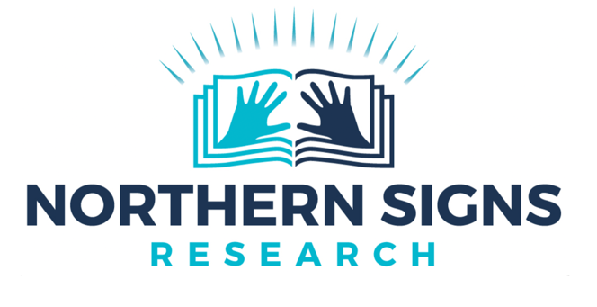 | 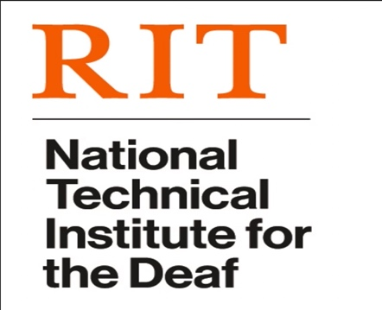
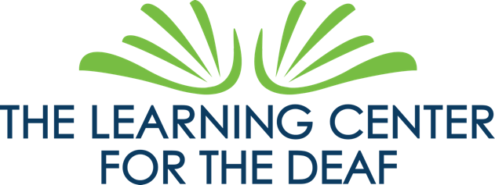 | 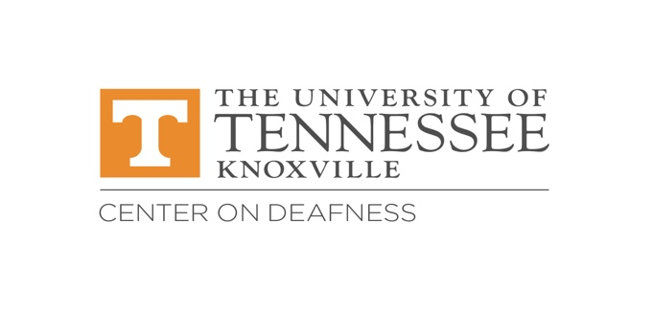
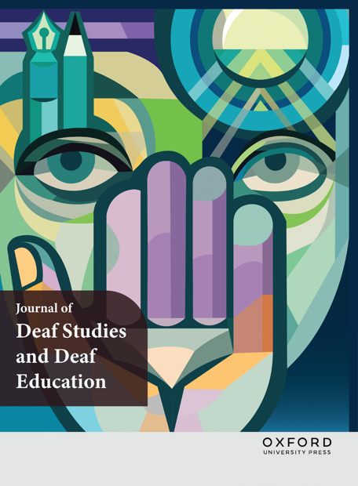 | 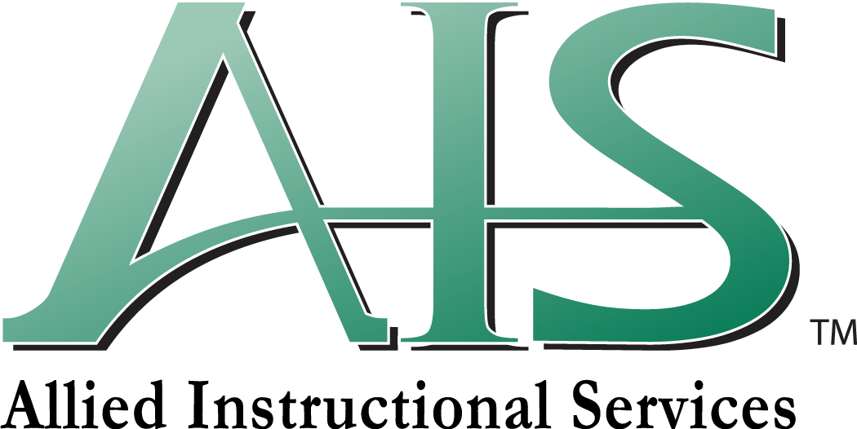
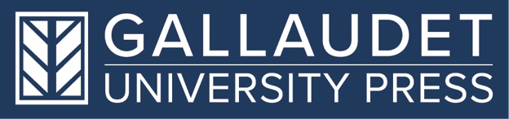 | 
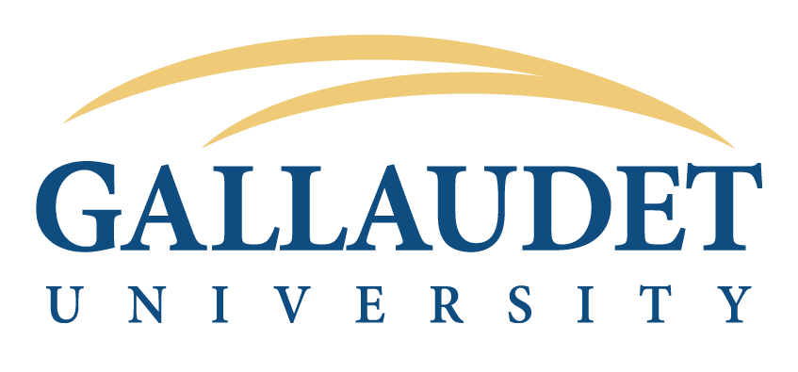 | 

