“An undeniably fun ride full of endearing characters.”
- Publishers Weekly

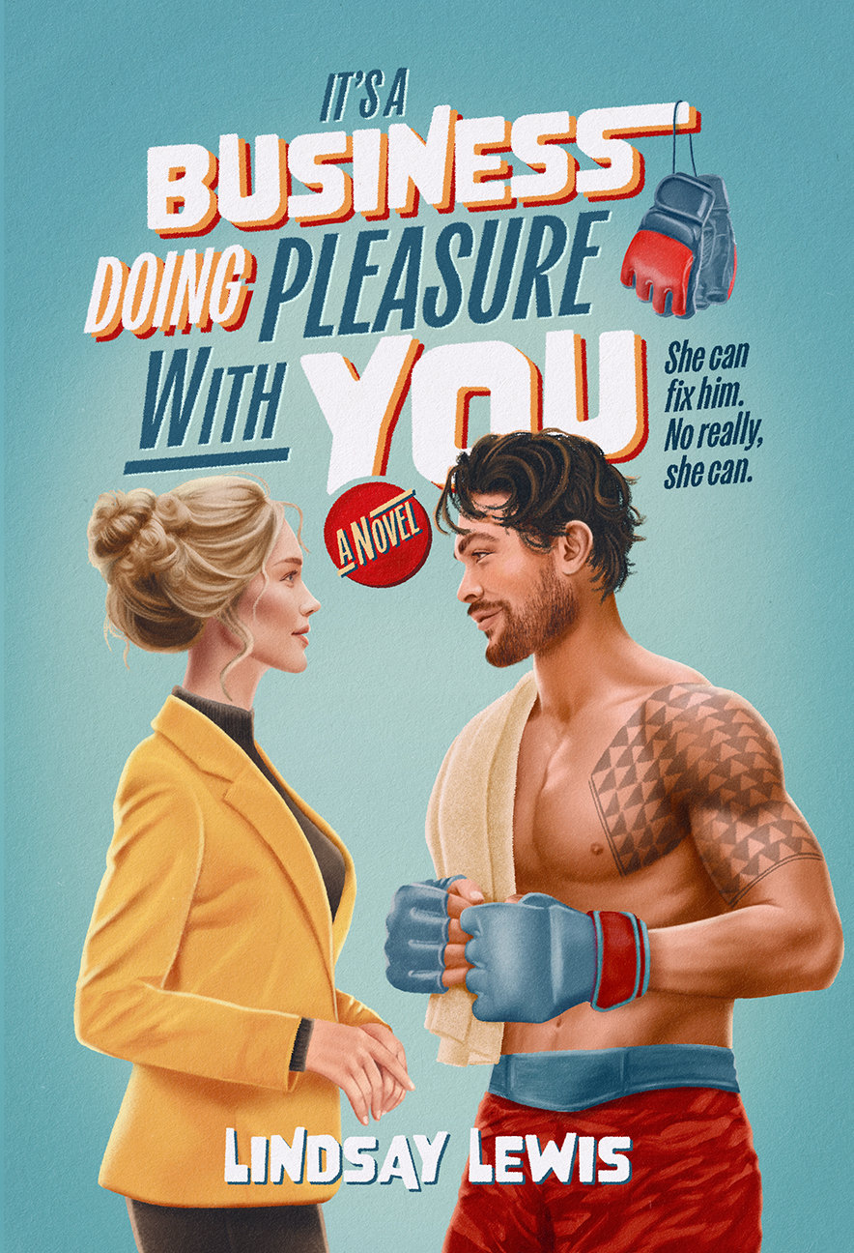 | It's a Business Doing Pleasure With You  By Lindsay Lewis  Genre: Sports Romance / Romantic Comedy  Formats: Hardcover, Paperback, E-Book, Audiobook  Publisher: Alcove Press (Penguin distribution. ISBN: 9798892427449)  A straitlaced life coach meets her match in a UFC fighter who lives only for pleasure in a steamy debut sports rom-com.

Book Description
Buttoned-up Lauren Hart excels at her job as a bespoke life coach. But her own life is a bit of a mess. Ever since her best friend Ally died six years ago, she's put everything on hold to help Ally's husband, Casey, raise the daughters Ally left behind. Now she's secretly in love with him and too scared to say anything.

Then Lauren is blindsided when Casey introduces his new girlfriend and announces that he and his daughters are moving to LA for the summer. But there's hope: A promotion at work would allow Lauren to build out the LA office—and see if her feelings for Casey are truly one-sided. All she has to do is keep her new client, troubled UFC fighter Danny Kekoa, in line until a critical fight.

Unfortunately, Danny doesn't want a babysitter, and he's intent on making Lauren's life hell. That is, until they come to a business agreement: She can coach him on living a disciplined life if he can coach her on the art of hedonism. From morning yoga to midnight bread-baking, the chemistry between Lauren and Danny grows, until they both learn that sometimes finding the right balance brings the most pleasure.

Reviews
"An undeniably fun ride full of endearing characters.”
—Publishers Weekly

IT'S A BUSINESS DOING PLEASURE WITH YOU is indeed full of pleasures, from the steamy love scenes to the laugh-out-loud banter. But Lindsay Lewis isn’t afraid to go deeper too, creating full, flawed characters who grapple with grief, mistakes, and the terrifying vulnerability of letting people see the real you. It’s a knockout." —Laura Hankin, author of One-Star Romance

About the author

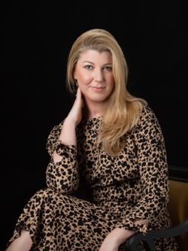
Lindsay Lewis fell in love with books when she realized she could escape algebra class by peeking at the romance novel hidden in her lap. Now she entertains herself by making the characters in her head kiss. Originally from Southern California, Lindsay currently lives in the Seattle area with her husband, their two teenagers, and seven guard chickens.

Media Inqueries
For review copies, and press inquiries, please contact:
Beata.Garrett@crookedlanebooks.com or LindsayLewisLit@gmail.com or visit www.LindsayLewisWrites.com

