



**WBRx** Biologics

WBRx Biologics Stem Cells Made Simple

© 2022 by WBRx Biologics LLC.

All Rights Reserved Under

International and Pan-American Copyright Conventions.

No part of this book may be used or reproduced in any manner whatsoever without written permission except in the case of brief quotations embodied in critical articles or reviews.

Printed in the United States of America by Graphic Connections Group Publishing Chesterfield, Missouri 63005

# TABLE OF CONTENTS

Introduction 5

Chapter One

You Are Miraculously Made 8

Chapter Two

Smart Medicine 10

Chapter Three

A Brief History of Stem Cell Therapy 13

Chapter Four

Degeneration, Regeneration, and You 14

Chapter Five

What Are Stem Cells? 16

Chapter Six

Types of Stem Cells 17

Chapter Seven

The Science and Research 19

Chapter Eight

What Scientists & Health Professionals Are Saying 20

Chapter Nine

Real People with Real Results 24

Chapter Ten

Stem Cells Made Simple Recap & FAQs 39

Resources

Complimentary Consultation 43



## INTRODUCTION

The explosion of knowledge that mankind has witnessed over the last several decades is absolutely astonishing. History has validated the immense capacity of our world to achieve things that are often unimaginable to the human mind. Until recently, we did not know how to unleash the regenerative ability of the human body. We have only *managed* our degeneration and illnesses, primarily with surgeries and drugs, leaving millions living with chronic health issues.

Consider that when the male and female DNA combine, and a new life takes root in the mother's womb. At that very time, there is an explosion of life, of stem cells, the cells that hold the blueprint for human life. Cells that create a beating heart in a mere 4 weeks and construct a complete perfect infant in 9 months. Consider the complexity of this creation.

Could this rich source of stem cells hold the key?

Stem cell therapy is the process of harnessing that creative power to activate *your* body's internal repair system. They are a natural regenerative tool. They are the wave of the future. We have good news to share with you today: the future of medicine is here. All the experts agree that stem cell therapy is the future of medicine and could even be the future of your personal health and longevity.

What if you could be YOUNGER and STRONGER for LONGER?

Does this sound too good to be true? The promise of stem cell therapy is real, and even as you read these pages, thousands upon thousands of people just like you are benefiting from regenerative medicine and stem cell therapy. There have been tens of thousands of stem cell therapies performed, and the amazing results that real people are experiencing are incredible. We will share some of their stories with you and you will hear in their own words how stem cells have improved their health and their lives. Stem cells require no instruction manual. Regeneration is encoded in their DNA and they know how to multiply, rebuild, and repair.

With medical costs rising and people suffering from an ever­ increasing number of stress and lifestyle-induced health challenges, it is essential that we find simpler ways to help people live happier, healthier, and more productive lives. When it comes to protecting your health, as well as your family's health, the choices are really quite simple: You can choose the agenda of our current culture (dependency on medications and invasive surgeries, to name a couple) or you can choose to adapt a mind-set of prevention and be proactive in your steps when it comes to your health.

Throughout life, stem cells are produced in the marrow of our bones, however, the umbilical cord which extends from the navel at birth houses a multitude of rich regenerative stem cells-the Master Cells of our Body! The answer to disease and degeneration is *regeneration* and we now know how to activate your body's internal repair system.

We want to free you from the fear that some virus or disease will devastate you and that getting old means your body must break down. You do not have to lose your mobility, your freedom, or your

ability to live. We want to ignite the possibility of a healing revolution in your life, and we truly believe that regeneration begins in your mind. Instead of expecting and believing that degeneration will happen to us, we can renew our minds and release our faith to the belief that the **power that created the body is the power that heals the body.** You are miraculously and marvelously made! Healing and regeneration are encoded in your DNA. We want you to be well and to live out your life with lasting health.

"The POWER That Created YOUR BODY is the POWER That HEALS Your Body."

We designed *Stem Cells Made Simple* to take the complicated, controversial, and often confusing subject of stem cell therapy and make it easy to learn, easy to understand, and easy to access. If you want to learn if stem cell therapy can benefit you or someone you love, then open your mind, open your heart, and continue to read. In our experience, people will recognize and resonate with the truth. We desire to impart a powerful truth into your life that the rest of your life will be the best of your life.

**"The REST of YOUR LIFE Will Be the BEST of YOUR LIFE."**

# CHAPTER ONE

#### YOU ARE MIRACULOUSLY MADE

Although we sometimes take it for granted, the human body-your

human body-is by far one of our most precious, valuable, and miraculous gifts. It is priceless and irreplaceable. We are all blessed at birth with a complex, mysterious, miraculous, intelligent, and awe-inspiring body. The most incredible creation in the universe is you, with your fantastic senses and strengths, your ingenious defense systems, your unparalleled regenerative abilities, and mental capabilities so great that you could never use them to their fullest. Your body is a structural masterpiece more amazing than science fiction. The more we learn about it, the more wonderful your body seems-incredibly intricate, vigilant, responsive, resilient, adaptable, and powerful. It is the citadel of the human spirit.

On this earth, our oldest and closest personal possession is the body in which we live, yet who has not been completely amazed to discover how it works? Your human body is overflowing with innate intelligence, universal synchronization, and infinite wisdom that are far beyond our current comprehension. It works for you 24/7, each and every second of your life. It is constantly balancing, readjusting, rebuilding, regenerating, communicating, protecting, and growing. We have no adjectives that are adequate to describe the wonder and complexity of the hundreds of thousands of chemical, electrical, and physical tasks it performs meticulously all the time.

Your heart is the most sophisticated pump ever created. It is a twelve-ounce organ that beats an average of seventy-five times per minute, 108,000 times per day, nearly 40 million times per year, and nearly 3 billion times in an average lifetime. With each beat of the heart about 1/3 cup of blood is being pumped into the body.

That equates to two thousand gallons per day, or 730,000 gallons per year, more than enough to fill eighty huge gasoline trucks. In one day, the blood travels about 12,000 miles; that is four times the distance of the US from coast to coast.

Your eyes make over 750,000 color distinctions, and they record the images you see directly into your memory.

Your immune system works 24/7 attacking viral and bacterial invaders, protecting you from a multitude of unseen dangers. New research clearly suggests that your immune system actually thinks.

Your circulatory system is made up of three independent systems that work together: the heart (cardiovascular); lungs (pulmonary); and arteries, veins, coronary and portal vessels (systemic). About 2,000 gallons of blood travel daily through about 60,000 miles of blood vessels in your body. This complex network moves blood, nutrients, and oxygen through your body.

Your digestive tract is about 30 feet long and responsible for converting food to the nutrients your body needs to survive. While digestion may seem simple, it actually takes a coordinated act of muscle contractions to move food through the process. This allows digestion to happen even if you are standing on your head. Your body controls, coordinates, and orchestrates with intricate precision all its systems-muscular, respiratory, reproductive, nervous, endocrine, circulatory, digestive, skeletal, lymphatic, etc.

-with amazing precision.

Make no mistake about it, you are a masterpiece. Miraculously and marvelously made and healing is already encoded in your DNA.

### CHAPTER TVVO

##### SMART MEDICINE

As we speak to groups and do seminars about health and wellness, we always ask the audience the question, what do you think of when you hear the word **medicine?** Lots of people always yell out "Pills," "Drugs," or "Pharmaceuticals," which is clearly a result of really great marketing on the part of the pharmaceutical companies and the $2-trillion-per-year industrial medical complex that, in our opinion, frequently over-treats, over-tests, over­ prescribes, and performs many unnecessary procedures and

surgeries. The true definition of the word **medicine** is stated below.

***Medicine is the science, study, and practice of the diagnosis, treatment, and prevention of disease.***

That is what medicine really is. **Smart Medicine** is practicing the power of prevention, taking responsibility, and being proactive when it comes to your health. Prevent an issue before it becomes a serious illness or a chronic disease.

Now let's discuss three types of alternative medicine that are absolutely essential for you to know about and implement in your life if your desire is to experience a higher level of health, wellness, and vitality.

##### MIND-BODY MEDICINE

Mind-body medicine is a real science. It's known as

**psychoneuroimmunology** and is defined as:

**The science of the study of how the thoughts you think, the emotions you feel, and what you choose to focus on affect your health, your physical body, and your nervous system.**



#### LIFESTYLE MEDICINE

Did you know that eight of the top ten killers (diseases) in the United States of America are preventable lifestyle­ driven diseases, not

something you catch, such as a virus a or bacteria, or something triggered by your genes or DNA? Rather, it is something caused by the decisions you make, or fail to make, regarding what you think about, the foods you eat, the things you drink, the amount of exercise that you do, and the toxin levels in your environment. You need to treat your body as if it belongs to someone you love. Be mindful of the decisions that you make concerning what you eat, drink, and think. Exercise and take steps to keep your environment healthy. By taking these simple steps, you can excel in this essential area of health.

#### REGENERATIVE MEDICINE

Regenerative Medicine is definitely the wave of the future, and it is here. All the experts agree that stem cell therapy is the future of medicine and your personal health and longevity. That's right, it's personal, healing and regeneration are encoded in

your DNA. After all, if your body knows how to heal itself, then why is there so much sickness, disease, injury, illness, and chronic pain? How is it that degeneration overtakes your body's regenerative process so easily and so often? The newest and hottest subject around is stem cells and stem cell therapy. Stem

cells have been discovered to be the superheroes of healing and they are now available for you. They are your body's internal repair system.

Stem cells are the foundation cells for our bodies. These highly specialized cells that make up our organs and tissues originally came from an initial pool of stem cells that formed shortly after fertilization. Throughout our lives, we continue to rely on persisting stem cells to repair injured tissues and replace cells that are lost every day, such as those in our skin, hair, blood, muscles, nerves, lining in our gut, brain, and all other organs and glands.

For centuries, medical professionals assumed that when an injury occurred-such as a cut through the skin, fat, and muscle­ cleaning and binding the wound together would cause the muscles and skin to grow into each other, thus healing the wound. By the 1960s, with the help from microscopes and modem technology, people discovered that it was actually stem cells filling in the gap of the wound. These cells were "differentiating," or transforming themselves, into muscle, fat, and skin cells needed to mend the wound. Stem cell therapy-the future of personal health and longevity-replaces lost or injured tissue. This happens to be the definition of **regenerate.**

,,=

**TIME**

The new research suggests that perhaps we should consider stem cells one of the secrets to

a longer life. ''

### CHAPTER THREE

#### A BRIEF HISTORY OF STEM CELL THERAPY

The term **stem cells** has been around since the nineteenth century, when German scientist and biologist Ernst Haeckel coined the phrase for scientific literature.

In the 1950s, these life-giving cells were widely used in the treatment of leukemia. Since that time, much more has been learned about the various health issues that can benefit from the use of stem cells.

People tend to think that stem cells are a brand-new phenomenon that landed on Earth in the past few years; however, in reality, they've been around for a very long time. Let's take a minute for a historical perspective. As far back as the 1800s, scientists recognized that cells are the building blocks of the body and that a particular type of cell could duplicate itself. In the early 1900s, they discovered

this duplicating cell in blood. And by the 1950s and early 1960s, they found the cell in bone marrow.

In the early 1960s, and possibly as late as 1968, the first successful bone marrow transplant took place, involving two siblings who had a condition called combined severe immunodeficiency. By 1978, scientists had discovered these duplicating cells in umbilical cord blood. It wasn't until 1988 that they were able to find these cells in adipose (fat) tissue. These duplicating cells are what we now know as stem cells.

Well, with the discovery of stem cells in adipose tissue in the 1980s, it was just a matter of a few years before stem cells were identified in every tissue in the body. This created an explosion of research and a lot of excitement and new therapies were associated with stem cells. Over the course of the next several years, scientists began to realize that stem cells from our own body have some limiting factors. These limiting factors, the quality and quantity of those cells, are based specifically on our age and our health.

### CHAPTER FOUR

#### DEGENERATION, REGENERATION, AND YOU

When it comes right down to it, the root or foundation of all sicknesses, diseases, illnesses, and aging is simply degeneration. Many people have heard that inflammation is at the core of it all. Although this is not altogether incorrect, it is, however, incomplete. What is inevitably at the core of all inflammation is degeneration, and the simple definition of **degenerate** is as follows:

**The Problem: de• gen• er•ate Verb**

**/di-'je-nc1-rat/**

to deteriorate physically or mentally, or to break down; fall apart; go into disrepair or be less than your

***former self***

This sounds a lot like the definition of sickness, illness, infirmity, chronic disease, injury, and aging. So, now that we have clearly identified the problem, let's discuss the solution: regeneration. The great news is that your body is already an expert at this because it has been regenerating itself since the day you were born (maybe even while you were in your mother's womb). Many of you have heard that every cell of your body is brand new in fewer than seven years. Your skin is brand new every few weeks, your stomach and digestive tract cells are all regenerated in just a few days, and your hair and fingernails are constantly growing. So, if your body knows how to regenerate itself, what is the issue? It's really quite simple. Disease, illness, and aging come about because the degeneration process overtakes the regeneration process. The definition of **regenerate** is as follows:

###### The Solution: re• gen• er• ate Verb

**/ri-'je-na-rat/**

to build, grow, repair, or create new tissue

That's where your stem cells come into the equation. Stem cells regenerate new tissue and act as your body's internal repair system. The challenge is that they rapidly decrease and decline as you age. The chart below describes how much they decline.

***Stem Cells Decrease and Decline with Age Causing Longer Repair and Recovery Times Leaving Us More Prone to Injury and Disease***

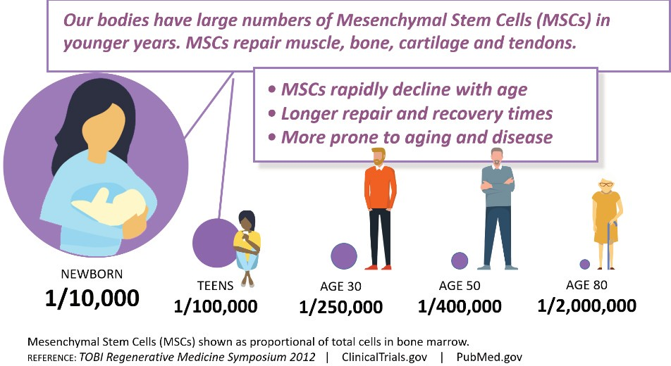

**"The Key to a Healthy Life is Healthy Regeneration."**

### CHAPTER FIVE

#### WHAT ARE STEM CELLS?

Stem cell

/'stem sel/ Noun

an undifferentiated cell of a multicellular organism that is capable of giving rise to indefinitely more cells of the same type, and from which certain other kinds of cells arise by differentiation

**Simply stated...**

* Stem cells are your body's internal repair system.
* Stem cells are the foundation cells for our bodies, and they repair injured tissue and replace cells that are damaged every day.

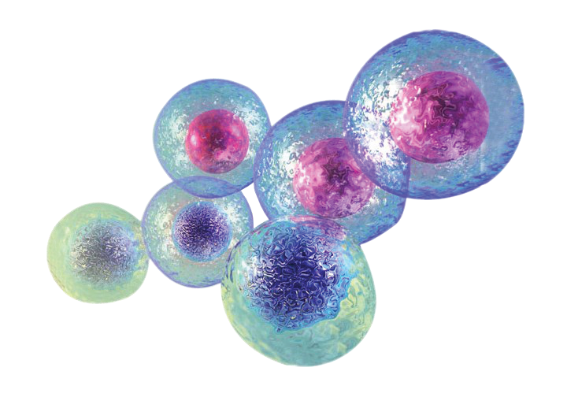

### CHAPTER SIX

#### TYPES OF STEM CELLS

###### Fetal/Embryonic

Derived from the undifferentiated inner mass cells of a human embryo.

* + **Illegal in the US**
  + **Extremely Controversial**
  + **Many Moral Issues**
  + **Jeopardizes Mother's Life**
  + **Embryo Taken Before Maturity**

###### Amniotic Fluid

Extracted from the amniotic sac by amniocentesis.

* + **Large Portion of Cellular Debris**
  + **Inconsistent Concentration**
  + **Unverifiable Stem Cell Count**

###### Placental

Extracted from the placenta by amniocentesis.

* + **Large Portion of Cellular Debris**
  + **Inconsistent Concentration**
  + **Unverifiable Stem Cell Count**

###### Autologous

Patient's own stem cells are collected through surgery.

* + **Often requires Surgical Procedure (potential complications, pain, recovery time)**
  + **Not Potent Enough for Substantial Difference**
  + **Expensive and Invasive**
  + **Dependent Upon Age** & **Health**

###### Umbilical Cord Stem Cells (Renewal Cells)

* + **Safe, Simple,** & **Fast**
  + **Customizable for Individual**
  + **Potent, Robust** & **Consistent**
  + **Based on Accepted Medical Practices**

###### Advantages of Umbilical Cord Stem Cells (Renewal Cells)

***-1*** Umbilical Cord Stem Cells (Renewal Cells) are immune system privileged-anyone can receive therapy without risk of rejection.

***-1*** Unsurpassed **regenerative** capabilities. They seek out degeneration and build, grow, and create new tissue.

***-1*** Nature's most powerful **anti-inflammatory** and immune modulating capacity.

***-1*** Can be **administered multiple times** in uniform dosages that contain high cell counts.

''

**Washinton Post “**

...stem cells promise to radically change medicine by engaging the body's own capacity of healing itself.

### CHAPTER SEVEN

#### THE SCIENCE AND RESEARCH

###### How are stem cells being used?

Research has shown positive outcomes with these and other conditions:

,; Chronic joint pain

,; Chronic back pain

,; Bulging/herniated discs

,; Spinal cord injuries

,; Knee injuries including meniscus, ACL, and MCL tears

,; Arthritis/ osteoarthritis

,; Hip labral tears

,; Tendinitis

,; Shoulder injuries

Stem Cell Therapy has the full attention of the medical community. Over 5000 studies are currently being conducted on the effects of stem cells on degenerative illnesses from autism to Parkinson's. If you want to learn more about these clinical trials, you can visit: [www.clinicaltrials.gov](http://www.clinicaltrials.gov/) and [www.pubmed.com](http://www.pubmed.com/)

**''MAYO** Stem cells and

**CLINIC** derived products

offer great promise

for new medical treatments.

==''

### CHAPTER EIGHT

#### WHAT SCIENTISTS & HEALTH PROFESSIONALS ARE SAYING

**Dr. Neil Riordan:** "Stem cells are the repair cells of your body. When there aren't enough of them, or they aren't working properly, chronic diseases can manifest and persist. From industry leaders, sports stars, and Hollywood icons to thousands of everyday ordinary people, stem cell therapy has helped when standard medicine failed. Many of them had lost hope."

**Dr. Matthew Brock:** "We are seeing remarkable results with Renewal Therapy. The theories keep coming; however, the proof is in the pudding clinically. I'd like to share the testimony of a 65-year-old female. This patient came to see me with significant degenerative disease of her cervical spine as well as degeneration in her eyes. She felt terrible and was battling fatigue.

When she came to the clinic to receive stem cell therapy, she was very nervous and almost backed out. Nonetheless, she went ahead with the therapy. Two weeks later, she calls the clinic and says, "I feel like I'm thirty years old... I'm out doing yard work. I'm digging holes. I just can't stop moving. I have so much energy. Thank you."

**Dr. Al Sears:** "Renewal Therapy is your reserve of 'replacement cells.' Your body can use them to replace any kind of cell that is damaged, old, or dying. They can morph into any kind of cell you need, including those for your eyes, muscles, skin, or blood. They also allow your body to regenerate damaged tissue in any organ-from your brain to your heart to your liver. As you age, your stem cells don't repair and regenerate as well as they once did. Fatigue sets in and can lead to poor regeneration or even degeneration of certain organs and tissues."

**Dr. Jon Young:** "I had four meniscal tears, osteoarthritis, and my knee was bone on bone. I was facing surgery as my only viable option. When I heard about stem cell therapy, I knew I had nothing to lose. In a few weeks, my knee was transformed. My MRI revealed that the tears were repaired, and my knee was rebuilt. I reviewed the science and was amazed at what I found. The research is valid, and I now have the most effective resource to help my patients get well and stay well. I have worked with hundreds of patients who have benefited from Renewal Therapy. We now actually can regenerate and repair the problem."

**Dr. Nikesh Jasani M.D.** : "The concept of mesenchymal stem cell's ability for regeneration and improvement of chronic inflammation is what really piqued my interest in the field. As someone who has

a chronic severe inflammatory dry eye for years, I have received Renewal Therapy myself. I have noticed significant improvements in my tear production. Considering the number of people who have chronic diseases from autoimmune conditions to chronic arthritis there is a real need for options that go beyond pharmaceutical symptom control. These cells are the conductors for sensing inflammation and triggering repair. More research and clinical trials will continue to expand our knowledge in the field."

**Dr. Nimesh Patel, M.D.** "Chronic diseases as a result of inflammatory changes in the body have riddled the healthcare system of the US and the world. Obviously, the best answer to fixing this problem is prevention in the first place. The ability of regeneration and repair has been a concept that is now coming to the forefront in changing healthcare as we know it. Renewal Therapy is actively involved in repairing, regenerating, and rebuilding damaged or absent tissue in the body that has been affected by disease, infection, or injury. People who might benefit from Renewal Therapy include those with spinal cord injuries, type 1 diabetes, Parkinson's disease, amyotrophic lateral sclerosis, Alzheimer's disease, heart disease, stroke, burns, cancer, and osteoarthritis.

I am a big proponent of the benefits of Renewal Therapy as I have been personally treated with them to improve both my knees on which I have had surgical intervention prior. I have seen a dramatic improvement in

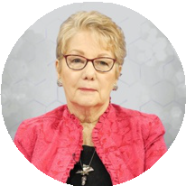functionality due to that treatment. Researchers continue to study the potential of therapeutic benefits and instead of donor organs, which are limited in supply, it is the next chapter in organ transplantation. The future is bright on what awaits us with the use of regenerative therapy."

**Martie Whittiken, CCN, National Radio Show Host:** "Renewal Therapy is the most marvelous thing I have found in the 40 years I've been in the field. Most people wait for the body to regenerate. If we had sufficient stem cells in our body they would fix things,

but as we age, we don't have enough. Sometimes, there's some big challenges or accidents and diseases we go through, and we need a supplement of Renewal Therapy. It's worked wonders for me, for my family, and so many of the listeners of my radio broadcast that I just can't say enough good about it.

I had a skiing knee that had bothered me a lot to the point where some days it was just hard to do the exercises that I wanted to do, and Renewal Therapy took care of that. Also just knowing that I was aging, I didn't know what was going on inside and that there are probably all kinds of things that are less than perfect, so I started periodically receiving Renewal Therapy. I kept making sure that I had enough stem cells in my system.

Later on, I had a stroke due to a condition I had ignored but the fact that I didn't sustain a lot of damage and recovered so well was incredible.

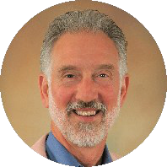Renewal Therapy changed my life for the better!"

**Dr. Ben Johnson:** "I've seen it happen with my own eyes. There is virtually nothing that your body can't regenerate with a little help from Renewal Therapy. When it comes to dealing with inflammation - it calms the waters of the sea. Where you had white caps

yesterday, you've got smooth water today. Join the Regeneration Revolution! It's amazing!"

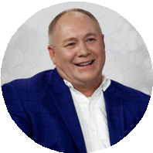**Dr. Koeing, DC:** "I have been a chiropractor for many years and unfortunately the job takes a toll on your body. I also sustained an injury to my knee a few years back. I was heading to a basketball game for my daughter, and I ran over a fire hydrant, and I shattered my knee. So, with that injury and with the strain of my job I started not

being able to do some of the things that I enjoyed. Walking and just normal activities got to be very painful for me and I couldn't do stuff with my wife and daughter that I wanted to do. I was not able to work out or play around with my grandkids without pain.

I started to look into Renewal Therapy, and I decided that it was a good idea for me. So, after I received Renewal Therapy, I started playing on the floor with my kids the very next day and I realized that I was not in any pain. Within 4 months of the therapy, I got back into walking and jogging without pain, and I am back to working as a chiropractor the way I used to. I am now enjoying my life again without pain and I love every second."

# CHAPTER NINE

#### REAL PEOPLE, REAL PROFESSIONALS, REAL RESULTS

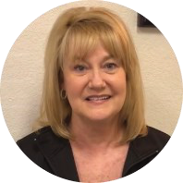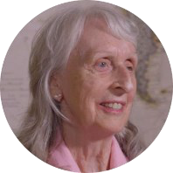**Jan Buscarino:** "I had a torn meniscus in my left knee and was told that I needed to have surgery. I am very happy I decided to research Renewal Therapy. Only 4 weeks after receiving Renewal Therapy my knee was 100% better. I can walk again with no pain."

**Barbara Schmidt:** "I am amazed that Renewal Therapy worked so well. My wrists were getting unusable from degeneration, but now I have almost complete mobility back. I am so happy with the results."

**Lulu:** "I'm 58 and a few years ago I was diagnosed with rheumatoid arthritis. I've also had severe hip, knee, and foot pain my entire adulthood. It got to be so bad and was so acute I could hardly walk. I couldn't climb a flight of stairs. I was told I would need knee replacement surgery as soon as possible in both knees. I was told I

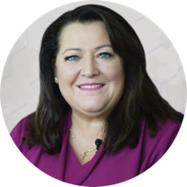had multiple meniscus tears, tendon inflammation, and fluid retention. It really put a halt to my life two-and-a-half years ago. I couldn't be on my feet for more than an hour and then I needed a day or two to recuperate on my back with pillows under my knees. My life had stopped. So, I received Renewal Therapy in both knees and both hips. I feel like I've turned the clock back on my health by at least 10 years. I walk, I'm losing weight. I've lost 25 pounds just because I can move again. I no longer need a cane to go to the grocery store. I'm so glad that I did because since then I've got my life back."

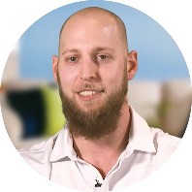**Travis Sissel:** "I was an active athlete, always trying to get bigger and stronger. Unfortunately, in my twenties, I was hit with testicular cancer and was subjected to many rounds of chemotherapy and lots of radiation. I had brain surgery, abdominal surgery, and lung surgery, all to pagen ve tumors left over from cancer. After all the cancer

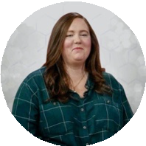treatments were done, I began experiencing unbearable hip pain that left me practically immobile. It's believed that the radiation done on my pelvis damaged the blood supply to my hips and the bones were literally dying. My only option was double hip replacement surgeries until I was recommended Renewal Therapy. Five weeks after receiving Renewal Therapy, I was able to walk around without pain. I am working to become just as strong as I was before. Today, I'm engaged and back on the golf course!"

**Chelsea:** "I was diagnosed with severe allergies to quite a few different items, from wheat to corn, dairy, and eggs. The nutritionist told me that I had an advanced form of celiac disease. I was very sick, and we discovered that due to my allergies I was not able to get the nutrients that my body needed. Soon after receiving Renewal

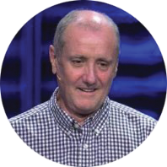Therapy, I had eaten some crackers that used to give me a bad reaction and after a couple of hours, I did not have any reaction - I was amazed! I started eating other foods that used to be a danger to my health and I was totally fine. I am now able to live a normal life and enjoy eating out with my family."

**Ron Campbell:** "I was involved in a land mine incident that left me critically wounded. I sustained a traumatic brain injury as well as numerous other injuries to my body. I recovered as best I could, but as I aged, I began to experience pain from the shrapnel and my other injuries. Doctors told me I would need to start medication long-

term, which I wanted to avoid. Renewal Therapy became my best option and I found almost immediate relief. It is truly amazing and has positively affected not only my pain, but it has helped my vision and my memory."

**Arthlene Rippy:** "I'm a television producer, a widow, the mother of two, a grandmother of five, and great­ grandmother of eight. I've never smoked and have been somewhat diligent about diet, and for the most part, a faithful exerciser. But even with these blessings, a few years ago I began to experience those unwanted

symptoms of arthritis. About four years ago, after a skilled rheumatologist drained my right knee, he told me that knee replacements were in my future. Following this prognosis, I did my best to stay active and put off the inevitable if possible.

About a year ago, I heard about Renewal Therapy. I chose to have this quick and painless therapy, and the results keep me smiling. Within the first couple of weeks following the therapy, I noticed I was sleeping much better. Before Renewal Therapy, arthritis was insidiously creeping through my hands. Because of extreme pain and swelling, I could no longer slide a ring on the ring finger of my right hand. But today, rings are no

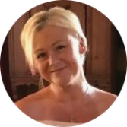problem-no problem at all. As for the arthritis in my knees, it's a distant memory. I just don't have it anymore. My knees have no pain, and I have no problem living my life, by the way, which includes a staircase at home and at my office. My overall quality of life is so much better because of Renewal Therapy."

**Roslyne Burns:** "I've worked as a physical therapist for over 20 years. My job required providing a great deal of physical assistance to my patients. Over the years, I've experienced a great deal of wear and tear on my body. The straw that broke the camel's back was the development of severe back pain. I saw one of the best

neurosurgeons in the area. He found that I had a herniated disc at Tl-T2 and severe stenosis at two levels above that. Renewal Therapy provided the solution. I was in and out of the office within 30 minutes. That was signing in, checking out, talking to the doctor, and receiving Renewal Therapy. Three weeks later, my pain resolved, and I've been pain-free ever since."

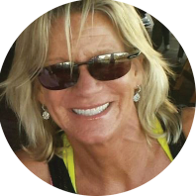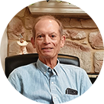**Tracy Sarallo:** "I am a gymnast and golfer, which has put a strain on my shoulders and elbows. Renewal Therapy was recommended to me because of the degeneration caused by my lifestyle. Six months later, I am back to working out as hard as I want, and it has even improved my golf game-all pain free."

**Andy Crosthwaite:** "I'm Andy Crosthwaite, and I received Renewal Therapy in my knees. My right knee, I've had trouble with since high school. Not severe problems, but I knew I couldn't move it as well as my left knee. As I've gotten older, things have gotten progressively worst. I had enough Orthopedic surgery, I don't need any more of that.

Almost immediately I had improved in just a few days. Suddenly, the soreness has gone away, and I can see that in another month, or two things are going to be quite a lot better than they are now."

**Hillary:** "My husband was diagnosed with Guillain Barre which is a rare disorder where your immune system starts to attack your nerve cells and the cells can go through your system and it causes paralysis. He was diagnosed when he was around 4 years old, and he spent quite a bit of time in the hospital paralyzed. Due

to the illness and the nerve damage, he has not been able to do all the things that he loved to do. It got to the point where he had to tell me that he wanted to do the things with me that I loved to do but he couldn't because of the pain. He couldn't even spend the time with our young son in the way he wanted to. He was told that there was really no hope of getting better and he should just accept his condition.

We then decided to give Renewal Therapy a shot. It completely changed his life within a few days. We went on vacation as a family and we went hiking, like I love to do, and the next morning he told me that he was not hurting. I was completely shocked that within eight weeks of having the therapy my husband was doing perfectly fine. We have not seen the pain

in his body that plagued him his whole life. He is now the husband and father that he always wanted to be.

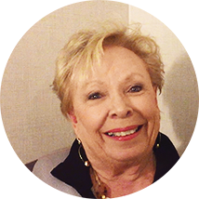Renewal Therapy gave me my husband back and I love every bit of it!"

**Betty Jones:** "I'm Betty Jones, and I received Renewal Therapy about eight weeks ago. At the time I was taking about 5 Curcumin and Boswellia a day. The sciatic nerves on both sides of my hips were in so much pain.

After receiving Renewal Therapy, I am not on anything.

My bones don't hurt. I have flexibility. I go to bed, I get up, and it's amazing!"

**Tenesa Rasmussen:** "I had suffered with pain in my lower back for years and years, excruciating, terrible pain. It had gotten to the point where I had tried cortisone shots. I had oblation where they burned the nerves. I had worn a brace. I finally went to see an orthopedic surgeon just to be told they couldn't help me

and that I was beyond surgery. I had three very damaged disks and I did receive surgery, it would make them worse.

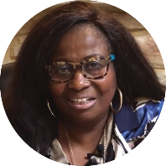I was desperate. A friend of mine told me about Renewal Therapy. I felt hope for the first time in years that there was something that could help me. All my disks have regenerated. I can walk normally! I can get dressed. I am not in pain. I can clean my house. I can sit and play my harp and sew at the sewing machine. I can live my life. I am so thrilled and excited!"

**Helen Johnson:** "I learned to tolerate the knee pain because it was there all the time. If you've ever lived with chronic pain, I want you to hear how Renewal Therapy benefited me. I didn't know that Renewal Therapy could provide the hope that I had been longing

for. I didn't know that I could get better. But, the day after receiving Renewal Therapy, the pain began reducing! Today, I'm able to wear my heels and I'm doing a lot of things I was not able to do before.

Amazing! Miraculous!"

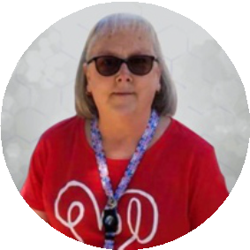**Peggy:** "For quite some time I have lived with type II diabetes and rheumatoid arthritis. Both ailments have plagued my life for years. I am forced to watch everything I do and everything that I eat. It is not where I want to be at all as I have many grandchildren that I love dearly, and I am not able to be the grandmother that

I want to be. My rheumatoid arthritis got to the point where I would have a flare up and I would be put down for weeks at a time. I could not dress myself and I could not do normal everyday functions like I used to do.

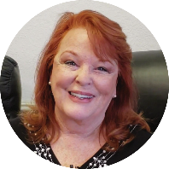I was then introduced to Renewal Therapy. I had seen amazing results in his body after receiving Renewal Therapy and I wanted to give it a try. At first, I thought it was not working because I still hurt in my joints, however, I went to an appointment with my diabetic doctor, and he took me off two of my diabetic medications. My AlC counts had normalized, and I was completely amazed. After another couple of weeks, I realized that I had not had a flare-up in my rheumatoid arthritis since I received Renewal Therapy."

**Dianne Hughes:** "I was told that I needed to have total knee replacement surgery on both knees. For three years, I struggled just to walk; every step was painful, and it was getting worse. In addition to the pain, it was affecting the quality of my life. The worst part was that I was not able to lift and carry my infant grandbaby.

That's when I found out about Renewal Therapy. I knew this was my answer and it gave me a non-surgical option. Personally, I did not have the necessary finances, however, I did have a very pretty diamond necklace. I decided that there wasn't much point in having that beautiful "bling" if I was struggling to walk and living with constant pain. So, I made a personal sacrifice and I have NO regrets!

Two months after receiving Renewal Therapy, I am completely pain free in my right knee. My left knee is at least 50% better. I still have several months of regeneration and healing ahead. I'm so grateful that I was able to avoid knee replacement surgery and all the risks involved!"

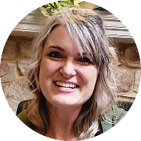**Jeannette Vaught:** "I've struggled for years with the symptoms of Fibromyalgia. Then, to make things worse, I was involved in a car accident that caused two of the disks in my back to rupture. I couldn't turn my head and had constant pain and headaches. I was in so much pain that I didn't want to live. I decided to try Renewal Therapy as a last resort.

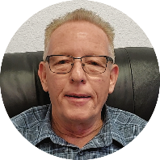Within 45 minutes of the therapy, I started noticing improvement. My headache started to go away. I thought, "oh my goodness! This is a miracle!" Today, I feel great! I get out of bed each morning with ease and excitement for the day. Anybody considering Renewal Therapy should do it. I did and it changed my life completely!"

**Jim Russell:** ''.After working 14 years, pounding the concrete at a home improvement warehouse store, I ended up with a stressed and traumatized right Achilles tendon. For about a year, I hobbled every day at work. I was facing surgery as the only solution and agonized over the decision. My sister suggested Renewal Therapy and I

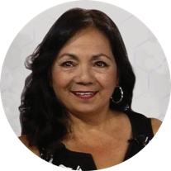decided to give it a try. I can't believe the difference. After 6 weeks, I was suddenly walking with no pain, 8 hours a day on concrete floors. It was miraculous! I would recommend Renewal Therapy. It's one of the best decisions I've ever made."

**Racquel:** "I have had pain in my knee and my lower back. I love the outdoors and it got to the point where I couldn't even walk. Once I received Renewal Therapy within three days, I walked seven miles. That was three years ago and now I still have no pain in my knee.

It has been so exciting that I have told everyone I work with how it gave me the ability to walk again. I have since gone back and received the Renewal Therapy in my back and I feel like a whole new person. I feel like I am back in the game. I was so excited that I told my 25-year-old daughter. She was living with me at that time, and she started feeling a ›lot of pain in the sciatic nerve to the point where she would lay out on the

floor with a lot of pain. So, she decided to receive the Renewal Therapy and in just three days she felt no pain. It has changed her life.

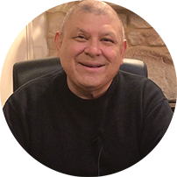The Renewal Therapy has changed our lives for the better and we are very grateful."

**Geraldo Martinez:** "I received Renewal Therapy a month ago and I have experienced already relief in my hips. No Pain. And finally, I have flexibility and it's only been one month. I realize how much more flexibility I have than I did a month ago with no pain.

The reason why I decided to receive Renewal Therapy is because I did not have insurance at the time. This is an affordable way of trying to take care of an issue I had with my hips."

**Meshia's Arebalo:** "I'd like to share with you how Renewal Therapy has affected several members of my family. My father-in law was eighty years old when he received his first Renewal Therapy. He went from spending most of his time laying on the couch to opening a transportation business. Suddenly, he had the energy to

drive two-hundred, three-hundred, and four-hundred-mile trips. He received a second therapy a few months later. Unfortunately, he had a major stoke 12 weeks later. Within six hours in the hospital, they were still running tests, and they couldn't figure out where the damage was. I watched a miracle of restoration happen before my eyes. Within 12 hours, all the facial dropping and paralysis had resolved. We're talking about a major stroke. We were warned that he would need to be in a nursing home where he could receive care 24 hours a day. I truly believe that having received Renewal Therapy allowed his body to recover at lightning speed.

My husband, who is diabetic, suffered with severe neuropathy. His neuropathy resolved completely after receiving Renewal Therapy. And, my sister-in law, watched her kidney function increase from the low forties to around eighty percent!

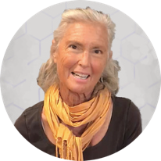Finally, for my personal story. X-rays showed that I did not have a disk between 14 and LS. I used to take medications daily just to function. Not anymore. Renewal Therapy greatly helped my back pain."

**Cynta De Narveaz:** "I've had Lyme disease for 30 years. I've had a heart problem for three years. And in the middle of January, my heart popped into PVCs. These irregular heartbeats your pulse goes from 35 to a 141. And you are feeling this incredible atrial fib and you can't get out of it. There's nothing anybody can do for you. So,

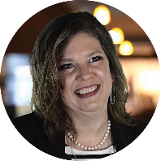on the 29th of January, I got stem cells injected into me and within 4 hours my PVCs were over. You can see where I have stopped moving. Since I've received Renewal Therapy, I can now do four and a half to five and a half miles a day; within 24 hours. My PVCs stopped. Renewal Therapy went directly to my heart within 24 hours, and I thank you."

**Angel Kuite:** "In 2016, I was involved in a serious car accident where I received a traumatic brain injury as well as four herniated discs in my back. From that day forward, I found myself living with chronic pain. I tried pain patches, pain cream, steroid injections; anything to stop the pain and help me get my life back. My husband

heard about Renewal Therapy. He said, ' ust try it. You have nothing to lose and everything to gain". I agreed. The fourth week after Renewal Therapy, I began experiencing relief. The fifth week was even better. By the end of the sixth week, I could honestly say that I was in no pain.

Renewal Therapy had worked and gave me my life back. Renewal Therapy helped me more than I could have imagined. It would be an injustice for me not to share my experience."

**David Aguilar:** "I began experiencing intense pain in my knees about five years ago. My doctor told me that I would probably need knee surgeries. My son told me about Renewal Therapy. He said that they can inject the therapy in the area that is hurting, in my case, in my knees. I was a little skeptical at first, because I didn't

think it was real. Since I wanted to avoid surgery, I went to the clinic for a consultation. They explained the process to me step by step and I decided

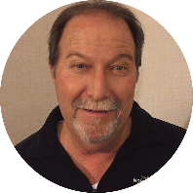to give it a try. I am so happy that I did! It's been two months since receiving Renewal Therapy and the improvement is incredible. I feel much better. I can walk well now! I'm pain free!"

**Harold Watkin:** "Recently, I had a flare-up of the symptoms of Crohn's Disease. I was very sick. I was experiencing bloody stools and intestinal cramping. It seemed like I was in the restroom every hour around the clock. This went on for about two months. I needed relief and learned about Renewal Therapy from a friend. One

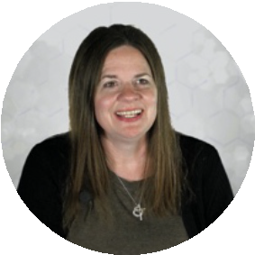week after receiving the therapy, the bleeding and cramping stopped! I am very thankful that Renewal Therapy worked!"

**Jill MacDonald:** "I was rear-ended in a car accident 3 years ago now. I immediately had neck and back injuries. Shortly after I developed non-epileptic seizures from what we discovered was a Traumatic Brain Injury. I couldn't even drive for two years because of it. I took pain medicine, anti-inflammatories. Nothing was helping.

We moved forward with Renewal Therapy. I was just targeting the back and neck injuries for inflammation and the best side-effect was that it immediately stopped my seizures, and I was able to return to driving. Now, I'm able to go up and down stairs and I can sleep better. I don't take any anti-inflammatories or pain medicine whatsoever. It's even helped decrease the intensity and frequency of migraines that I had even prior to the accident. My seizures are under control and now I just get Renewal Therapy on a regular basis to keep those seizures away.

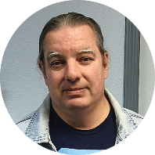Basically, I would totally recommend Renewal Therapy for anybody."

**Michael Tinaystich:** ''At the age of 3, I was diagnosed with a syndrome that destroyed my sense of smell and threatened my life. After receiving Renewal Therapy, my sense of smell began returning! It's been amazing to be able to smell after almost 50 years of not being able to! I wish that I had found Renewal Therapy sooner."

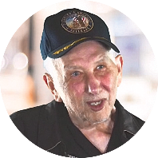**Paul Wilson:** "The bones in my right shoulder had collapsed on each other leaving me in chronic pain. I couldn't raise my arm without intense pain. Receiving Renewal Therapy; I am no longer in pain. My x-rays show space between the two bones in my shoulder again. The bones are regenerating! I would recommend

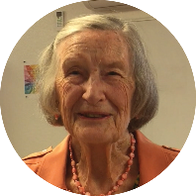Renewal Therapy to anyone considering surgery. It's been a huge success!"

**Ruby D. Smith:** "I'm ninety-three years old and have been dealing with the typical issues attributed to aging. I received Renewal Therapy to support my general health. Here are a few of the things that I noticed: my posture improved, and my skin started renewing itself. It's not so dry and looks more youthful. I also had an eye test and

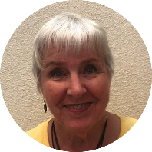the optometrist said that my symptoms of glaucoma were reduced. I'm looking forward to more improvements. Though I know I won't find the fountain of youth, I am ready for another 10 years. Thank you, Renewal Therapy!"

Jerri Ray: "I received Renewal Therapy a month ago and I felt the regeneration immediately. The following morning after Renewal Therapy; I bounced out of bed at 7AM. I usually do not get up that early. I feel confident in saying that my energy tripled in one month. Now I'm pushing eighty years old, but I'm feeling more like fifty-five. I have

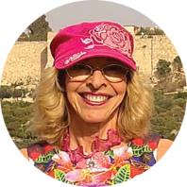energy all day long. My husband can attest to this too. I am really surprised and very happy with the results."

**Karen Faith:** "I have always loved to ski! I used to ski every year. The deeper the powder, the crazier the skiing, the more I liked it! That all changed when I hurt my knee. In fact, one year, I was skiing very deep powder and I ended up in the emergency room. I didn't want surgery and pain pills didn't seem like a good option

either. So, I decided to have a small injection of Renewal Therapy in my damaged knee. It was very simple. Around five to six weeks after the therapy; I suddenly realized that I had no knee pain! I mean no pain at

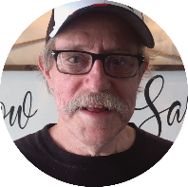all! If you are considering knee surgery, or taking pain pills, I encourage you to look into Renewal Therapy. It worked for me! It was amazing! I'm like new and can ski again!"

**Larry Kramer:** "I was surprised how fast I experienced relief from the sciatic pain that had become chronic.

Before Renewal Therapy, my pain level was an 8 to 9 on a scale of 10. 10 being the most severe.

Twenty minutes after Renewal Therapy, the pain reduction began. It continued to diminish until it was

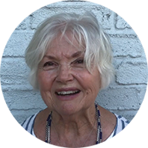very faint. Incredible! As a bonus, my mobility improved too."

**Joanie Castleman:** "Today, I can get out of the car after a ride and not have to stand there. I can get out and walk. Something's happening in my legs. I just feel good. I can walk out from the house to the mailbox and not feel tired and exhausted like I was and that's a big, big change.

That's what I was hoping these stem cells would do, and they're doing it."

**Annabelle W:** "I run a nonprofit organization called furnishing families. We furnish new homes for people who are just coming off the streets and taking control of their new homes. I need to stay energetic and full of energy to maintain this ministry as it means a lot to me.

However, I recently had 5 root canals. They were in my head for 30 years and they did a lot of damage and evidently, the bacteria in them eat at your cartilage. Due to that fact, I had hips that needed to be replaced because there was no cartilage, and on top of that my mom says I was a dancer; I was an athlete. I used my hips a lot and so the combination really left my hips in bad shape. All these things came together, and I had no cartilage. I got to the point where I could hardly walk. I eventually had both hips replaced in one year and it was a hardship in my life.

But then I met people who introduced me to Renewal Therapy, and I went ahead and received the therapy. I'm almost a hundred percent into my full use of everything and I am so energetic. I can use my body all day now. I

don't have to sit down and tell my guys I'll see you later. I can keep up with them now and partake in my ministry. Everyone around me, who's known me has been asking what happened to you. Give me some of that. It's beautiful.

Renewal Therapy has allowed me to continue my ministry and I am forever grateful!!"

**Lynn Ellen:** "I started to get very ill and lost a lot of weight. My husband and I decided that we were going to receive Renewal Therapy and it literally sustained me. I was sadly at a point where I had gone down to 104 lbs, and it got me to a place of stability. For me, I literally don't think I'd be here if I hadn't done it."

**Mary Hanna:** "For about the last two years, I was fighting pain in every part of my body; mostly in my shoulder, my neck, my lower back, and then inflammation would pull things out of alignment. I was going to Massage Envy one week, a chiropractor the next week, and then a medical massage the next week, and

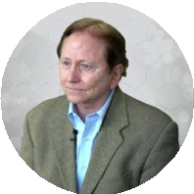then I'd start the cycle over again. It got so bad, that I could not sleep at night. I was just desperate to get rid of the pain! I decided to receive Renewal Therapy. Since then, I've noticed a reduction in skin irritation with psoriatic arthritis. I was having no luck getting that thing to heal up! Two weeks ago, I noticed that when I went to choir rehearsal, I can climb the stairs now!"

**Doug Williamson:** "I've been a runner and an athlete all my life. I worked out four or five times a week where I would run 5 to 10 miles a week. In January; I had a major meltdown with my back, and I couldn't sleep. I was in intense pain and found out that I had an eight­ millimeter bulge in my LS disc and a four-millimeter

bulge in my L3 and L4 that just incapacitated me. I discovered Renewal Therapy and received therapy on February 6th. Within two weeks I could sleep which was amazing. Within a month I was starting to work out again. It's been three months and now I'm working out four times a week.

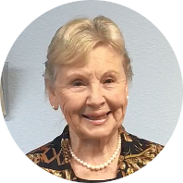If you have chronic pain, intense pain, rather than having surgery, I would definitely recommend that you look into Renewal Therapy as an alternative. It's amazing."

**Jean Stanfield:** "I'm 82 years old and have suffered with breakouts of Shingles for over fifty-five years. I just couldn't seem to get rid of them. After the very first therapy with Renewal Therapy, I noticed that the shingles episodes were much lighter. Instead of lasting three and a half weeks, the breakouts lasted for only about three

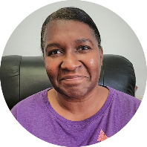days. To me that was marvelous! I also have had problems with some of my joints aching and they are feeling better. In fact, I think I am feeling better all over."

**Dee Ellen Jennings:** "I chose Renewal Therapy because I was having a lot of pain in my knees and back. I also dealt with the symptoms of peripheral neuropathy, a lot of nerve damage. Physical therapy was not providing a solution and I was tired of hurting. I am so happy with my results! I walked out of the clinic the same day that I

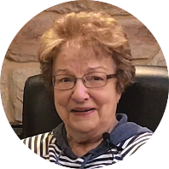received Renewal Therapy "pain free"! I can do things that I wasn't able to do for over a year. I feel like I have my life back."

**Nancy Casun:** "My husband, Bob, was diagnosed with dementia about 3 years ago. His short-term memory is the primary thing that he has problems with. His long­ term memory is better.

In the first month following Renewal Therapy, I've noticed that he's more engaged. He began to initiate activities

that he had stopped doing. Such as, unloading the dishwasher and putting things where they go. I was amazed because remembering the location of items was difficult for him.

The changes are wonderful! I would say that if you're struggling with any type of memory loss or problems like that, consider Renewal Therapy!"

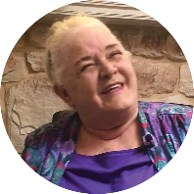**Mary Ann Tatum:** "I suffered with scoliosis, severe knee pain, a shattered arm with 13 pins and a plate, and pain in every joint in my body. I relied on a cushion in my wheelchair to help manage my chronic pain. Just six short weeks after receiving Renewal Therapy, I experienced remarkable changes in my life. The swelling

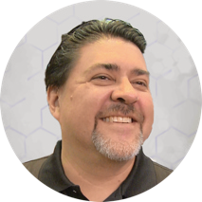in my feet and ankles went away and I can wear shoes that I haven't worn in four to five years. I'm able to stand up straight and my joint pain has dramatically reduced. I have more energy and self-confidence. I can't tell you how happy I am. I have taken my life back and it is a beautiful thing!"

**Brad Underwood:** "I had a bad car accident, and I was in pain, so I went and had X-rays taken. The X-rays showed that I had a torn meniscus. They thought I was a really good candidate for Renewal Therapy. We can now see in all the x-rays that the meniscus is growing back.

We can see the measurable quantifiable distance in between there my back; the discs are growing back slowly. It's great, you don't have to have anesthesia and be knocked out and all those risks that go with that. I mean it was great. I didn't have to medicate, I regenerated."

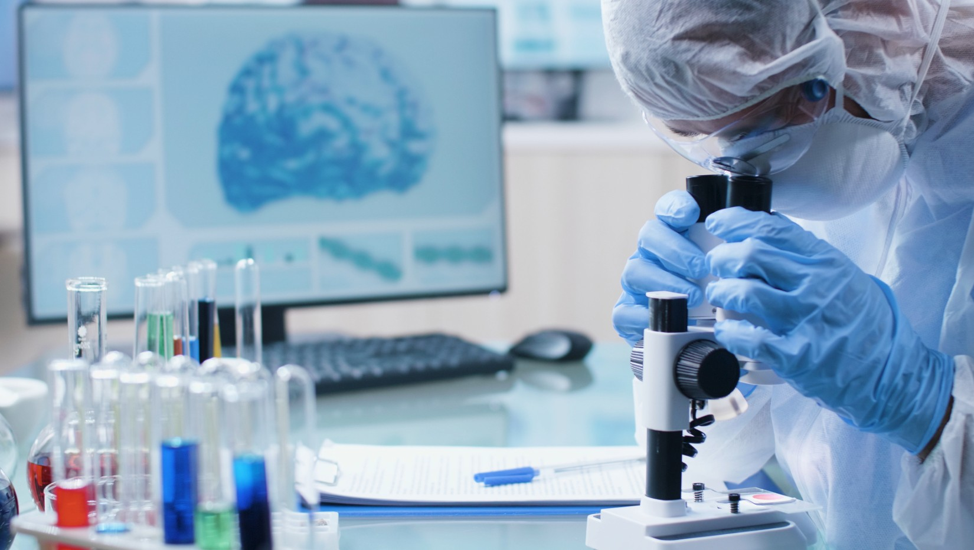

### CHAPTER TEN

#### STEM CELLS MADE SIMPLE RECAP & FAQS

So, let's do a quick recap of what we discussed so far:

* You were created as a masterpiece (healing and regeneration are encoded in your DNA).
* Stem cells are the wave of the future and the future is here and now.
* All the experts believe that Stem Cell Therapy is the future of medicine, but remember: it's personal because stem cells are the future of *your* personal health and longevity.
* The problem is degeneration (i.e., inflammation causes sickness, disease, pain, and aging).
* The solution is regeneration (i.e., to build, grow, and create new tissue).
* Stem cells decline rapidly as we age, leaving us more susceptible to illness, disease, and accelerated aging.
* Stem cells are now available and are simple, safe, convenient, effective, affordable, and produce amazing results.
* Stem cells are your body's internal repair system.
* Of the five types of stem cells, the most effective and beneficial are human umbilical cord stem cells.
* The science and research are undeniable and progressing rapidly.
* The rest of your life will be the best of your life.

Are stem cells FDA-approved?

The labs are regulated by and registered with the FDA. Stem Cell Therapy is a natural therapy and natural therapies are not approved by the FDA. The entire process in handled within the United States.

How long does the therapy take?

Only a few minutes for a specific injection site, and about one hour for an *N* infusion.

How many therapies do I need?

Each patient varies. According to research, most people respond very well to one therapy. Other patients benefit from a second therapy three to six months later. Some patients choose to schedule regular therapy to help the body maintain good health. Research indicates that stem cells reproduce every twenty-eight hours for about sixty­ five generations. That means that you can expect to see the regenerative effects up to six months - while the benefits can last a lifetime.

Are there any potential side effects?

Possible mild temporary discomfort or bruising at the injection site. One to two percent of patients experience mild flu-like symptoms.

How fast will I see results?

Patient responses vary. Anti-inflammatory results can be immediate or within a few days. Regenerative effects are typically first seen in four to six weeks. Remember, regeneration takes time.

Are there guarantees that the area that I want to regenerate will undergo the regeneration?

No. The stem cells do not speak the language of disease and we cannot tell them where to go and what to do.

Instead, the body uses a process referred to as paracrine signaling to call the stem cells to injured or damaged areas. The body will prioritize the regenerative process by repairing vital organs such as the heart and lungs first.

Many people experience benefits that they did not expect, such as, better vision, stabilization of blood sugar levels, and more.

Who is a candidate for Stem Cell Therapy?

Anyone who is trying to keep their body functioning optimally should consider a consultation to discuss their personal situation and needs.

Is the therapy safe?

Yes. The cells are tested for your safety and complete sterility is validated and maintained throughout the entire process. All regulatory guidelines are met or exceeded.

*In accordance with the FTC guidelines concerning the use of endorsements and testimonials in advertising, please be aware of the following.*

*Federal regulations require us to advise you that all reviews, testimonials, and/ or endorsements of any kind reflect the personal experience of those individuals who have expressed their own personal opinions, and those opinions and experiences may not be representative of what every consumer may personally experience with the endorsement.*

*All reviews and testimonials are the sole opinions, findings, and/or experiences of the people sharing their stories. The people are not compensated in any way.*

*These statements have not been evaluated by the US Food and Drug Administration (FDA). We are required to inform you that there is no intention-implied or otherwise-that represents or infers that these statements be used in the cure, diagnosis, mitigation, treatment,*

*and/ or prevention of any disease.*

*These testimonials do not imply that similar results would or could happen for you. These testimonials are not intended to diagnose specific illnesses or conditions or be a treatment to eliminate diseases or other medical conditions or complications.*

*We make no medical claims as to the benefits of anything to improve medical conditions.*

###### The one that created you

**can heal you.**

Stem Cells Made Simple takes the complicated, controversial, and often confusing subject of stem cell therapy and makes it easy to learn, easy to understand, and easy to access.

"Stem cells promise to radically change medicine by enhancing the body's own capacity of healing itself."

- ***THE WASHINGTON POST***

"The new research suggests that perhaps we should consider stem cells one of the secrets to a longer life."

- ***TIME MAGAZINE***

**"Stem** cells **and derived products** offer **great promise for new**

medical **treatments."**

- ***MAYO CLINIC***

*The next step:*

**Is a no charge phone consultation with**

**Dr. David L. Hartz at 850-933-5616**

**to see if Renewal therapy is right for you.**

**Also, to register for a online meeting or in-person workshop to gather even more information.**

**Go to** [**www.stembiologics.life**](http://www.stembiologics.life)

**Or www.wbrxbiologics.com**