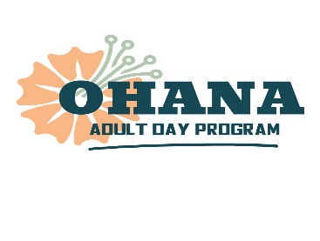
Phone: (470)-251-4450
Website: Ohana-day.org
Email: donica@ohana-day.org

INSTRUCTIONS: Fill out all requested information in the shaded areas and boxes on this form and email to donica@ohana-day.org. Once form is received, we will contact you to schedule your free 2-hour visit.

ON-LINE REGISTRATION FORM
APPLICANT INFORMATION
First Name: Enter Text Here |  |  |  | Last Name: Enter Text Here |  |  |  |  | MI: Enter Text Here
Address: (Street, City, State, Zip) Enter Text Here

Phone Number: Enter Text Here |  |  | Email Address: Enter Text Here
Age: | Male☐ Female☐ | Marital Status: ☐Married☐Divorced☐Widow☐ Never Married☐
Who does applicant live with? Enter Text Here |  |  |  |  |  | Relationship: Enter Text Here
APPLICANT HEALTH HISTORY
List any major health conditions: Enter Text Here

Primary Care Physician: Enter Text Here |  |  |  |  | Dietary Requirements: (please check)  ☐Regular☐ Low-sodium☐ Diabetic ☐ Other, please specify: Enter Text Here
Is supervision or help required with medications?
(please check) ☐No☐Yes If yes, please explain: Enter Text Here
What assistance, if any, is required in the following areas: (please check applicable boxes and explain)
☐Walking or Standing (Explain) Enter Text Here
☐Toileting (Explain) Enter Text Here
☐Bathing (Explain) Enter Text Here
☐Eating (Explain) Enter Text Here

Requested Start Date: Click or tap to enter a date. |  |  |  |  | ☐F/T (≥ 5hrs. daily)☐P/T (< 5hrs. daily)
Days Requested: (Please check) ☐Mon ☐Tue ☐Wed ☐Thurs ☐Fri

What additional special needs does the applicant have, if any? (i.e., need for socialization, supervision, medical assistance, wound changing, bathing…) Enter Text Here

Person completing this form: Enter Text Here |  |  |  |  |  |  |  | Contact Number: Enter Text Here
Relationship to Applicant: Click or tap here to enter text . |  |  |  |  |  |  | Email: Click or tap here to enter text.

PLEASE EMAIL COMPLETED FORM to donica@ohana-day.org. Thank you!

