Women in Government Mentoring Program

Activities/Events

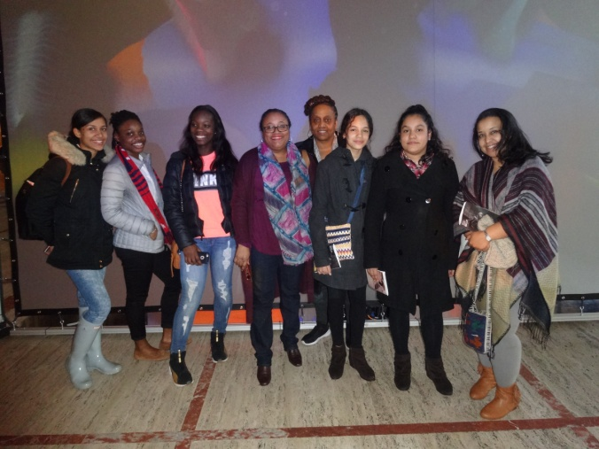

|  |
| --- |
| Activities/Events |
| Mentoring Program Kick-Off  Mentors and Mentees meet and get to know each other for the first time |
|  |
| Parents Dinner  Mentors meet their mentee's parents and/or guardians to introduce the program and get to know each other |
| College Tours |
| Mentees and mentors visit local area colleges and universities |
| Alvin Ailey and Other Cultural Events |
|  |
| Mentees' Book Club Meetings |
|  |
| National Mentoring Month - annually volunteer mentors celebrate their role and reflect on the ways mentees have enhanced their world |
| Bowling Activity for Mentors and Mentees |
|  |
| Career Forum  Professionals from a variety of sectors and former mentees participate as panelist |

Mentoring Program Closing Event

Mentors celebrate mentees' accomplishments and graduation from high school