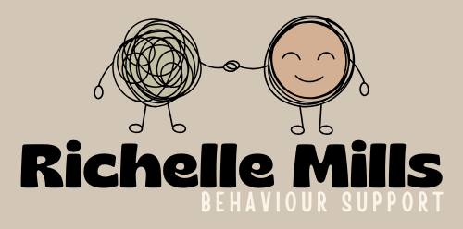
NDIS - Participant Intake Form

Participant Information
First Name |  |  |  |  | Surname
Street Address |  |  |  |  |  |  |  | Post code
Phone/TTY |  | Mobile |  |  |  |  | Email
Date of Birth |  | Gender |  |  |  |  | NDIS #
NOMINEE CONTACT
First Name |  |  |  | Surname
Street Address |  |  |  |  |  |  | Post code
Phone/TTY |  | Mobile |  |  |  | Email

FUNDING DETAILS
NDIS Plan Dates  (dates listed on the participants NDIS plan) |  | Start Date |  |  |  |  | End Date
Service Delivery Dates  (dates the practitioner will begin/end delivering services) |  | Start Date |  |  |  |  | End Date
Fund Management  (for the funding category we will be accessing) |  | Self-Managed |  | Agency Managed |  |  | Plan Managed |  | PACE
If self/plan managed, invoices to (email)
SUMMARY OF SERVICES TO BE PROVIDED
Improved Relationships |  |  |  |  |  |  |  | Number of Hours or $
11_022_0110_7_3 Specialist Behavioural Intervention Support
11_023_0110_7_3 Behaviour management plan, training in behaviour management strategies
Support Coordination |  |  |  |  |  |  |  | Number of Hours or $
07_002_0106_8_3 Support Coordination Level 2: Coordination of Supports
07_004_0132_8_3 Support Coordination Level 3: Specialist Support Coordination
CONSENT TO SHARE
List other organisations involved:

Completed by ___________________________________________________ |  |  |  |  | Date: _____________

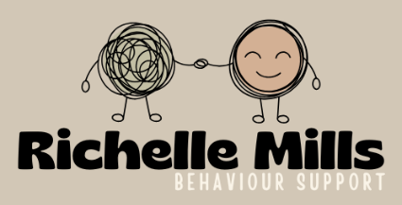
Service Plan Information

Date Service Plan developed:
Date Service Plan to be reviewed:
Completed by (name):
Practitioner/s (name):
Individuals consulted in Service Plan development:

CULTURAL BACKGROUND AND PREFERENCES
Aboriginal or Torres Strait Islander Origin? |  | - No  - Yes, Aboriginal  - Yes, Torres Strait Islander  - Yes, both Aboriginal and Torres Strait Islander
CALD Status
Preferred language
Interpreter Required
DIAGNOSES/HEALTH
Primary Disability |  |  | - ADHD  - Acquired Brain Injury  - Autism Spectrum Disorder  - Blind/Vision Impairment  - Cerebral Palsy  - Deaf/Hearing Impairment  - Developmental Delay  - Multiple Sclerosis |  | - Neurological  - Psychosocial Disability  - Speech Impairment  - Spinal Cord Injury  - Stroke  - Intellectual Disability  - Down Syndrome  - Other  Specify:
Communication Method |  | - Verbal  - Non-verbal  - Sign language - Auslan or Makaton  - Key Word Sign  - Point/gesture  - Augmentative and Alternative Communication (AAC)
Any ongoing health issues?
E.g., Mobility, Epilepsy

SUPPORTS
How will supports be provided?

Participant likes/dislikes/strengths

Goals of support

Has a home safety checklist been completed? | - Yes  - No |  |  | Comments:

Does the participant have a current Positive Behaviour Support Plan? | - Yes  - No | Comments:
Does the participant have a current risk assessment relating to their behaviour or support needs?  NOTE:  - Complete PBS Risk Assessment for participants funded under IR  - Complete General Risk Assessment for participants funded under IDL and Support Coordination | - Yes  - No | Comments:

Restrictive Practices
Date Identified | Restrictive Type | Related BOC | Frequency  routine/PRN,  provide details | RP Prescriber | Risk Rating | Risk considerations regarding using the restraint
 |  |  |  |  |  | Negative Effects | Positive Effects

Other Behaviours of Concern Please record any other behaviours of concern or significant risk that are not addressed in the above Restrictive Practice Table
BOC Description | Risk Rating | Current support strategies | Considerations regarding the risks of the BOC
 |  |  | i.e.: risk of utilizing Rp’s if BOC is displayed

Behaviours of Concern Risk Rating and Matrix
Likelihood |  |  | Consequence |  |  | Consequences | 1  Insignificant | 2  Minor | 3  Moderate | 4  Major | 5 Catastrophic
Rating | Description |  | Rating | Description |  | Likelihood
Almost Certain | Expected to occur in most circumstances, e.g., daily |  | 1  Insignificant | - No injuries  - No Increase in support  - No disruption to service delivery  - Brief emotional disturbance |  | Almost  Certain | Low | Moderate | High | Extreme | Extreme
Likely | Will probably occur in most circumstances, e.g., weekly |  | 2  Minor | - Minor injury treated with First Aid  - Minor emotional disturbance impacting more than 2 days – does not require treatment  - Increased level of support or monitoring  - Manageable disruption to service delivery  - Minor property damage |  | Likely | Low | Moderate | High | High | Extreme
Possible | Could occur at some time, e.g., monthly |  | 3  Moderate | - Medical treatment required  - Moderate emotional trauma  - Increase in on-going support levels  - Disruption to service delivery  - Moderate property damage  - Exacerbation of mental health illness requiring treatment  - Abuse or neglect of a participant |  | Possible | Low | Moderate | High | High | Extreme
Unlikely | Unlikely in the foreseeable future, e.g., six-monthly |  | 4  Major | - Hospital admission or attendance for treatment  - Psychological trauma  - Major property damage  - Service delivery is ceased  - Significant faults allowing significant abuse or neglect of a participant. |  | Unlikely | Low | Low | Moderate | High | Extreme
Rare | Occurrence requires exceptional circumstances, e.g., yearly |  | 5 Catastrophic | - Loss of life  - Exposure to immediate threat  - Severe psychological trauma  - Long term loss of ability for participant  - Systemic faults of widespread abuse or neglect of participant |  | Rare | Low | Low | Low | Moderate | Extreme

