USS DAVIS DD937 ASSOCIATION
SHIP’S STORE ORDER FORM

Name: _____________________________________________________________ Date: ______________________________

Address: _____________________________________________________________________________________________________

City: ____________________________________________ State: _____________ Zip Code: _________________________

Email: ________________________________________________ Phone Number: _____________________________________

ITEM PRICE QUANTITY TOTAL

BALL CAP: Navy blue, embroidered USS Davis
DD 937 in gold, Destroyer Silhouette in silver $17.00 __________ __________
TEE SHIRT: White USS Davis DD 937
Circle: Medium - Large - XLarge $20.00 __________ __________
XX Large - XXX Large $24.00 __________ __________

LADIES PINK U.S. NAVY T-SHIRT
Circle: Small - Medium - Large - XLarge $12.00 __________ __________
XX Large - XXX Large $12.00 __________ __________
POLO SHIRT: Navy blue or white - embroidered
Circle: Medium - Large - XLarge $27.00 __________ __________
XX Large - XXX Large $32.00 __________ __________

WINDBREAKER: Navy blue - embroidered
Circle: Medium - Large - XLarge $40.00 __________ __________
XX Large - XXX Large $43.00 __________ __________

SWEATSHIRT: wording: U.S. NAVY
Circle: Medium - Large - XLarge $30.00 __________ __________
XX Large - XXX Large $33.00 __________ __________

SHIP EMBLEM: embroidered, 4” diameter
1957-1969 (red) $ 5.00 __________ __________
1970-1982 (blue) $ 5.00 __________ __________

CHALLENGE COINS
Protect the 2nd Amendment $15.00 __________ __________
Vietnam Veteran $15.00 __________ __________
U.S. Navy – We Own the Seas $15.00 __________ __________

PINS Vietnam Veteran $6.00 __________ __________
American Flag $5.00 __________ __________
Vietnam Veteran’s Ribbon $5.00 __________ __________

COFFEE MUG: White with USS Davis DD 937 $15.00 __________ __________
Turn over for total

SHIPPING and HANDLING
See Postal Shipping Rates on the reverse side of this form ORDER TOTAL: _________________
PLUS S & H: __________________
GRAND TOTAL: __________________
MAKE CHECKS PAYABLE TO: USS DAVIS ASSOCIATION
MAIL TO: JIM DONNELLY, 1242 Southampton Road, Philadelphia, PA 19116 – (610) 360-5682
NOTE: Suppliers of custom items require minimum orders, usually at least 6 items, so at certain times delivery may be delayed while supplies are replenished.

COST OF SHIPPING
Shipping is a combination of weight and distance shipped. Weight is calculated in increments of one pound, including the shipping container. Distance is calculated by postage zones across the country. Only the following items weigh one pound or less: ball cap, mug by itself, decals and labels. Everything else weighs more than one pound which goes up to the two pound weight.
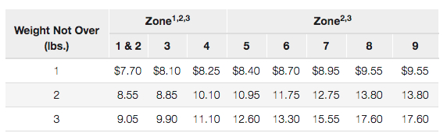

Find the first three digits of your zip code on the chart below. The number to the right gives your postal zone, as calculated from the ship’s store in Philadelphia to your location.

