Disability Network Southwest Michigan
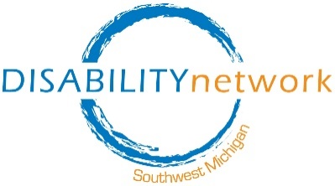

Four Levels of Ableism

Personal (Ideas or Values):
- I’m so glad my baby is “healthy” (wasn’t born with a disability).
- People with disabilities are so “inspirational” and nice.
- At least I can still walk (and not use a wheelchair)!
- His body is breaking down, but his mind is sharp as a tack!

Interpersonal (Between People):
- She can’t be on this committee – she would have too much trouble understanding what’s going on.
- We’re not going to hire her because I don’t know how a blind person could do this job.
- He’s not working hard enough on his goals.
- I’m not going to give him a reminder call about his appointment. He should make a note (Like I do)!
- We can’t hire someone with schizophrenia – we work with “vulnerable” populations… (What makes a whole group of people “vulnerable”? Assumption of violence when not support by evidence).
- If he would just cheer up and be more positive he wouldn’t have to take those pills. It’s all about self-control!
- It’s so cute! He has a “girlfriend.”
over

Organizational (In Organizations - Ways of Doing):
- Our policy says that people have to come to our office to be eligible for services.
- You must be able to lift 50 pounds for this job. (All the time? Can this be changed?)
- We’d make our building more accessible but people with disabilities don’t really come here.
- We’re going to choose an event location that works for “most people.” If people with disabilities can’t come, they can still get information another way.
- Our intake paperwork is pretty complicated, but we can’t change it because of state law.
- Staff don’t have time to go through everything. The person will have to get help from someone else if they don’t understand it.
- We have separate programs for people with autism to accommodate their “unique needs.”

Institutional (In Social Structures: Government, Education, Law & Media)
- If you are receiving social security disability benefits and get married you lose some of your benefit.
- It’s okay to build houses that some people cannot get inside.
- Many religions say that disability is a punishment from God.
- The health care system decides what equipment people with disabilities need and they often must pay for disability related equipment or services out of pocket.
- There is a process where people with disabilities can lose their rights to make any decision about their life. This process does not exist for people without disabilities.
Updated December 2022

