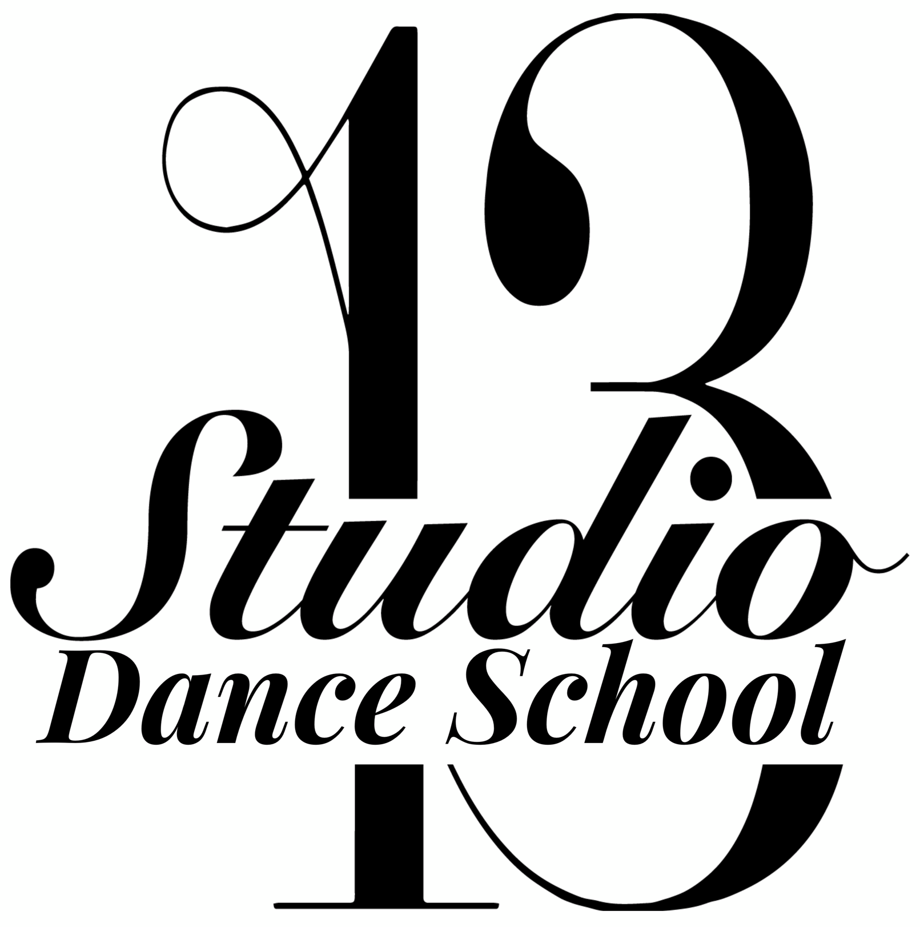

Our Privacy Policy & Safe Guarding

Upon joining Studio 13 Dance School you will be asked to fill out a registration form. All information asked for on this form is for insurance purposes to ensure the safety of your child or yourself.

Only qualified members of staff have access to this information.
Your information will not be shared with any third parties unless in the case of an emergency. If an emergency arises a legal guardian stated on the form will be contacted immediately.

Your details will only be kept for the duration of your time at Studio 13 Dance School. Once you inform a member of staff you will be leaving all paperwork regarding you and your child will be destroyed.

If you are absent from class and no contact has been made your contact information will be kept for a maximum of 4 weeks. After this time period your information will be destroyed. If you then return you will be asked to fill in another registration form.

It is your responsibility to update us with any changes to addresses and contact information. If we cannot get in contact with you in the case of an emergency a member of our qualified team will act as guardian for your child until we get contact with yourself.

A child will only be released to a parent that is known by a member of staff. If any other family member or friend is picking up a child, a member of our staff must be informed beforehand otherwise we will not release your child into their care. If you have other family or friends that will be collecting your child from class it is compulsory to have this in written form.

If you would like anymore information on any matter above, any other questions you may have or would like to discuss further, please email or contact Principle Chloe Massey on chloemassey13@aol.co.uk

