REVIEW THE SEA TOW CALL
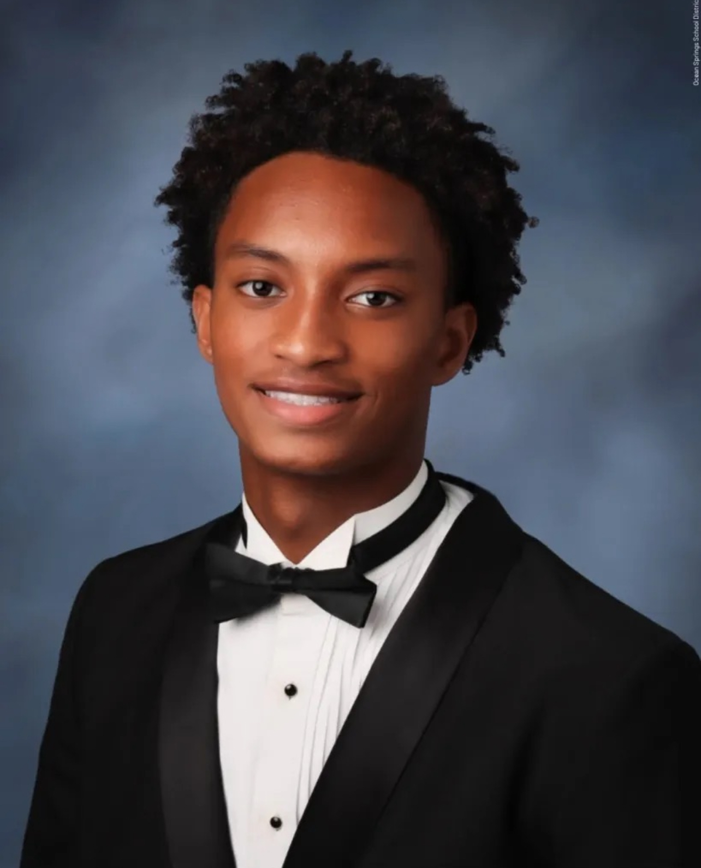
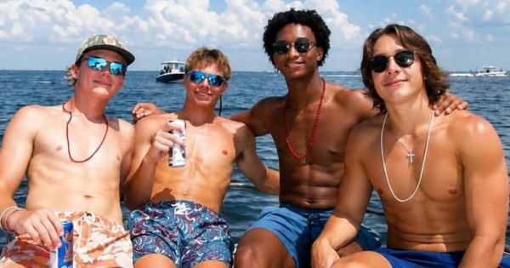
I request clarification on whether the full, unredacted Sea Tow call recording, reportedly made when members of the boating group requested assistance, has been obtained and reviewed by the appropriate investigative authorities. Bart was mentioned too.
If not, I request that the recording be obtained and evaluated as potential evidence in the investigation into Nolan Xavier Wells’ death in Mississippi.
His family deserves answers.

