To Whom It May Concern,

I am writing as a concerned citizen to address ongoing issues with our water supply, particularly events that affect the Ohio River. The February 2023 train derailment in East Palestine, Ohio, contaminated local water sources and left residents without clean water for nearly two weeks, with limited initial federal response. Independent industrial hygienist and chemical exposure expert Stephen E. Petty conducted on-site testing of water, soil, and air shortly after the incident, highlighting uncertainties in official testing methods and cautioning that it was premature to declare the area safe (see on-site footage and interview here: https://www.youtube.com/watch?v=6Z1UV4cLCtg). FEMA only intervened after former President Trump announced his visit and provided bottled water to affected communities. Residents were initially misled about the train's contents, the reasons for the uncontrolled vinyl chloride burn (as shown in public videos), and the government's delayed involvement, which later shifted blame to Norfolk Southern for cleanup. This pattern of neglect—coupled with independent findings of persistent contamination—raises serious questions: Could federal inaction be tied to broader plans for redeveloping contaminated areas, such as for data centers or semiconductor plants? Once cleanup concludes, the region risks being deemed uninhabitable, highlighting how government responses to disasters often prioritize other agendas over public health. Proper remediation seems secondary to advancing international goals, like the UN's Agenda 2030 (already done deal), which exacerbates water shortages with high-water-use industries. Data centers and chip plants consume millions of gallons of water daily, potentially manufacturing artificial crises. Uruguay's experience after adopting the 2030 Agenda in 2015 illustrates this: Despite its vast aquifer, the country now faces shortages, economic strain, and agricultural losses due to water diversion for industrial use and recycled wastewater initiatives. This isn't natural scarcity—it's rationing enabled by global policies and supported by governments.
Pollution in our waterways has worsened over time, accelerated by industrial byproducts like 1,4-dioxane, a persistent chemical from processes including herbicides, pesticides, plastics manufacturing, waste incineration, and atmospheric spraying. The EPA classifies 1,4-dioxane as a probable human carcinogen that accumulates in the food chain. Why does the federal government permit any level of this toxin in our water? Studies from Arizona and New Jersey have prompted treatment recommendations and contaminant limits, yet addressing "forever chemicals" remains an ongoing challenge. Despite decades of efforts by organizations like the Ohio River Valley Water Sanitation Commission (ORSANCO) and the Ohio River Basin Alliance (ORBA), pollutants persist, causing health risks. This ongoing contamination may be driving us toward reliance on recycled industrial water as the "solution."
Kentuckians recognize the Ohio River's vital role in our economy and environment. In 1980, the U.S. Supreme Court ruled that Kentucky holds sovereignty over the river along its borders, providing legal precedent to protect it from pollution or depletion. Kentucky has long participated in ORSANCO and ORBA to reduce pollution, with state law codifying the Ohio River Valley Sanitation Compact. Article IX of the Compact empowers states to enforce pollution controls. The U.S. Army Corps of Engineers and ORBA's 2020-2025 Plan outlines goals for clean water, involving over 130 partners. ORBA's primary objective is abundant clean water, targeting measurable improvements by 2030.
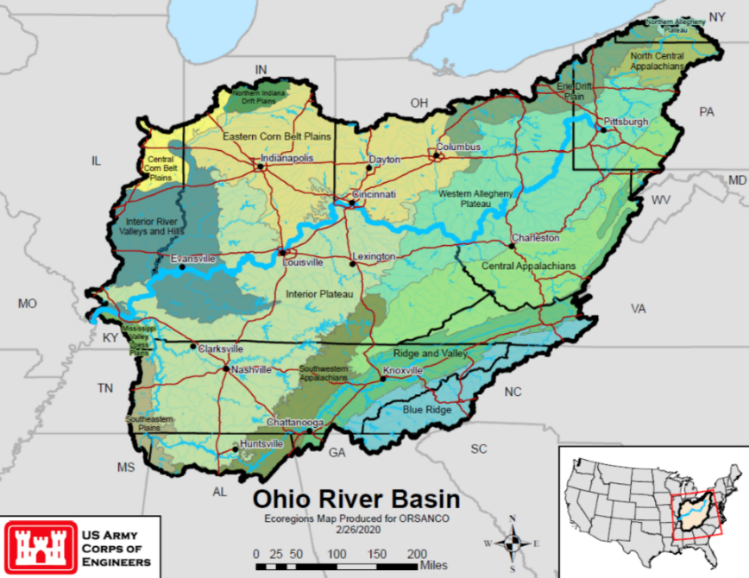
Yet, after 80 years of initiative, water quality issues persist. Rather than restricting polluting industries like semiconductor plants, Congress has boosted their production via the CHIPS Act, increasing dioxane levels and water usage (5-10 million gallons daily per plant). Kentucky's adoption of the Clean Water Act (codified in KRS Chapter 224) has ceded some control to federal oversight, while states like West Virginia and Ohio approve high-water-use facilities. Arizona's experience with Intel plants shows the impact: Tucson now requires dioxane treatment due to contamination. Federal ownership of western lands, dams, and basins underscores this control shift—not for cleanliness, but for management of resources.
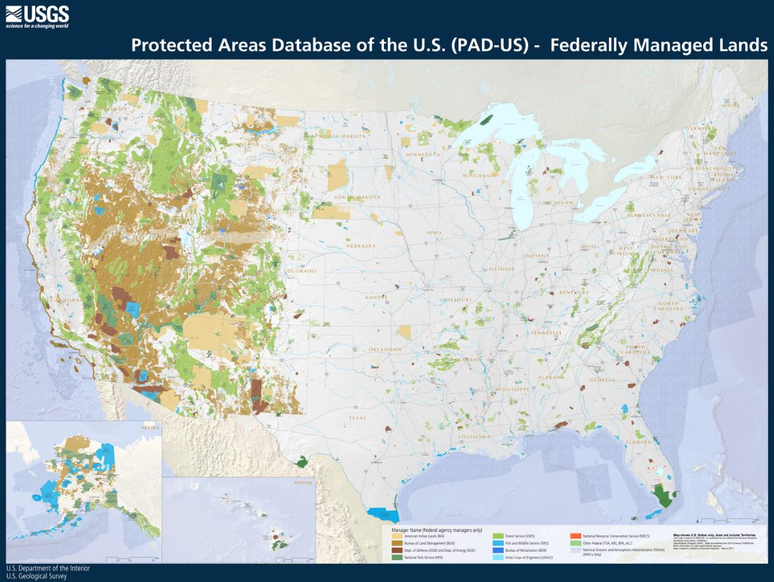
Our sovereignty has been eroded since the 1919 Treaty of Versailles, which set precedents for global governance, leading to the League of Nations and later the United Nations (UN) in 1945. The World Economic Forum (WEF) now partners with the UN, involving figures like Bill Gates in water and climate initiatives aligned with Agenda 2030's 17 goals, including Goal 6 for water control. Many officials embrace these programs, promoting wastewater recycling—even Gates has endorsed "poop water." WEF visions suggest a future where people "own nothing and be happy," reliant on shared resources.
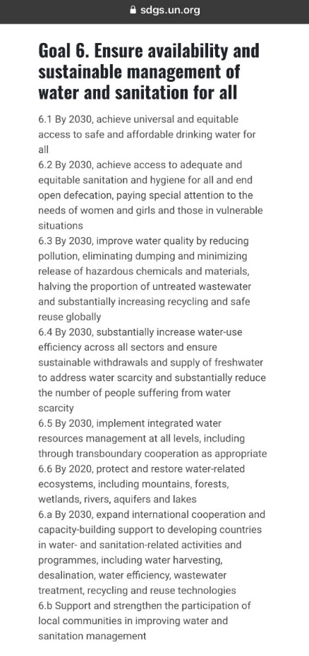
Clean water is achievable through restrictions on toxic discharges and natural solutions like mycoremediation (using mushrooms to break down pollutants). However, boosting semiconductor production will increase toxicity, forcing reliance on government-provided recycled water under the guise of scarcity.
Kentucky officials must uphold their oaths, defend constitutional rights, and prioritize local control over global interests by investigating these concerns, enforcing pollution controls, and rejecting initiatives that compromise our water sovereignty. Most topics discussed came from investigative journalist Tore Maras via her articles (www.toresays.com) and educational podcasts (https://toresays.com/tore-says-show/).

https://nypost.com/2023/02/18/fema-sends-help-to-east-palestine-after-refusing-for-2-weeks/
https://truthout.org/articles/the-us-tested-bombs-on-the-marshall-islands-now-victims-are-seeking-justice/
https://www.bbc.com/news/world-us-canada-50951981
https://docta.ucm.es/rest/api/core/bitstreams/6da5cde5-1ee2-4335-8f6d-3ef58c326ff3/content
https://iwaponline.com/jwh/article/21/10/1448/97595/Implementation-of-a-national-regulatory-framework
https://borgenproject.org/water-scarcity-in-uruguay/
https://www.epa.gov/dioxin/learn-about-dioxin
https://www.thedailybeast.com/white-house-admits-we-might-need-to-block-the-sun-to-stop-climate-change?source=articles&via=rss
https://semspub.epa.gov/work/01/575107.pdf
https://14d-1.itrcweb.org/wp-content/uploads/2021/02/14d_regulatory_framework_021621.pdf
https://www.state.nj.us/dep/watersupply/pdf/treatment-dioxane-20200925.pdf
https://cen.acs.org/environment/pollution/14-Dioxane-Another-forever-chemical/98/i43
https://www.dispatch.com/story/news/2023/02/20/ohio-river-importance-to-economy-environment-after-derailment/69917013007/
https://supreme.justia.com/cases/federal/us/444/335/
https://www.orsanco.org/about-us/
https://www.lrd.usace.army.mil/Missions/Planning/Programs-Projects/Ohio-River-Basin-Comprehensive-Reconnaissance-Study/
https://www.lrd.usace.army.mil/News/News-Releases/Article/3786485/recap-ohio-river-basin-day-on-the-hill-2024/
https://www.orsanco.org/wp-content/uploads/2022/03/compact-2.pdf
https://www.lrd.usace.army.mil/Missions/Planning/Programs-Projects/Ohio-River-Basin-Comprehensive-Reconnaissance-Study/
https://www.orsanco.org/wp-content/uploads/2023/04/Plan-for-the-Ohio-River-Basin_FINAL.pdf
https://www.cnn.com/2022/07/28/politics/house-vote-chips-bill-semiconductor/index.html
https://www.wvva.com/2023/02/15/wva-senate-passes-funding-bill-site-improvements-bill-gates-backed-battery-company/
https://www.dispatch.com/story/business/information-technology/2022/01/14/intel-near-columbus-ohio-what-know-site-factory-project/6514569001/
https://spectrum.ieee.org/fabs-cut-back-water-use
https://www.tucsonaz.gov/Departments/Water/Water-Quality/Water-Quality-Monitoring/1-4-Dioxane
https://www.un.org/en/about-us/history-of-the-un/predecessor
https://www.foxnews.com/world/world-economic-forum-chair-klaus-schwab-declares-chinese-state-tv-china-model-many-nations
https://www.weforum.org/press/2019/06/world-economic-forum-and-un-sign-strategic-partnership-framework
https://tottnews.com/2022/10/06/gates-foundation-agenda-2030/
https://www.gatesfoundation.org/our-work/programs/global-growth-and-opportunity/water-sanitation-and-hygiene
https://economictimes.indiatimes.com/prime/environment/bill-gates-harvard-university-back-solar-geoengineering-to-fight-global-warming-aim-dim-the-sun-/primearticleshow/82842982.cms
https://sdgs.un.org/2030agenda
https://www.npr.org/sections/goatsandsoda/2015/01/10/376182321/bill-gates-raises-a-glass-to-and-of-water-made-from-poop
https://www3.weforum.org/docs/WEF_The_Future_Of_Nature_And_Business_2020.pdf
https://web.archive.org/web/20161122130926/https://www.weforum.org/agenda/2016/11/8-predictions-for-the-world-in-2030/
https://www.yesmagazine.org/environment/2019/03/05/mushrooms-clean-up-toxic-mess-including-plastic-why-arent-they-used-more

