**A Range of Events Pick Up Instructions:** Contactless porch pick up is the method used for this service. You can come anytime at or after your pickup time even very late at night or early in the morning.

Feel free to text (218)410-0858 when you’re on your way but it’s not required.

Address: **605 Jefferson Avenue, St. Paul, MN 55102**

Park anyplace as close to the house as possible for easy hauling.

House photo: Go through the fence (we have no dog so please don’t be concerned).

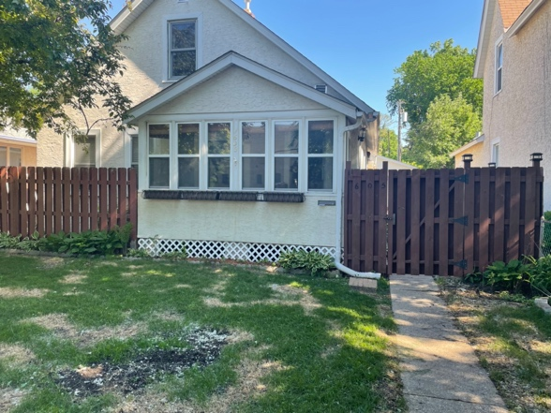

Porch Door & Pick Up Zone: (the porch door is immediately to your left when you enter gate).

Items will be labeled with your contract number. There are cameras in there so your items are safe.

Feel free to prop the screen door open with the little slider hook while you load.

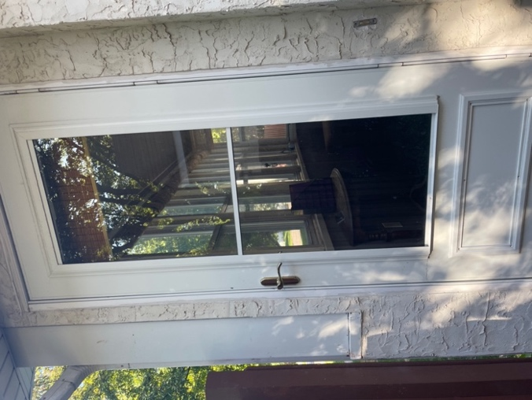

Paperwork Folder: (Please complete the highlighted portions on the paperwork & leave damage check).

*Item Returns will be done exactly the same way.*