\* Dumpster located

across from City Hall

Saturday June 28th only

From 7am – 4pm

Kinross Spring Clean Up!

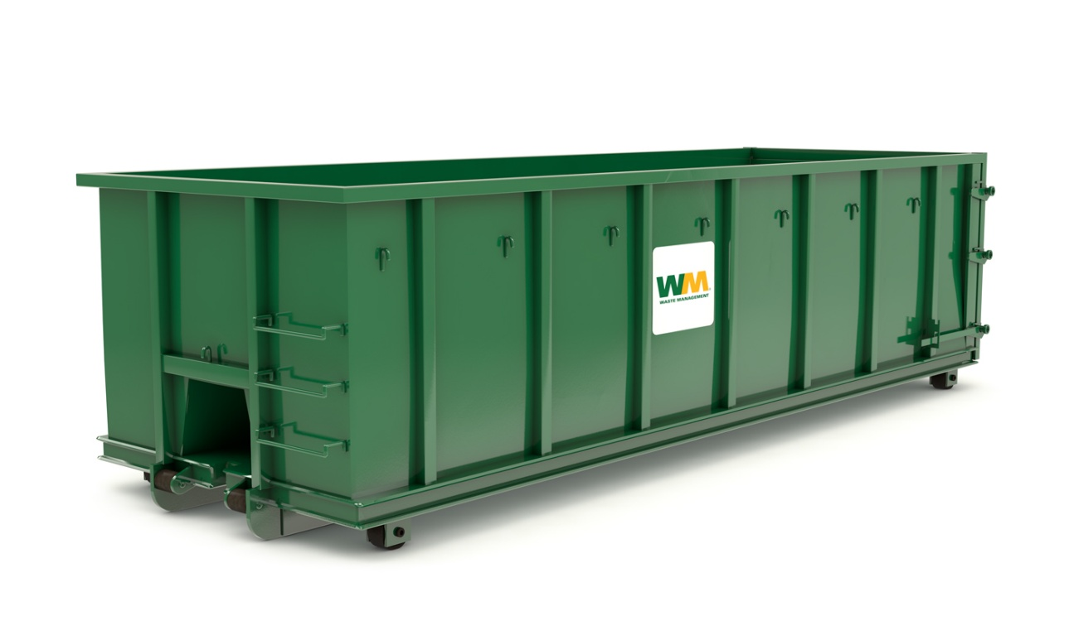

Banned Items

* Appliances
* Paint
* Batteries
* Hazardous Material
* Tires

There will be no exepctions to these items, they are simply not allowed

Accepted Items

* Household garbage
* Plastic patio/storage containers
* Glass
* Bicycles
* Cardboard

We are changing it up this year, and will also have a fall clean up date which is to be determined.

Along with a sign in sheet for the citizens utilizing the dumpster. We ask that only Kinross Town Citizens utilize the dumpster otherwise we as a city will no longer be able to offer this to the town. Thank you for your understanding, and happy spring cleaning!