http://www.primack.net/professional/

Brian A. Primack, MD, PhD
Dean of the University Honors College
Bernice L. and Morton S. Lerner Chair
Professor of Medicine, Pediatrics, and Clinical & Translational Science, University of Pittsburgh School of Medicine
Director, Center for Research on Media, Technology, and Health, University of Pittsburgh
- Home
- Biography
- Publications
- Grants
- Teaching
- Awards
- Newsroom
- Interests
- Vitae
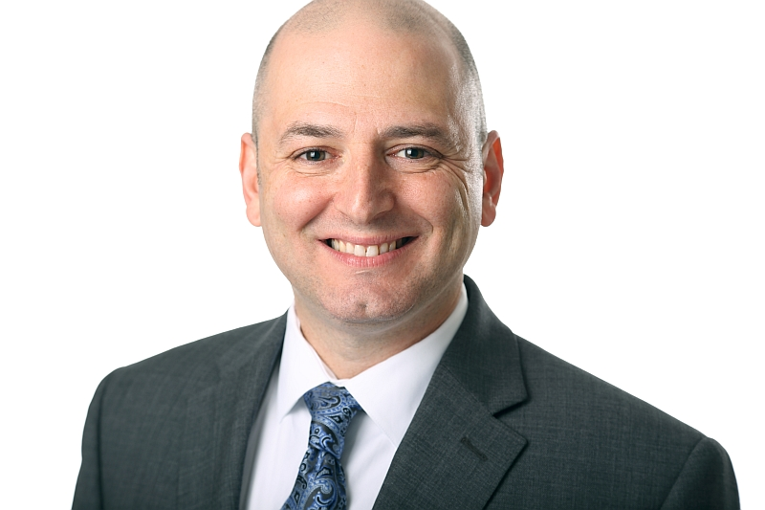

Highlights

- CBS News feature on loneliness (February, 2019)
- Featured Grantee at National Cancer Institute (January, 2019)
- Interviewed about social media and peer comparison in the New York Times(December, 2018)
- Commentary in TIME about screen use (October, 2018)
- American Journal of Preventive Medicine2017 Article of the Year (August, 2018)
- NPR All Things Considered interview on social media (August, 2018)
- CNBC reports on Facebook taking first step in addressing social media and mental health concerns (August, 2018)
- Interviewed on Washington Post Live about technology and mental well-being (June, 2018)
- Forbes covers negative social media experiences and depression paper published in Depression and Anxiety(June, 2018)
- Commentary on smartphone use in Time (May, 2018)
- Interview on Today Show about social media and isolation (April, 2018)
- Vaping as a geateway to cigarettes for young adults (March, 2018)
- Social media before bed and social isolation research cited by BBC (January, 2018)
- Interview on CNBC about technology addiction in children (January, 2018)
- Center for Research on Media, Technology, and Health releases 2017 Annual Report (January, 2018)
- The Guardian: When Facebook asks if social media is bad for us, it's time to listen (December, 2017)
- Family and technology symposium at Penn State (November, 2017)
- Offline October student-led social media blackout (October, 2017)
- Time article on kids and smartphones quotes Dr. Primack (October, 2017)
- BMJ news article on YouTube and alcohol research (September, 2017)
- Portrayal of alcohol on YouTube research featured on US News and World Report (September, 2017)
- Quoted in Success Magazine about media literacy and technology (August, 2017)
- Named the Bernice L. and Morton S. Lerner Chair and dean of the University of Pittsburgh’s University Honors College (July, 2017)
- Research on social media featured on Time Health (May, 2017)
- Social media research featured on NIH Director's Blog (March, 2017)
- Social isolation research covered by NPR (March, 2017)
- Center for Research on Media, Technology, and Health releases 2016 Annual Report (January, 2017)
- Yahoo! News covers e-cigarette study published in JAMA Pediatrics (November, 2016)
- International Baccalaureate World Magazine features social media research (September, 2016)
- Social media and eating concerns research covered by Yahoo! News (May, 2016)
- Social media and depression research featured in the The Tribune Review (April, 2016)
- Center for Research on Media, Technology, and Health releases 2015 Annual Report (January, 2016)
- Coverage of hookah meta-analysis by many news outlets, including the Huffington Post (January, 2016)
- Public Health Reports article also featured in Yahoo! News
- JAMA Pediatrics article on progression after electronic cigarettes featured in news outlets such as Time (September, 2015)
- Research on alcohol and YouTube reported in over 200 international news outlets including NPR national (March, 2015)
- Washington Post features blog and video about Dr. Primack's research (February, 2015)
- Selected as Outstanding Medical Student Mentor for second year in a row (August, 2014)
- Featured TEDMED Main Speaker (September, 2014)
- Becomes inaugural director of the Center for Research on Media, Technology, and Health (July, 2014)
- Appointed Assistant Vice Chancellor for Research on Health and Society at University of Pittsburgh (July, 2014)
- Popularity of hookah bars and smoking among young adults raise health concerns covered in Pittsburgh Post Gazette (June, 2014)
- Students initiate hookah smoking despite health warnings, covered in USA Today (June, 2014)
- Research on binge drinking featured in US News and World Report (April 8, 2014)
- Interviewed on local NPR station regarding innovative health promotion programming (January, 2014)
- Editorial published in JAMA (January, 2014)
- Selected as Outstanding Medical Student Mentor (August, 2013)
- Becomes Director of Program for Research on Media and Health (June, 2012)
- Waterpipe smoking research on CNN Health cover page (June, 2012)
- Video game research in multiple news sources (May, 2012)
- Movie smoking research on US News and World Report (March, 2012)
- Promoted to Associate Professor of Medicine, Pediatrics, and Clinical and Translational Science (December, 2011)
- Receives PhD in Clinical and Translational Science (December, 2011)
- Alcohol in music research published in Addiction, lead substance use journal worldwide (October, 2011)
- Depression research covered in US News and World Report (April, 2011)
- Selected as Society of Behavioral Medicine's Early Career Researcher for 2010 (June, 2010)
- Given University of Pittsburgh Cancer Institute Junior Faculty Scholar Award for 2010 (June, 2010)
- Interviewed on live Pittsburgh TV regarding adolesent alcohol use (May, 2010)
- National study on hookah smoking published in Journal of Adolescent Health (August, 2009)
- Interviewed on BBC regarding video games (August, 2009)
- Commentary on video games featured in multiple news outlets (August, 2009)
- Lead commentary in American Journal of Preventive Medicine (August, 2009)
- Research highlighted in Nature feature article (June, 2009)
- Research on sexual behavior and media reported in hundreds of major news outlets internationally; "most emailed" story on Yahoo.com (February, 2009)
- Research on depression and media featured in New York Times, LA Times, and multiple international media markets including England, Thailand, Greece, Brazil, Hungary, and Taiwan (February, 2009)
- Hookah smoking research covered in multiple national news sources (September, 2008)
- Quoted in New York Times regarding tobacco and disparities research (May, 2008)
- Health education research featured in American Association of Medical Colleges report (April, 2008)
- Featured guest for Medical Education podcast on patient care (April, 2008)
- Interviewed on WNYC public radio with LA Times music critic about Grammy Awards, popular music, and substance use (February, 2008)
- Substance use research covered in New York Times, Washington Post, US News and World Report, Sydney Morning Herald, and others (February, 2008)
- American Public Health Association talk on substance use and popular music covered in US News and World Report, ABC News, CBS News, and Reuters (November, 2007)
- Disparities research featured on NPR national (August, 2007)
- Disparities research reported in New York Times (August, 2007)
- AD IT UP aired on regional television (February, 2007)
- Research on smoking and media literacy covered in Miami Herald (October, 2006)
- Awarded 3-year Robert Wood Johnson Faculty Scholar Award (July, 2006)
- Winner of Bronze Telly Award in health/wellness category for AD IT UP (July, 2005)
- Media effects review (July, 2005)
Last updated 2019
All Rights Reserved

