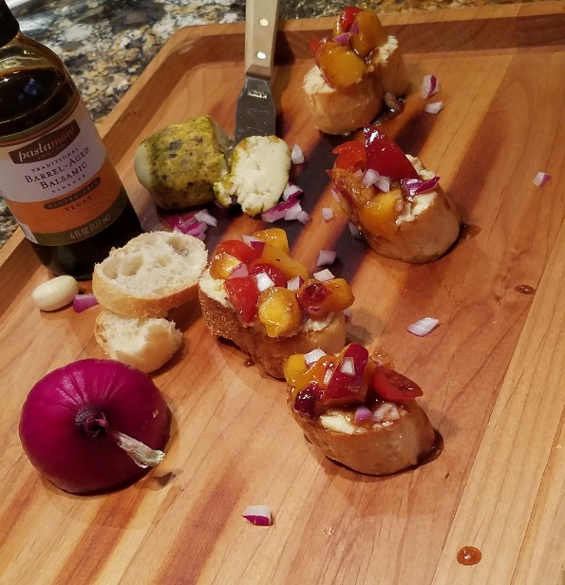

Sweet Summer Bruschetta
Inspired by Home is Where the Boat is
Ingredients
For the fruit mixture
-3 medium nectarines and/or peaches chopped into small pieces
-1/2 cup of cherry or grape tomatoes quartered
-1 tablespoon of finely diced red onion
-3 tablespoons olive oil
-1 and 1/5 tablespoons balsamic vinegar
-a dash of salt and pepper
-1/2 tablespoon honey
-1 1/2 tablespoons finely shredded fresh basil (optional)
For the toasted bread
-1 baguette or a loaf of French bread cut into 1 inch thick rounds
-2 tablespoons of olive oil
-2-3 garlic cloves finely minced
Additional ingredients
-fresh basil strips to garnish (optional)
-Spreadable cheese
*Ingredients supplied by our fresh produce vendors
*Ingredients supplied by our specialty food vendors
Directions
Toasting the bread
Preheat the oven to 350 °F. In wide shallow bowl combine minced garlic cloves with the 2 tablespoons of olive oil. Stir to mix. Add the baguette rounds and thoroughly coat them with the oil-garlic mixture. Lay the coated rounds out on a cookie sheet and toast for 3-5 minutes depending on the texture desired. Leave the rounds to cool.
For the fruit mixture
Combine all the ingredients for the mixture except the peaches/nectarines and tomatoes. Whisk to mix well. Set aside some of the mixture in a separate bowl. Add the peaches/nectarines and tomatoes to the rest of the mixture. Mix gently and set aside to let the flavors combine.
For assembly
Drizzle the reserved non-fruit mixture over each toasted baguette round. Next, slather each round with spreadable cheese. Add a spoonful of the fruit topping on top of the cheese and garnish with additional fresh basil if desired.

