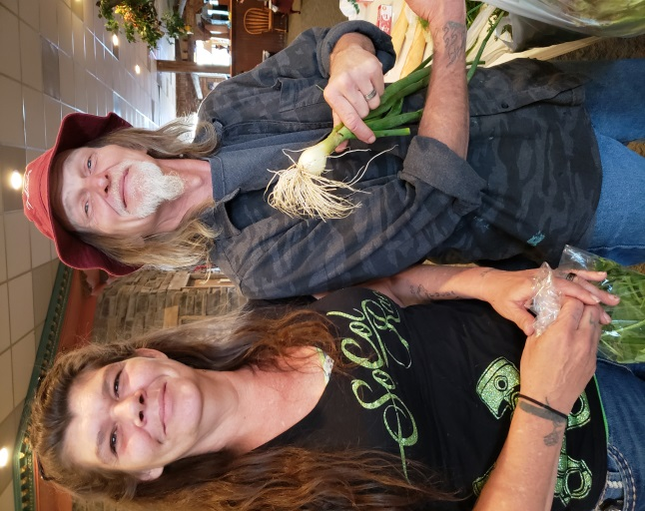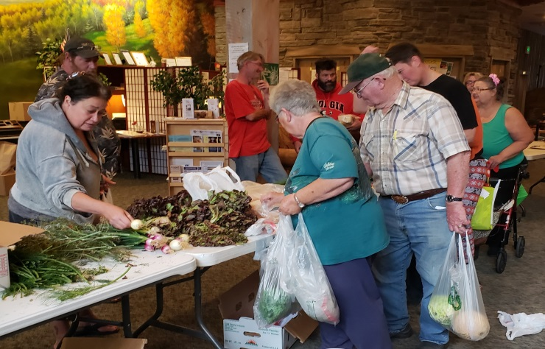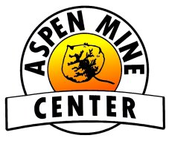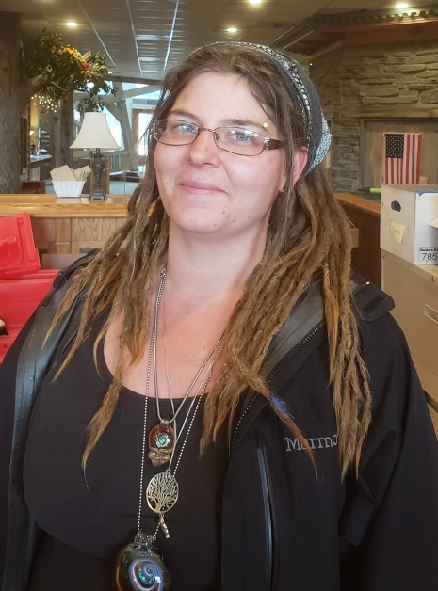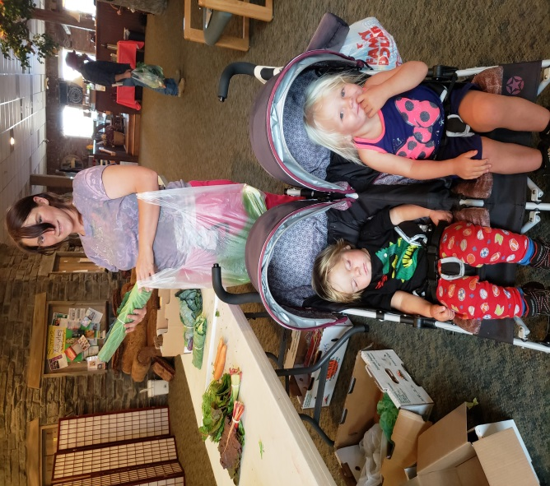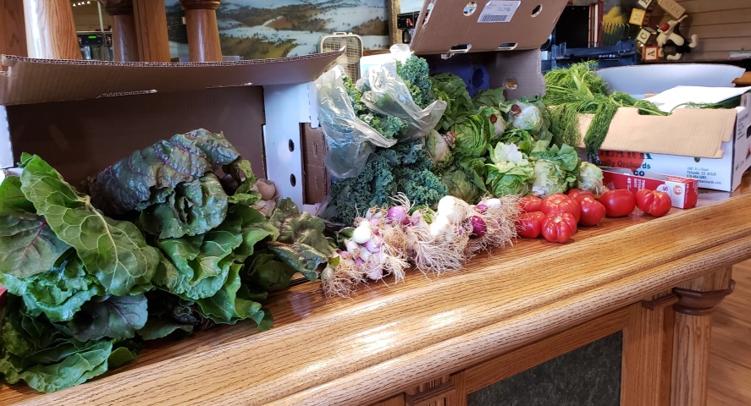

James and Shelly are amazed at the variety of produce that is donated to **The Longer Table** by the Woodland Park Farmer’s Market. They say “Thank You!” for the opportunity to add fresh fruits and vegetables to their meals.

**The Longer Table** at the Aspen Mine Center began on July 13, 2018 with a generous load of fruits and vegetables, and 25 people waiting in line to take advantage of the bounty!!

LesLee and her little ones are excited to find out about **The Longer Table** – Mom says both of her children are good veggie eaters, although Michael was much more relaxed about stuffed cabbage leaves for dinner than his sister Annabella!

We have been blessed with delicious donations of all kinds of veggies – some that are less common than others, such as Swiss chard and kale– which has led to great recipe sharing and numerous memories of “I ate that when I was a kid!”….

Conversations Around

The Longer Table

“If you have more than you need, build a longer table, not a higher wall.”

* Anonymous

Sunshine and her family are grateful that **The Longer Table** is “bringing Woodland Park to me!” Without reliable transportation, getting to the Farmer’s Market is difficult for many low income families and individuals.