beingbe

2025 Program Offerings:



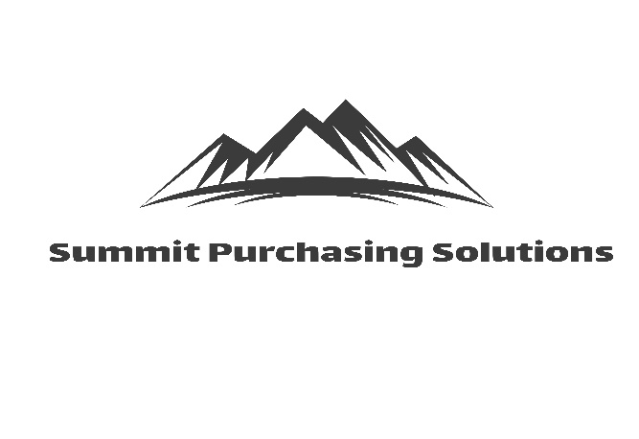

**INSURANCE SERVICES**

* Health Insurance
* Worksite & Voluntary Insurance

Accident Coverage

Critical Illness/Cancer

Hospital Indemnity

* Ancillary Insurance Programs

Dental, Vision, Life Insurances

Long & Short-Term Disability

* Non-profit Property & Casualty Insurances

Property, General Liability, Auto

Executive Liability

Malpractice Insurance

**SPENDING ANALYSIS**

* Apples to apples price comparison
* Provides alternative pricing when appropriate
* Identifies terms conditions of contract

Auto renewal

Auto price increase

Length/dates of contracts

Shipping costs

* Detailed Spreadsheet with results & recommendations

**INFORMATION TECHNOLOGY**

* New Computer Hardware
* Microsoft Certified & Non-profit Discounts
* Internet & Telecommunication Services
* Technology Planning & Budgeting
* Security Services & Disaster Recovery

**PURCHASING PROGRAMS**

* Office Supplies
* PPE & Supplies
* Furniture - Commercial Grade
* Janitorial Paper Products
* Cleaning Supplies
* Break Room Supplies/Coffee/Sugar
* Shredding Services
* Trash Removal & Recycling Services
* Medical Waste Removal
* Telephone Communication Systems
* Copier/Printers/Faxes
* Mailroom & Postage Equipment
* Commercial Printing
* Floor Mats
* Medical Supplies
* Marketing Brochures, Fliers, Banners
* Request for Proposals

**ENERGY CONSERVATION**

* Electric
* Natural Gas

**NEW SERVICES IN 2025**

* **Engaging Workforce Development**

Management Training Programs

* **SERVPRO**

Water/Fire Damage ER Response

Emergency Response Planning

* **Technagroup**

Building/office security and surveillance systems

IT network security & cyber management

Outsourced IT support and IT management services

**SPENDING ANALYSIS Services Include:**

* Identifying terms & conditions of contract:

Automatic contract renewal

Automatic price increases

The expiration date of the contract

Shipping costs

* Apples-to-apples price comparison
* Provides alternative pricing when appropriate or requested
* Providing a detailed spreadsheet with results & recommendations

**INSURANCE SERVICES**

* Health Insurance
* Worksite & Voluntary Insurance

Accident Coverage

Critical Illness/Cancer

Hospital Indemnity

* Ancillary Insurance Programs

Dental, Vision, Life, and

Long & Short-Term Disability

* Property & Casualty Insurances

General Liability, Auto,

Executive Liability,

Malpractice Insurance

**INFORMATION TECHNOLOGY**

* New Computer Hardware
* Internet & Telecommunication Services
* Technology Planning & Budgeting
* Security Services & Disaster Recovery

**Insignia Business Partners ~ *Building Blocks to Success***

**Ed Casey ~ Cell: 330-703-0141**

[**ecasey@insigniabusinesspartners.com**](mailto:ecasey@insigniabusinesspartners.com)

[**www.insigniabusinesspartners.com**](http://www.insigniabusinesspartners.com)