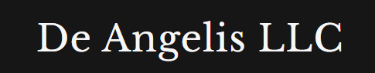
Weekly Market Report

02/05/2026

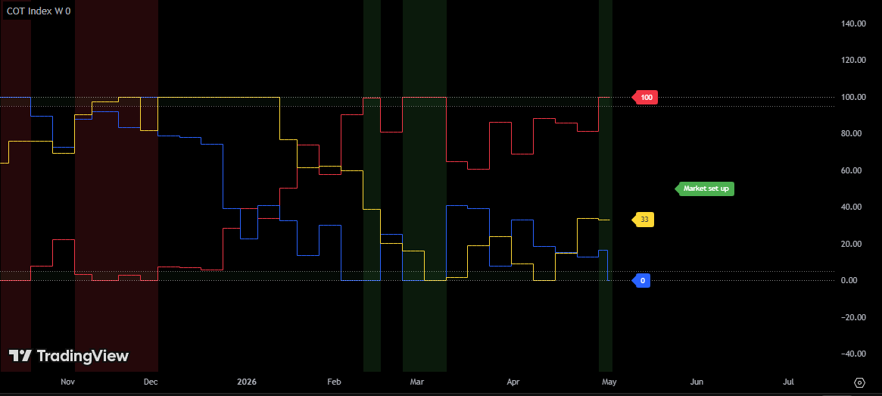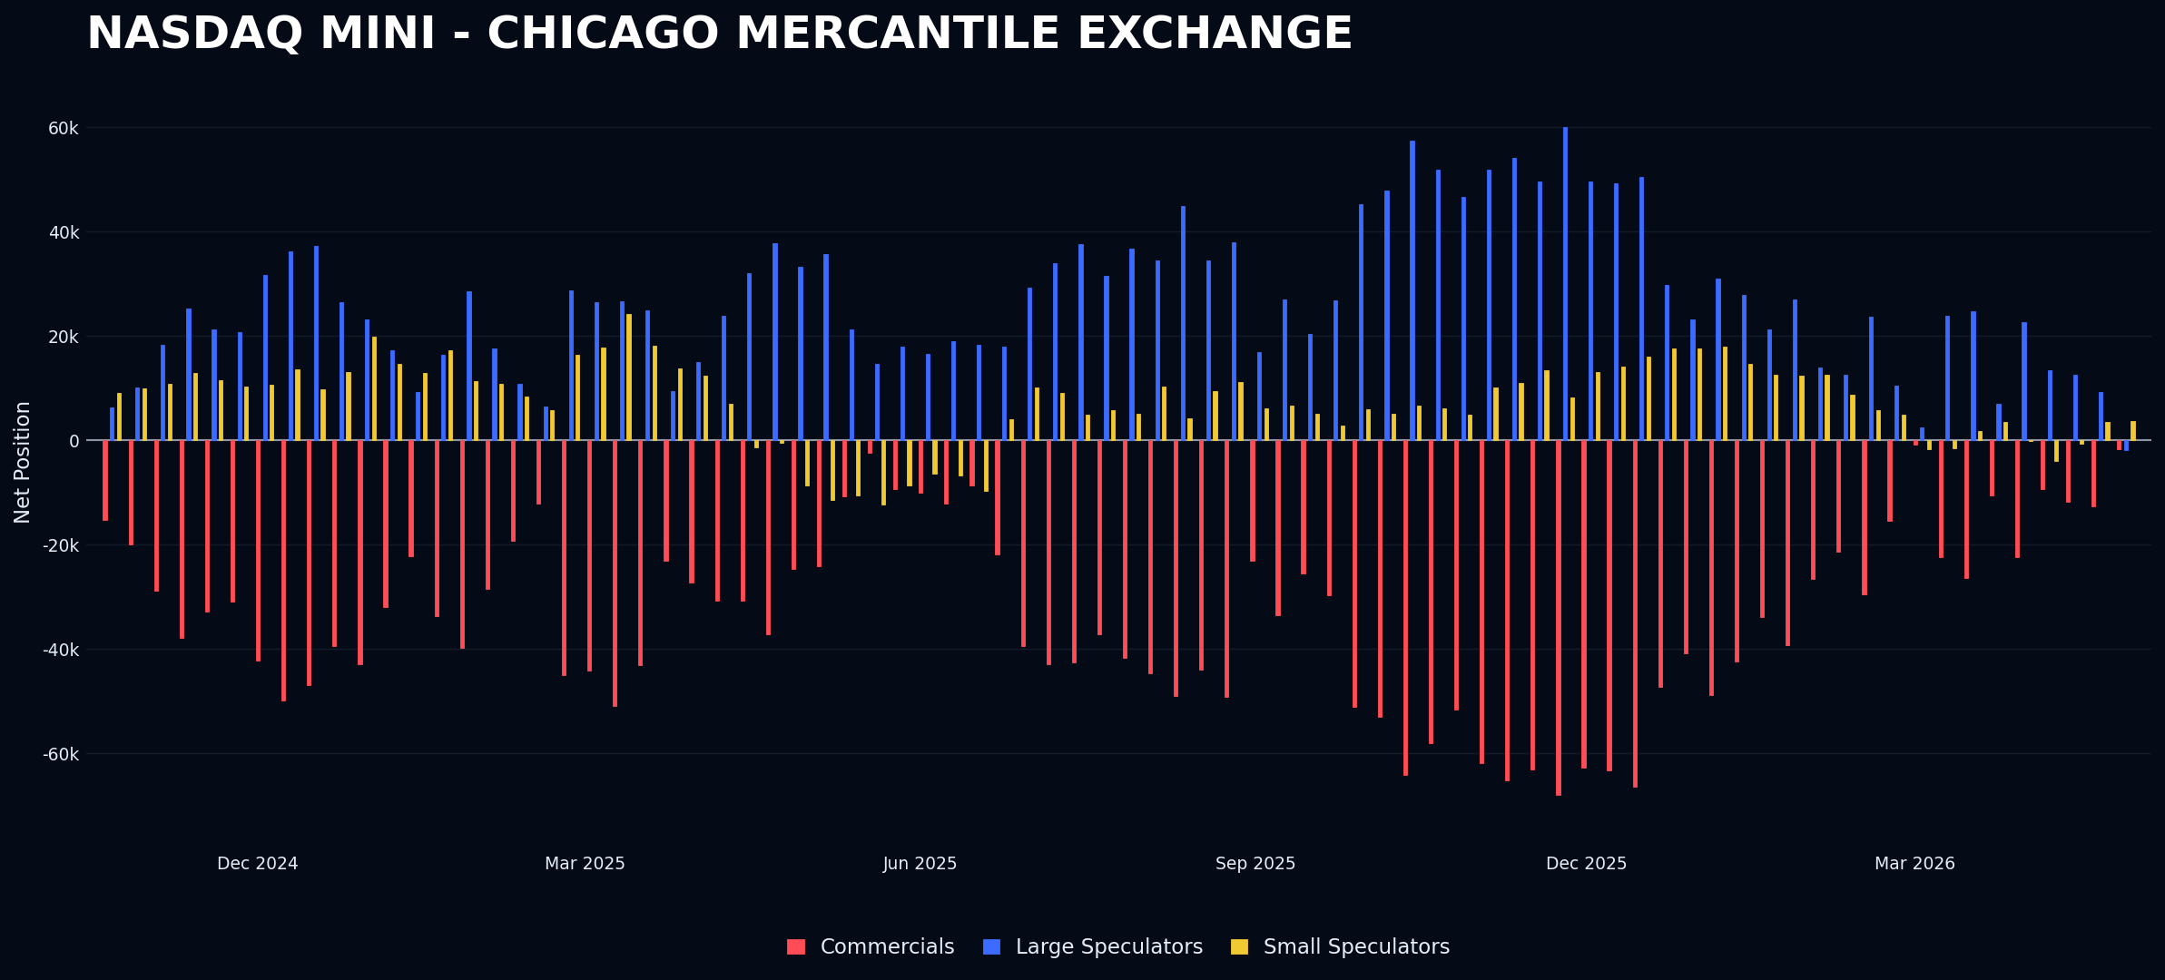
Nasdaq is set up as a buy, with commercials at 100. An interesting news trigger for entry could be on Tuesday, May 5th, based on the ISM manufacturing index data (https://tradingeconomics.com/united-states/non-manufacturing-pmi). I need to see negative news with prices closing higher at the end of the day.
Execution should occur only at the end of the day, aligning with the process, and only if the news is very clear.
Alternatively, we can wait for Friday’s NFP report (https://tradingeconomics.com/united-states/non-farm-payrolls). The preferred option is the news that causes the largest intraday initial move, typically NFP, which usually triggers the biggest market reaction hence the best news failure available.

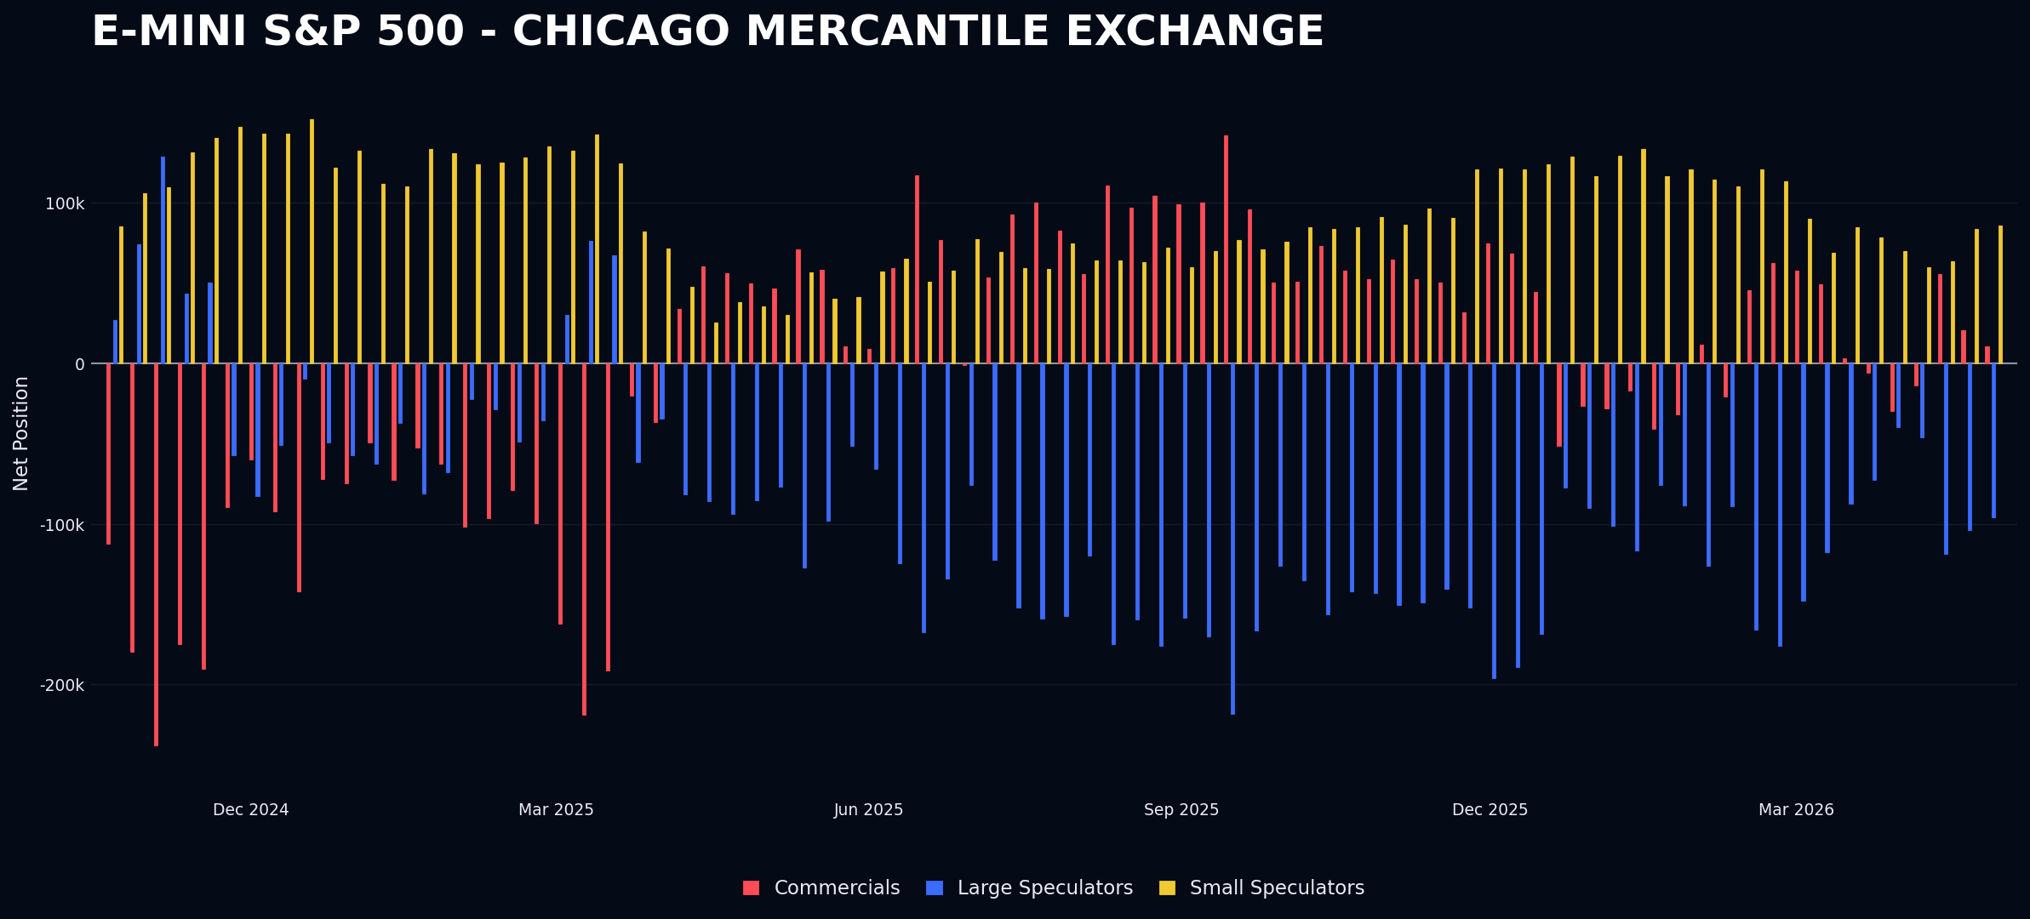
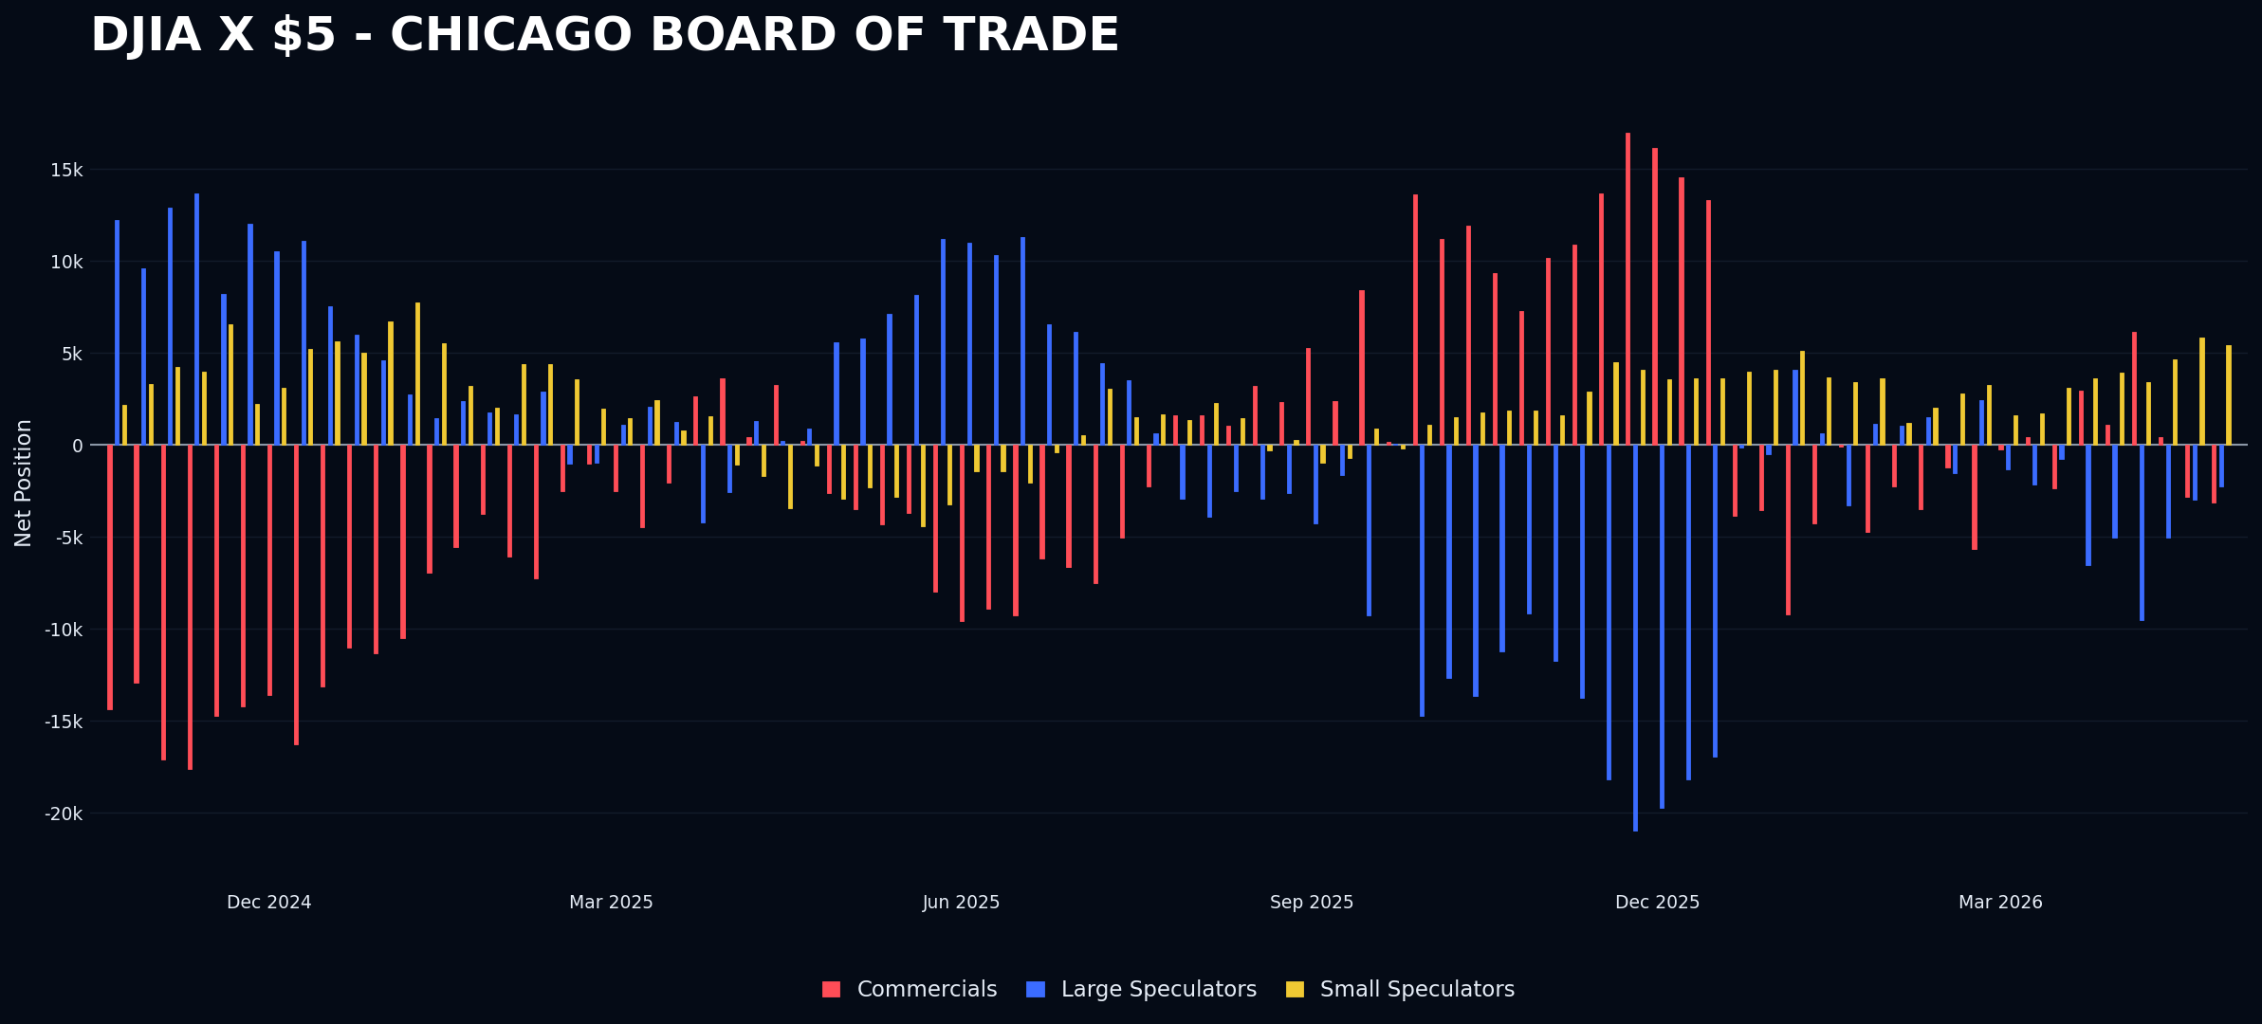
Nothing interesting here; all equities are trading at or near all-time highs. The DJIA appears to be the weakest asset, coincidentally, with small speculators holding the longest positions relative to other equity indexes. I believe the current system could be useful for long-term portfolio construction, focusing solely on the net relative positioning of assets within the same class. This approach might help in assessing asset strength and potential shifts in market dynamics.

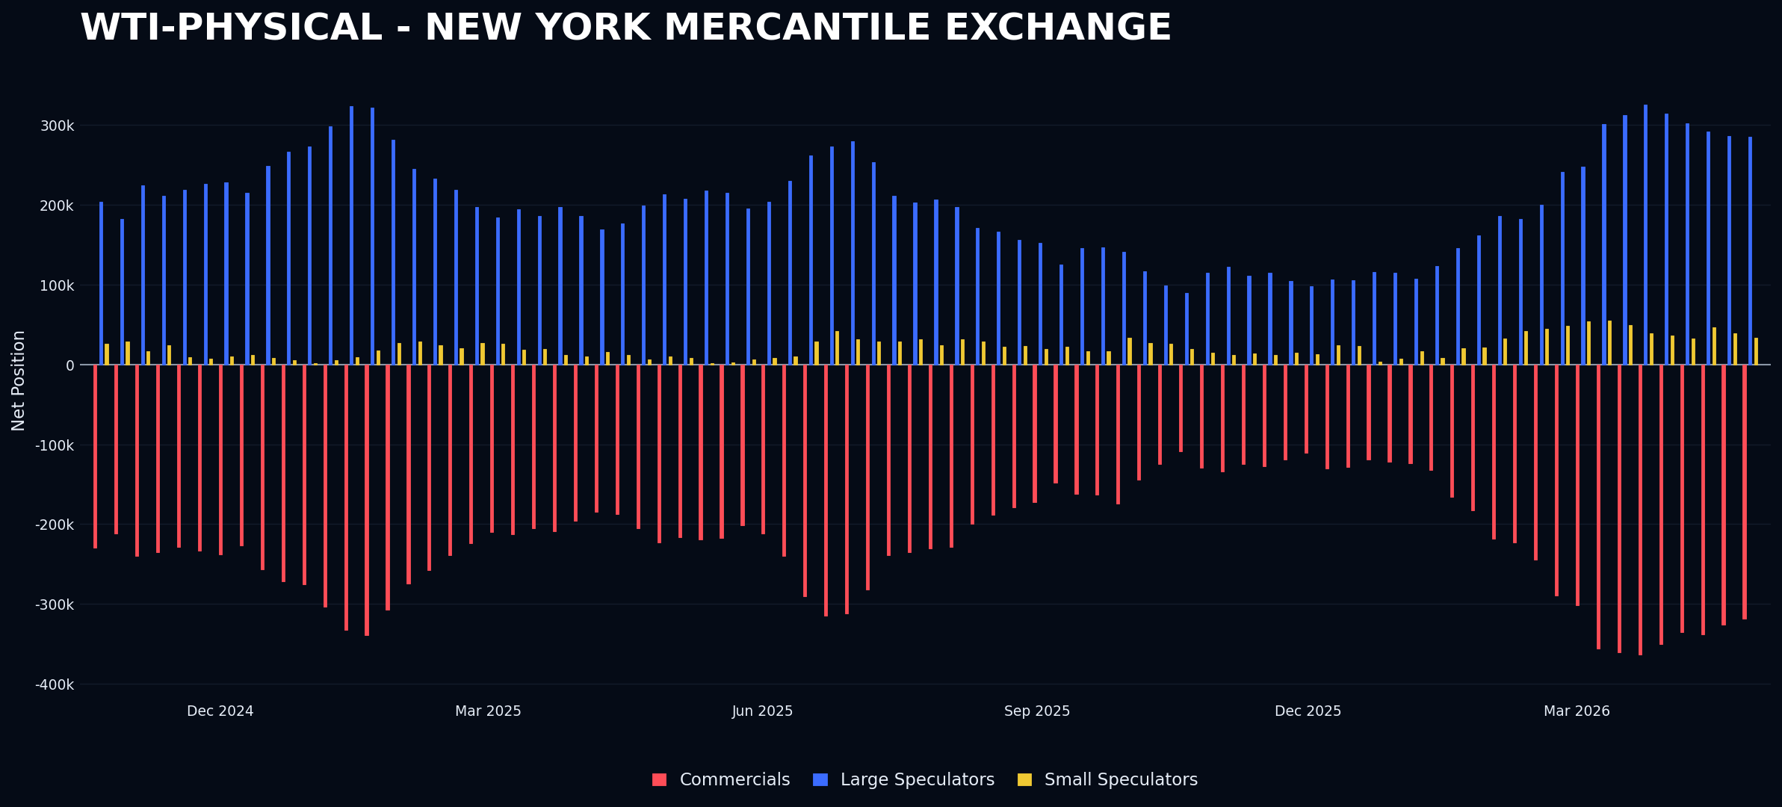
Crude oil is being sold for the past 5 weeks with oil prices just going higher and with higher vol
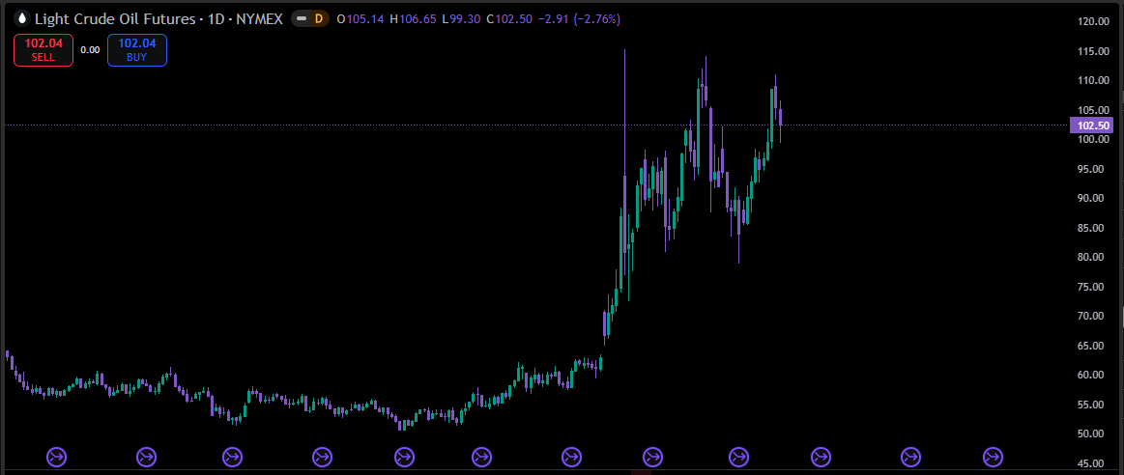
What do I anticipate? My analysis suggests a potential short-term pullback and a rotation out of risk and inflation assets into bonds and the dollar. This scenario aligns with a common pattern where high win percentages and low risk-reward ratios lead to short-term gains but expose investors to significant losses on rare bad trades. Recognizing this, we plan to remain fully in cash and adhere strictly to our investment strategy. Additionally, recent reports and the cover of The Economist, which states "oil prices have not risen enough," combined with the bullish stance of some of my market counterparts, indicate a possible imminent reversal in energy markets. I intend to revisit this analysis in the coming weeks, comparing market developments to my current outlook to refine my understanding.
This approach aims to balance short-term market signals with long-term strategic discipline, ensuring we stay aligned with our risk management principles while remaining adaptable to evolving market conditions.
Currencies are not showing any maximum crowded positioning. The Australian dollar remains the closest at this time. On Monday, interest rate reports will be released on AUD, which could trigger interesting reactions. Although the index is not fully set up, there might be considerations for opening a position if prices decline further.
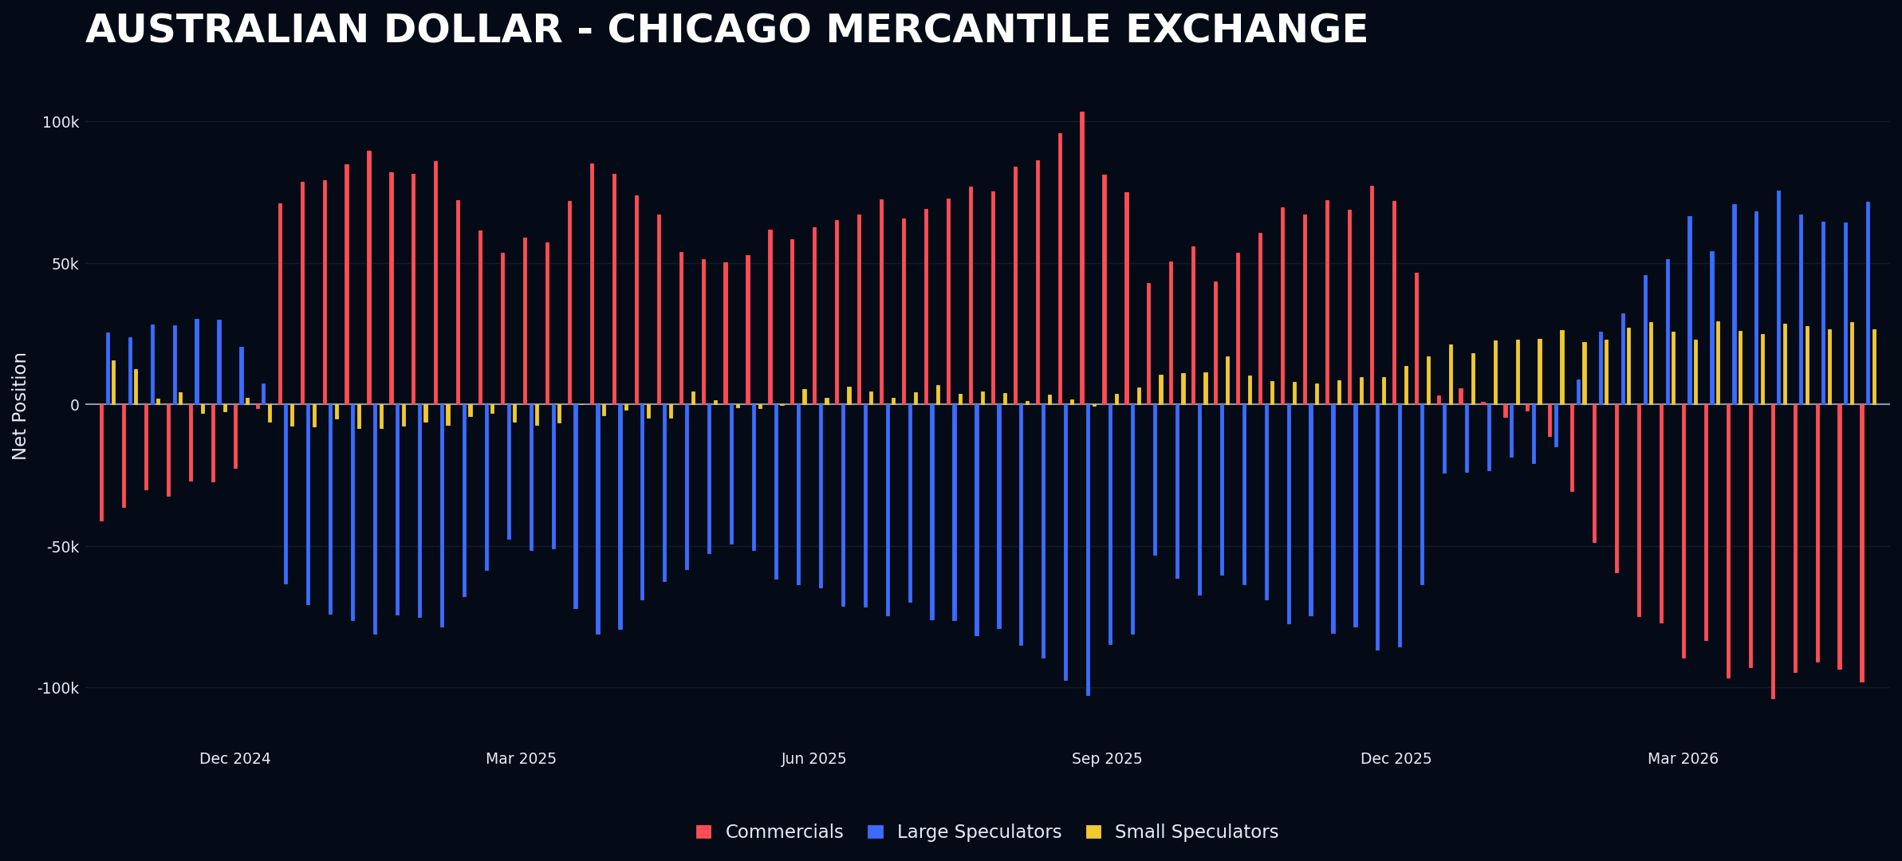
The most 2 interesting assets are Cotton set up as a short and Wheat set up as a short. There was also Soybean oil but small spec is just not there.
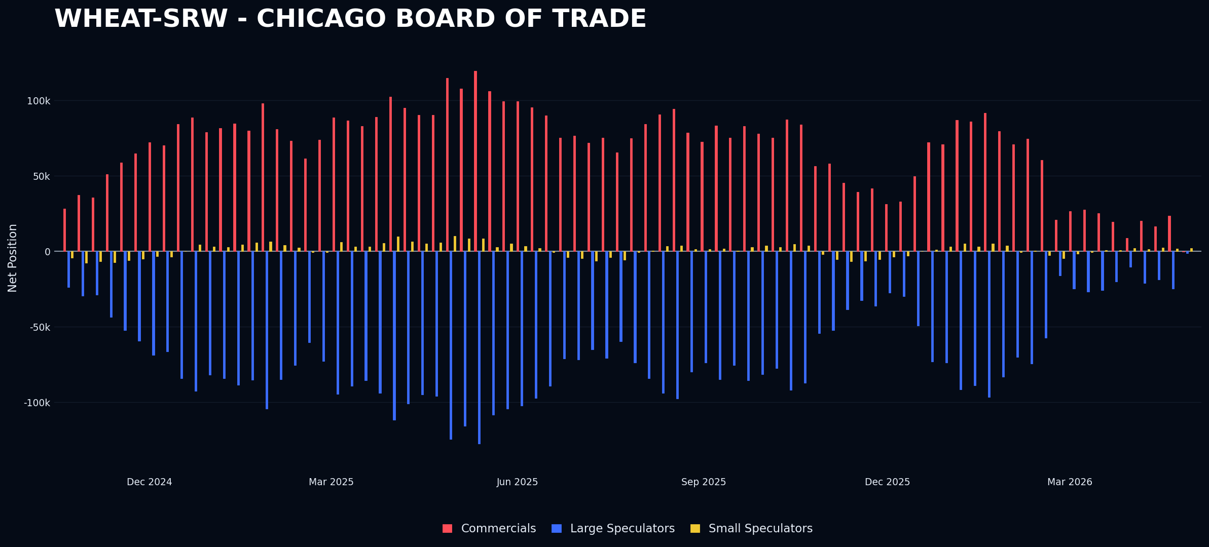
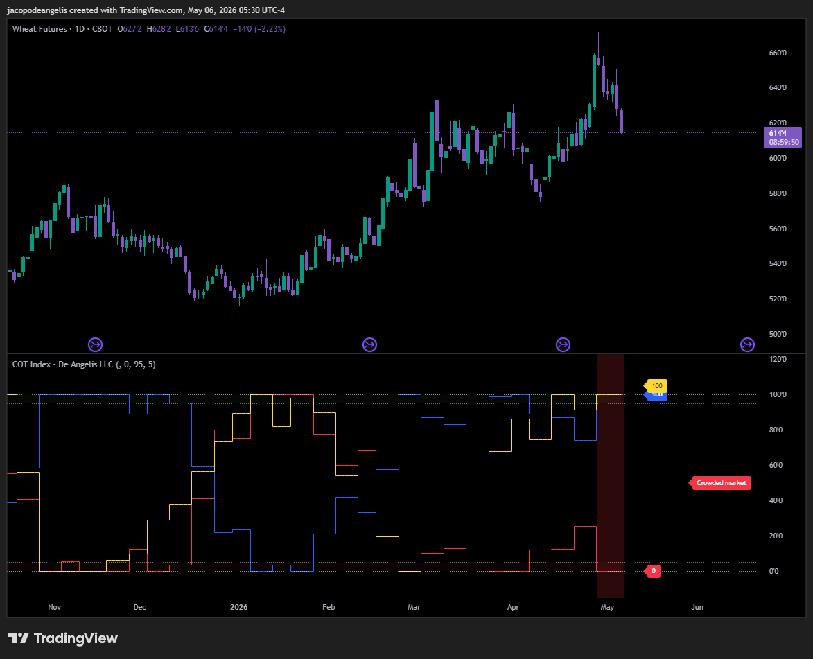
As of Tuesday, the market has already reversed, and there is a risk of losing the current position. No significant news has been reported in the grains sector recently. The most important upcoming information will be the WASDE report scheduled for May 12. For more details, visit this link.
Based on my previous experience with quick entries in grains and soft commodities, I plan to wait until the market stabilizes and the WASDE report is released, even if this means potentially missing a profitable trade.
My past struggles in 2025, when I entered trades solely based on technical analysis, resulted in significant losses, especially in Soybean Meal. Similarly, as we are seeing this year, trades based on correlation failures rarely succeeded. My most successful trades were driven by clear economic data reports that caused substantial intraday price movements, often reversing afterward, indicating a news failure event. Events requiring interpretation or analysis rarely proved profitable. Therefore, I focus on straightforward news-driven trades, avoiding ambiguous situations that demand interpretation.
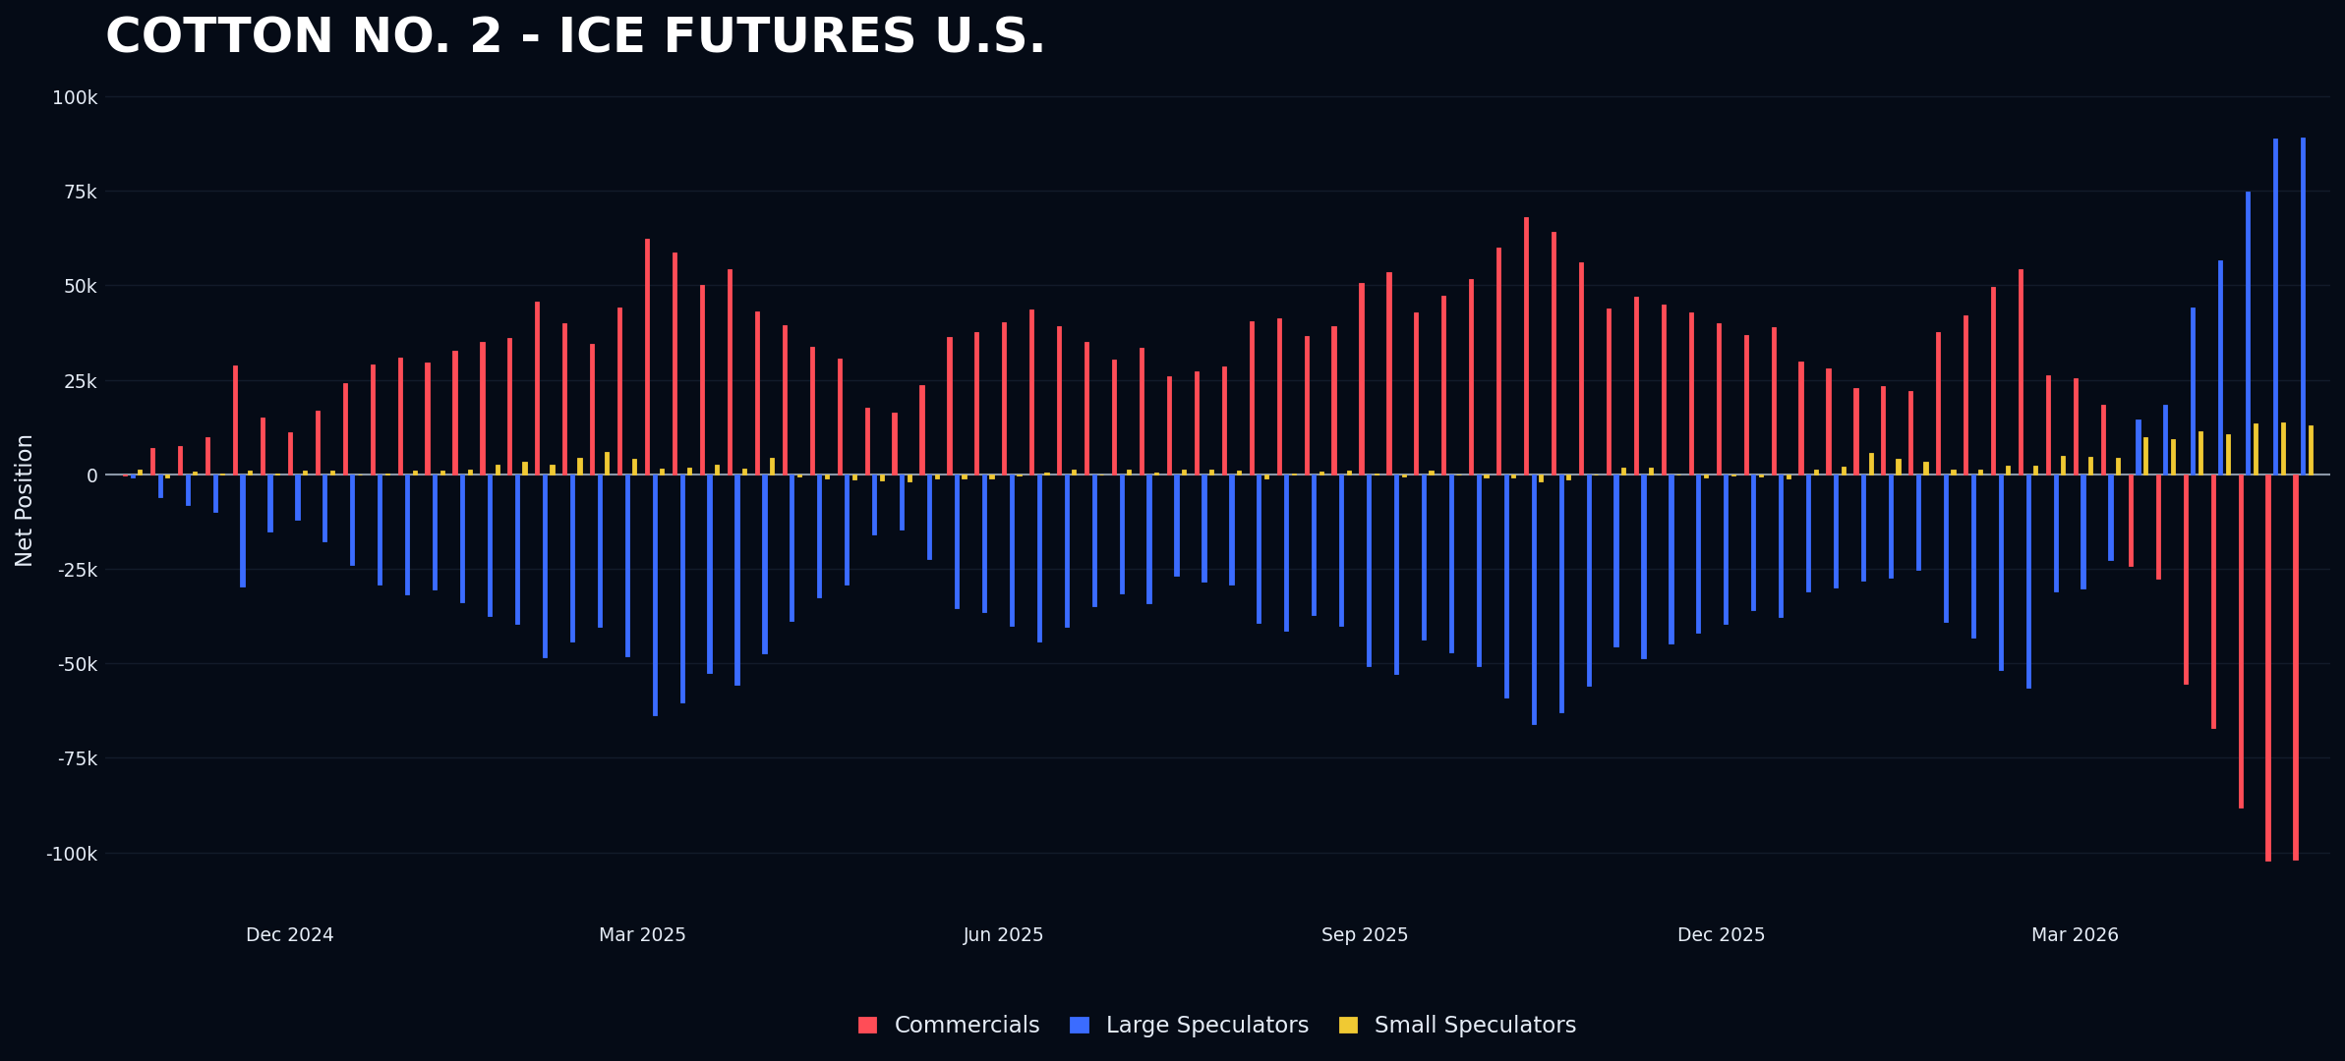
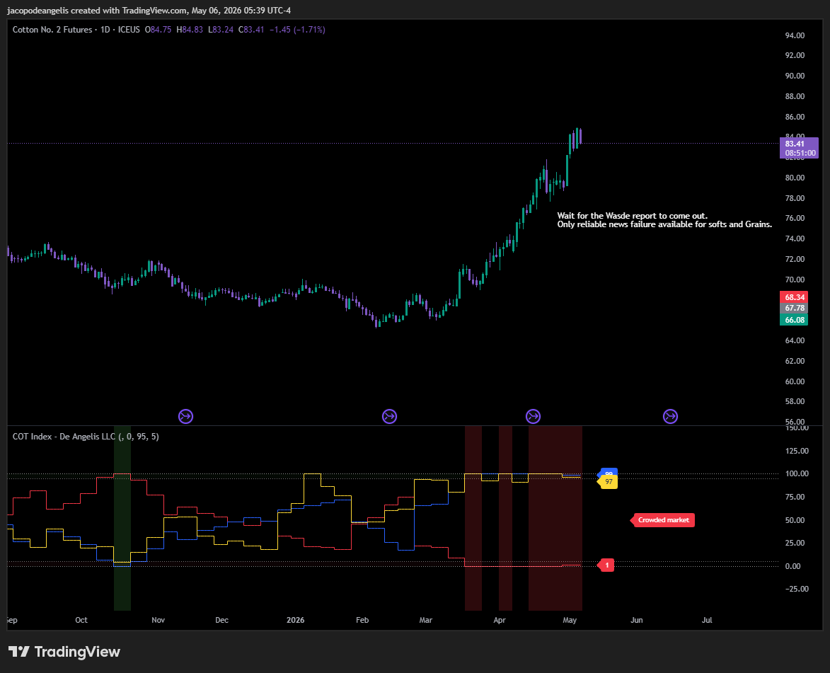
Cotton remains on a strong upward trend with no signs of weakening at this time. For this reason, entering a trade based solely on technical signals would be a poor decision, in my opinion. I prefer to wait for a news failure in the WASDE report. Given the volatility of these assets, I need to be actively pulled into the trade rather than forcing myself to make one. This is an important principle I paid at my own expenses in the past.
My final thoughts concern Silver and Gold, both considered inflation hedges. However, silver is more of a risk asset due to its correlation with equities. Currently, neither asset is set up in the market with our strategy. When assets are not aligned with my trading system, I find it difficult to make clear decisions. Despite their popularity and current debate, I will share my perspective: Gold was trading as a risk asset before the war, but since then, it has flattened out. This appears to be a classic "buy the rumor, sell the news" scenario. Based on my experience these scenarios do not lead to anything good since the “juice” Is already gone, they are lagging compared to equities and their momentum has now vanished, laggards are losers. Until I see a news failure, I prefer to wait before committing any amount of capital to any trade.
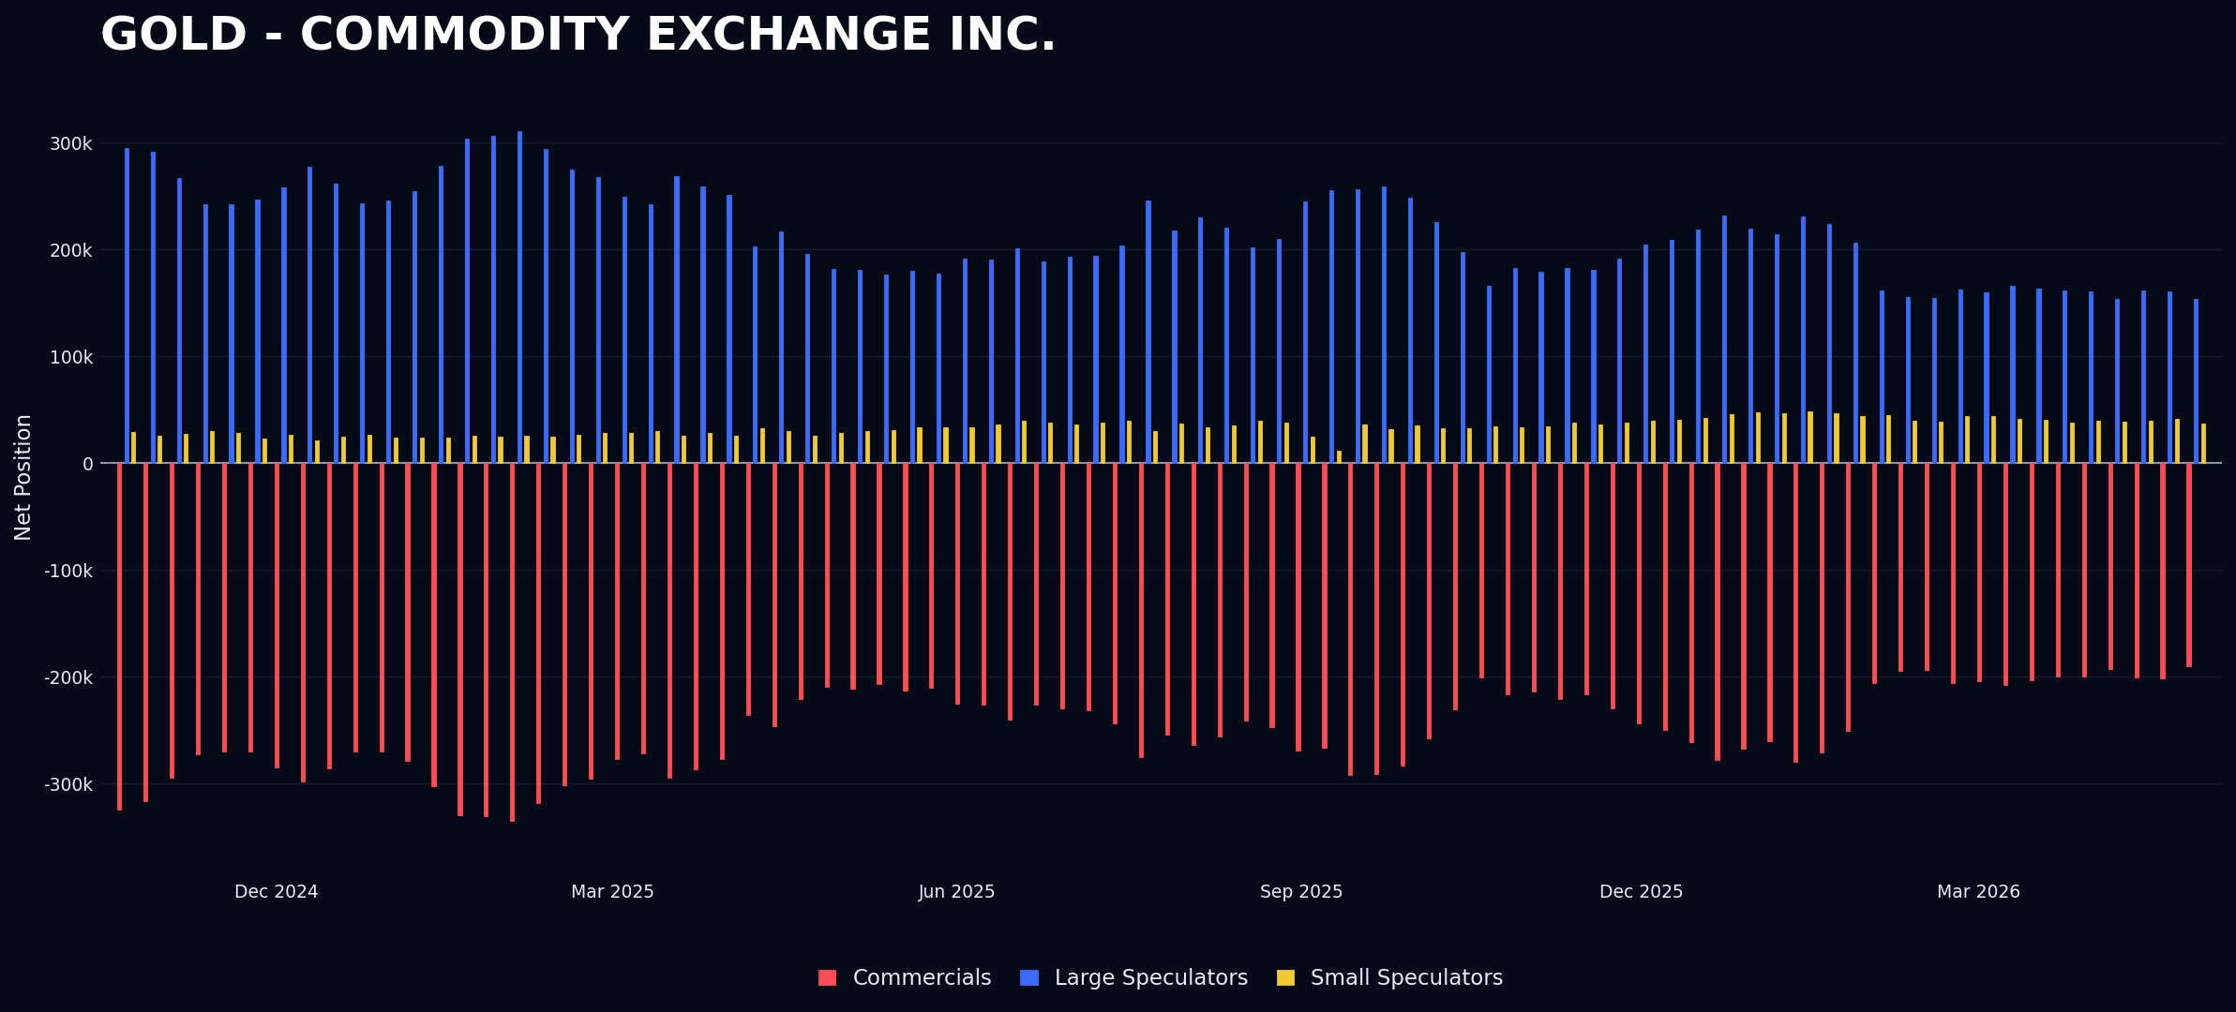
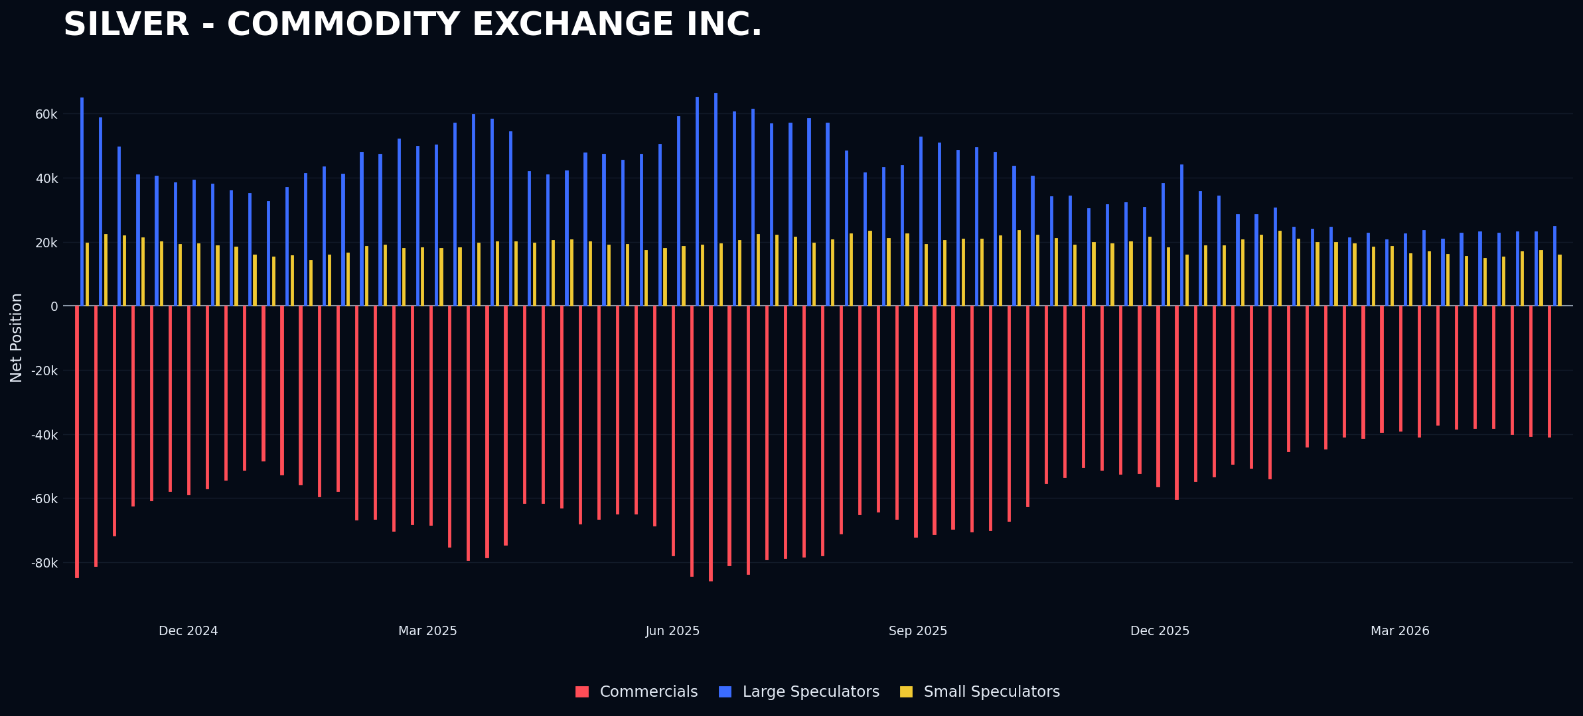

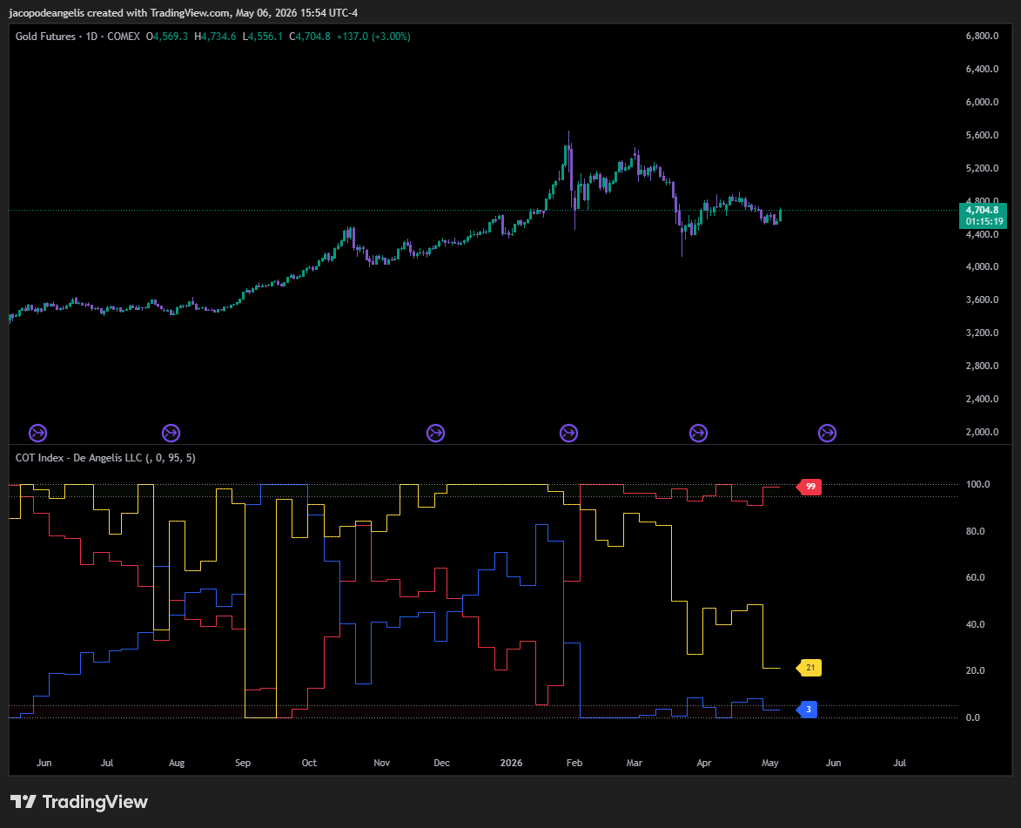
The Current situation
Over the past week, one of the most valuable learning opportunities I encountered was watching an interview with Paul Tudor Jones on YouTube: https://youtu.be/S31J5ACsOqU?si=6qGRbdYLdUhfpAwb.
To facilitate future reference, I have summarized the key lessons from this interview. Writing these points down helps me focus more attentively on such videos.
- Jones discusses his returns without specifying annual figures. Instead, he emphasizes that his returns are uncorrelated with the S&P 500, implying they are purely alpha. I appreciated this aspect because it aligns with my goal of building a fund with similar characteristics. This non-correlation is a crucial trait I aim to develop.
- Throughout the interview, Jones emphasizes that the goal is not to be right but to make money. The key takeaway is that in current market conditions, profitability outweighs having a correct market opinion. This means that traders should not base their decisions on personal market forecasts but on a disciplined process. This approach distinguishes a skilled professional fund manager from an amateur, highlighting the importance of process over opinion.
- The third and most important point I think is when he talks about his goal of his fund. Which is to make the highest amount of money possible so he can give them all away. That is what I think the most powerful of the statements he could give and it’s so aligned to what I want to do in my future.

Next Week Markets
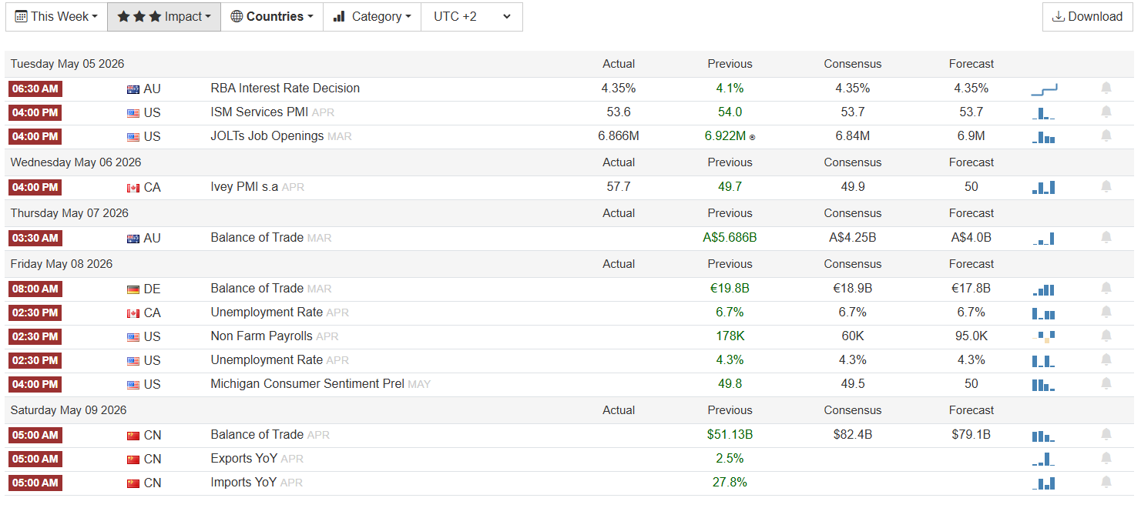
Official Setups
Long Nasdaq, Short Wheat, Short Cotton. The presence of AUD as a close setup could be a potential short opportunity on Friday, following the NFP report, or on Tuesday, during the RBA interest rate decisions.
Nasdaq
I will wait until Friday to release the jobs report; there is no rush to execute this trade since the market is currently surging. Based on past observations, long setups when the market reaches all-time highs tend to be weak, similar to short setups when prices are low. These setups rarely succeed, and even when they do, they often fail over time because prices frequently experience technical pullbacks that stop traders out of their positions.
Wheat & Cotton
No interest until the WASDE report is released.
6A
This could be the most interesting setup since it has a correlation with risk assets. It’s crowded long and could benefit as a short position if there is a market pullback. Observing its movements, it has stopped rising as strongly as before. However, it remains in an uptrend. I will look for signs of a hawkish RBA statement, with price reactions closing to the downside on the day, or for the Friday jobs report to influence the market.
Jacopo De Angelis

