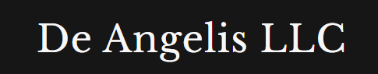
Weekly Market Report

6th June 2026
Content

Equities 3
Energies 3
Metals 3
Fixed Income 3
Crypto 3
Currencies 3
Softs 3
Livestock 3
Grains 3
Combining | Positioning, Sentiment, Price Action… 3
Next week Calendar | What I expect? 3
Current set ups and how I want to execute them? 3
Open trades 3
Closed trades 3

Equities
I am not impressed anymore in seeing equities being shorted even further with market advancing for the whole week until Friday dump (which I believe it was when people that were shorting capitulated)
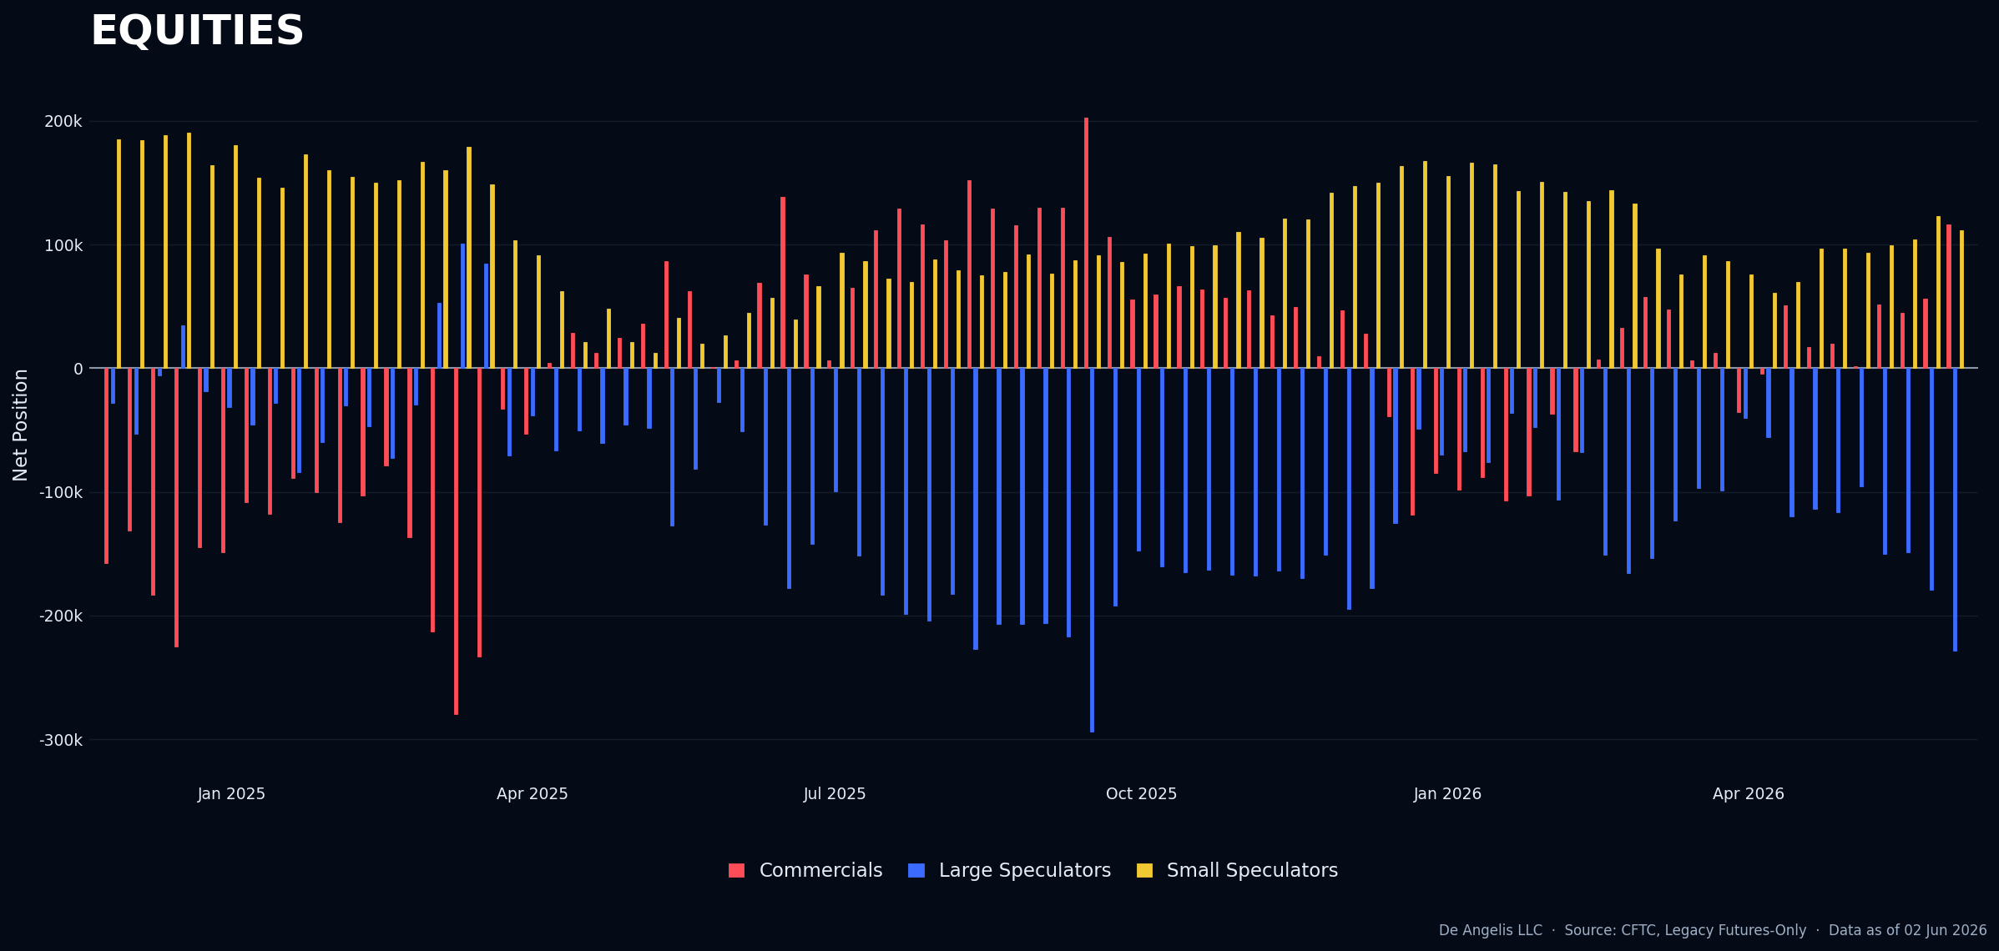
Nasdaq remains the most hated index in the group.
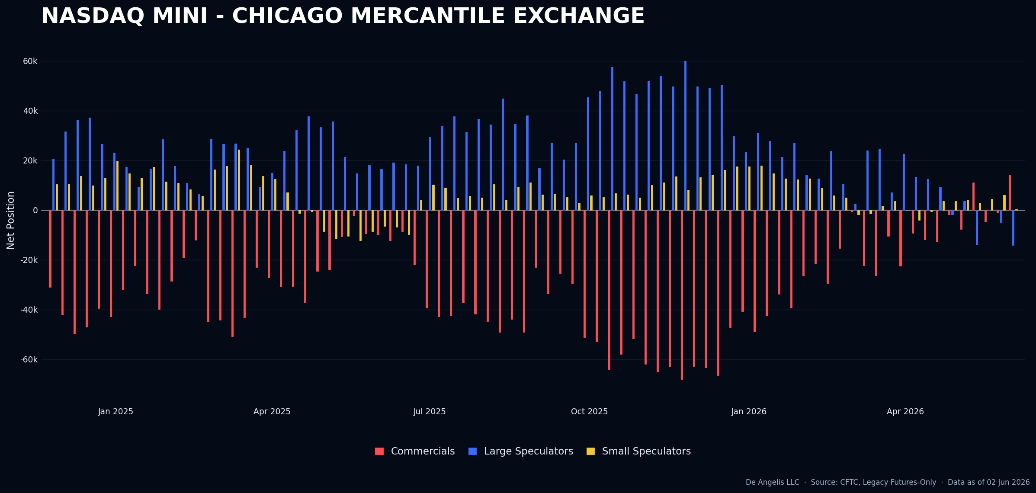

Same for S&P500, large spec increasing their net short exposure with small spec unchanged, process only to climb until the end of the week. Same story of Nasdaq.
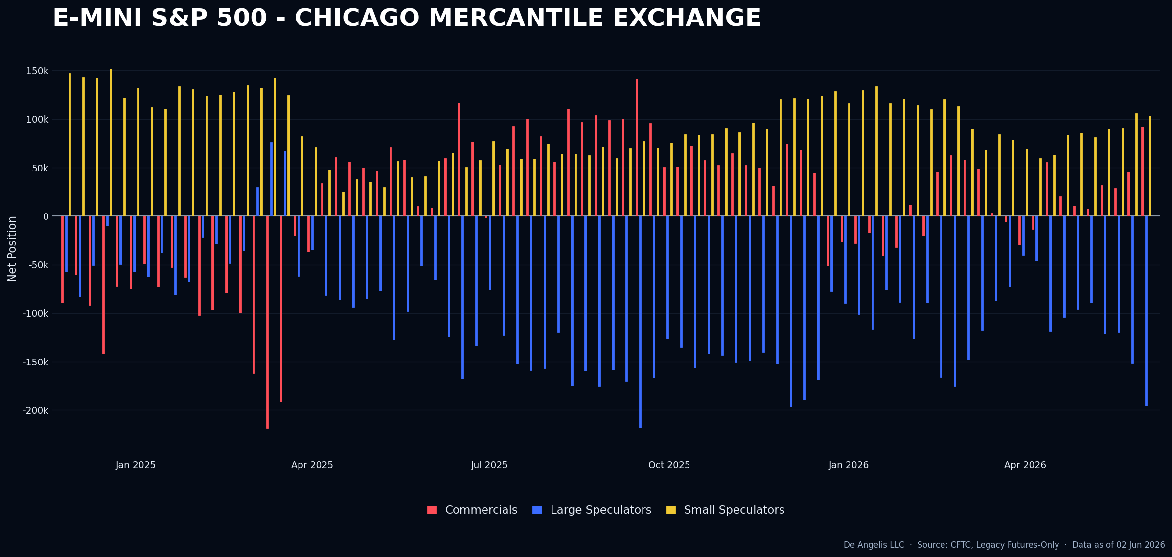
Dow exhibits the most “rational” behavior of all, with the best performances compared to the other indexes.
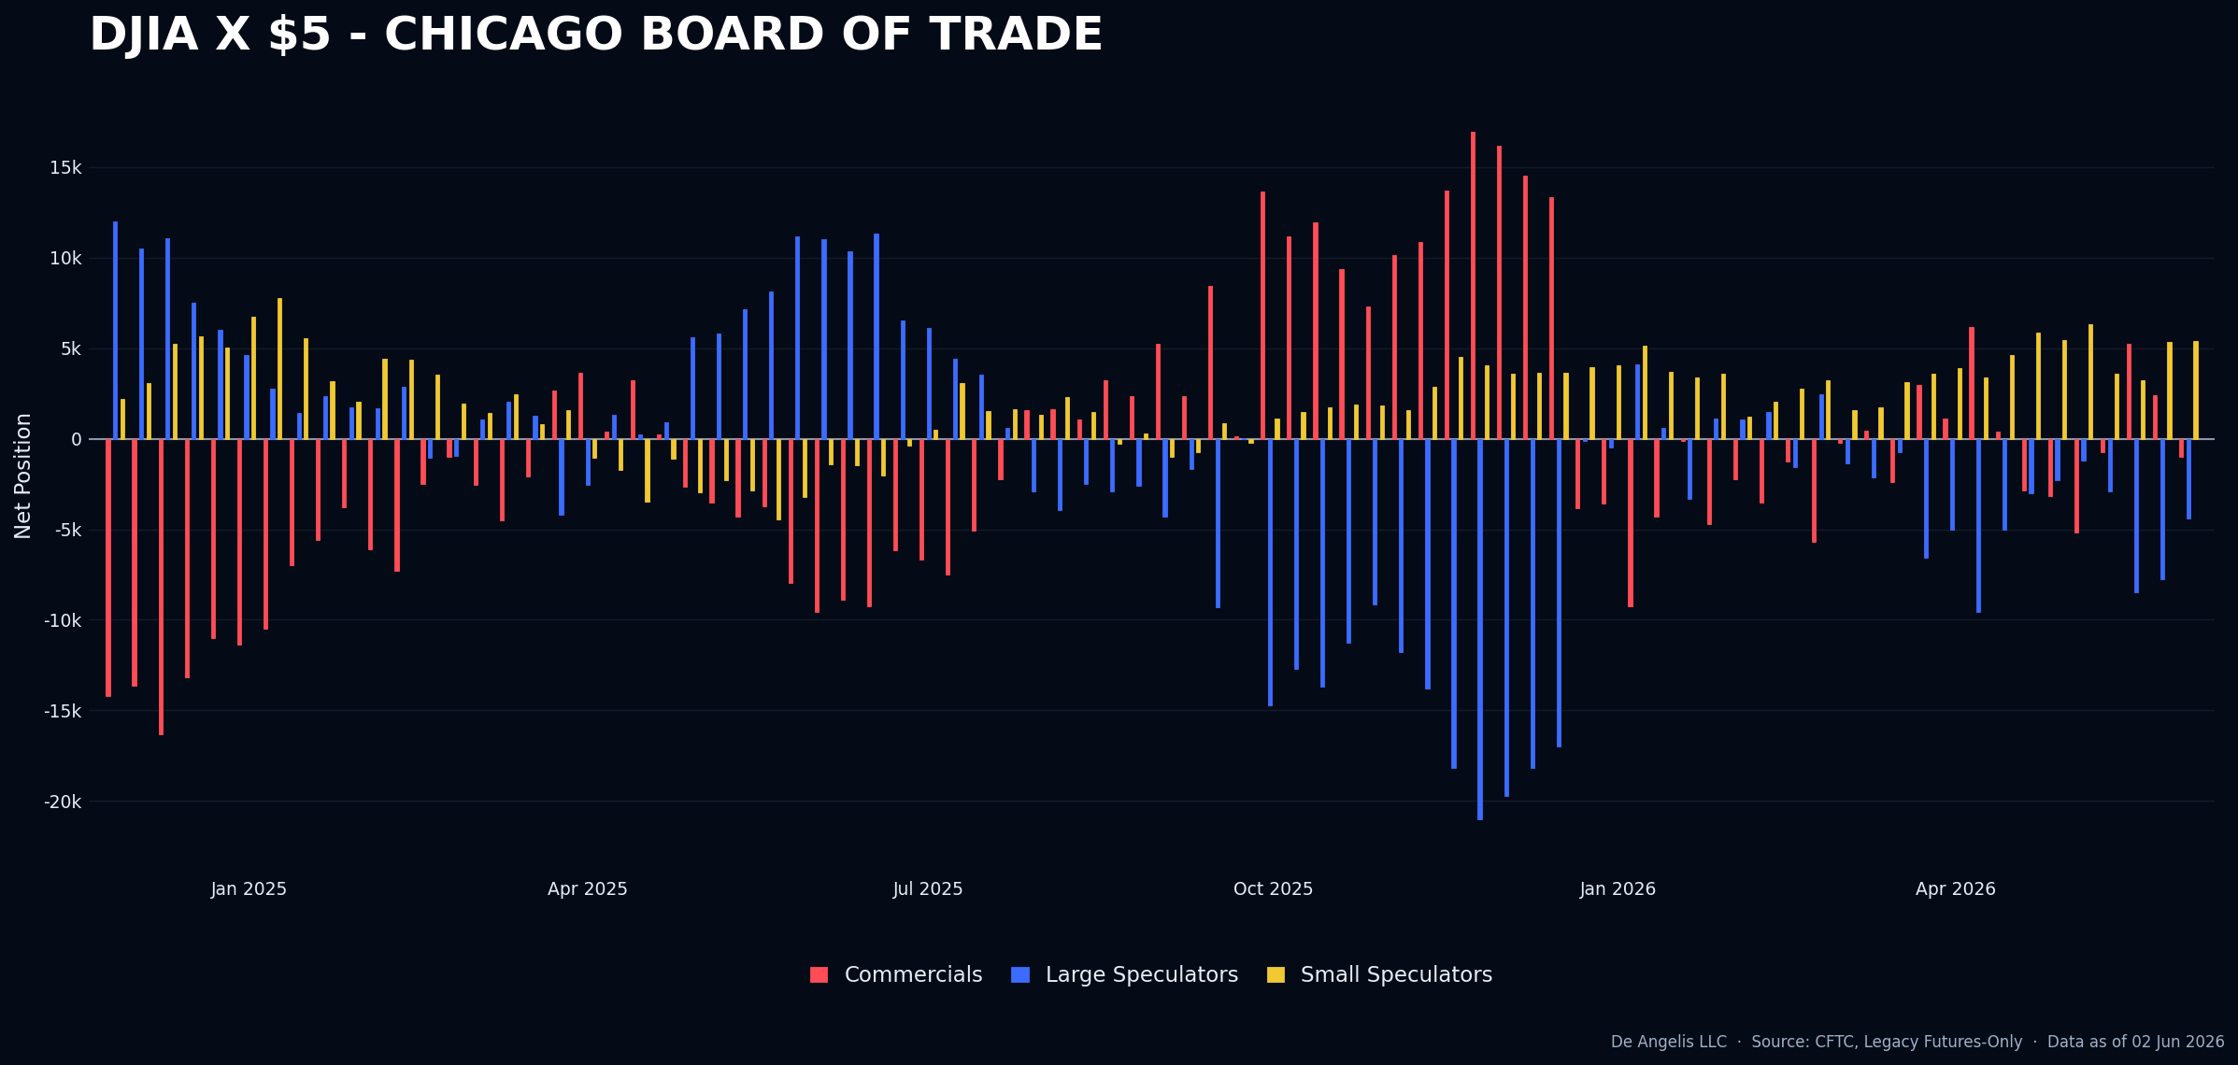
Russell world of nothingness, won’t even show it.

Energies
Natural Gas from last week, it was about to become a long set up but positioning came off this week and it’s not there anymore.
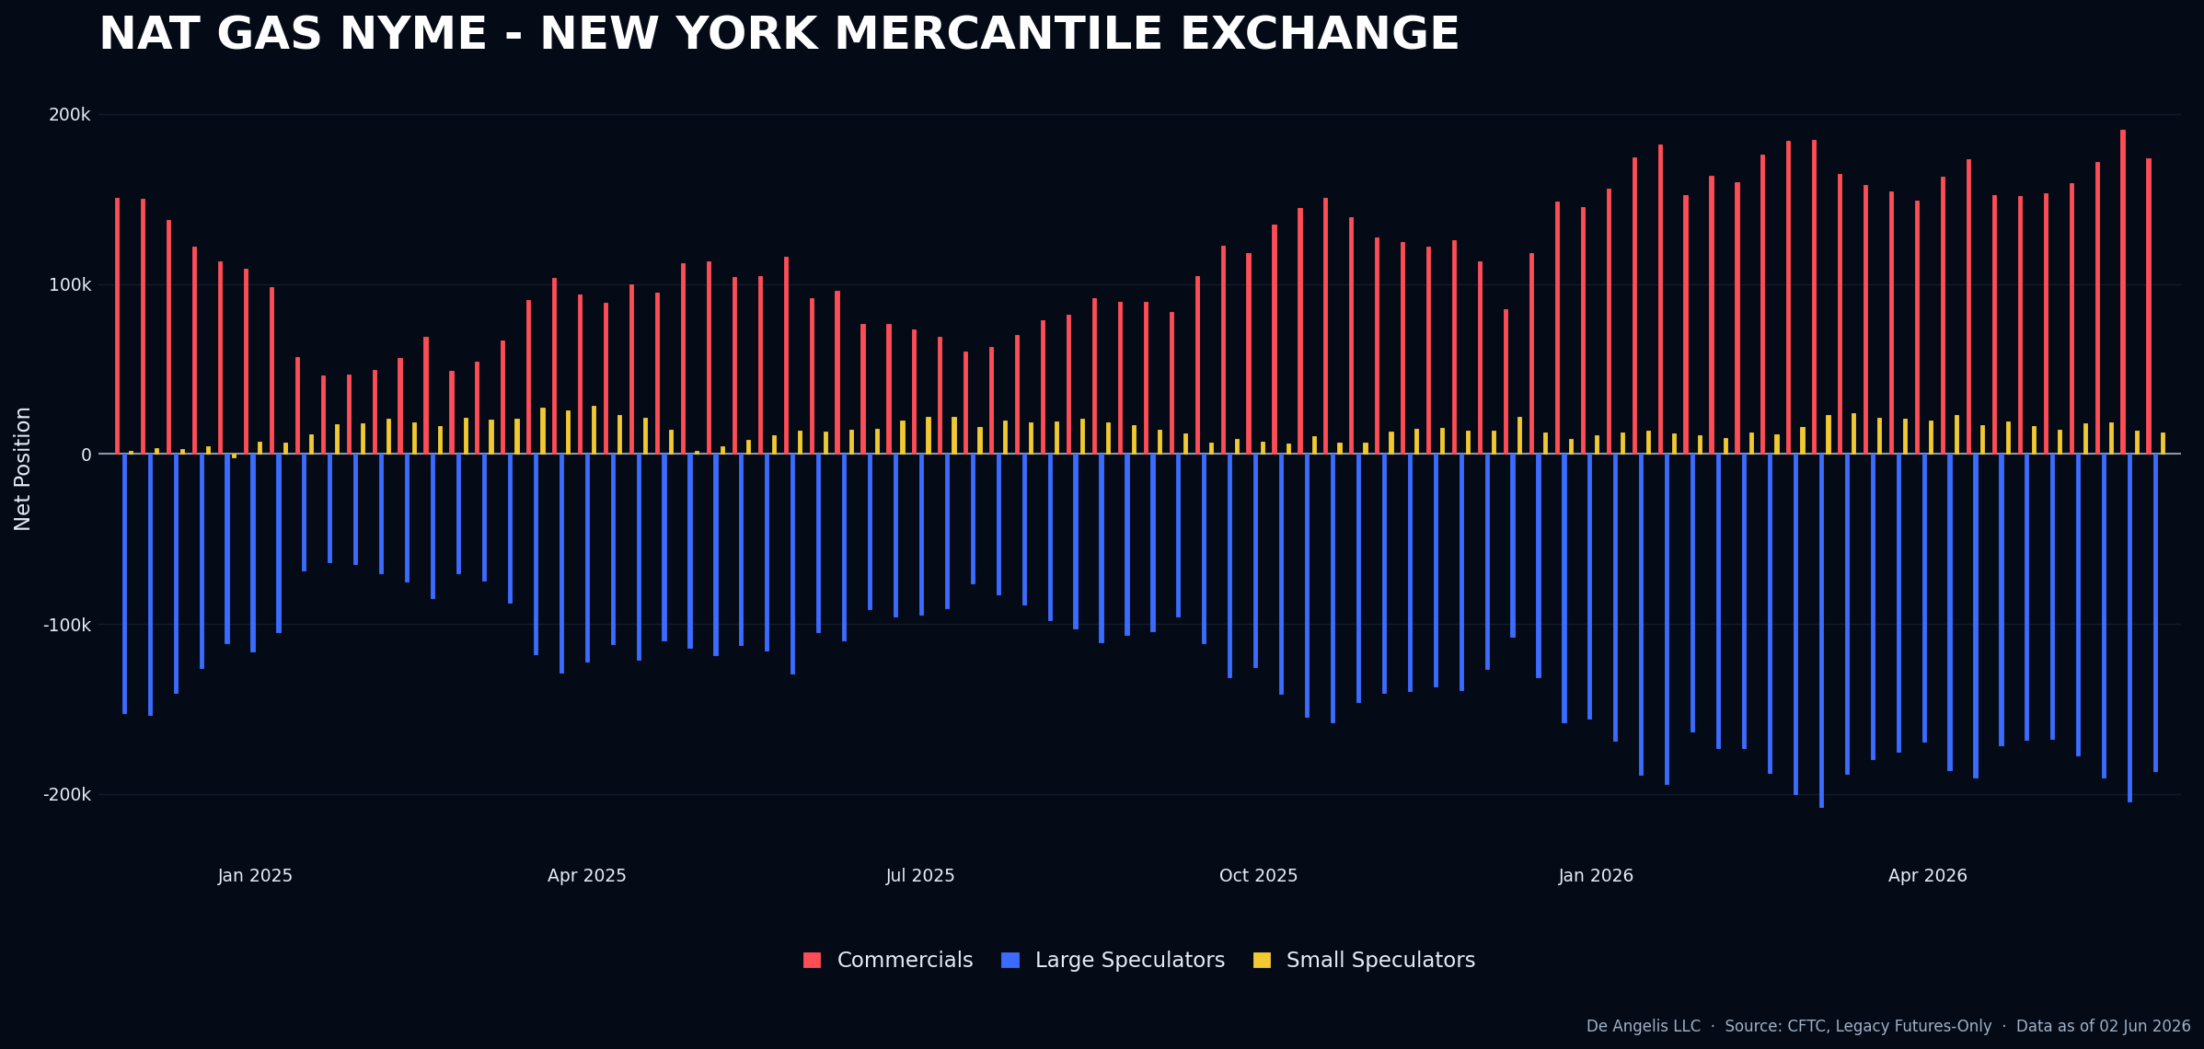
Crude oil same story; Again, I see no edge on any side in trading Oil at this time. Market going sideways since March with people going crazy trying to predict where it’s going to go based on Macro bets. Not my game.
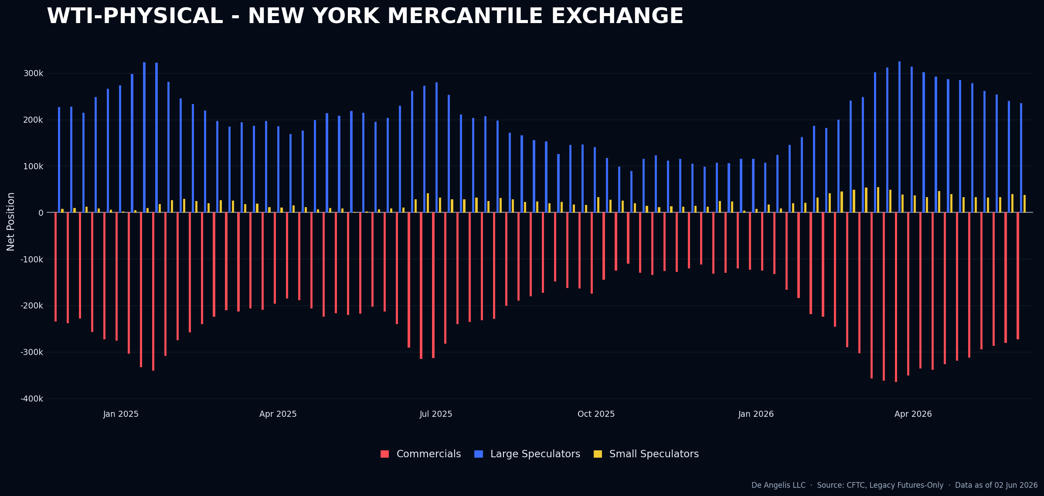

Metals
Gold Long set up came off a lot and it’s now out of my watchlist. The Correlation Failure of the 29th of May would have been stopped out on yesterday price action hitting the Low and not coming back on the close.
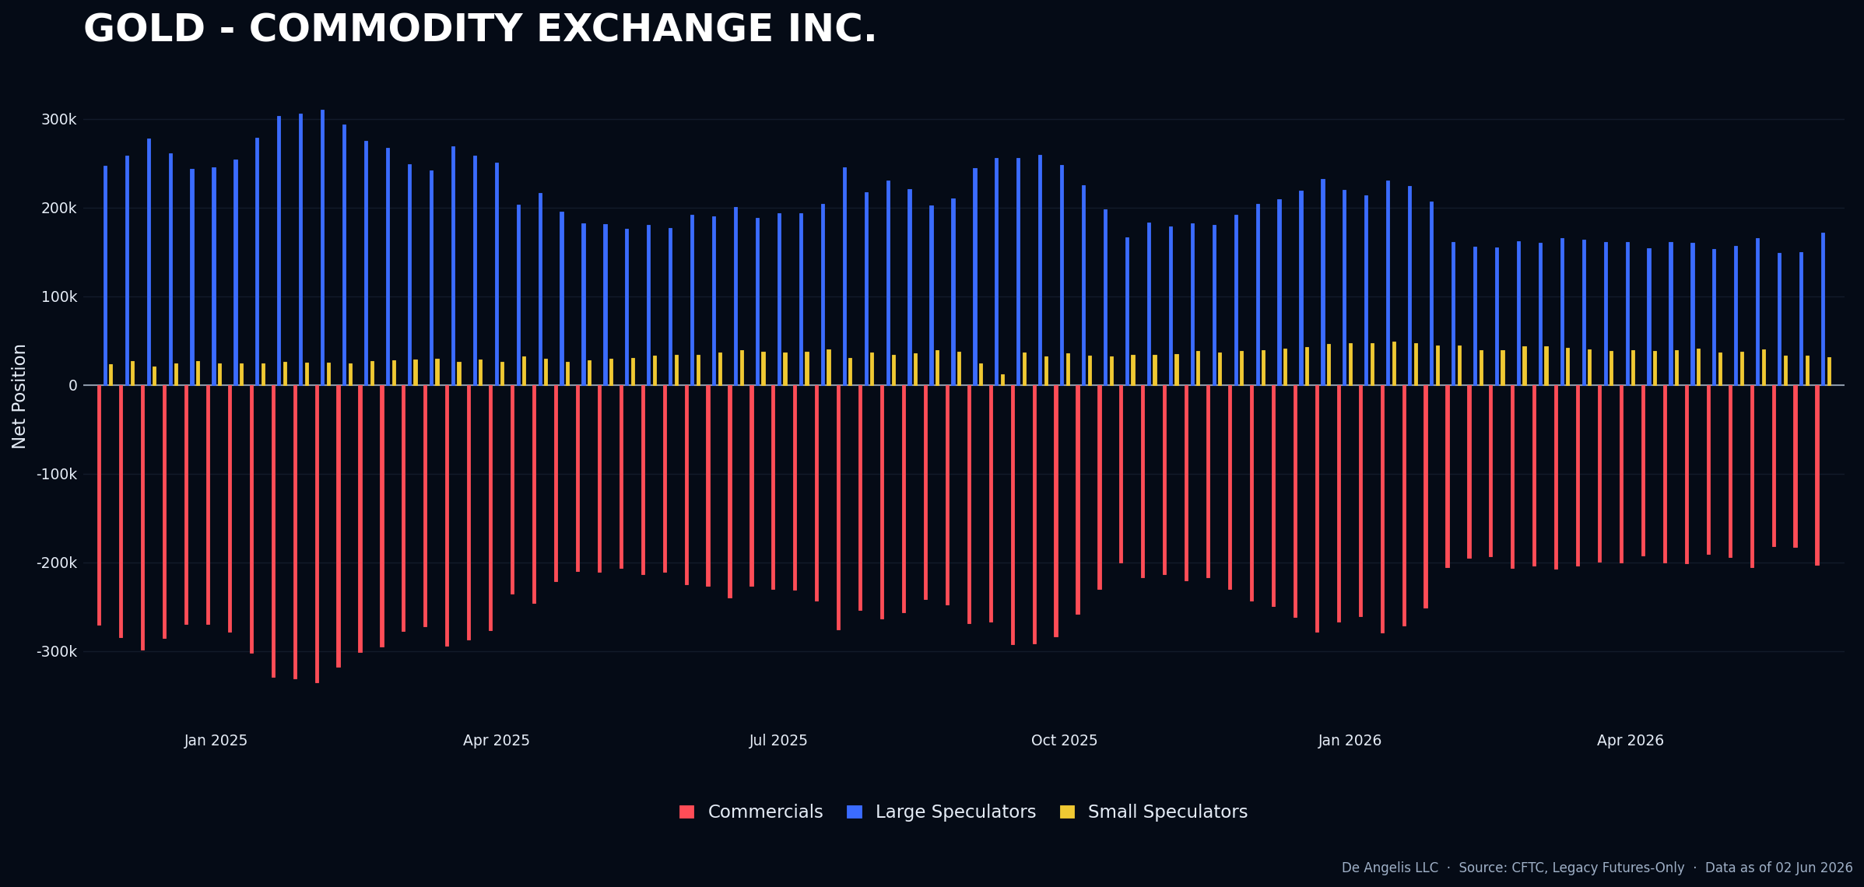
Not interesting anymore. I was trying to look if something could happen with Non-Farm Payrolls this week but we only went down. I will explain this further in the next section.
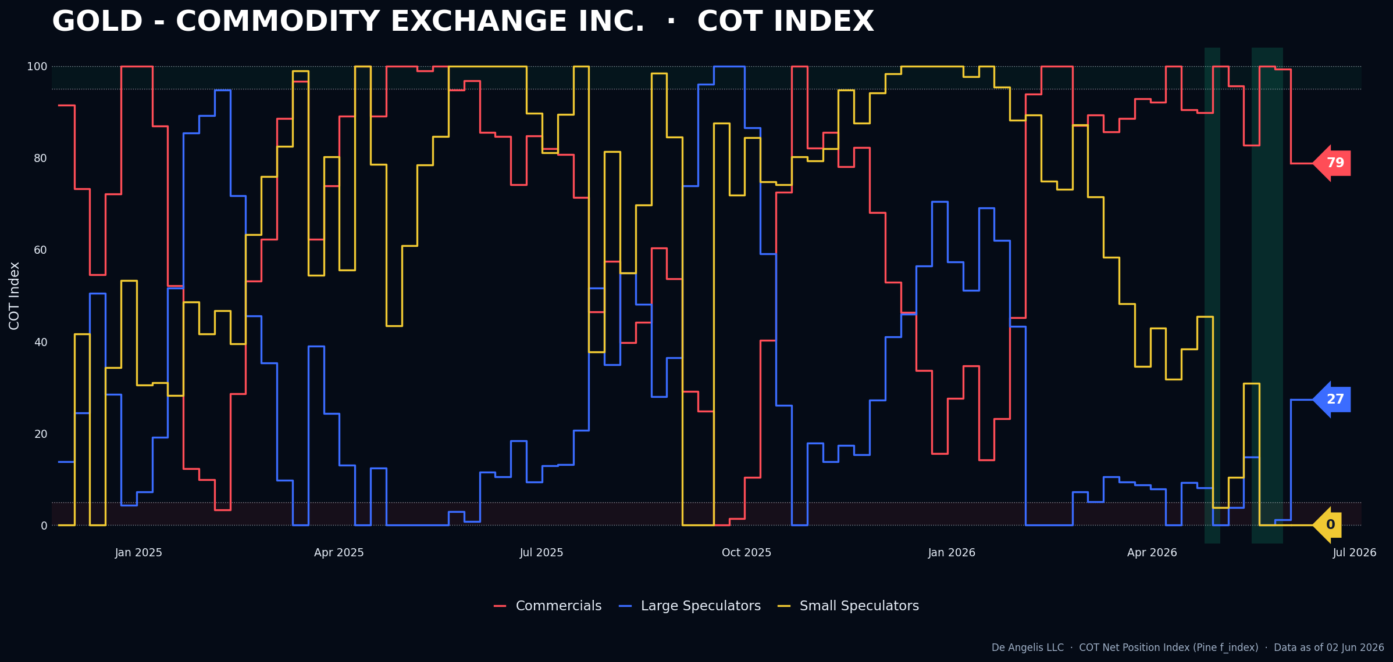

Copper remains the most interesting consensus short out there in my opinion. Positioning is now very long and the views are one sided to the long side.
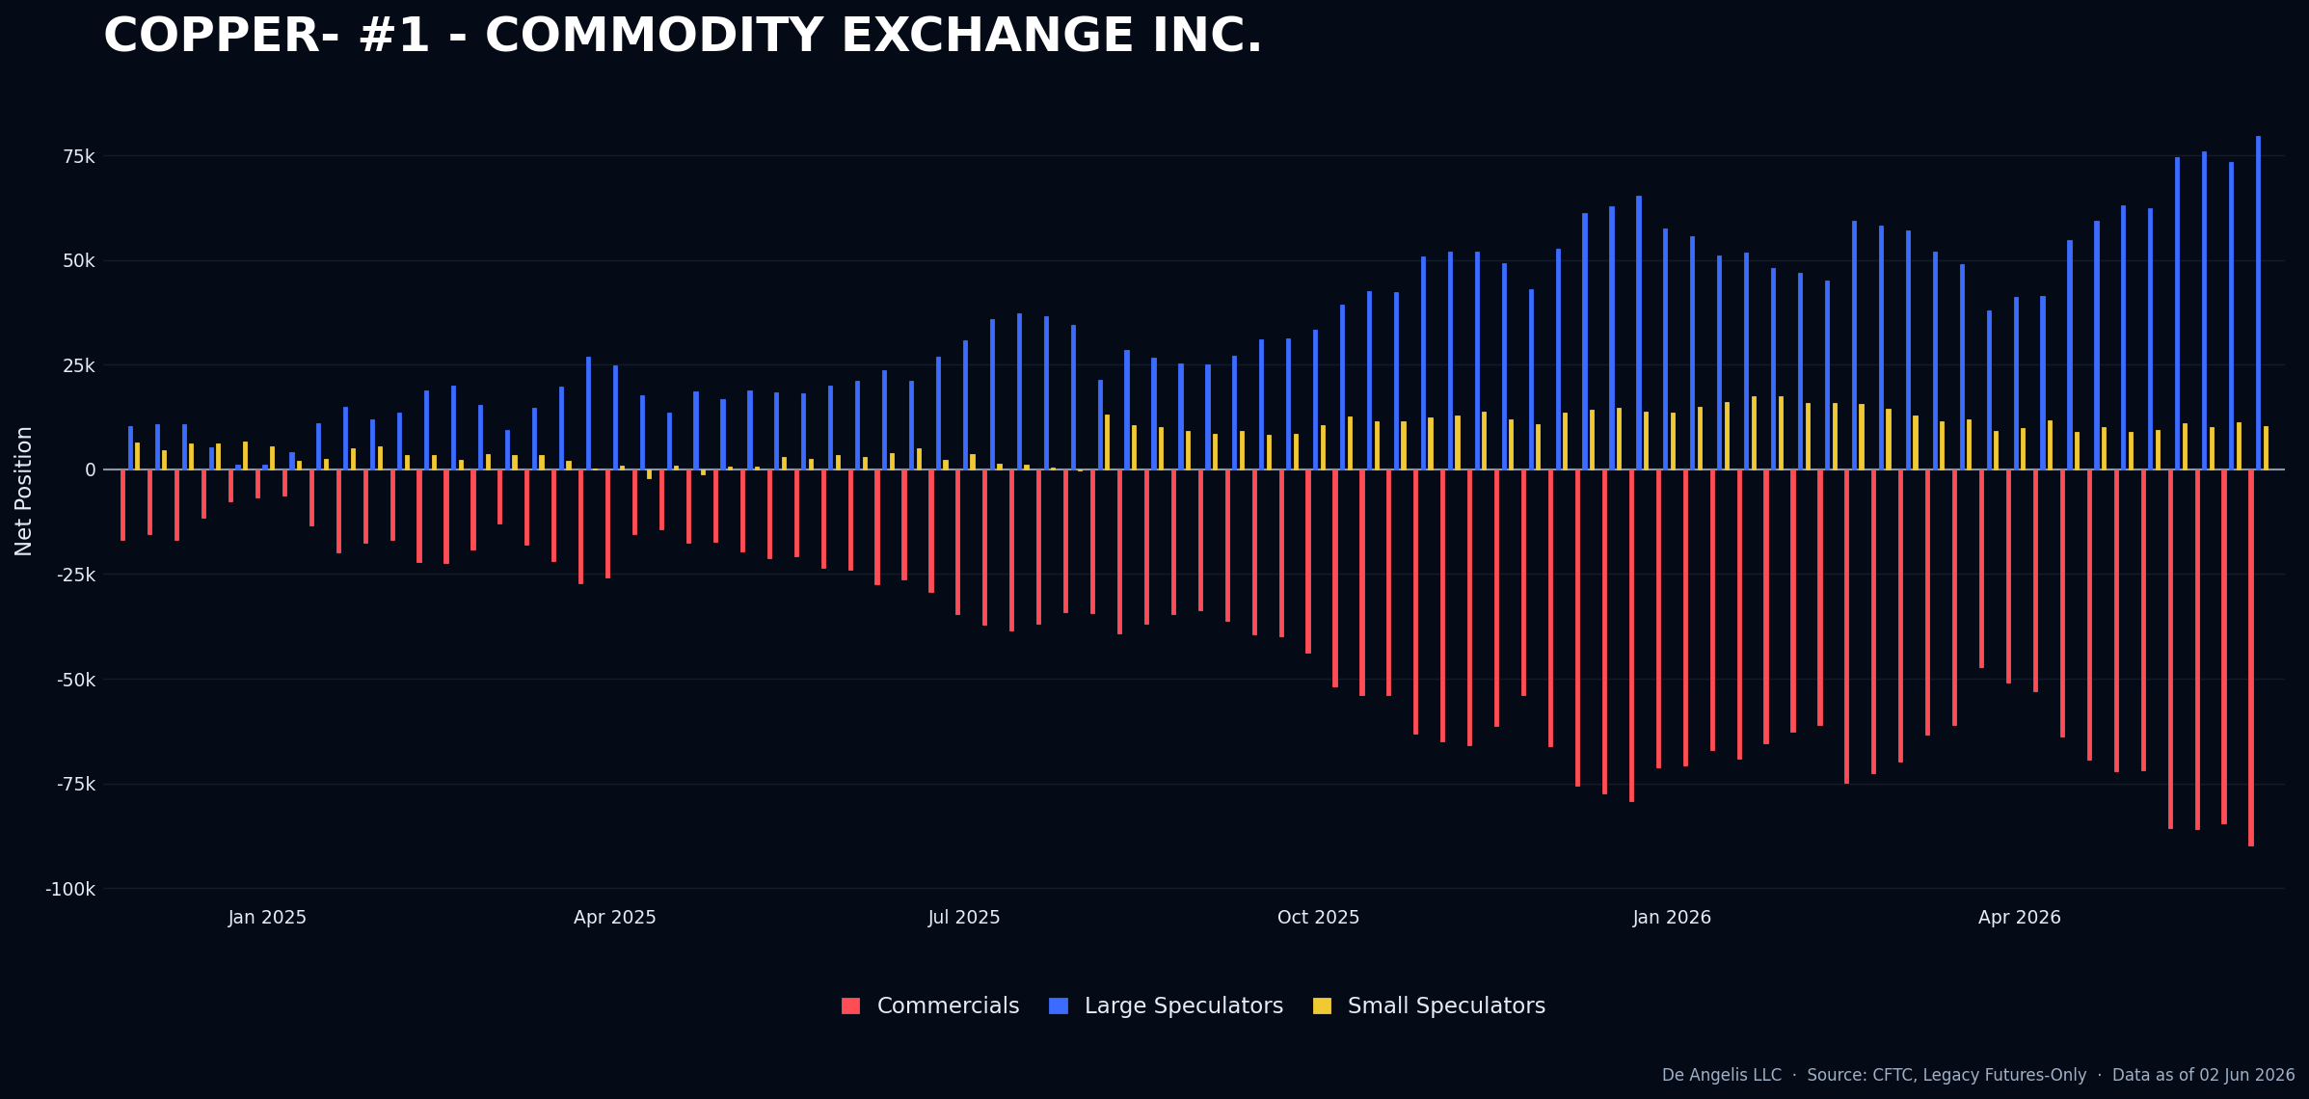
Although small speculators are not there yet. If there is a strong and clear news failure I could try it though. Will go further about this in the next section.
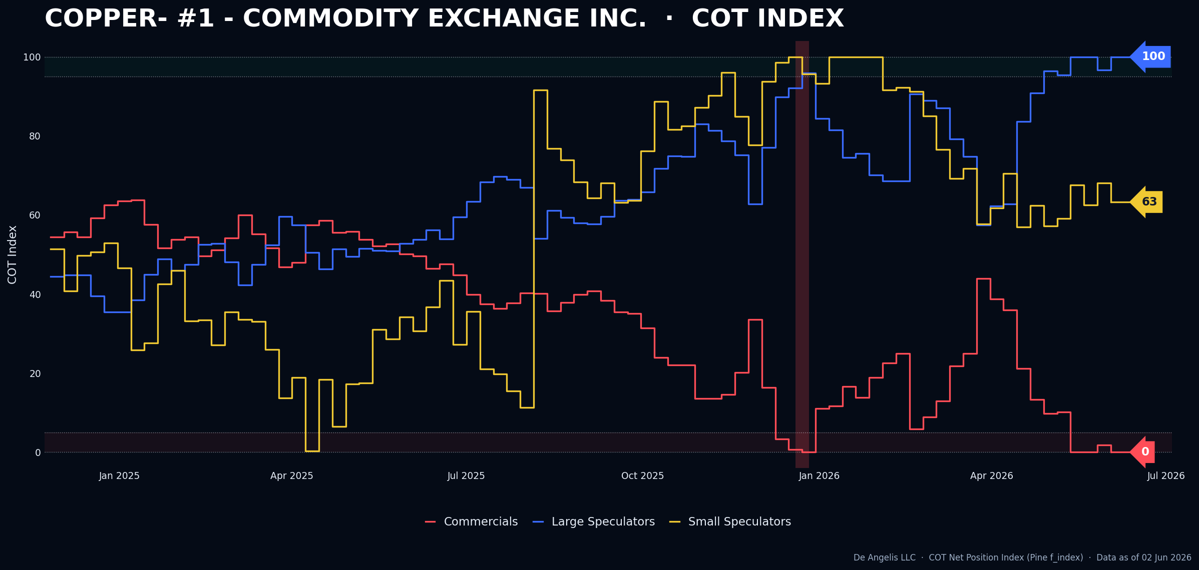
The rest of the metals have done absolutely nothing in terms of positioning over the past few weeks.

Fixed Income
30 years is coming off from the extreme short positioning of last week in Large speculators. No Edge here.
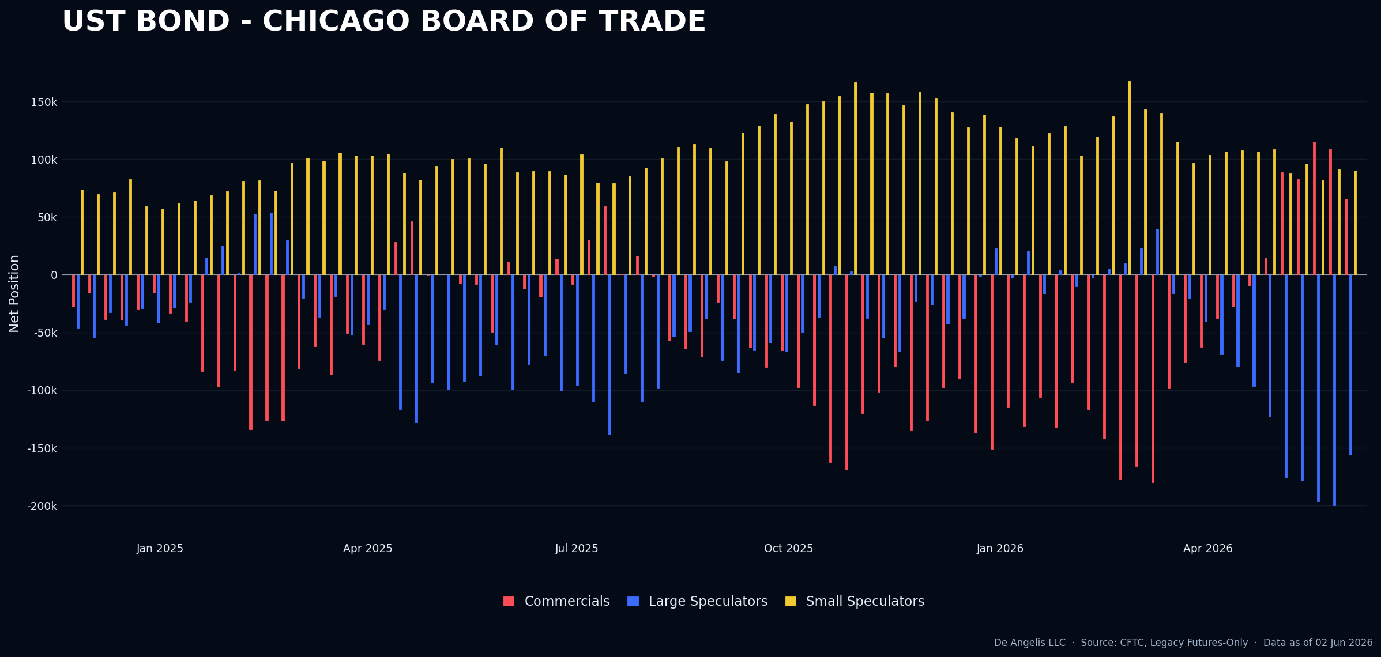
2 years increase in net short again but not edge here as well.
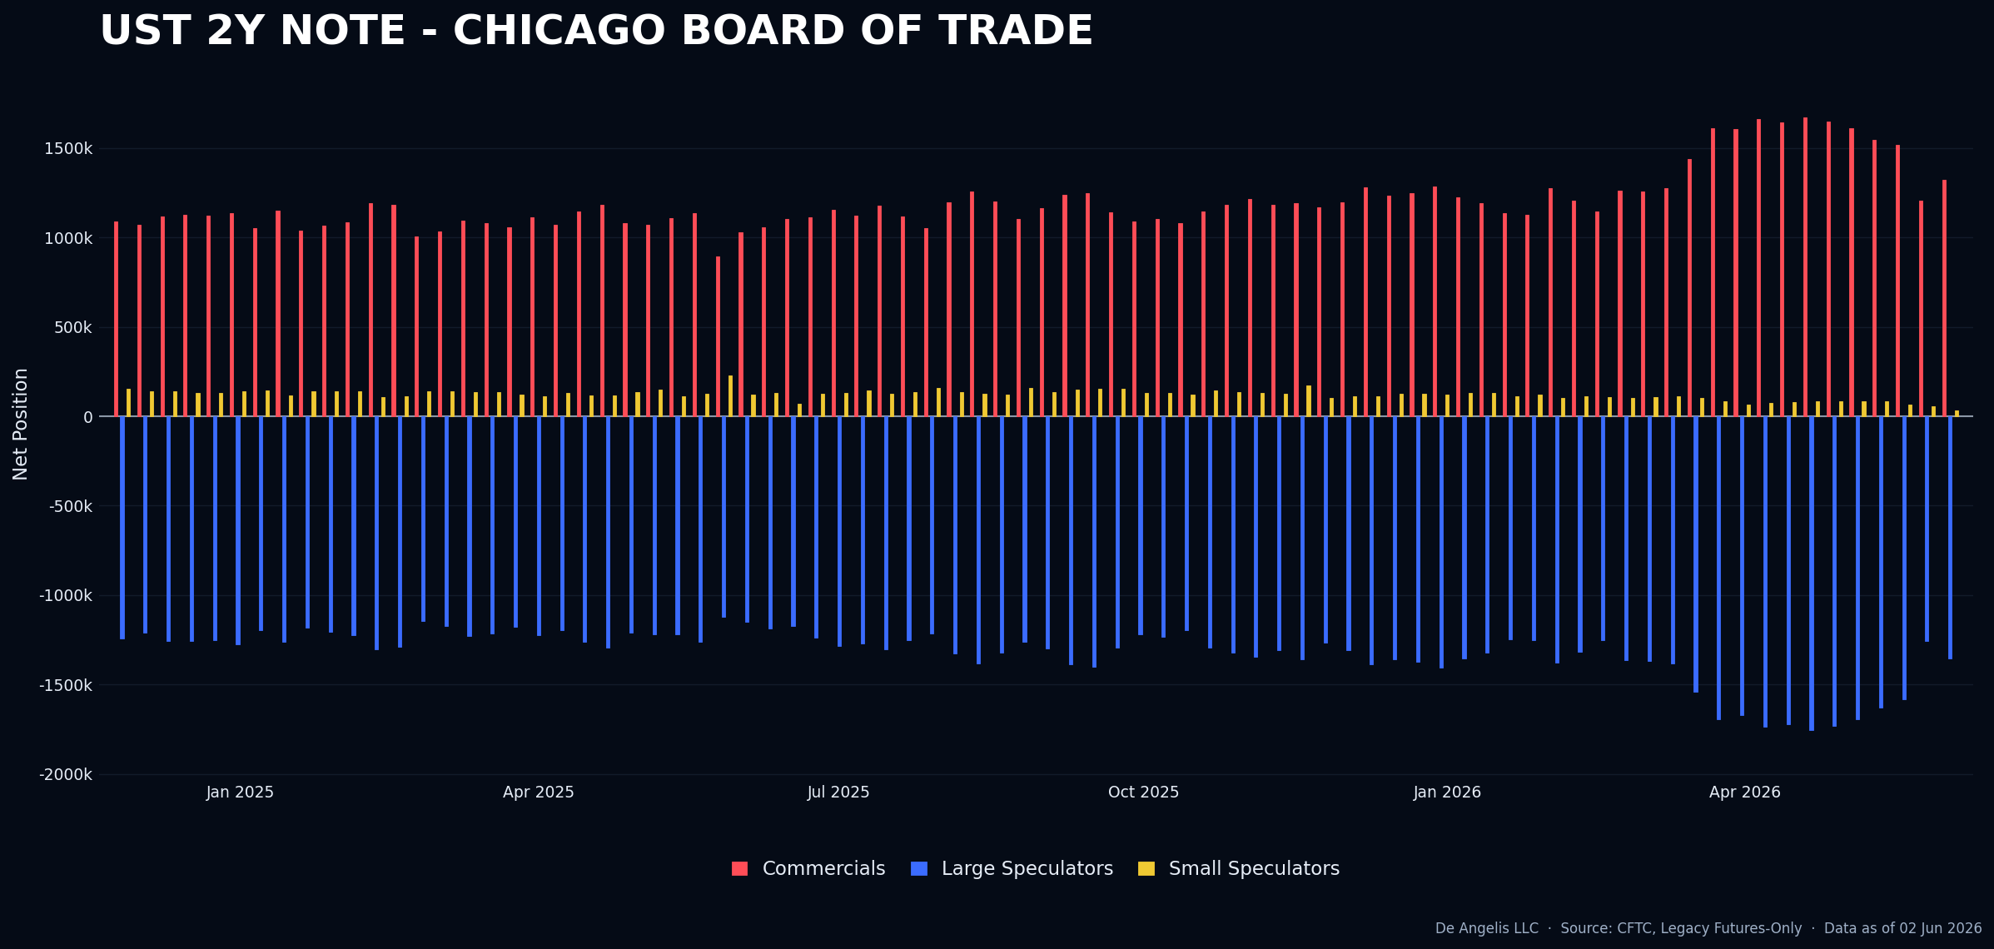
I see nothing interesting in fixed income and it’s highly discussed as a market. Probably too much, it usually leads to no direction at all.

Crypto
Jex Christ save me. That’s all I have to say. Will explain this in the next section further. This is probably the most interesting market out there right now.
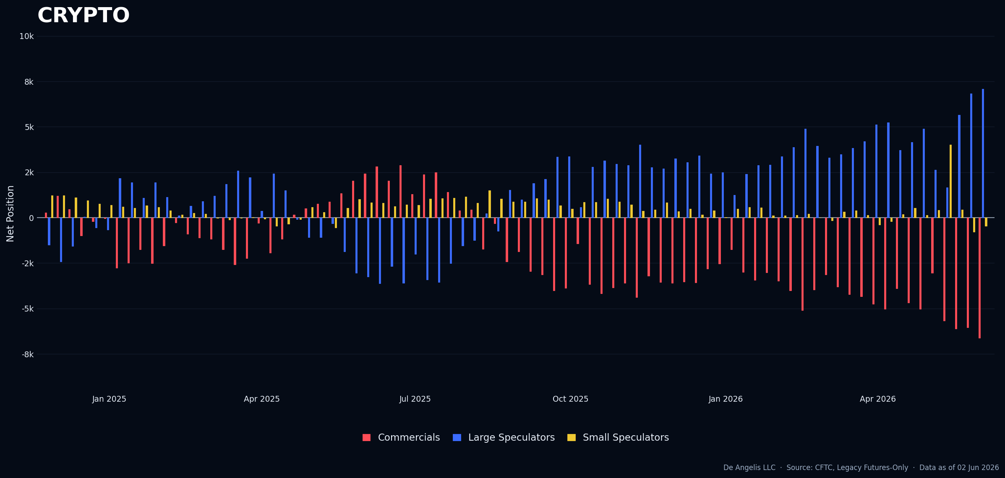
Eth holders being completely destroyed. Small specs buying while prices collapsing.
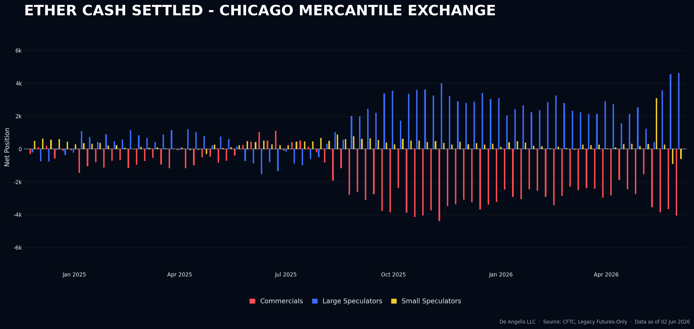

For the bit coiners it’s the same story. Increasing their net long holdings while prices collapse. This is the divergence pattern studied and identified in September 2025 and as observed it does not lead to any good outcome.
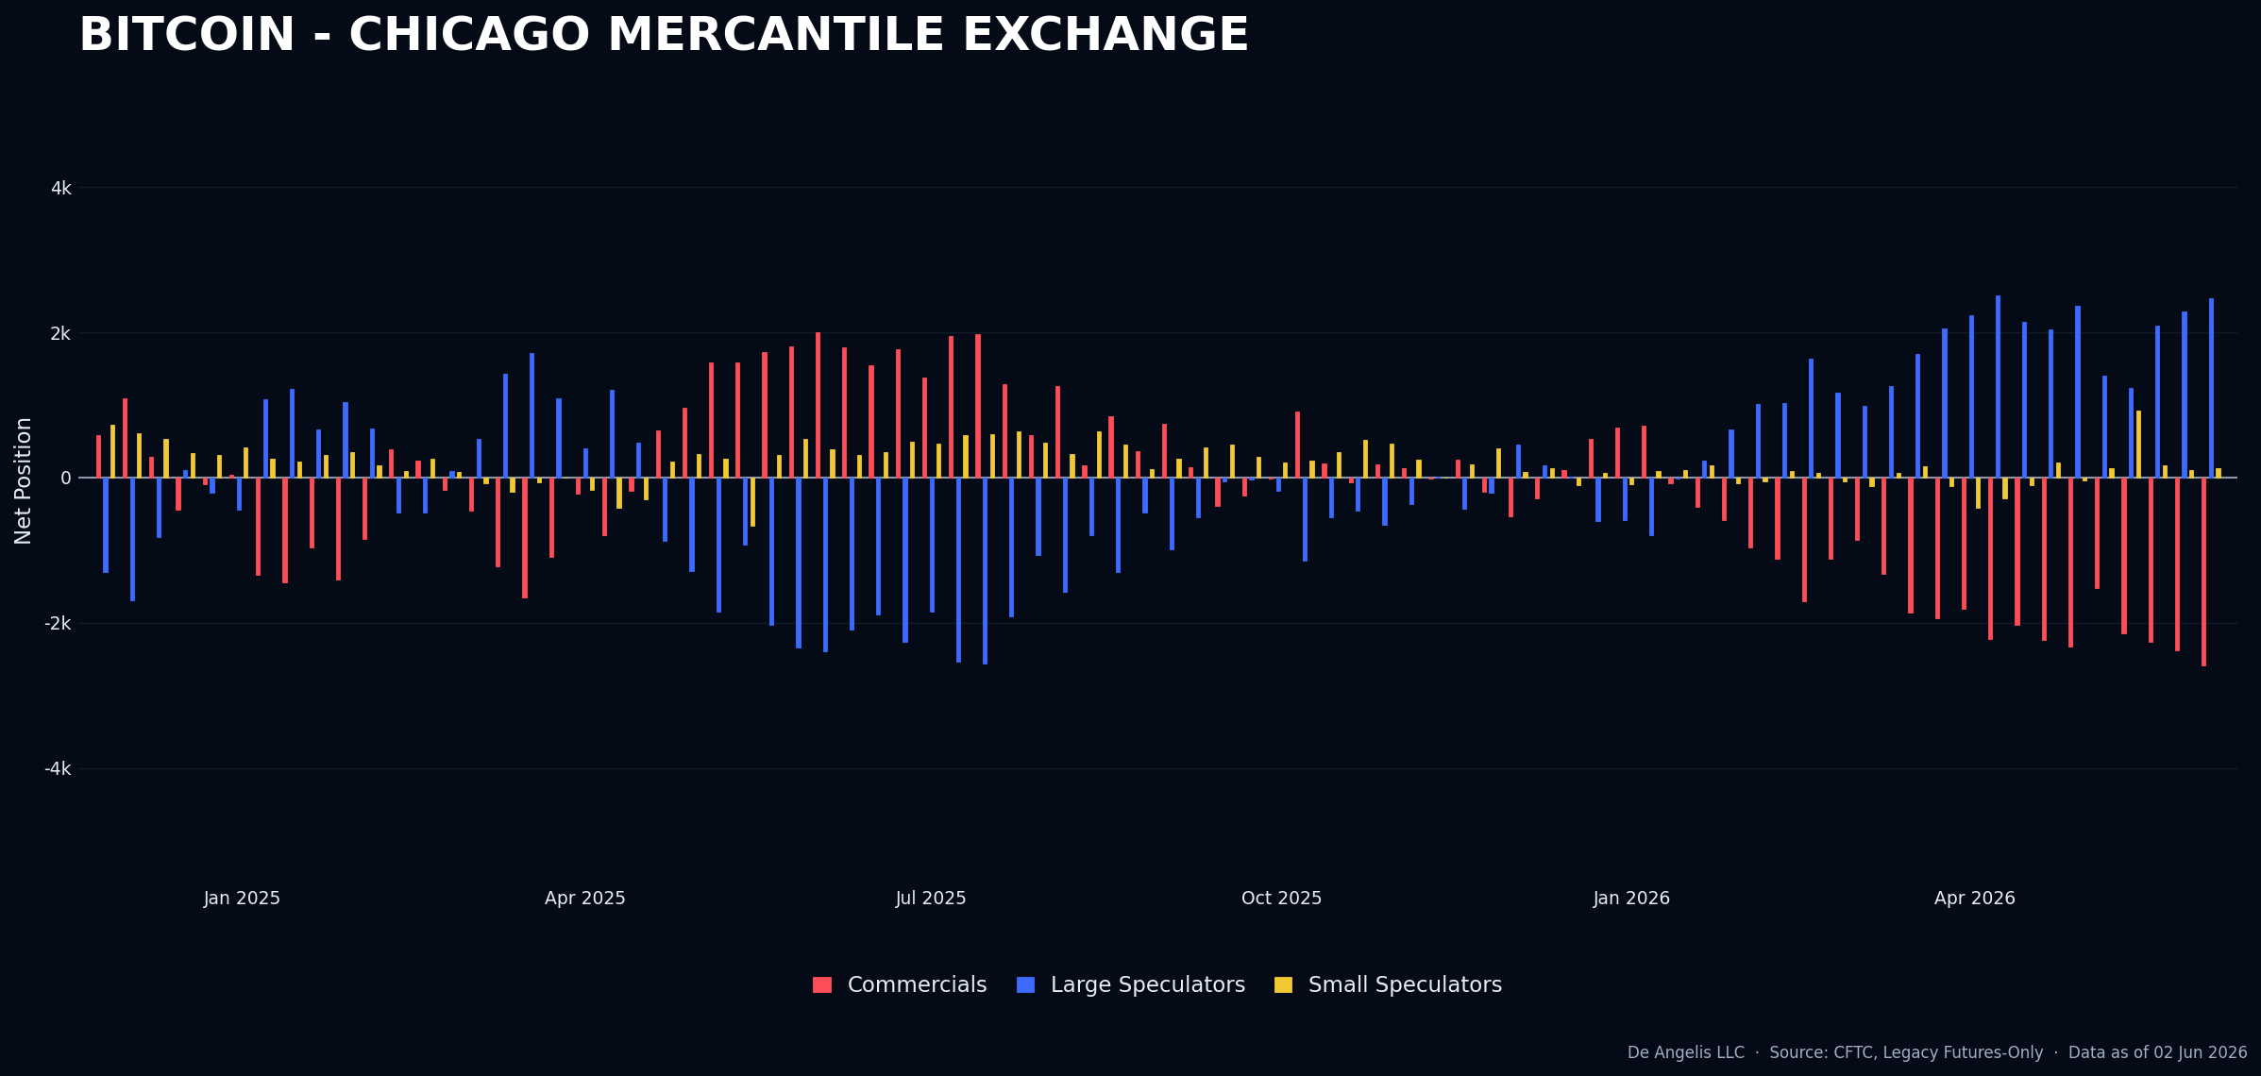

Currencies
Aussie dollar now off from positioning highs. This trade was missed but there was no news failure that was identified to trigger a short entry on this asset. So this would have been an out of process trades that would have worked. We know what happens when we take out of process trades. What I am going to do in the next section is to go back and identify if I missed anything with this asset and see.
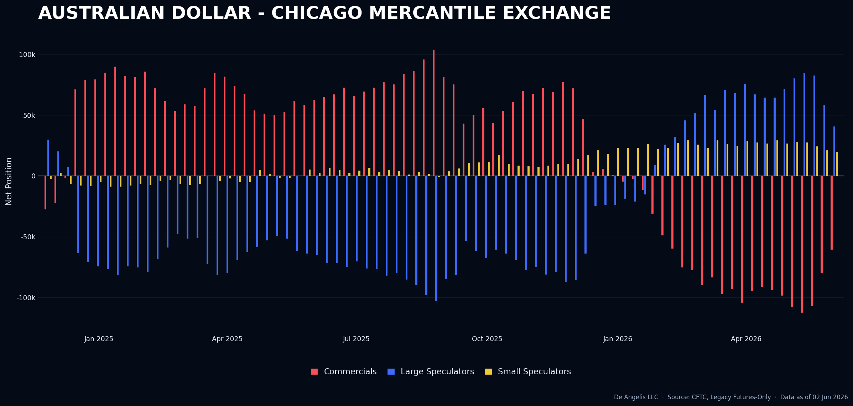
Small spec in Swiss franc getting interesting. Not there on an index level though.
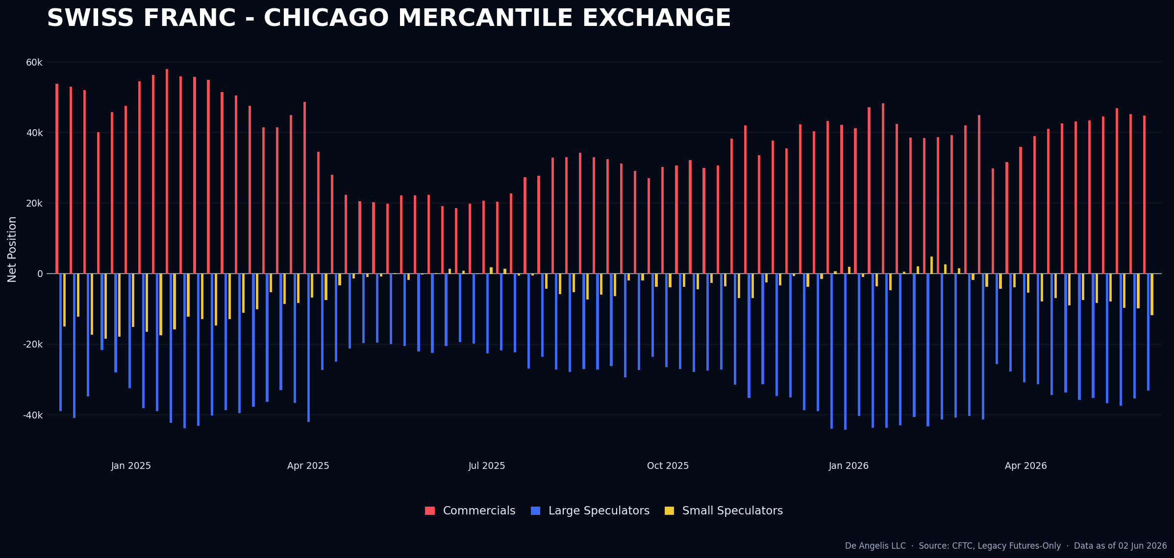

Yen is the most interesting candidate for a long for the next few weeks. Although Small speculators are just not there yet.

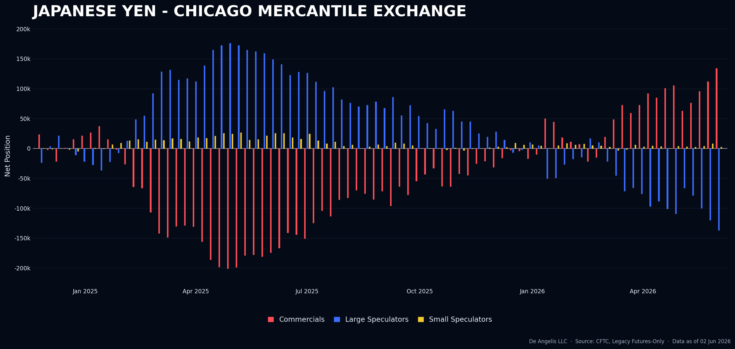
Index not working yet although the shorts were increased by a substantial amount.
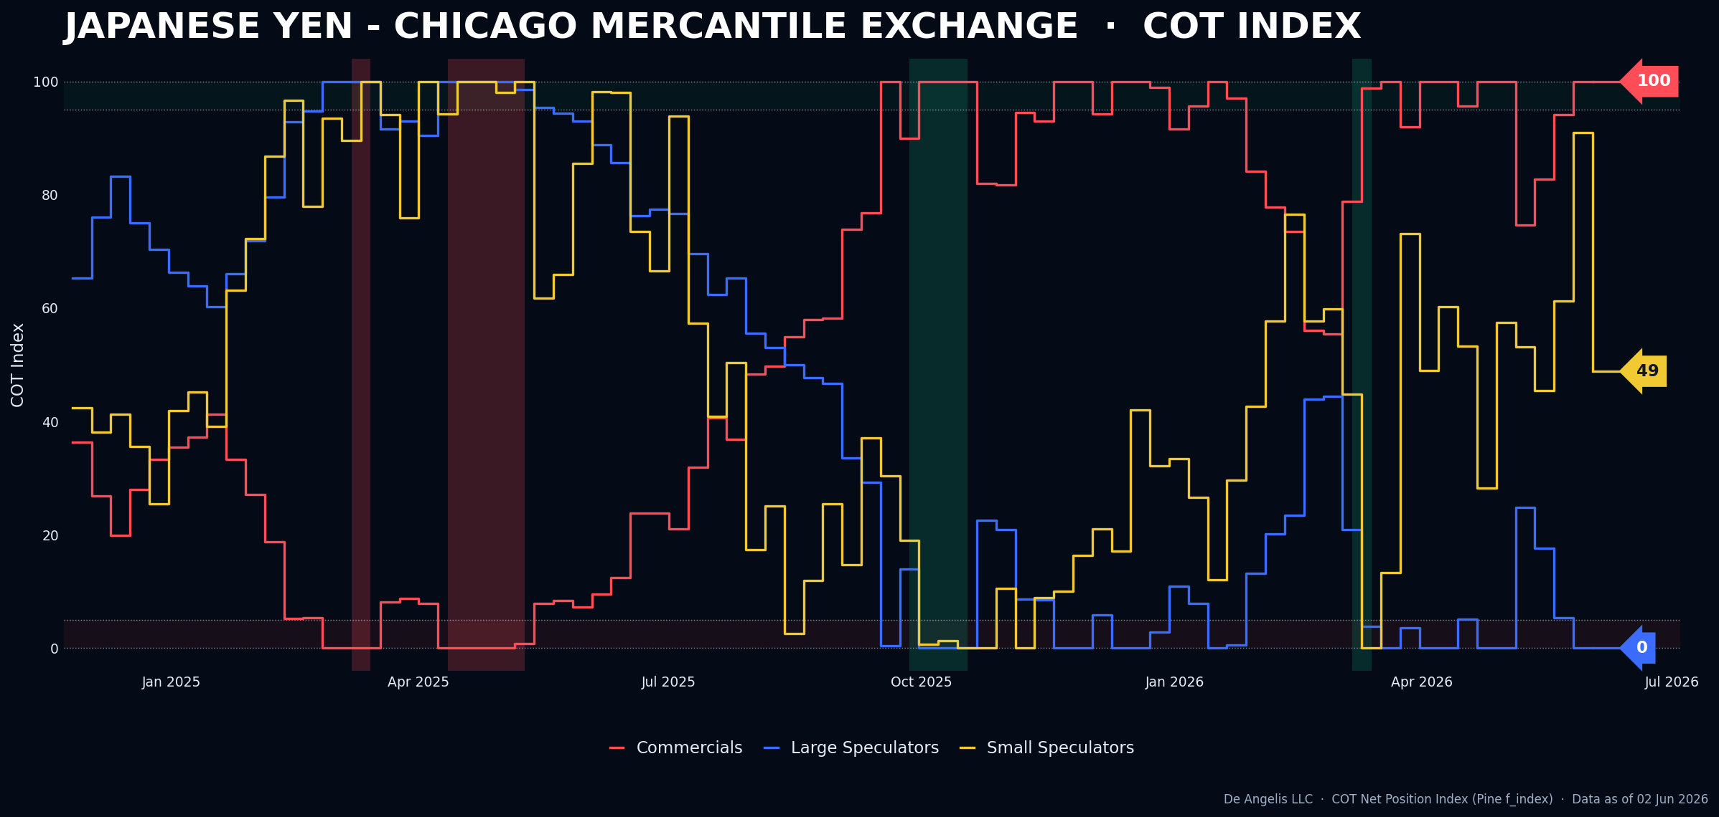

Softs
Cotton is our current position and although prices have moved substantially lower from the highs the net positioning has not, showing that there is a large number of small speculators and Hedge funds holding on this asset. I believe it comes from the fundamentals about inflation.
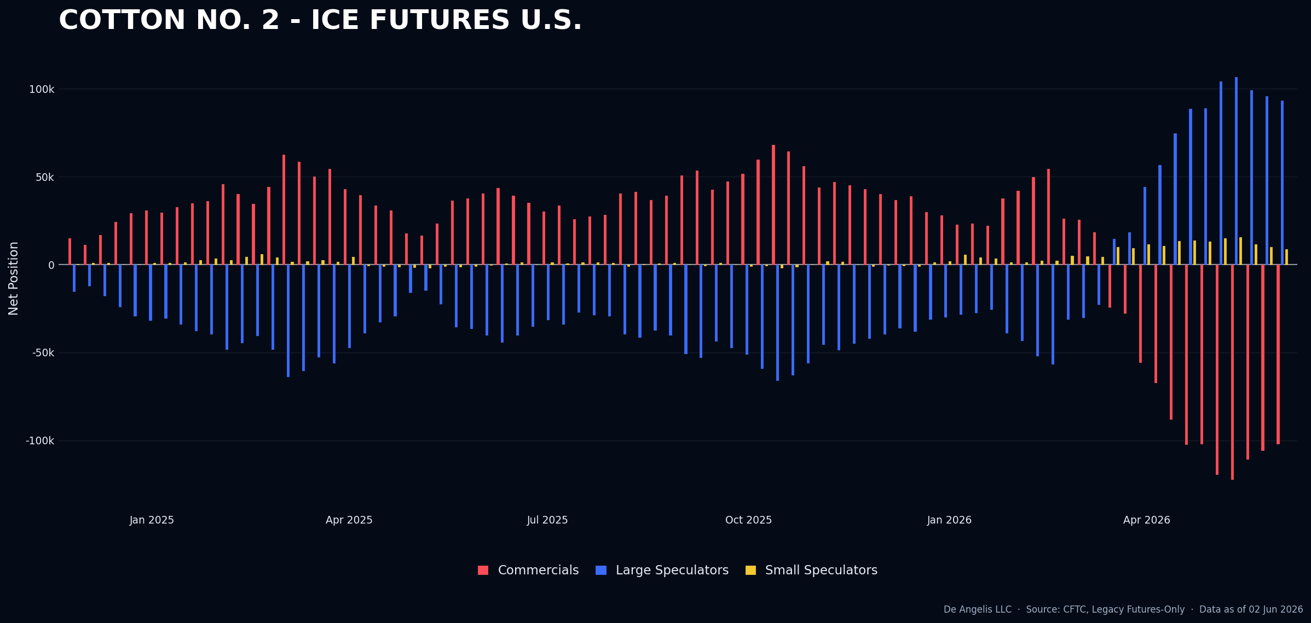
The index not triggering an exit yet.
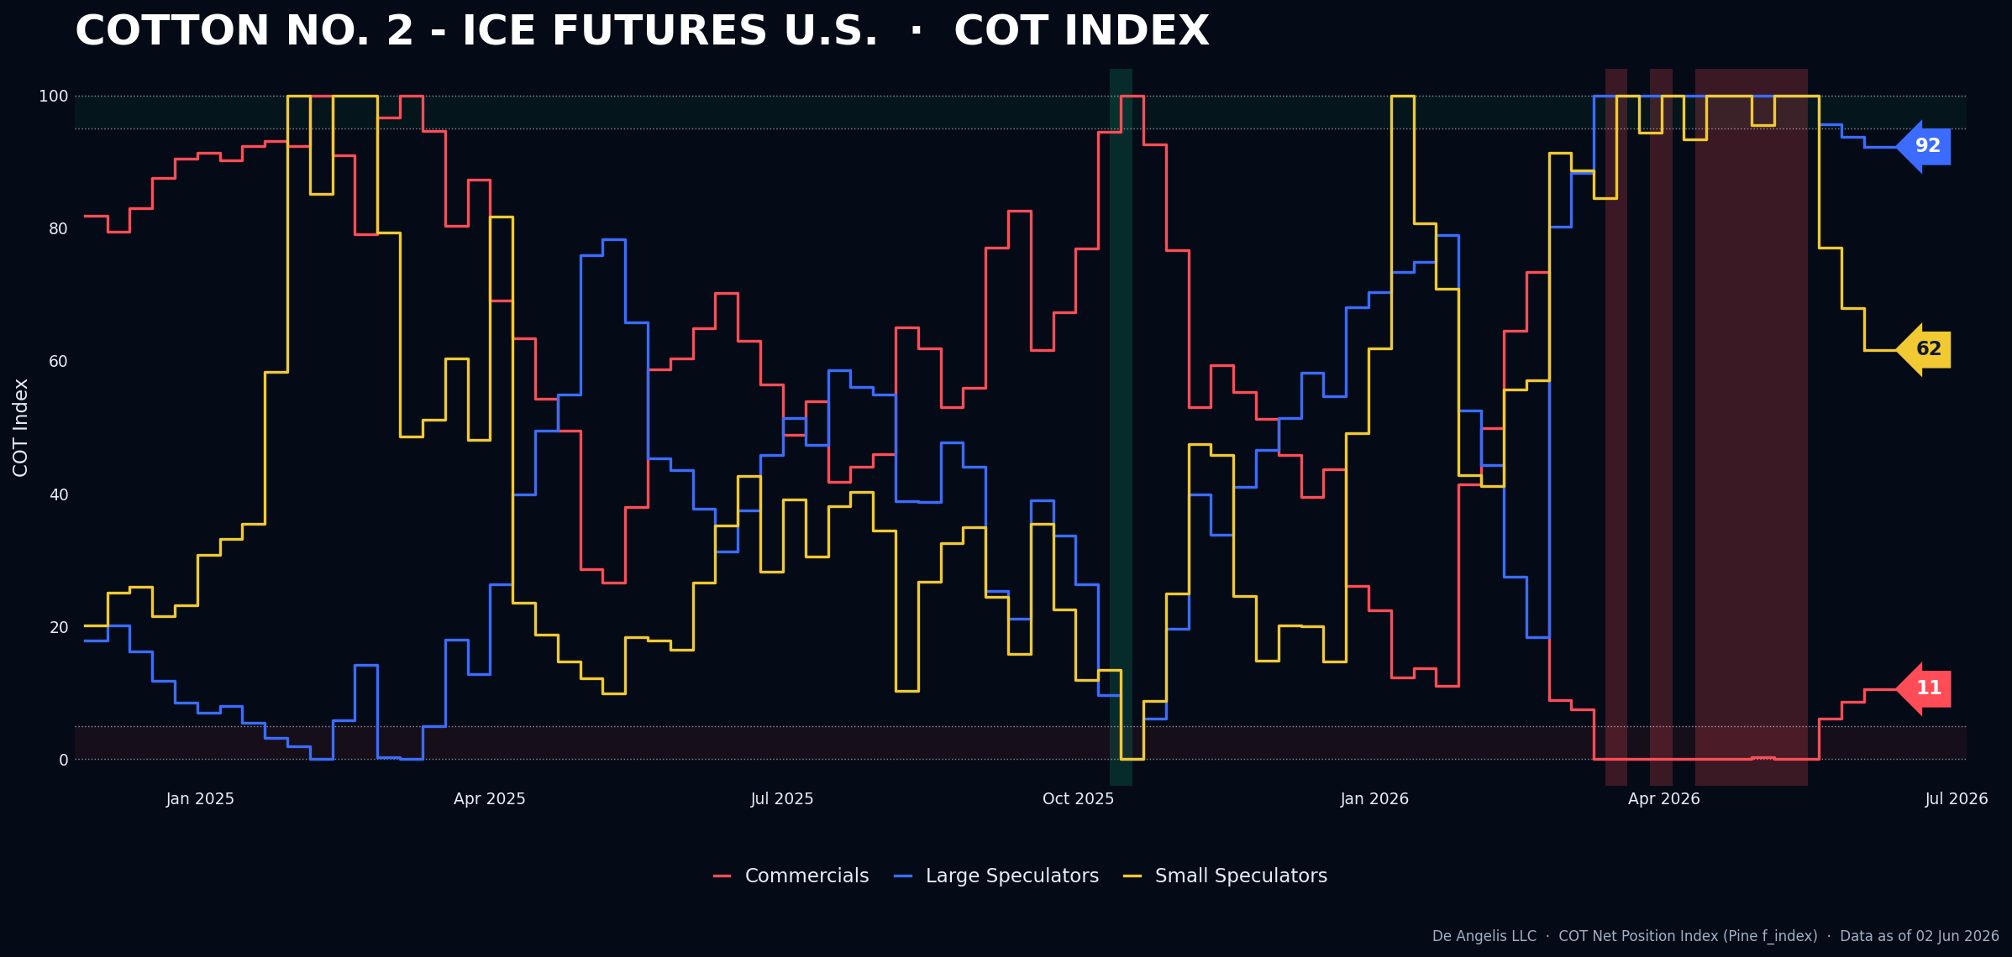

Orange Juice was a Long set up last week but after investigation into it I found there is not going to be any interesting report that would make me willing to initiate a long position on a news failure until July. So at this time, I am going to sit and wait.
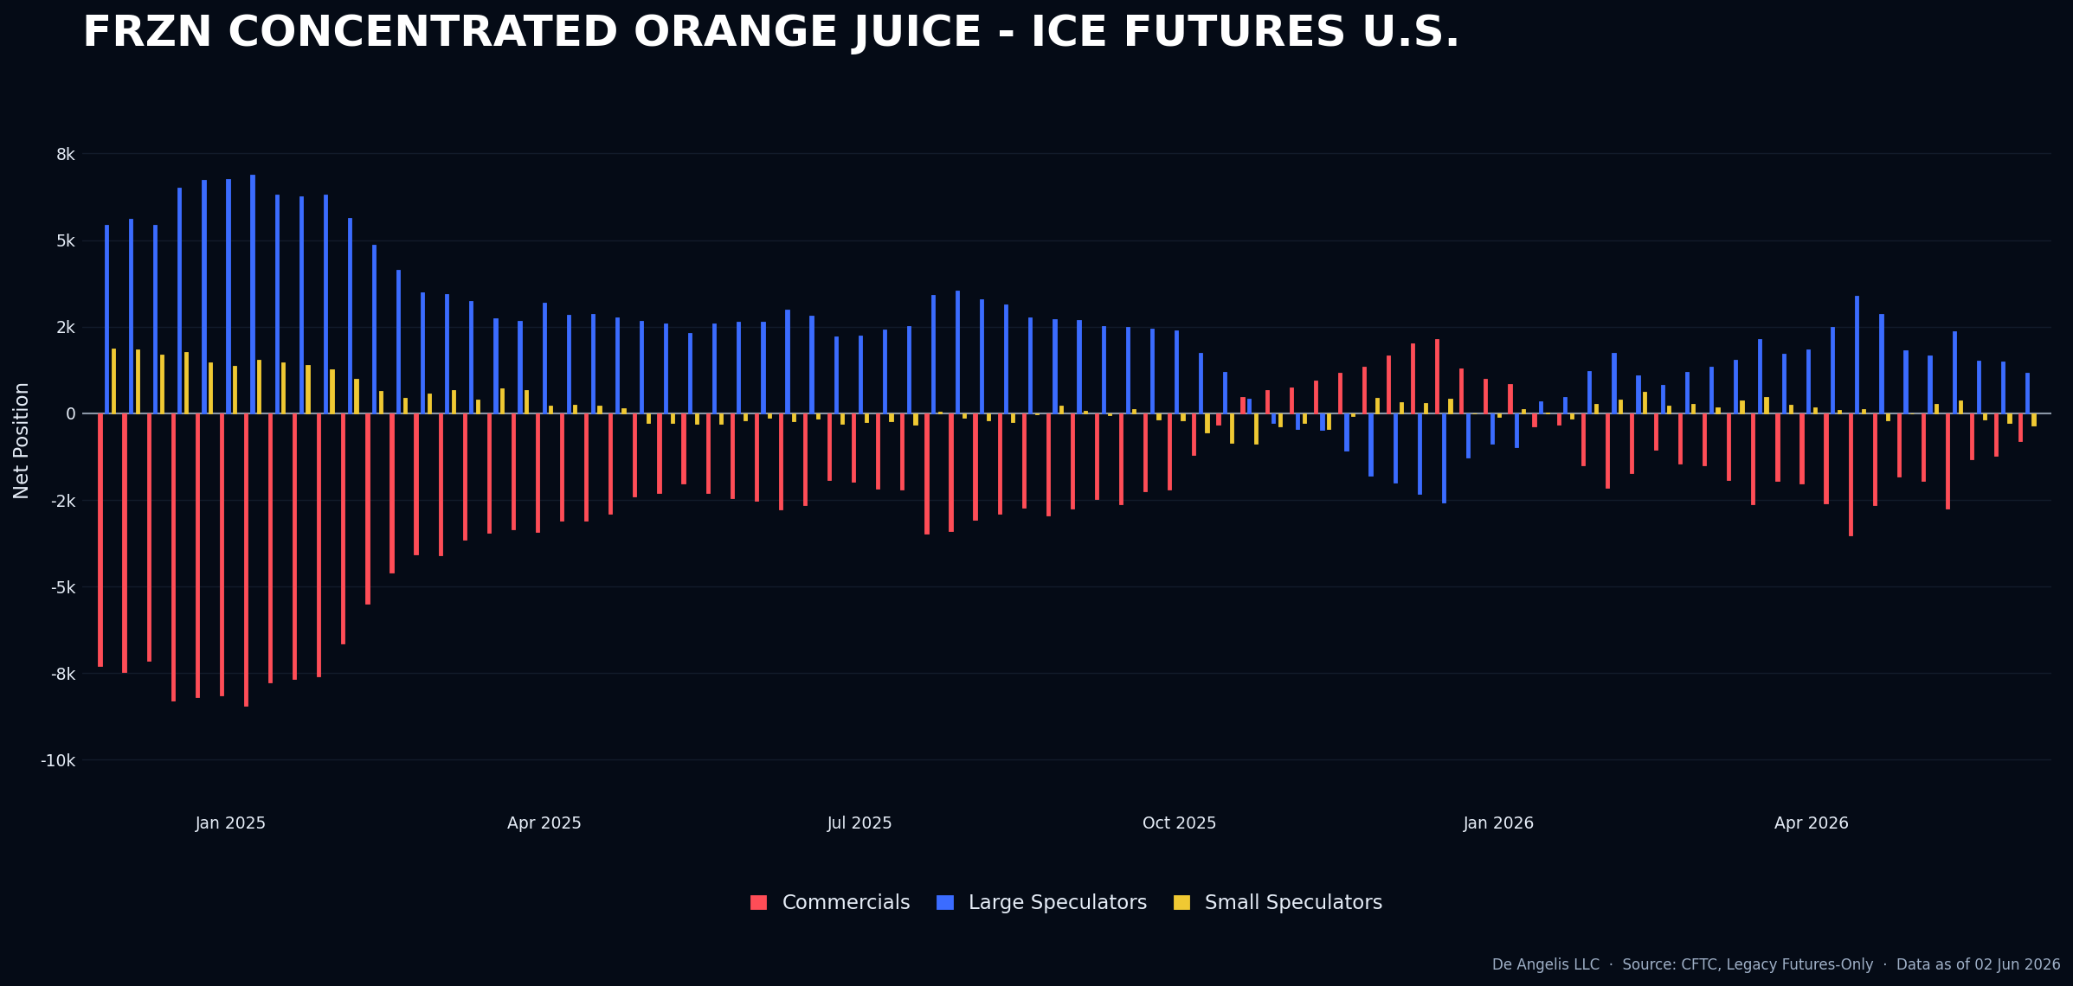
Index is still a Long set up.
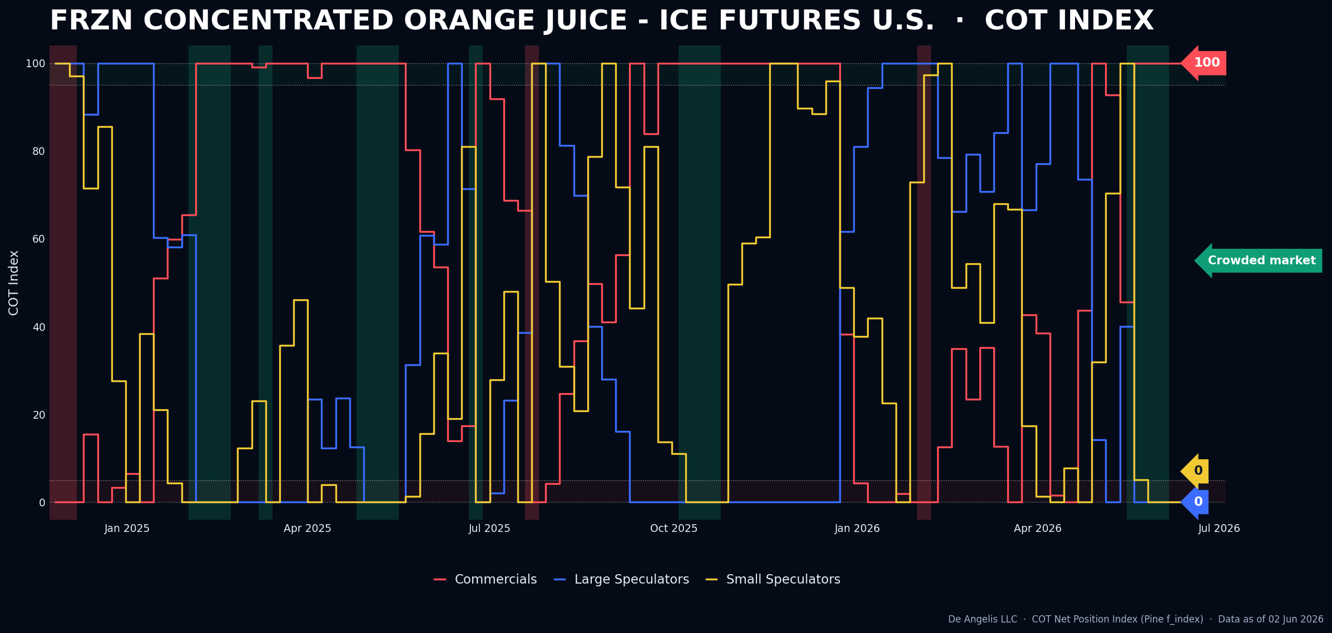

Livestock
Nothing interesting in here as well
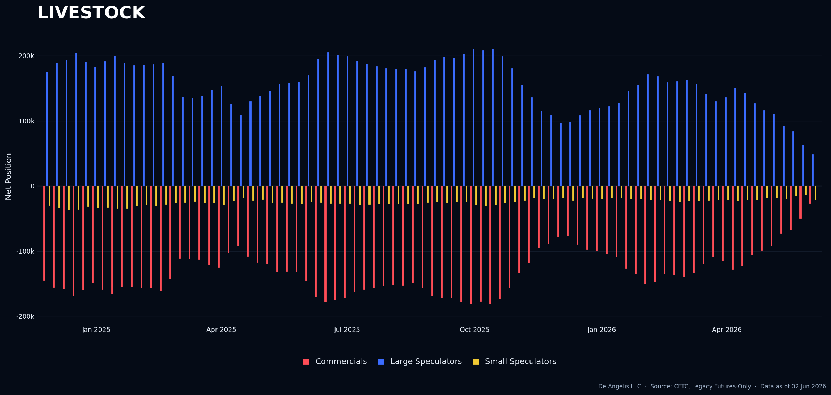
Lean hogs getting bit more shorts from large specs which are now net short since September 2024
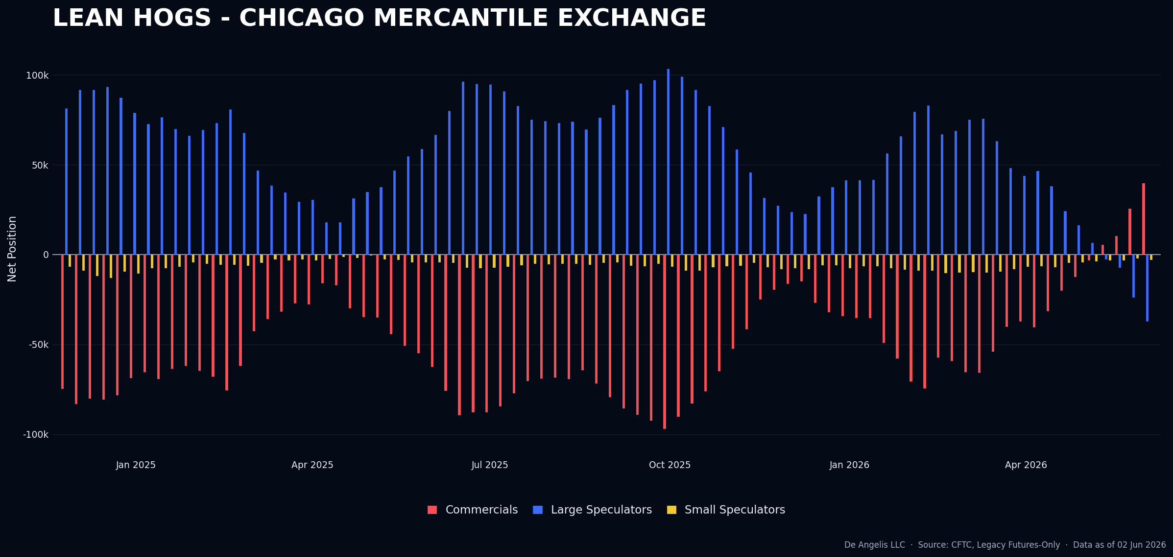

Grains
Soybean Meal has come off a lot from the short set up positioning and it’s now neutral from small spec
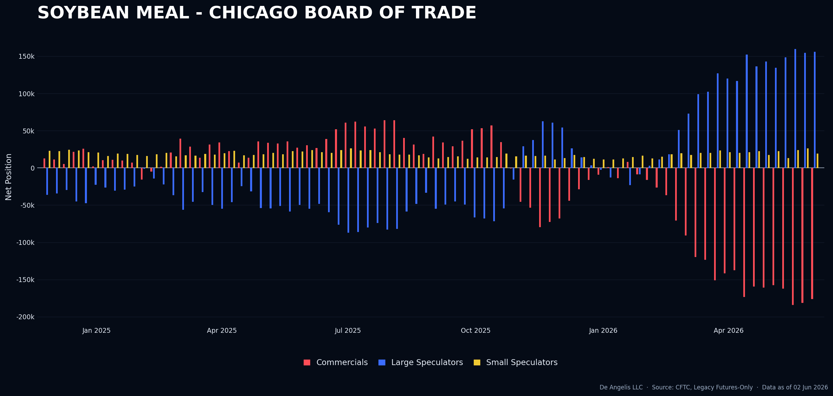
Index showing that.
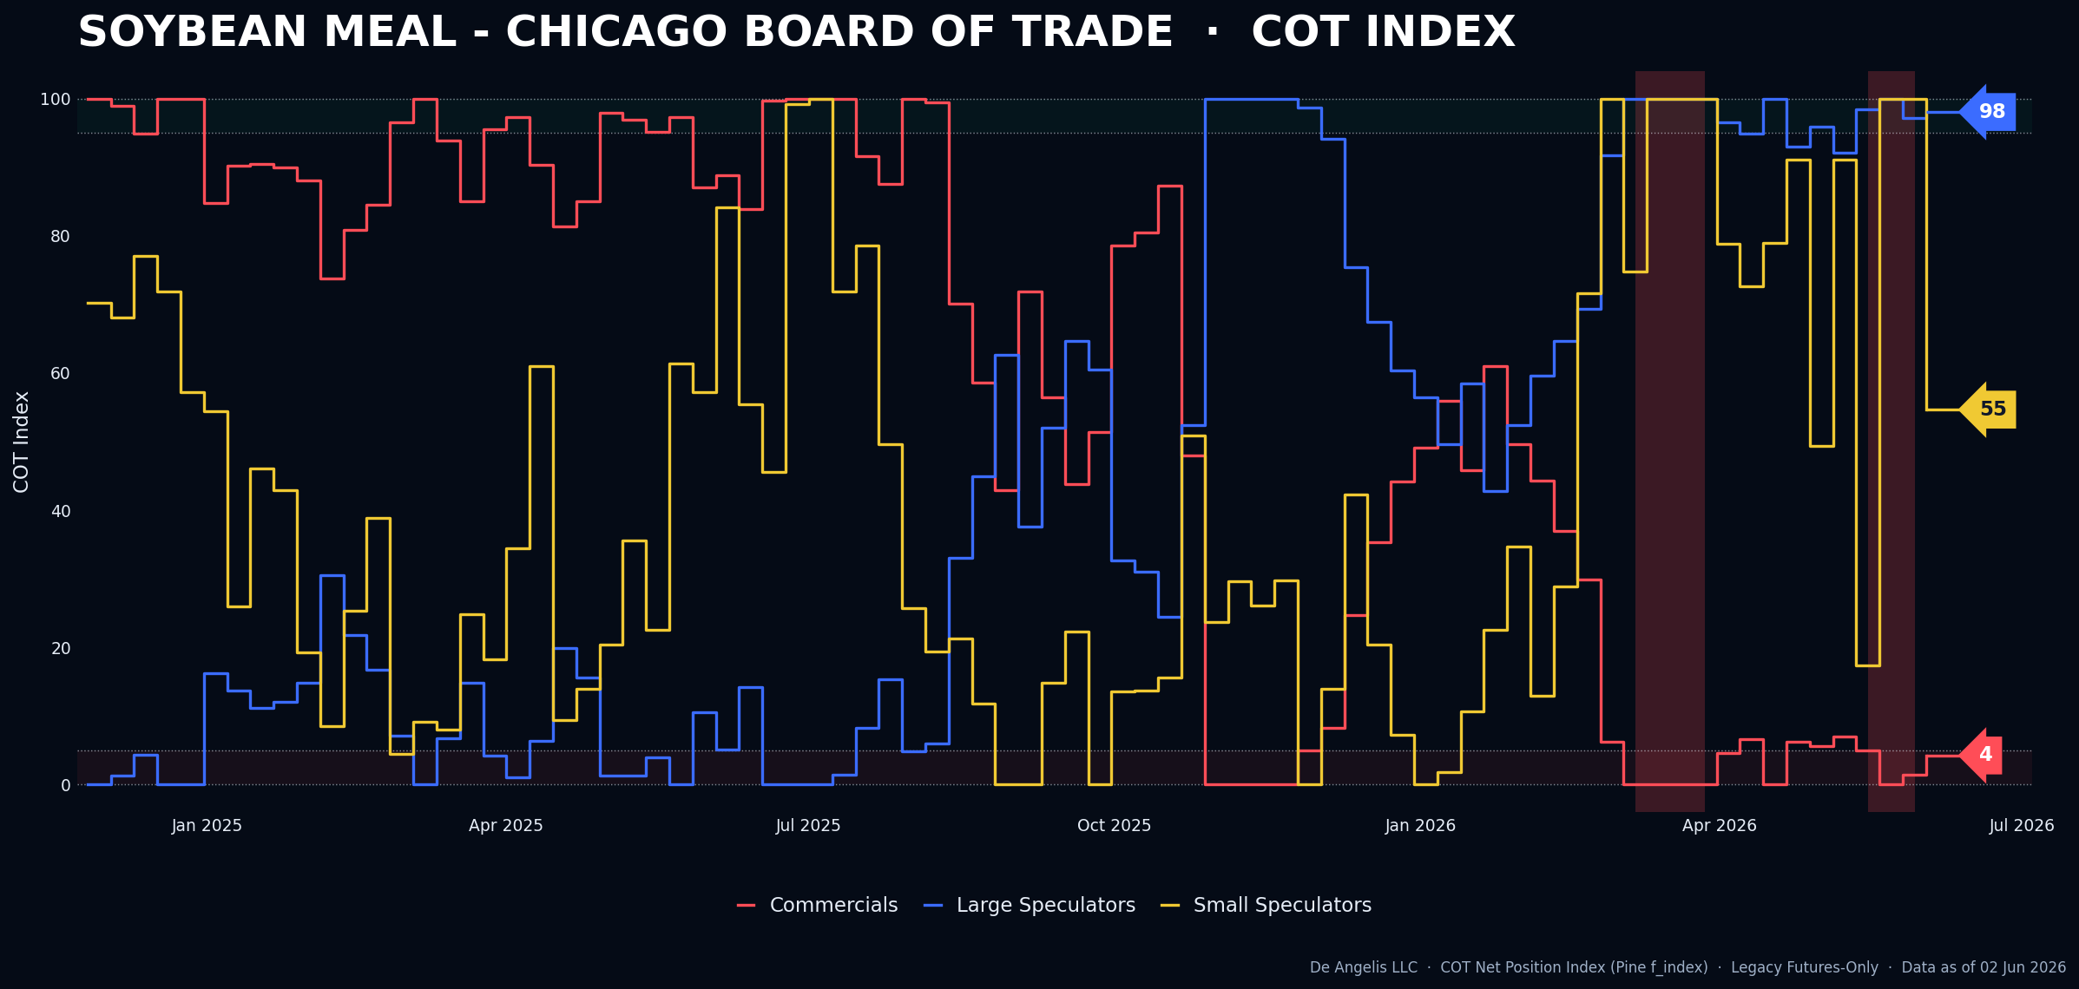

Combining | Positioning, Sentiment, Price Action…
This was a hell of a week, and I have several points I want to cover about what happened and what matters during these moments.
Starting with equities, I spoke with the majority of people in various trading groups, and from what I observed, especially around Wednesday, many capitulated their portfolios: some accepted large losses, while others went full cash, displaying intense emotions with anger being at the top of the list. The people I spoke with reflect the current state of many market participants. They shorted on the way up, and when they capitulated the market promptly moved in the direction they had initially wanted, which is exactly what happens when groups react this way. I spoke with someone who called this market “non-directional” and “a casino for gamblers” this week. I don’t know what’s non-directional about a market that rose 34% in less than two months. As usual, I started to argue, only to realize the person was exhausted by the market’s dispersion and had gone full cash.
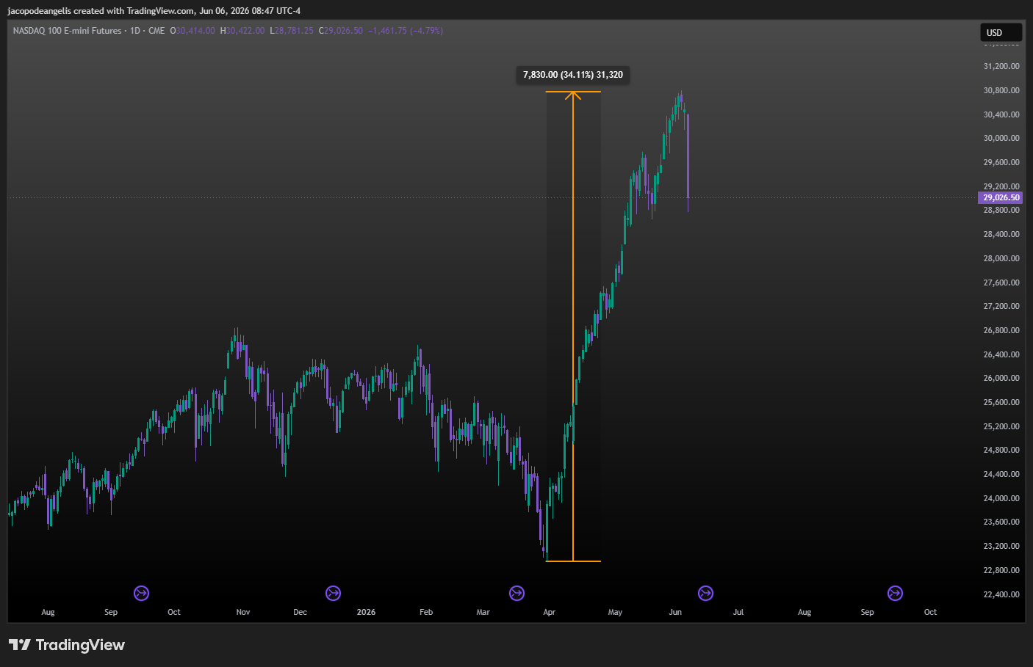
This is something that happens very often at tops and bottoms I’ve noticed. People going full cash, showing signs of desperation or greediness only to be proven otherwise on the same day or few days later.
Regardless of what a reader of this market action might think I want to take a guess on why all of this happened from a deeper more psychological perspective.
First of all If this was a scenario that was pre-planned and controlled through a process of placing a clear stop loss on a level that would make the trader think the market invalidated his thesis and there was an exit signal that would make the trader think that his edge is not present anymore, would this trader have moments of intense emotions and delusional views about the market?
I believe there would be very few traders who had the reactions of the people I spoke with this week. Nothing dramatic honestly but I felt pain in the groups I spoke with. The general advice I gave which is really an advice I give to myself is to establish a process. Down here I will write down the way that I used on myself to establish a process and hopefully the reader can get some benefit:
- Observe someone who is running a process similar like yours and learn from him. Since nothing new is invented in the market I don’t think that a person entering the financial market needs to try to create or invent the “hot water”. I believe in observation and mentorship during the first phase.
- Make mistakes as quickly as possible. If I make mistakes, I want to do them as quickly as possible and as early as possible. Blow the accounts you need to blow as fast as possible and with the least amount of money possible. This is a phase that no one can avoid. Everyone needs to get through this phase so I won’t give the same boring advice “learn from my mistakes ho ho ho!”. I mean f**k that and fuck to the people who give that advice, I tell you “Lose all of your money and do it quickly”
- Once you’re done with all of the above then I believe someone is either ready to repeat point 2 again and, in that case, it would mean that this is not the right profession for him/her, or really incorporate the principles that his mentor originally tried to pass. You will then need to use those principles on your own because I then think that point 4 will become evident and that’s where the real learning will show.
- At some point during the application of the principles that the mentor originally passed you will find out that you can’t get the same results of the mentor. Why is that? Because the process that the mentor gave to you is not your process, it’s his process. So, this is where the real learning needs to occur. You need to go BACK; you need to go back and study and see the principles yourself. Test it and make the process yours. That is the only way that you will begin the process of mastery and this is the way that has worked for me now to stop having bad habits of breaking process over and over again.
Going back to market observation now I believe the crypto market is one of the most interesting markets and it also demonstrates why becoming married to a position will hurt a trader. Crypto went on an incredible run last year while many tried to short it, only to top in September and then suffer a dramatic fall that intensified over the past week. That decline is visible to everyone, so I will avoid getting bogged down in lengthy explanations found in many market reports. What is notable is that behind these down moves are traders and institutions seemingly married to these markets as if there were no tomorrow. As my mentor Jason warns, that mindset can ultimately create financial disaster. I want to add that the source of such disaster is explained in the book I finished this week, Trading in the Zone by Mark Douglas: anything can happen in the market. If a trader truly understood and believed that anything can happen, they would always use a stop loss. Too many participants in the crypto space do not use stop losses, and I’d say almost everyone lacks an investment process. Moreover, the divergence between positioning and price action reveals another violated principle: the belief that one can predict market prices. If traders did not assume they could predict prices, they would reduce exposure as the market falls. Instead, in this case, they increase exposure, suffering from the harmful of the biases in the market which is that that they can or must know what will happen next to make money. That bias leads to the most intense emotions of Anger and ultimately shame and guilt in the market.
Looking at the past report of the last week, I can see I was looking at Nonfarm payrolls and some other numbers to establish potentially new position in the portfolio. However, things did not trigger any new trade and I will show why down here so I can keep record of my thinking process. Also, the ISM manufacturing report on Monday and Tuesday job openings did not move the market. Nothing happened, so I did not bother considering new positions.
With Nonfarm Payrolls on Friday, there was a strong downward move across equities and other correlated assets, triggered by the current market narrative:
Higher Nonfarm Payrolls → Higher inflation → Higher expectations for interest rates → Equities and related assets decline.
The focus in equities is not on earnings right now but on yields and the dollar, as observed on Friday and in prior weeks. That is why equities fall on better-than-expected Nonfarm data. Understanding this dynamic helps avoid surprise when the market drops sharply and establishes a reading for News Failures in the upcoming weeks. Any asset that will close the other way after a reaction like yesterday would have triggered a new position of some set ups. So, if Gold was a set up and yesterday close was up after the initial down move it would have triggered a new long Position.
As mentioned also in the previous report I find no news that would have triggered a short in the Aussie dollar this week. On Wednesday the stronger than expected ISM have triggered some very small up move in the currency but it was not CLEAR, which is what I always put at the end of each report about the reading of a news failure. Added to the fact that as of Tuesday the Aussie dollar was not a short set up anymore, I am happy to having missed this trade. Again this “missing” of trades is not triggering any emotional response in my mind because It was NOT A PROCESS TRADE. If it was then yes, it would have been a problem, So since it’s not a in process trade then it’s like someone telling me “Hey you know that the Malesia rubber future went down this week?” I would just say “ok” … easy.
Soybean Meal was a set up and it went down a lot, but after investigating all of the possible combination last week I came to the conclusion that the only available CLEAR report would be the WASDE report and it’s coming out in 2 weeks from now. So I’m good and the report for this week will conclude here.

Next week Calendar | What I expect?
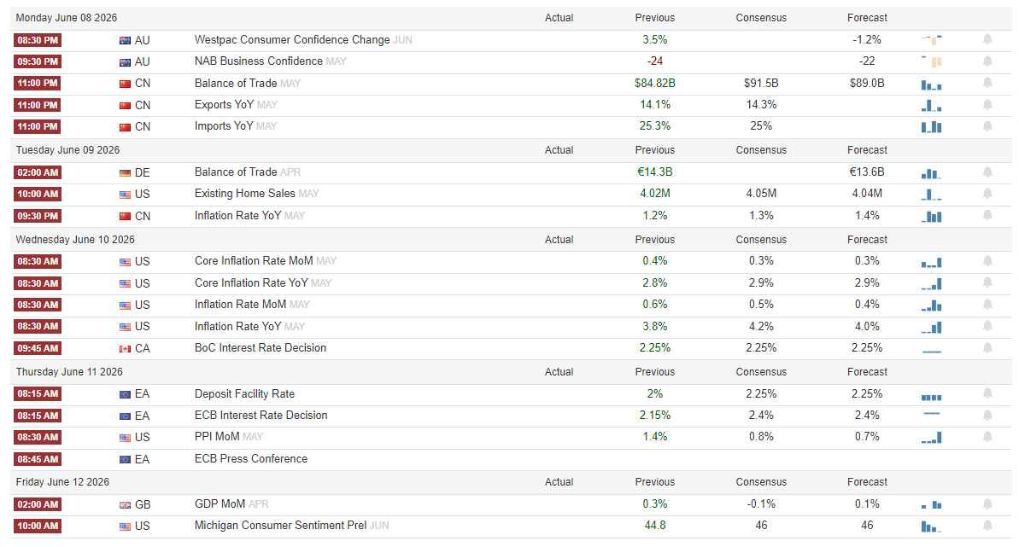
- CPI in the US coming out on Wednesday will be helpful to monitor the price action of equities since they are the only set ups for new positions that we have for this week. A stronger than expected Inflation number would mean, higher than expected interest rates expectations and therefore lower than expected equities prices in the short term, an up close could trigger a long in Nasdaq or the S&P500.

Current set ups and how I want to execute them?
- LONG NASDAQ: Reading of 100 in the commercials is the trigger. Eyes on CPI
- LONG S&P500: Reading of 100 in the commercials. Same as Nasdaq
I’d like to see indexes going down into Wednesday, possibly even down big and then make a reversal on CPI. Will be hard but I’ll see if my little prediction of the week based on hope strategy (historically pretty bad RR and Win%) will reveal to be true.
Again, I want to remind myself that the most important thing in news failure and market reading is Clarity

Open trades
- SHORT COTTON: from the 12th of May on bullish WASDE Report

Closed trades
- N/A

