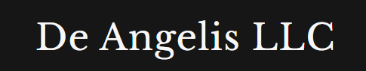
Weekly Market Report

16th May, 2026
Contents

Equities 3
Energies 5
Metals 6
Fixed Income 7
Crypto 9
Currencies 10
Softs 11
Livestock 12
Grains 13
Combining | Positioning, Sentiment & Price Action… 14
Next week Calendar | What to expect? 16
Current set ups and how I want to execute them? 16
Open trades 16
Closed trades 16

Equities
I’m stunned by the amount of people who are shorting the rally in equities, especially in Nasdaq, which is now a long set up again with market at all-time highs.
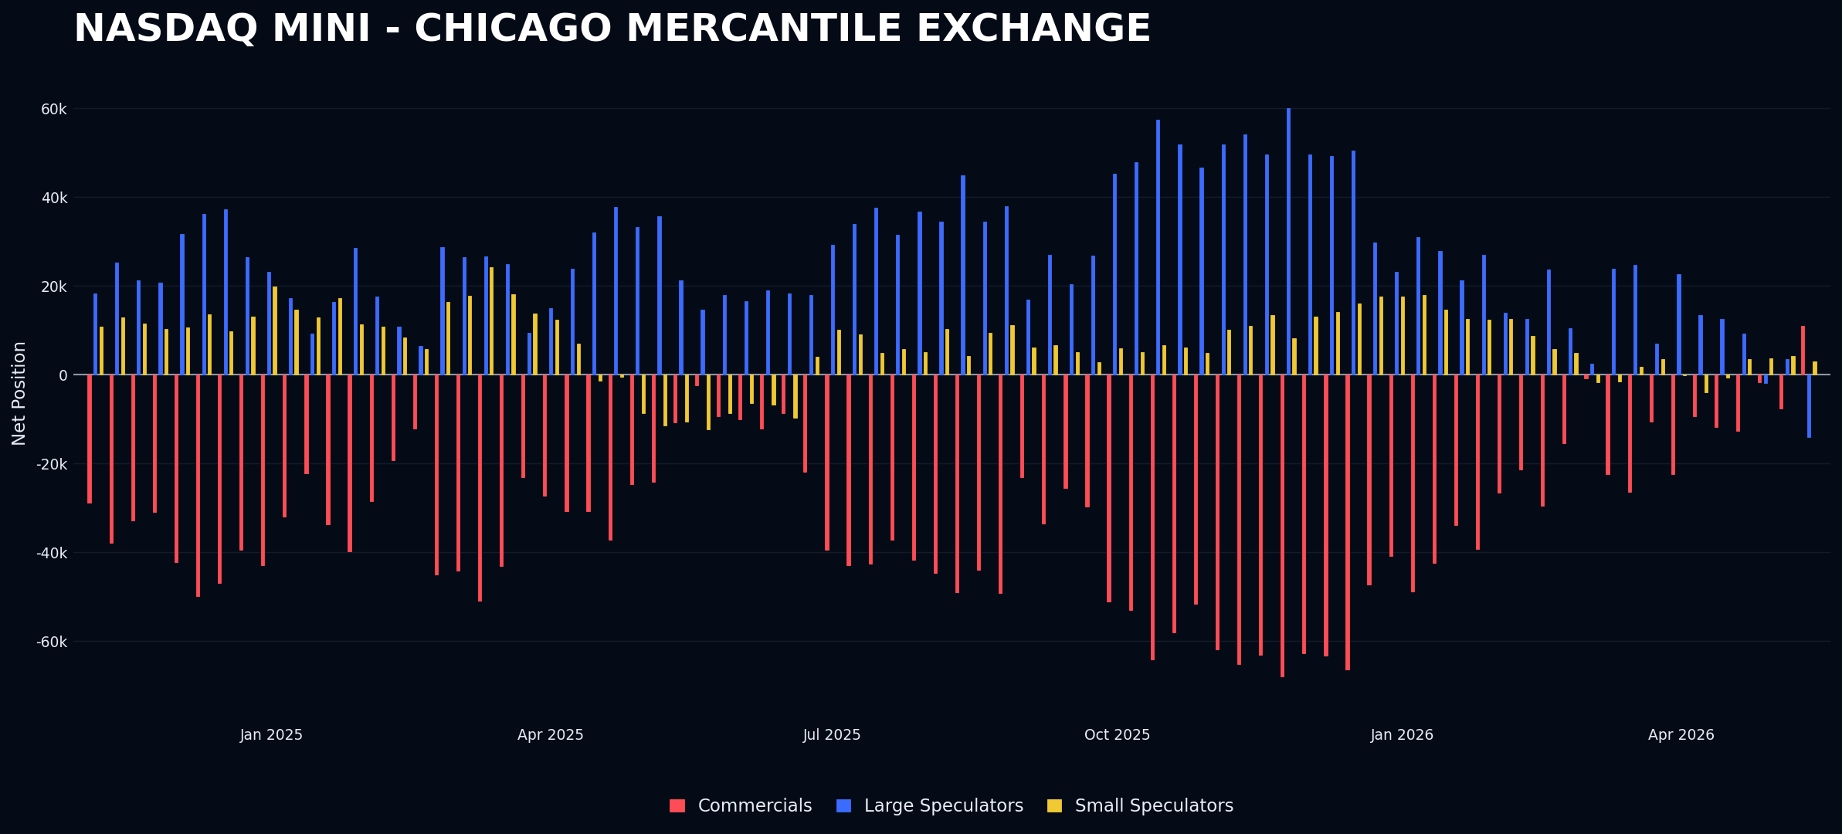
Dow was the most probable potential short last week however with the increase in shorting of this week it’s not there anymore.
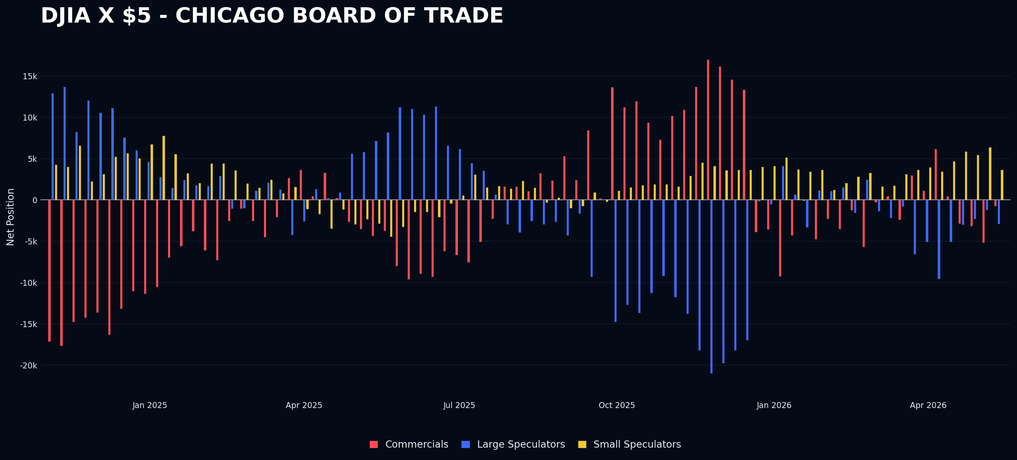

I will keep the discussion about equities going into the current situation section but this reminds me of a study that I have been doing inside the company about positioning and market sentiment in 2021.
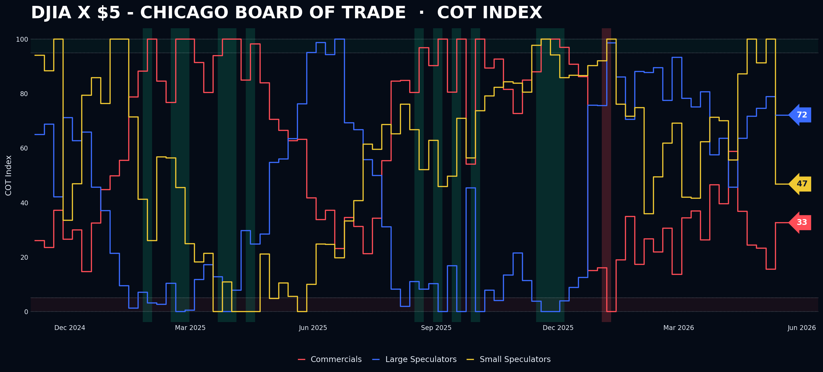

Energies
Nothing worth noticing happening in energies although they are on the mouth of everyone across the street
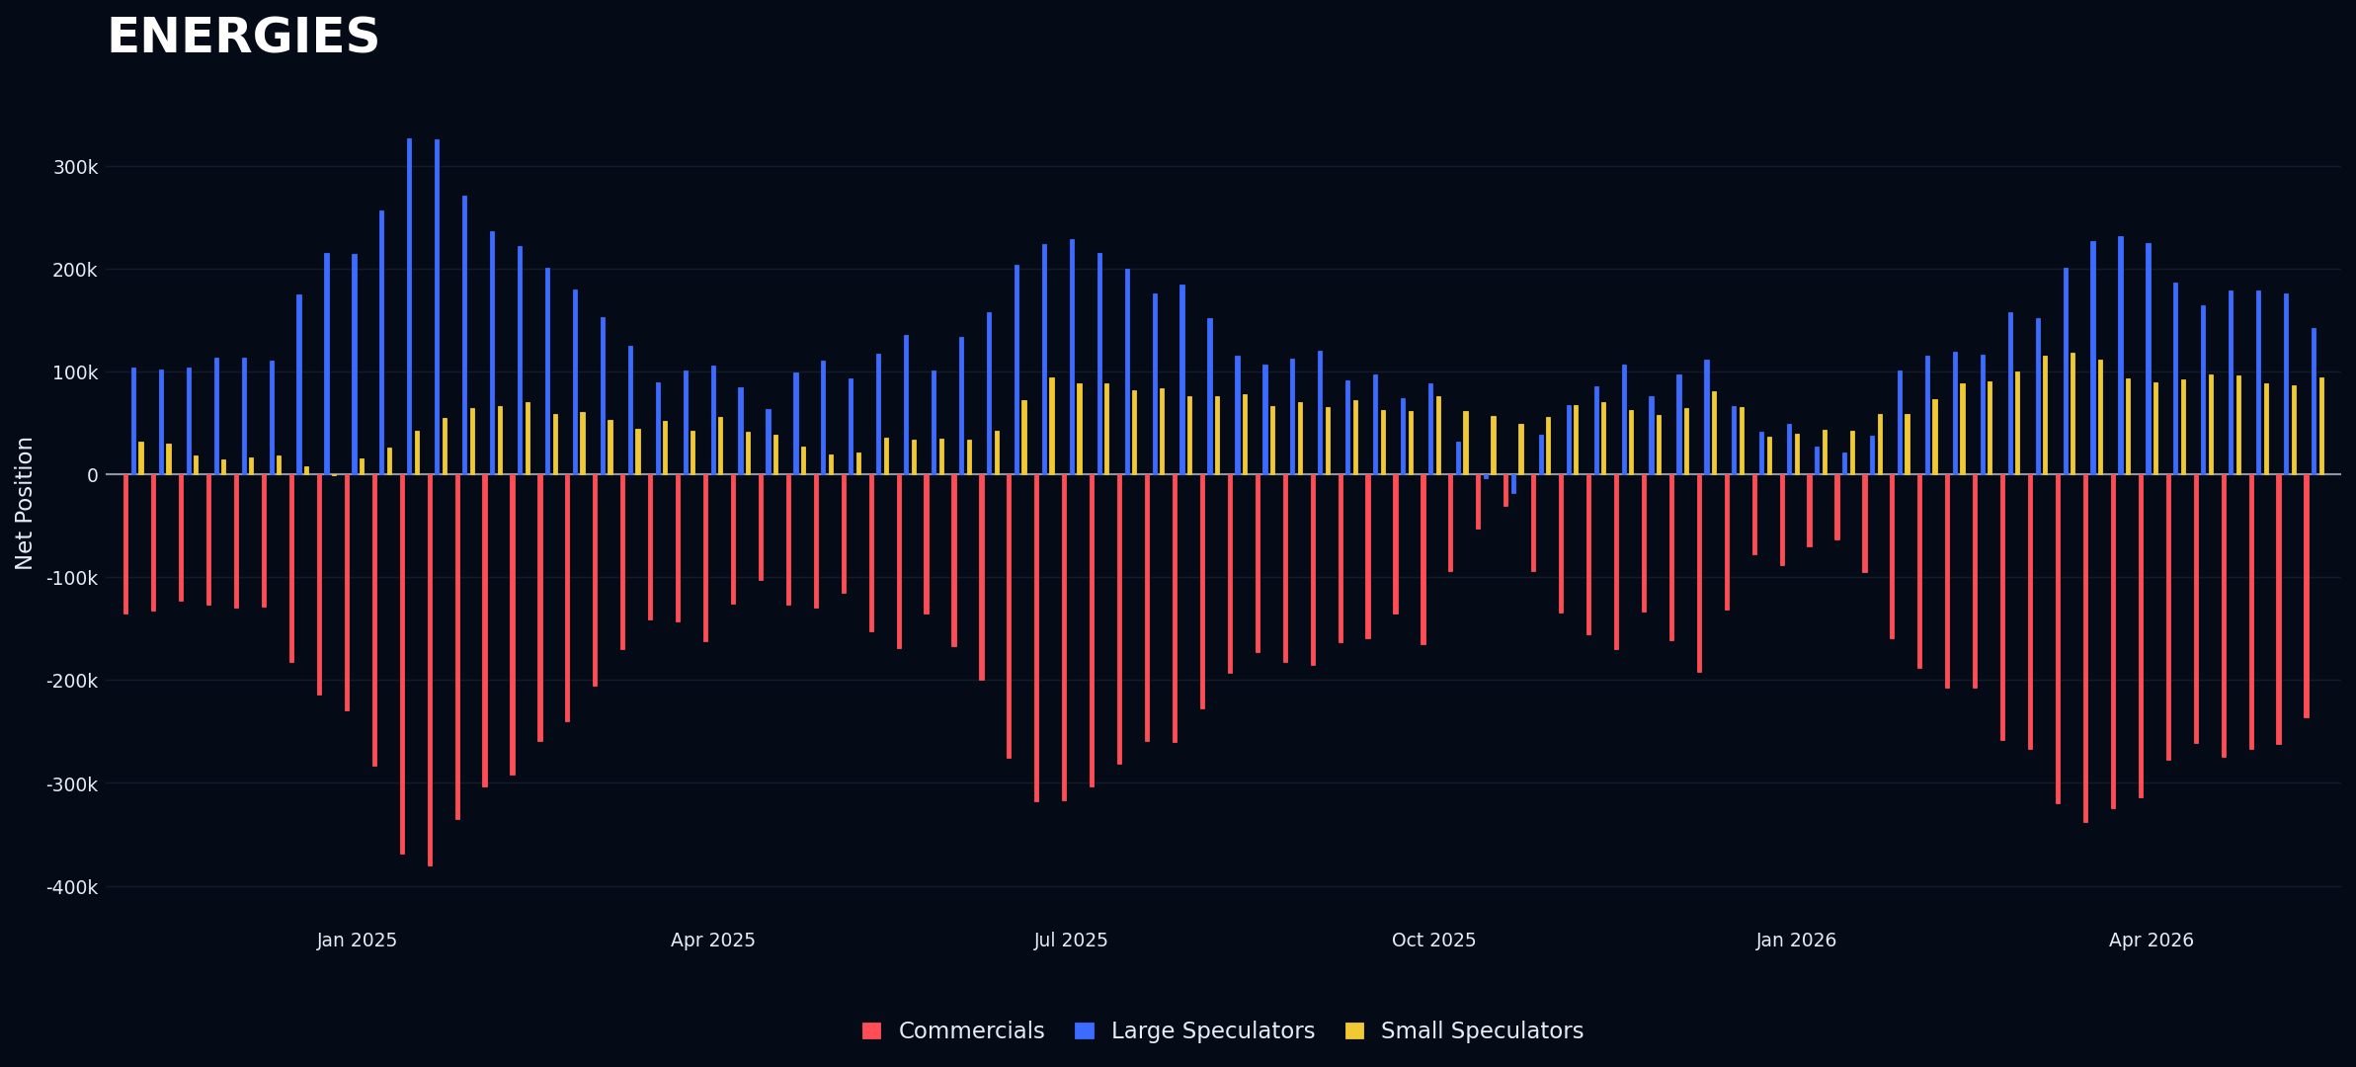
Another week of selling in Crude oil, I believe there is no edge in being on any side in energies right now
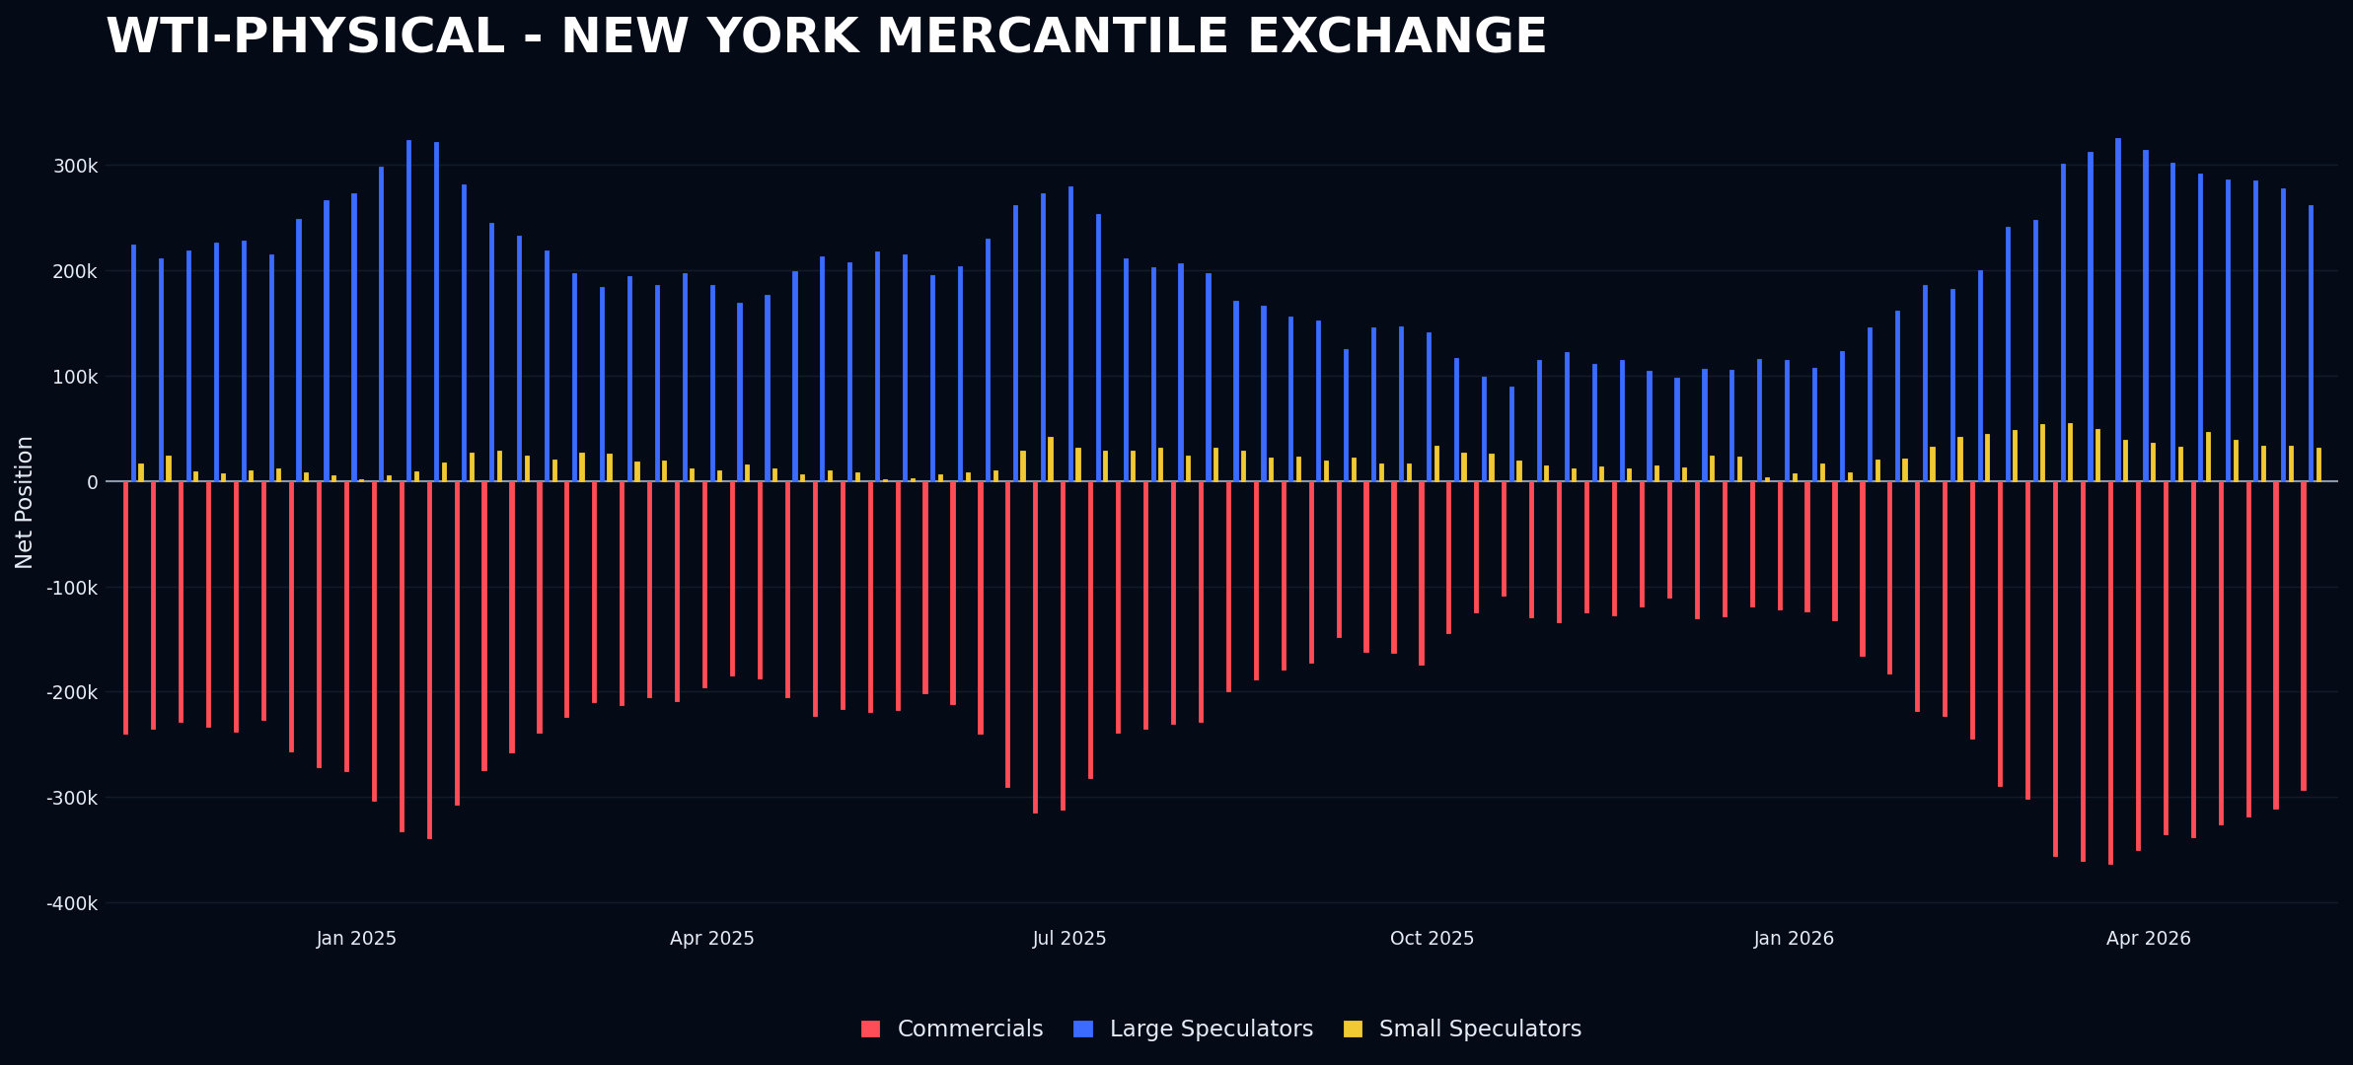

Metals
After the monster move of Silver at the beginning of this week the net positioning increased only slightly to the upside, all gains were then erased by the end of the week. More comments about metals in the current situation section.
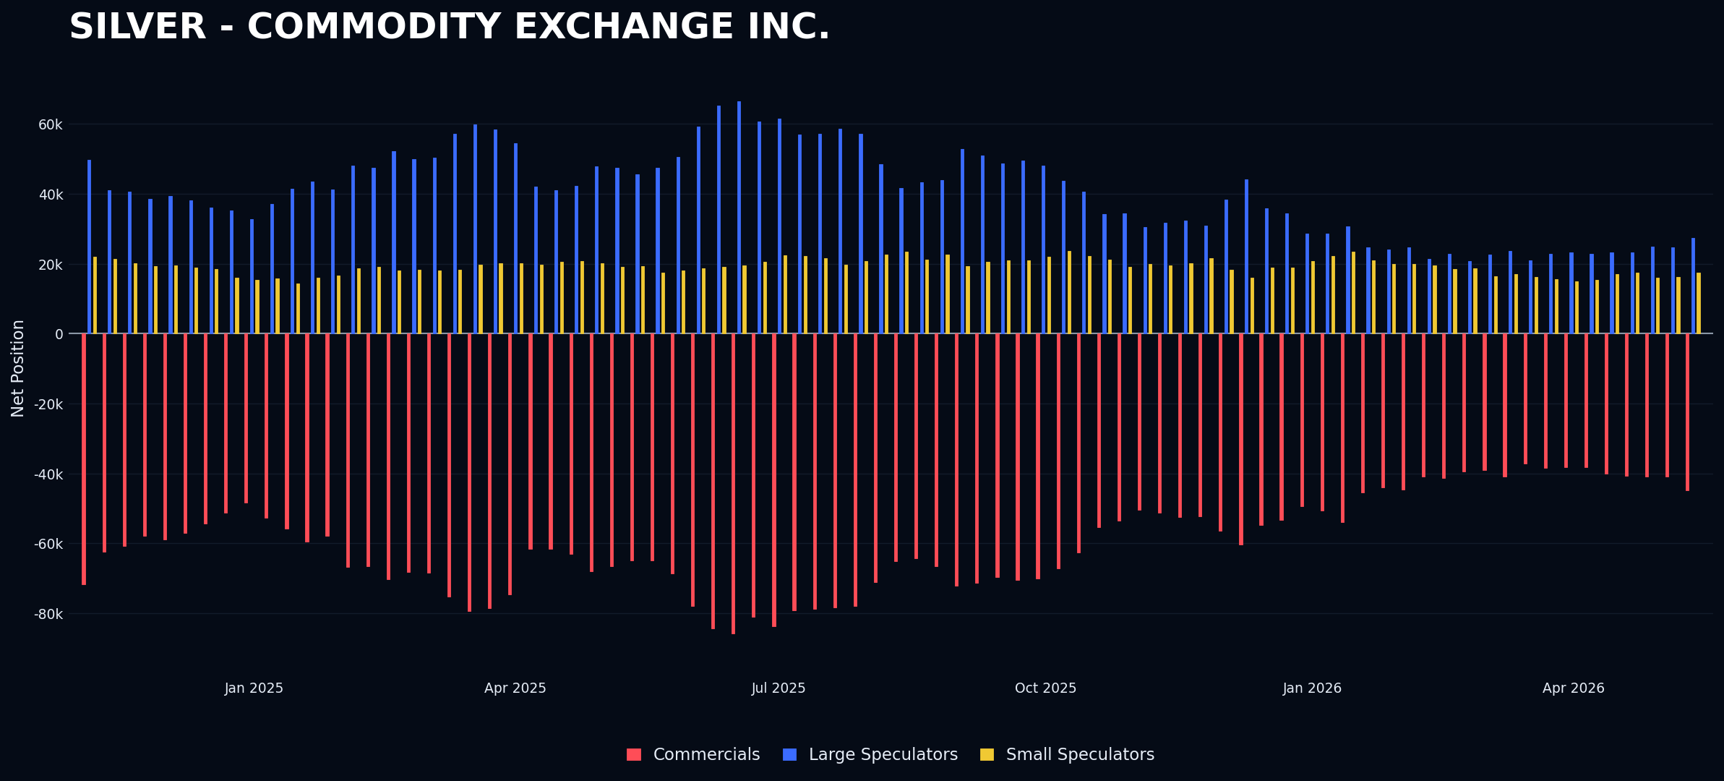
Gold has remained stable in both positioning and price since January. Currently, I believe there is no advantage in trading these assets, and those expecting a multi-year super cycle are mistaken, as positioning shows no clear direction. The primary risk in my opinion is only to incur in high broker commissions without significant gains. Overall, the market shows little movement, and traders should exercise caution to avoid unnecessary costs.
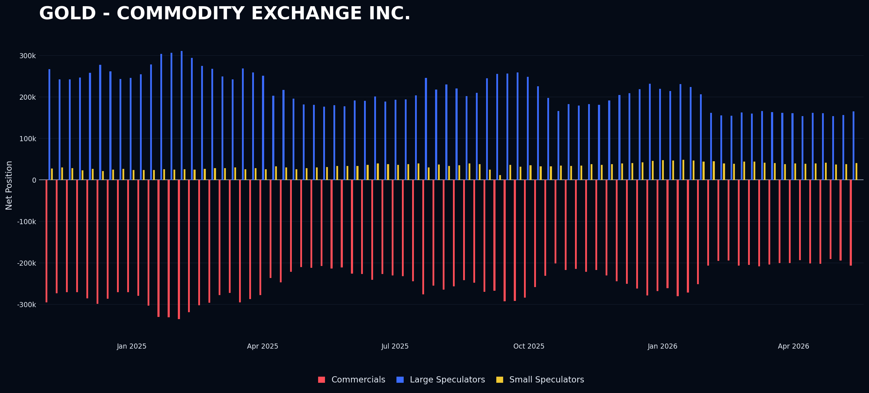

Fixed Income
I am reading about some people shorting TLT and buying the short end of the curve. This is clearly reflected in positioning. Following the 30-years, hedge funds shifted to net short positioning in the market, increasing their shorts again this week as prices declined sharply toward the week's end. This strategy has been profitable for hedge funds so far. Retail traders however bought, fighting with the tape again and likely jumping into TLT collectively. I anticipate more activity in the coming weeks. Currently, there is no advantage for us to participate in this market, as the conditions do not favor our position or provide a clear edge.
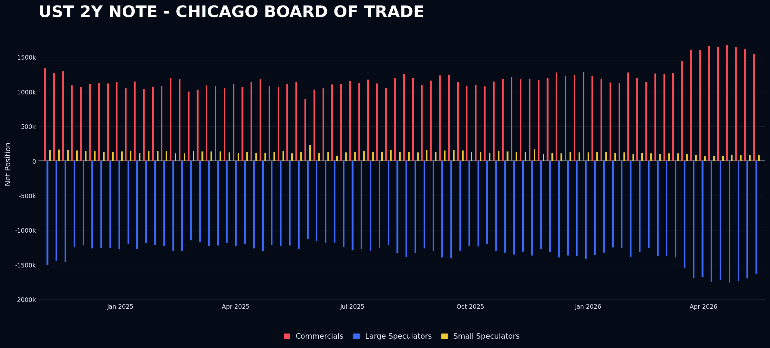
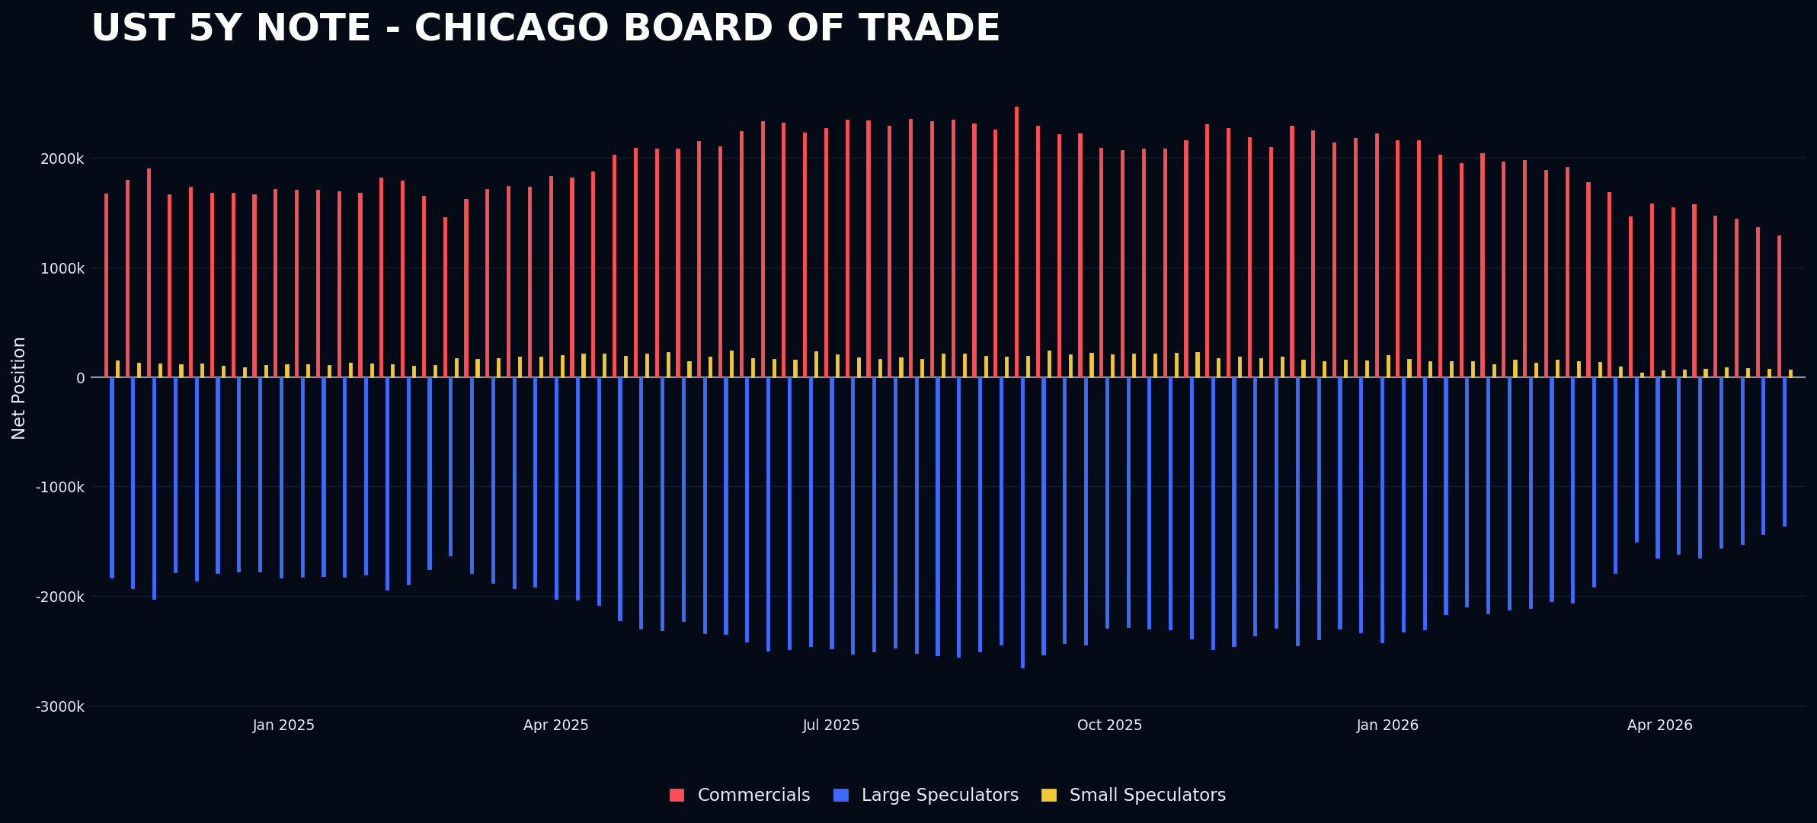

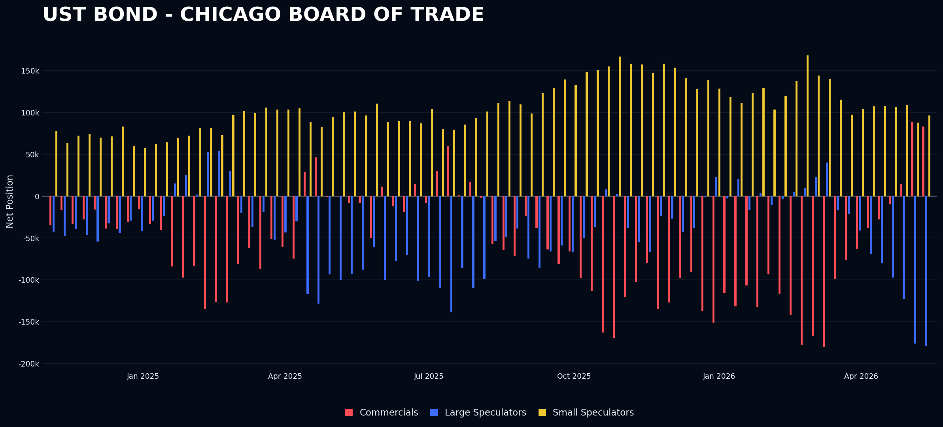
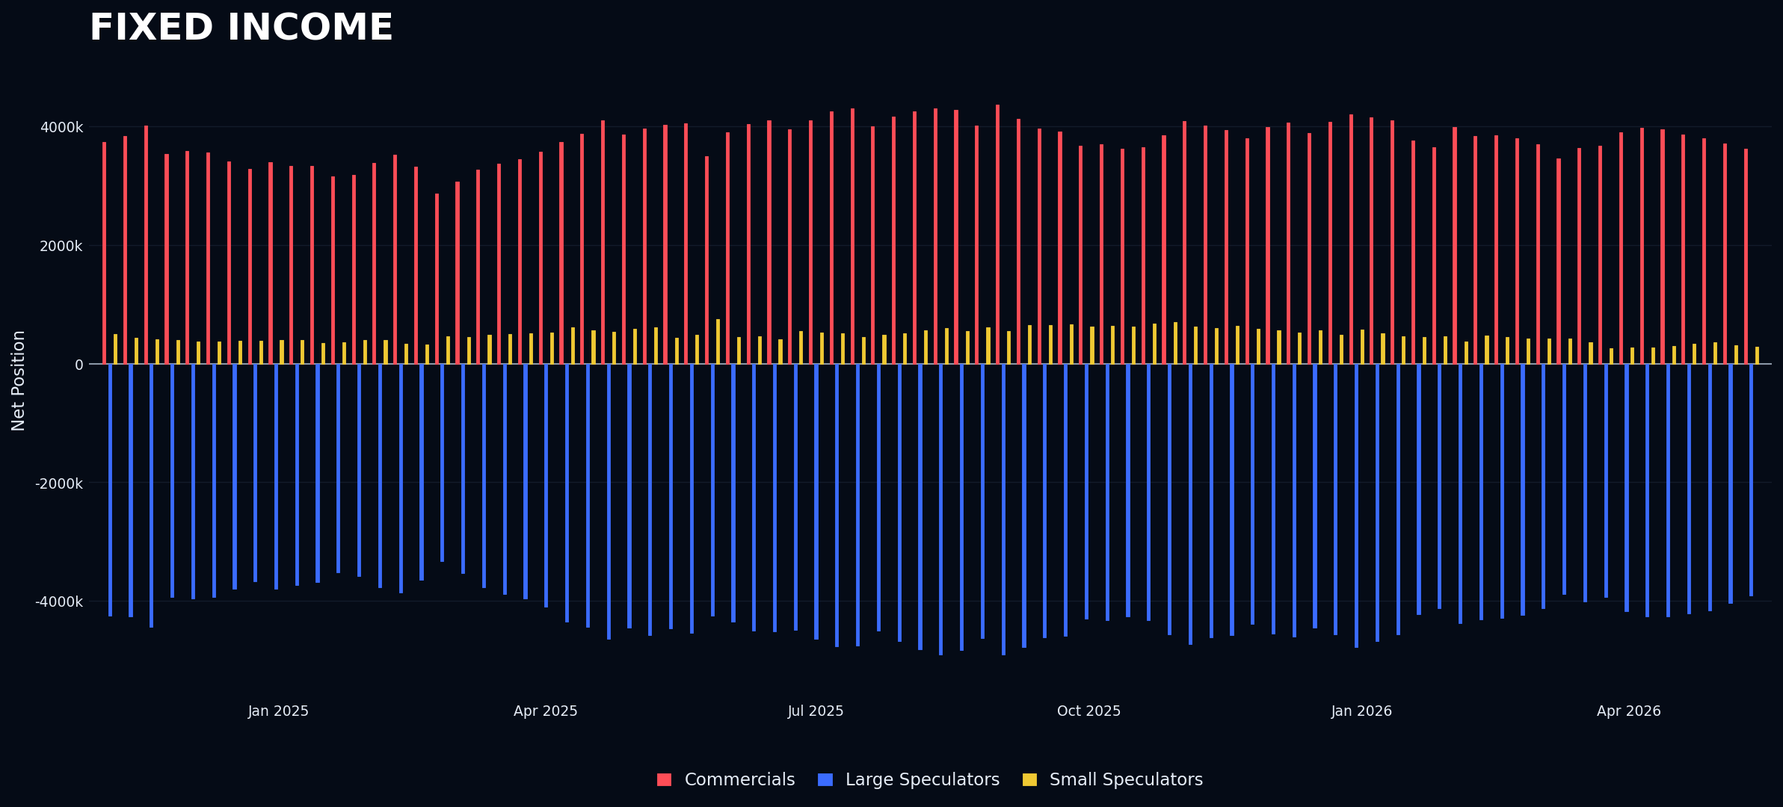

Crypto
The net change in small speculators becoming extreme Long is not a bug and neither a mistake. It’s real and this has been seen both in Ether and Bitcoin. Being a degenerate Gen Z I want to give my own personal comment in the current situation section.
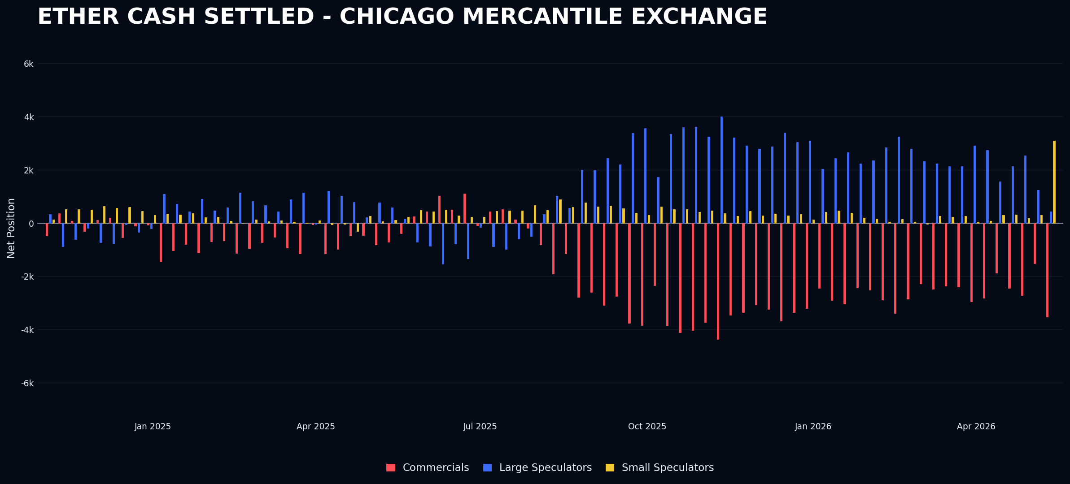
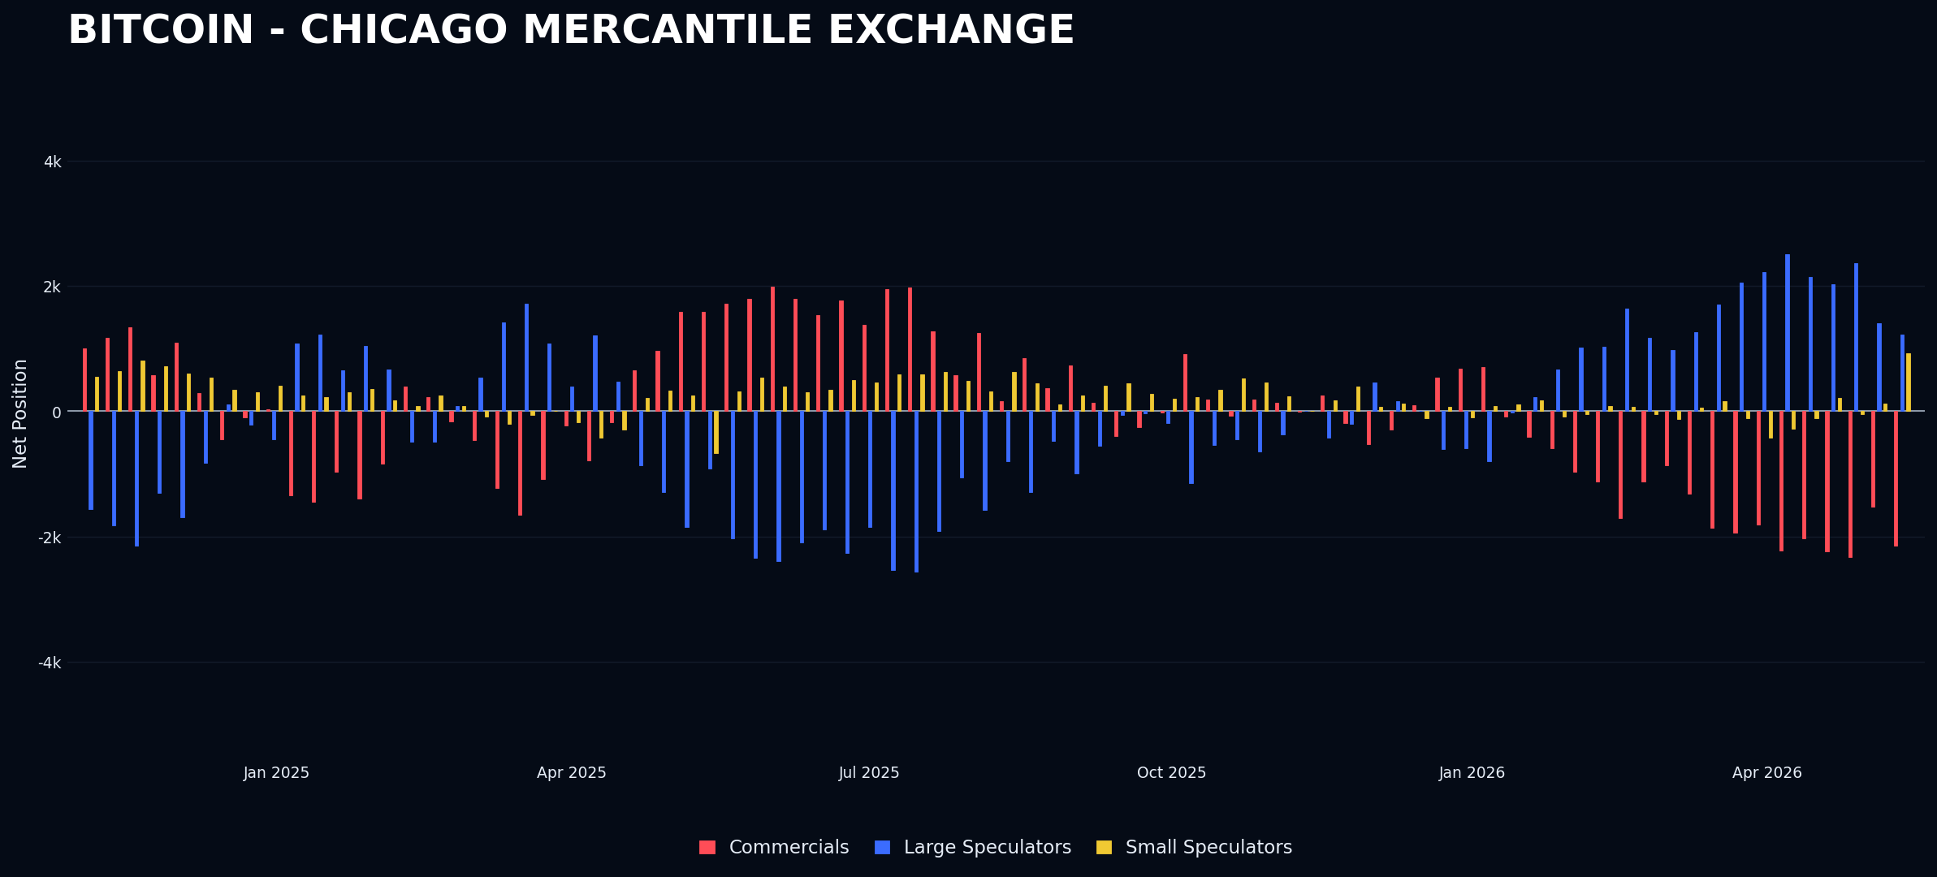

Currencies
The Australian Dollar remains the most crowded market in the currency space as of Tuesday. We have seen some promising price action toward the end of the week.
6A is a current short set up on my index.
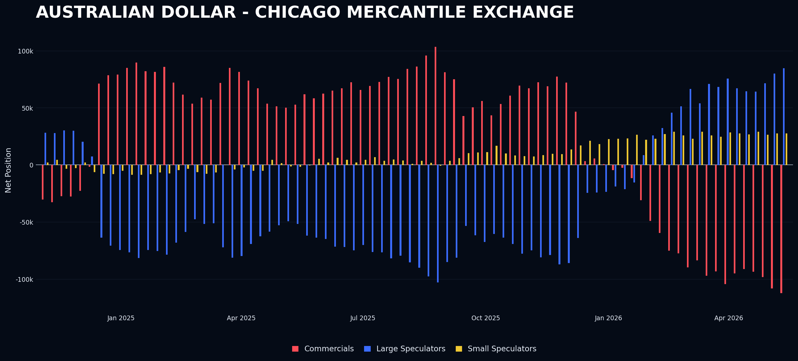
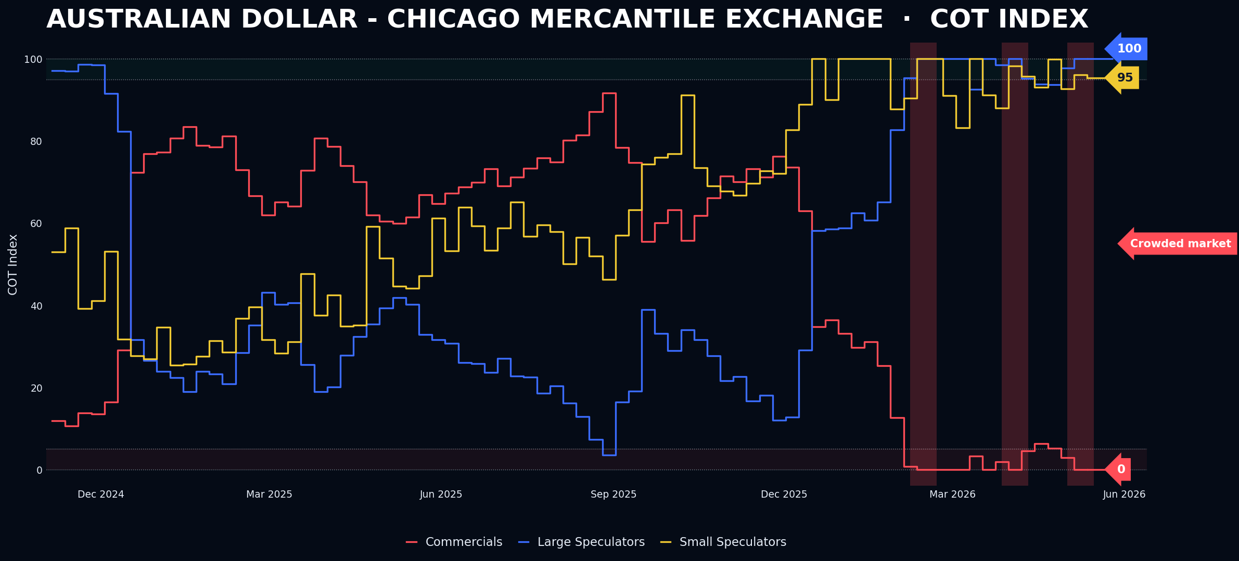

Softs
Cotton remains the most crowded of all Softs, with no major changes in other markets in this space
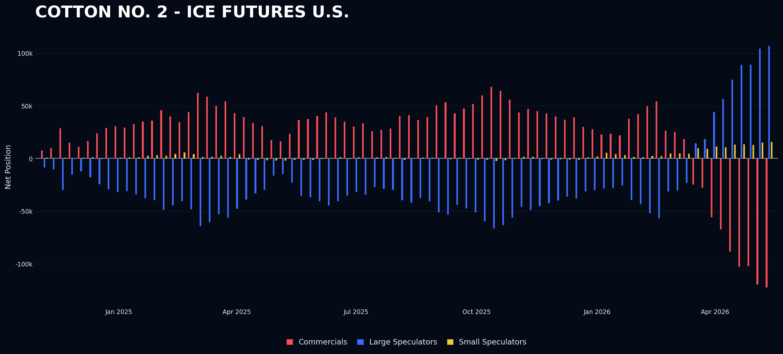
Overall they don’t seem to have any edge combined together
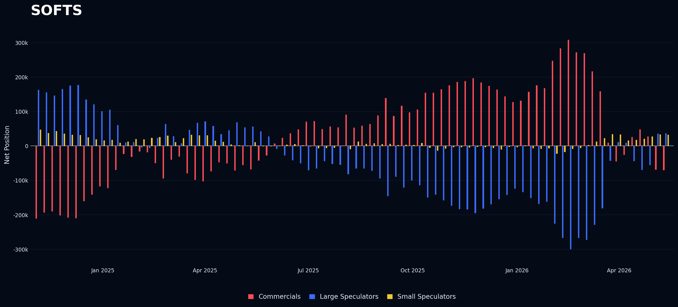

Livestock
Not my market and also very little edge in this space at this time
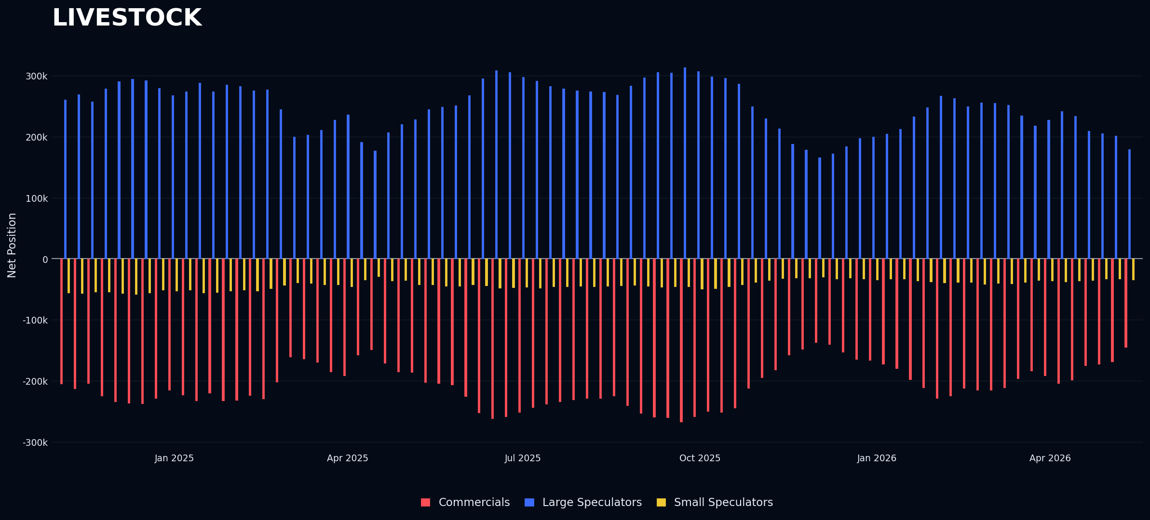

Grains
Wheat was set up as of last week, but its positioning dropped significantly. The WASDE report initially pushed prices upward, but all gains faded within a few days. Those who went long based on bullish numbers from the report were heavily burned. This is why I avoid executing trades based solely on price confirmation; I prefer to act on price failure. Relying on news alone can be misleading, as it’s too easy to assume the trend will continue in the same direction.
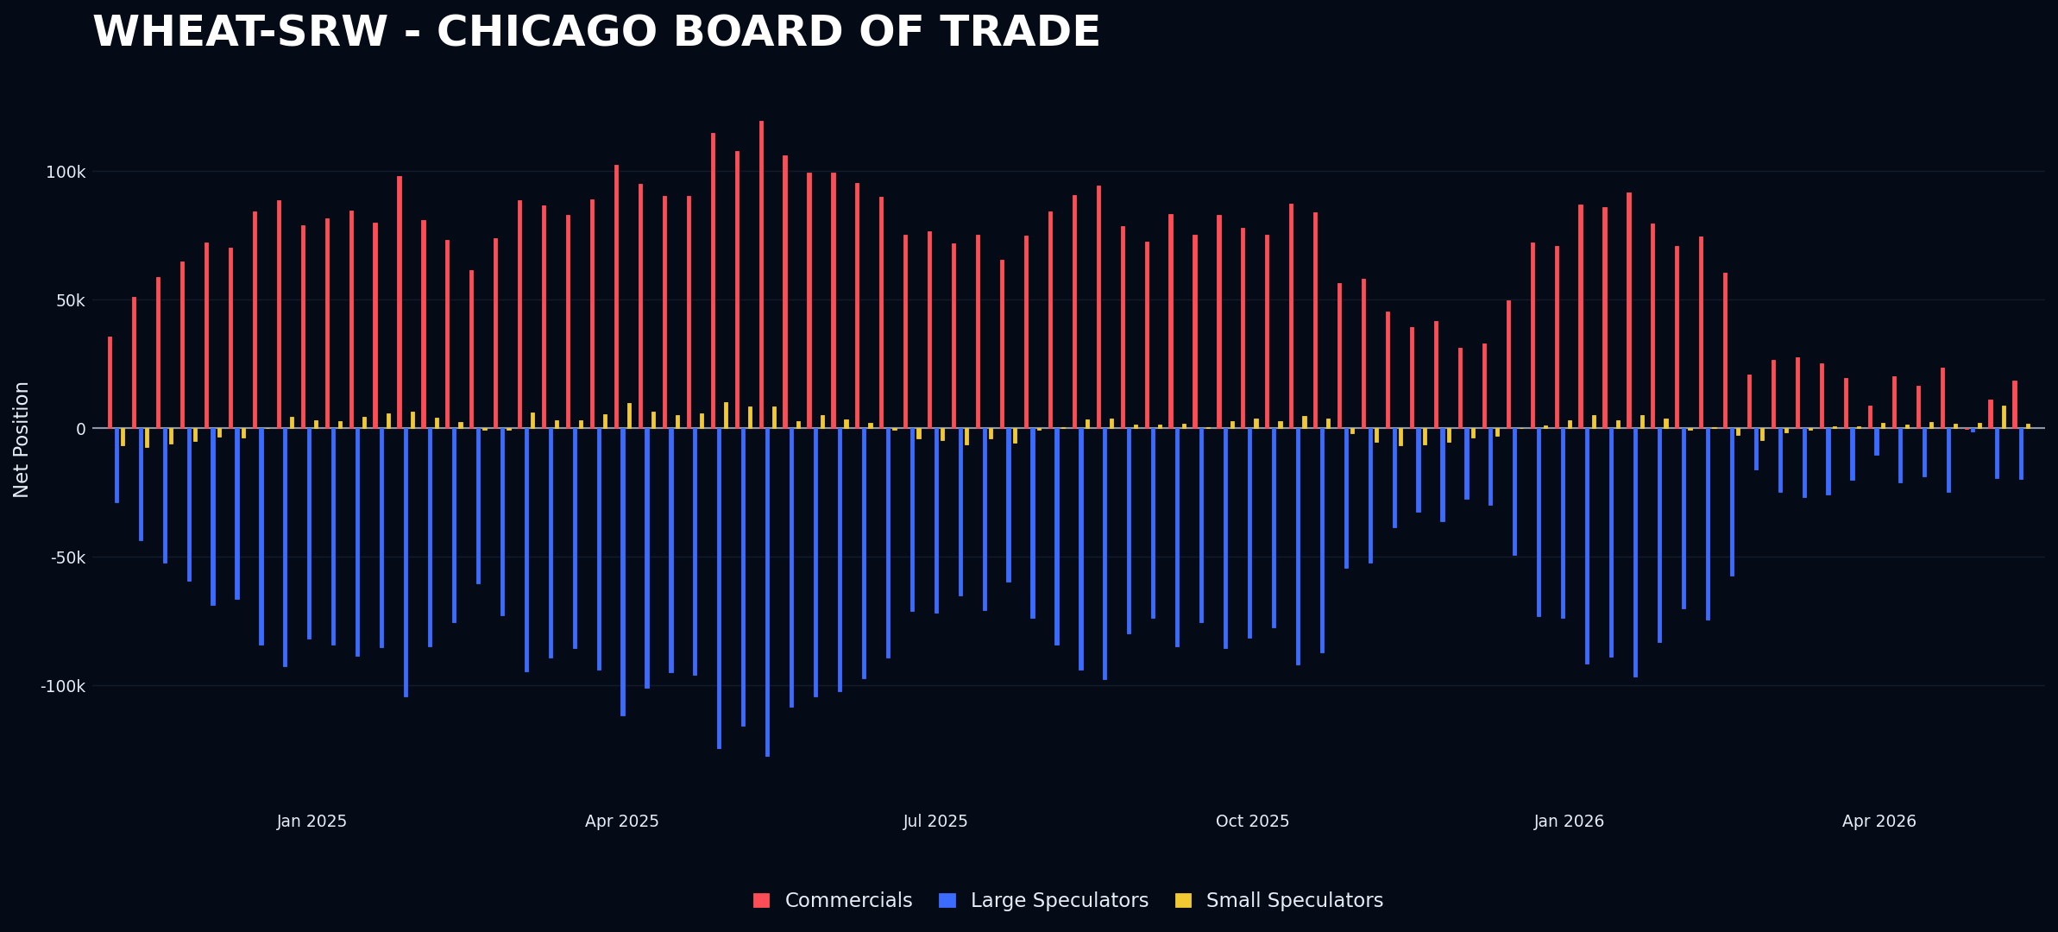
SoyBean Meal had pretty much the same reaction of Wheat.
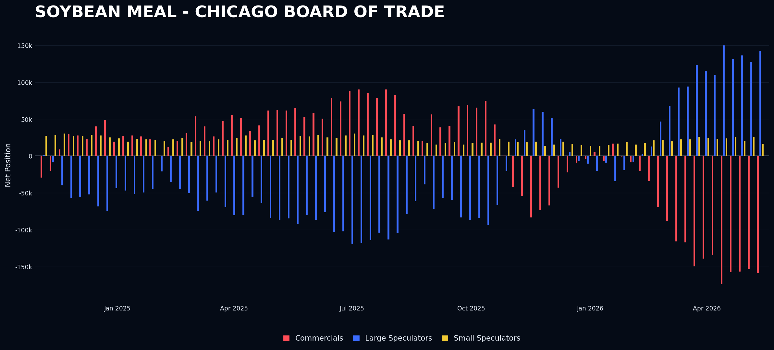

Combining | Positioning, Sentiment & Price Action…
What a week—both on the news front and in terms of price action. I will begin with equities, as I want to address a behavior I have observed during a study I am currently conducting. This study involves analyzing years of positioning data and market activity. The current situation in equities is not an anomaly; rather, it exemplifies typical behavior seen in a healthy bull market. I believe that the prevailing sentiment among market participants—being overly bearish and expecting an imminent pullback before re-entering—is actually fueling the market's continuous rise. This shorting activity and the cash reserves held outside the market are driving prices higher, especially since the bottom on March 30th. This phenomenon can be described as an "uncrowded bull market," which, according to my investment process and analysis, is among the healthiest types of bull markets. I have identified this pattern as a "Divergence Pattern," which manifests when speculators short into a bull market or buy into a bear market. This behavior reflects the so-called "Angry Bear" mentality that has persisted since 2022. Many investors expect a bear market soon and thus stay outside the market, leading to an uncrowded environment. Paradoxically, this results in the market climbing higher, causing investors to miss out on further gains. Eventually, a bear market will occur, and they will claim to have "known it" all along. However, the question remains: will they be solvent when that happens? The adage "the market can stay irrational longer than you can stay solvent" is well known. I prefer to respect this principle and, rather than fighting it, choose to submit to it. The key lesson from this situation is not to fight the trend. I personally experienced this firsthand in 2023 when I tore down two trading accounts for not respecting this principle. I do not recommend such actions to anyone.
Regarding news, inflation data released on Tuesday was slightly hotter than expected, but the market's price movements were not significantly impacted. Overall, sentiment remains overly bearish, in my opinion, and until this skepticism diminishes, I do not anticipate any meaningful downward movement in the stock market. It is also noteworthy that bearish sentiment, as measured by the AAII survey, has increased week over week despite the market grinding higher. I find this disconnect to be irrational and somewhat absurd.
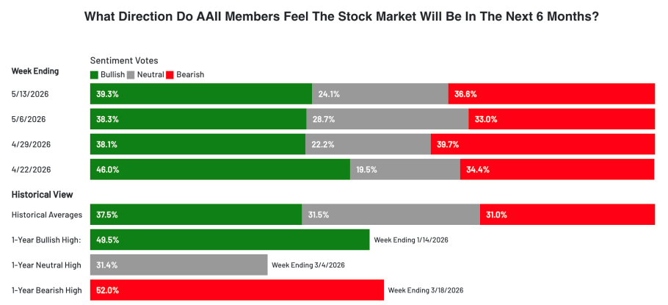

Leaning into metals and their price action, I must say that the reason I don’t buy into markets that break out without showing any crowdedness—meaning no shorts to be squeezed—can be observed in the price action of silver this week. As of Tuesday, silver broke out of its range, printing a 9% move to the upside and seemingly leaving everyone on the outside. It was widely discussed, and it appeared to be the asset to buy. However, by Friday, it had already given back all the gains and was trading lower than it started. I could have gone long, driven by FOMO on Tuesday’s move, but since there was no trigger in my process, I stayed out, and this decision paid off. I can’t recall how many times I’ve fallen into that trap in the past. Along with mistakes like buying intraday based on promising moves only to end the day at a loss or overtrading, I have made nearly every mistake possible and paid a heavy price for it. To put it into perspective, I reviewed my past trading records from the early years and found that during the first three years, I executed over 200 trades annually. That’s excessive. What kind of process can have an edge with over 200 trades per year? Clearly, it was driven by FOMO, overtrading, trading out of process, and a fundamental lack of understanding of how the sector operates. I now consider myself beginning to understand how the market works and how to wait for the right opportunities. Since the start of this year, on May 16th, I have made only eight trades—trades where I had full conviction and which aligned with my process. Of these, six resulted in losses, one was profitable, and one is still open and currently profitable. Despite the losses, I am up 4% year-to-date. I find this approach satisfying; it feels correct, and I believe it aligns well with my personality. This is what I refer to as “a process that fits my personality.”
Regarding cryptocurrencies, I am quite confused about what is happening in that space. Retail traders have become extremely bullish on Ether and Bitcoin, as if there is no tomorrow. I wouldn’t be surprised if both assets decline in the coming weeks or if some news emerges revealing significant fraud within the crypto sector. The sudden change in positioning seems suspicious.
Lastly, this week’s key point concerns the WASDE report released on Tuesday, which was clearly bullish for cotton and grains. All grains closed higher, but cotton—initially our short setup—rose only to close decisively lower at the end of the day. Last week, I mentioned the importance of clarity in news failures, and this week’s market movements reflect that. I acted accordingly by shorting cotton at the end of Tuesday, placing a stop-loss at the day’s high. This approach aligns with my goal of trading based on clear signals and understanding market fundamentals.

Next week Calendar | What to expect?
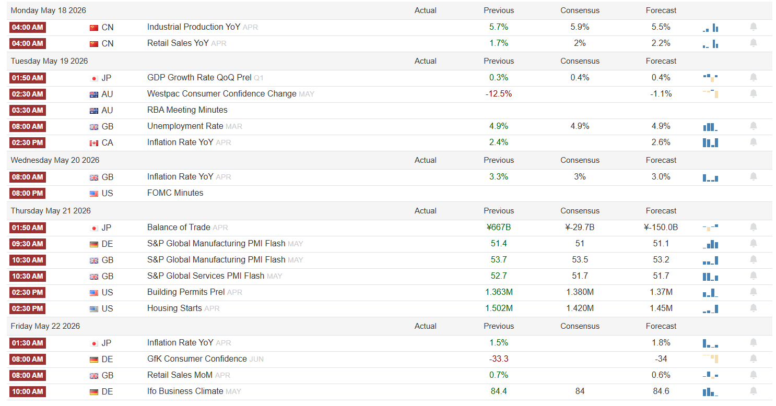
- We have the RBA meeting in Australia to monitor; any hawkish comments could significantly boost the AUD intraday and close lower, potentially triggering a short.
- Additionally, monitor the FOMC Minutes for a possible long in Nasdaq, although they usually do not lead to significant movements.

Current set ups and how I want to execute them?
- LONG NASDAQ: I want to see FOMC minutes moving market substantially. Need to come out something with an anomaly to convince me to put such a position on. I don’t think anything is going to happen.
- SHORT 6A: As I said above, I need to see something impactful from the RBA meetings. A more Hawkish than expected comments and a substantial intraday move with a down close otherwise I’m willing to let go of this trade.
- SHORT COTTON: It’s already an open trade.

Open trades
- SHORT COTTON as of Tuesday 12th of May Close. Stop on the high of the day.
https://www.usda.gov/oce/commodity/wasde/wasde0526v2.pdf

Closed trades
- n/a

