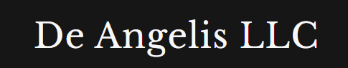
Weekly Market Report

30th May 2026
Contents

Equities 3
Energies 5
Metals 7
Fixed Income 8
Crypto 9
Currencies 10
Softs 11
Livestock 12
Grains 13
Combining | Positioning, Sentiment, Price Action… 14
Next week Calendar | What I expect? 16
Current set ups and how I want to execute them? 16
Open trades 16

Equities
Equities are now diverging from the positioning of small speculators to the one of large speculators
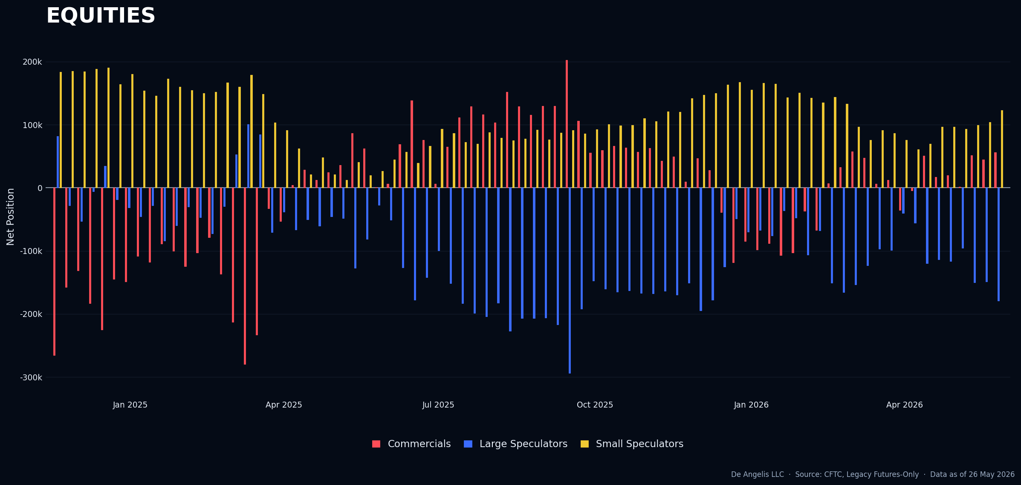
Visible also in single equities I’d say the most interesting asset to keep a lot at remains DOW where small ones have decided to go long after the move of this week
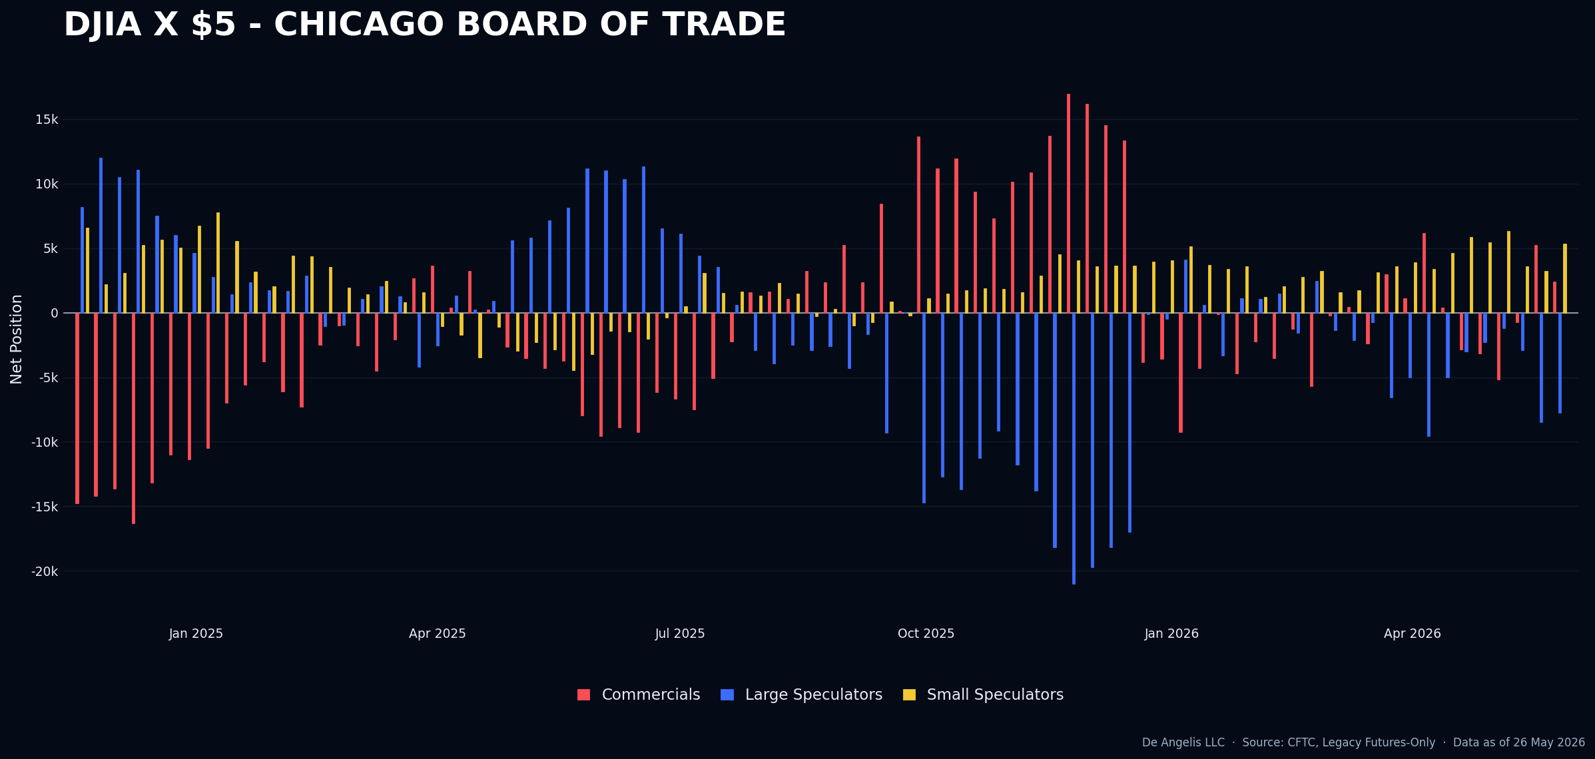
At this time, I see no edge in being short or long equities.

S&P 500 is in a clear divergence in positioning. Price is going up at the moment.
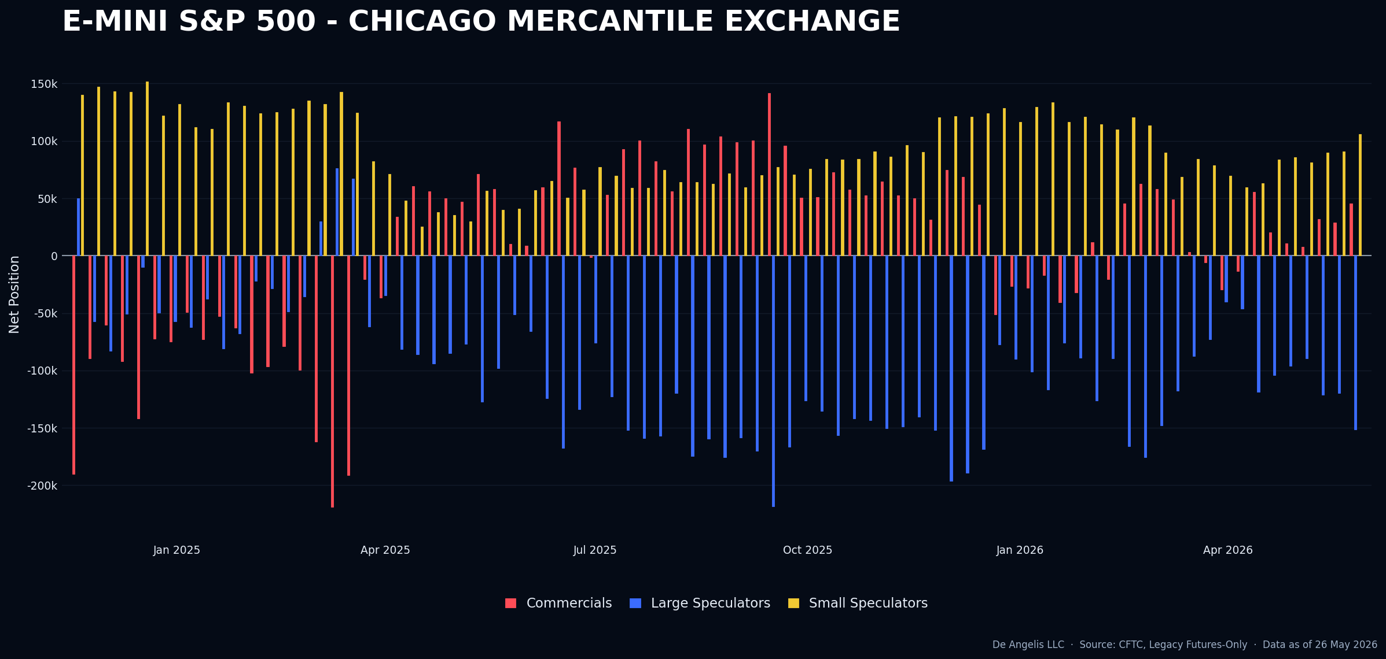
The surprise remains there where people just don’t seem to buy into the rally and this is fueling it. We have seen earnings for many companies last week including DELL. Pretty undeniable right? Up 32% in a single day
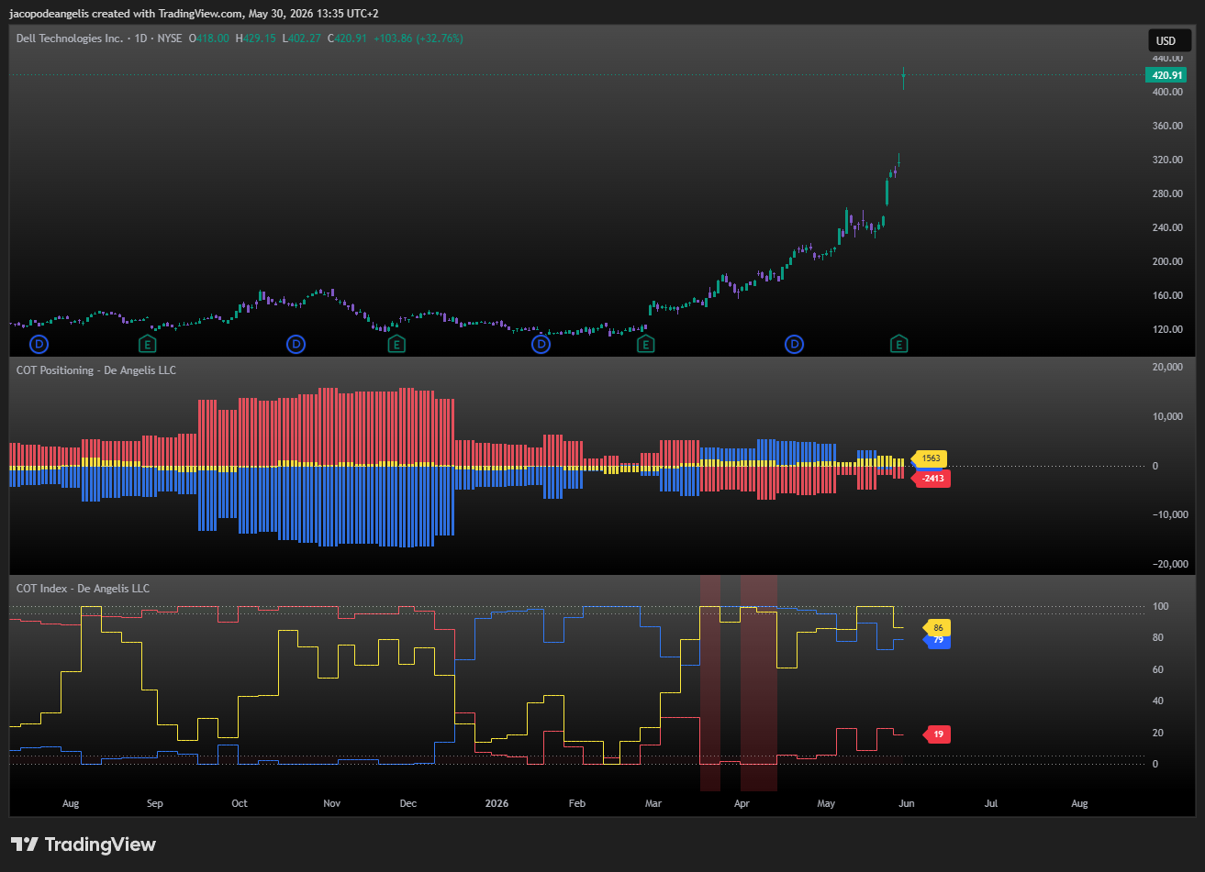

Energies
Since Crude Oil had a news failure on the 20th of May on a Bullish crude oil stocks change and prices closing down there was no coming back to the highs until now.
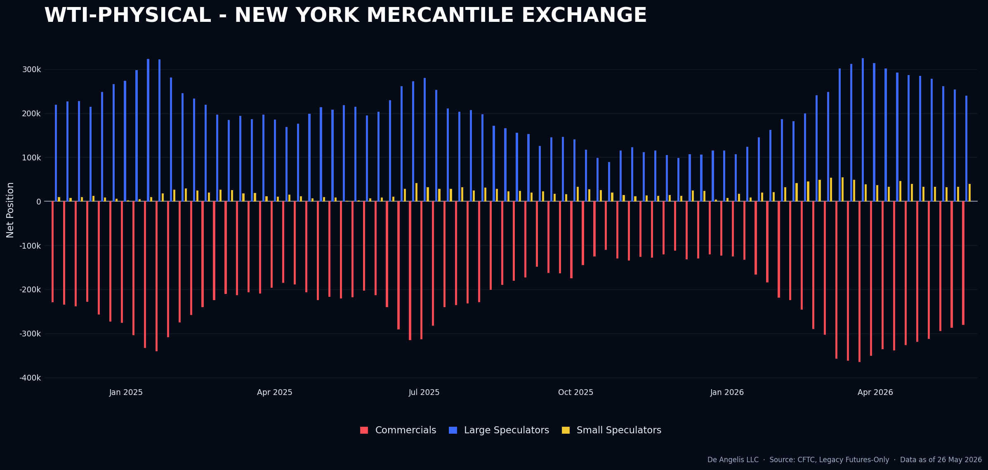
This week they got more long, however we are not there. Fighting with the tape it looks like to me
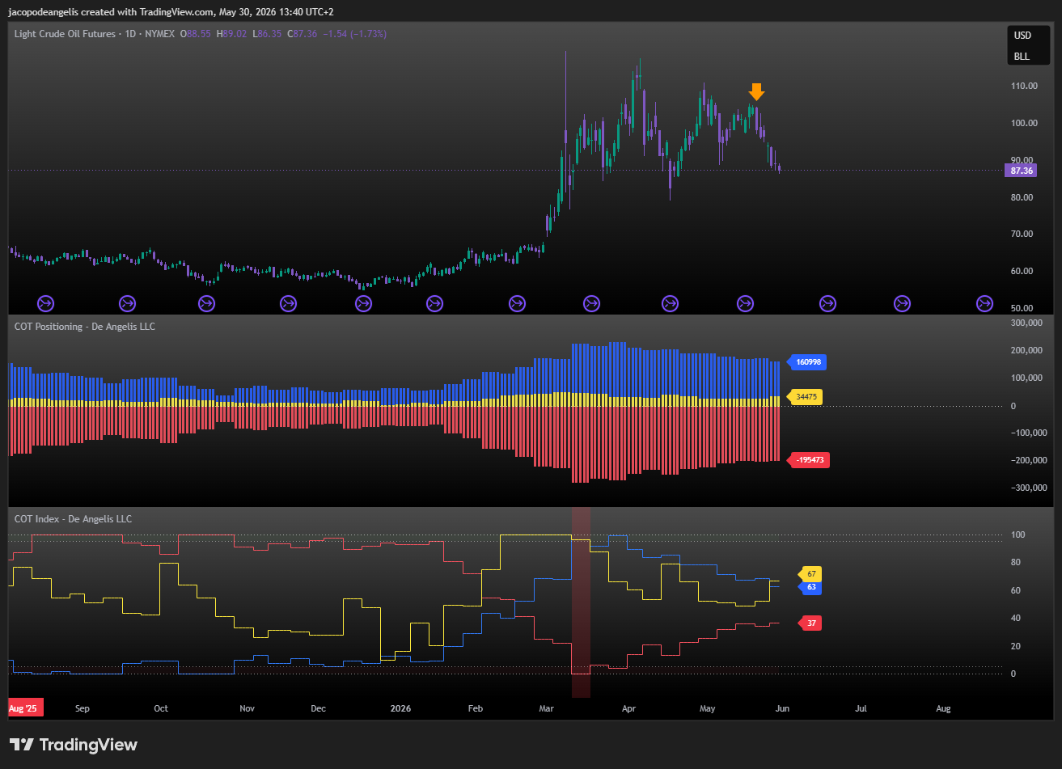

Natural Gas traders are getting shorter and shorter despite prices climbing higher. Index is now almost there, will be interesting to monitor the price action of this next week.
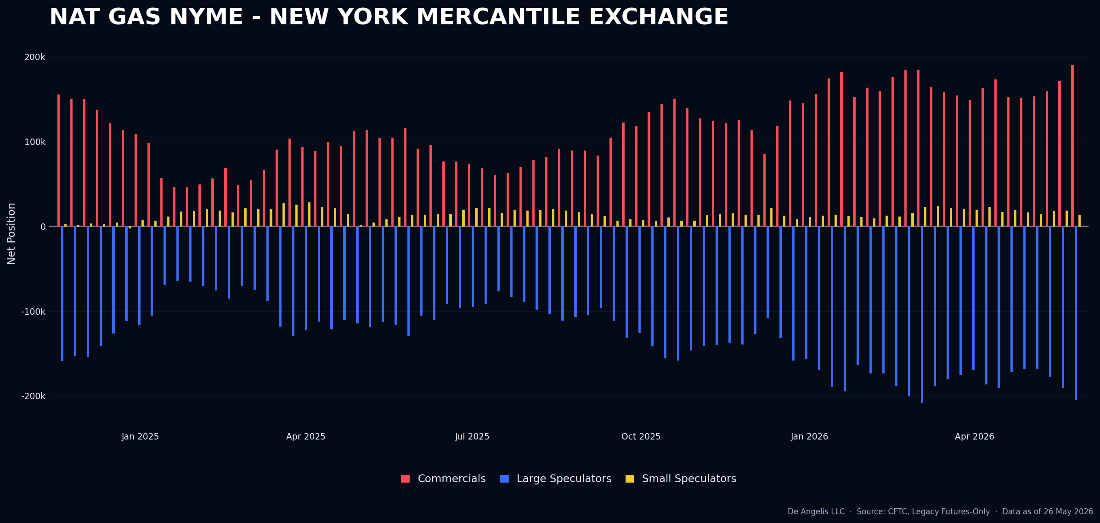
Index with small speculators is not there yet though.
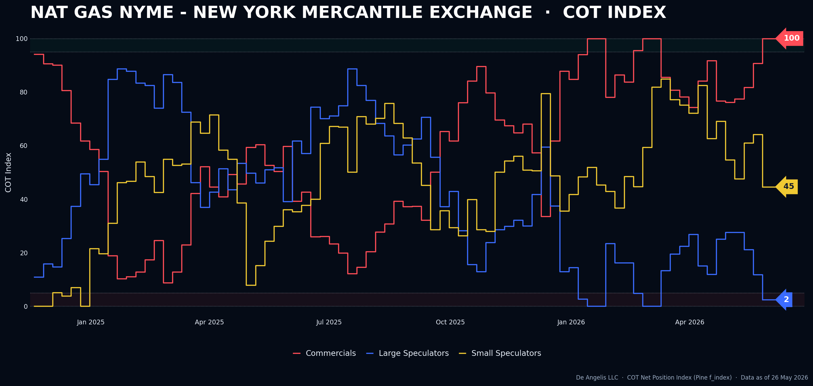

Metals
Gold Is a long set up and I think we might have a good entry point this week with reports upcoming on the new month. I’ll discuss this in the set-up section.
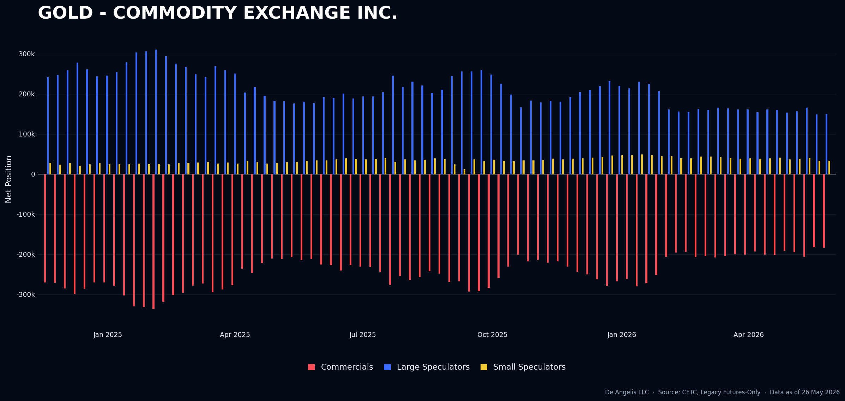
Index is showing crowdedness levels for the second week. We had a reversal candle on Thursday with no news
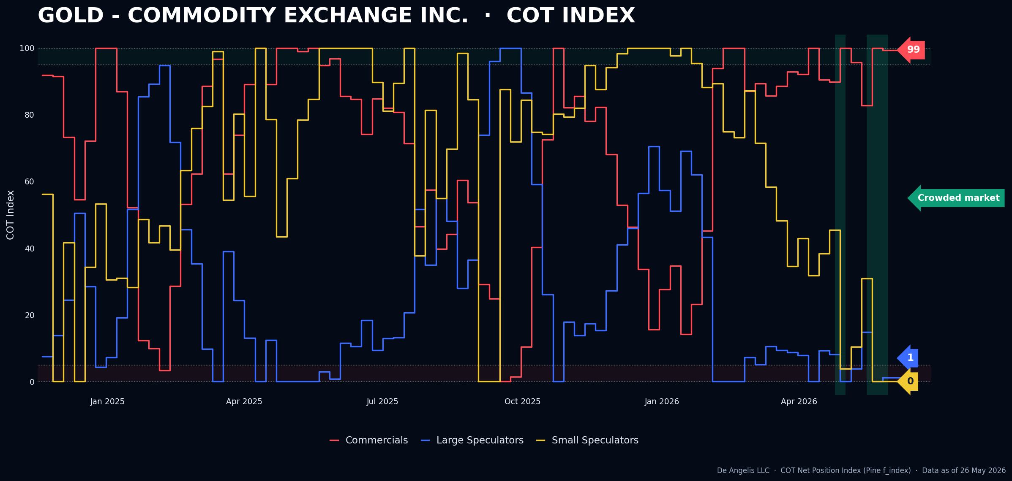

Fixed Income
Small speculators just deciding to go ballistic on the 10 years and shorting the 30 years. Don’t really know what to say at this time as none of them is an official set up
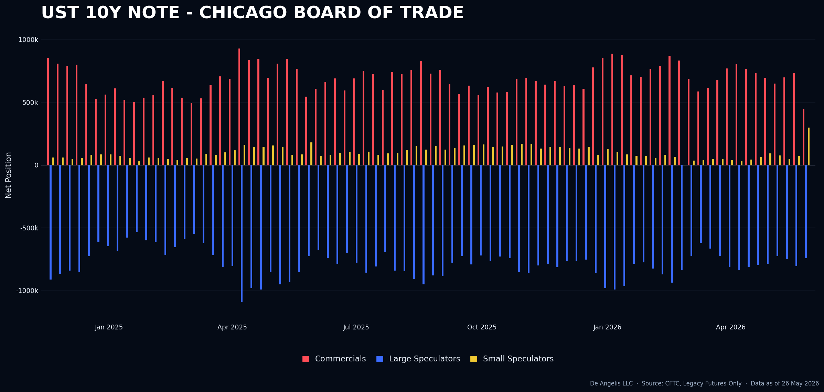
30 years
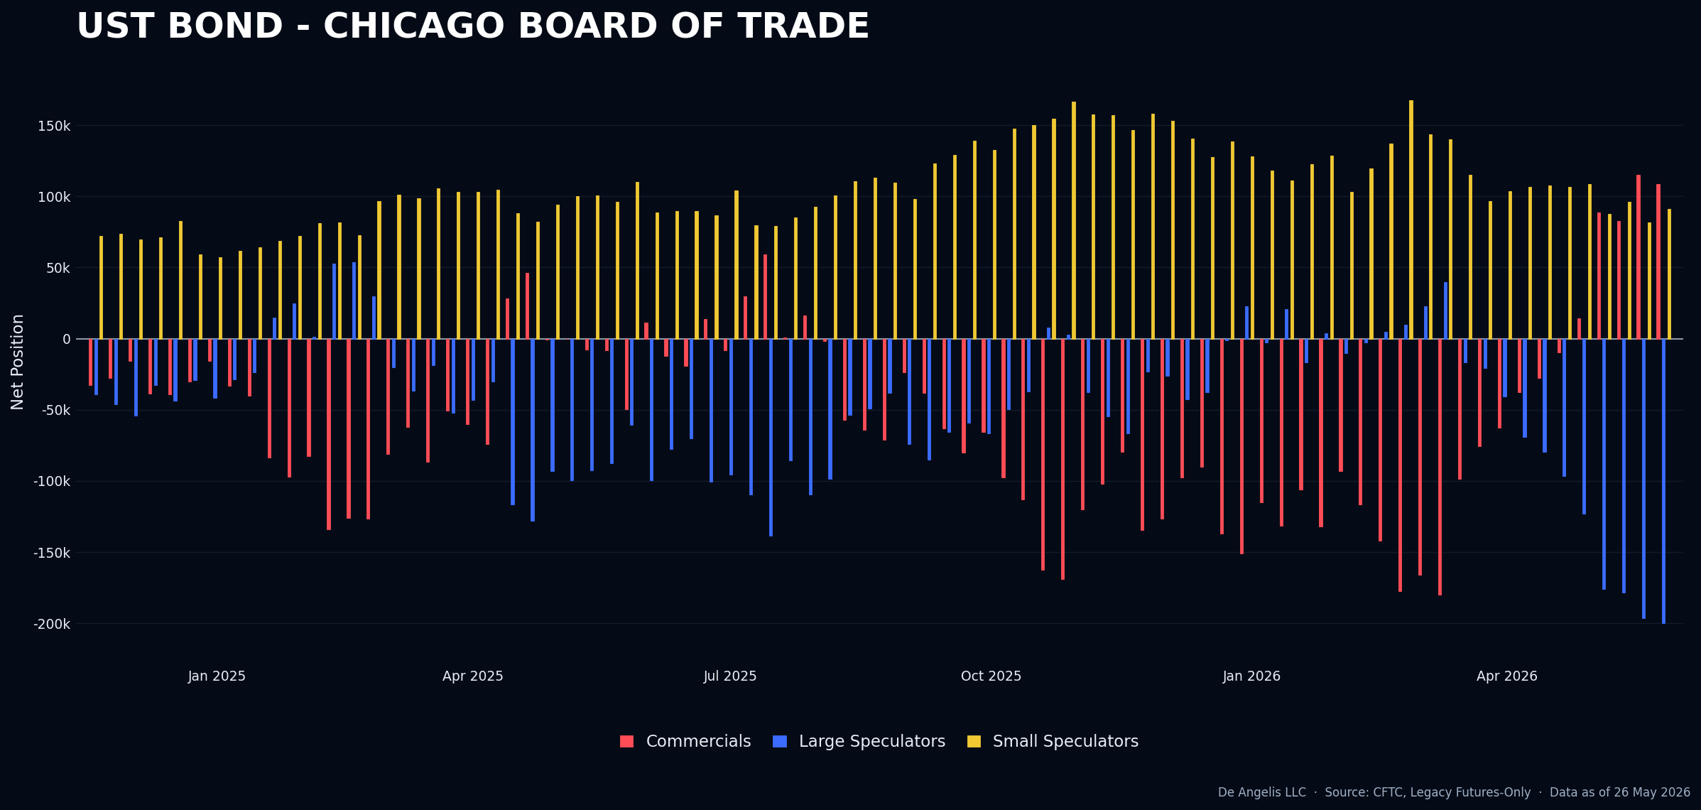

Crypto
Cryptos remain the most interesting market I am seeing, small speculators have now reversed into a net short in Ether and Small speculators have gone ballistic long. It might get really interesting soon in this space really.
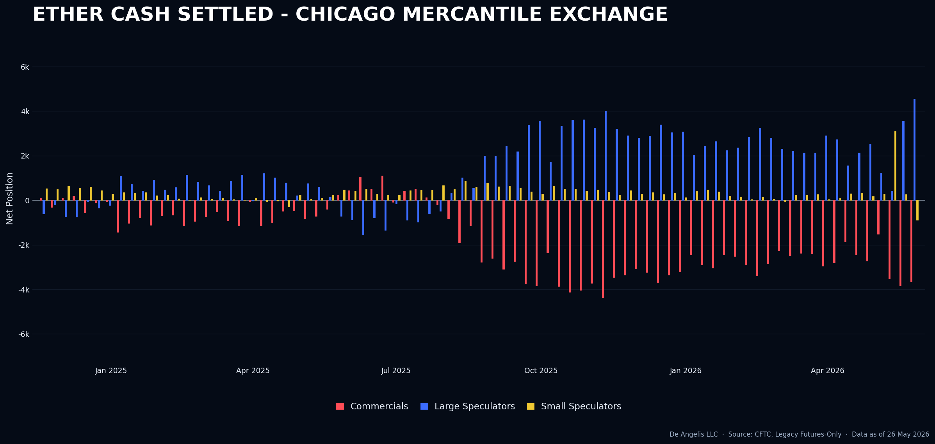
Bitcoin same for large spec and small spec unchanged
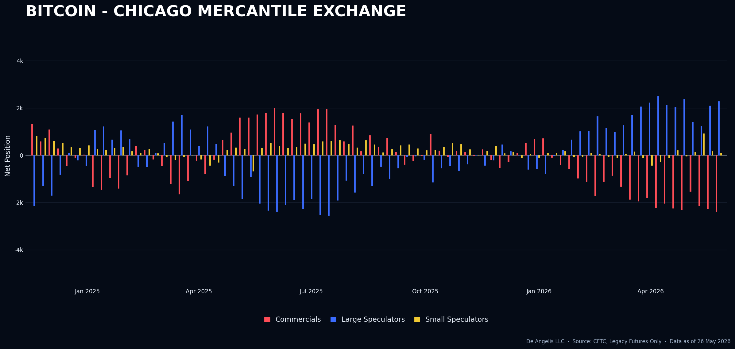

Currencies
The Australian dollar is not interesting anymore, and positioning is off. There was really no news failure to execute on anyway so I’m glad I didn’t take this trade, it means I respected my process.
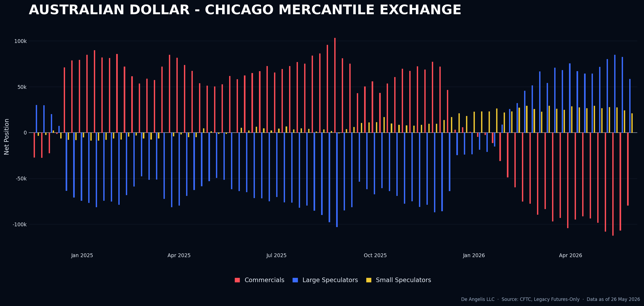
YEN is not there with the small speculators
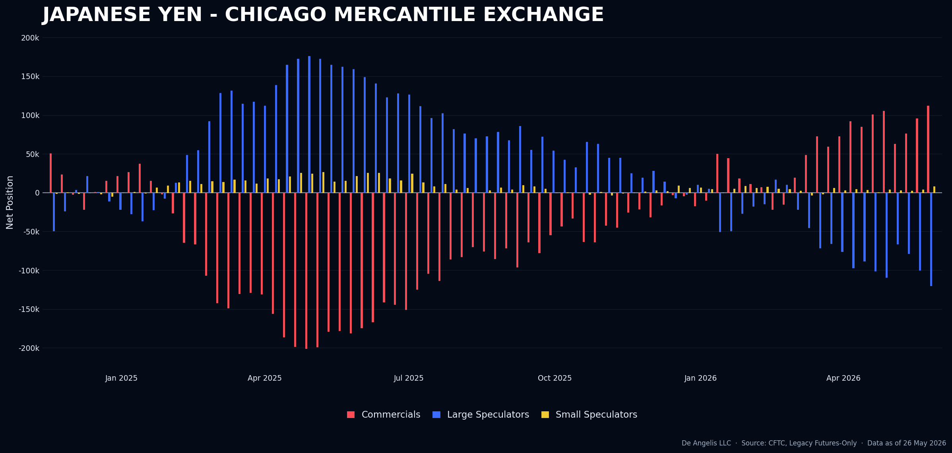

Softs
Cotton coming of highs in positioning since our short initiated. Still, it has not gone neutral yet.
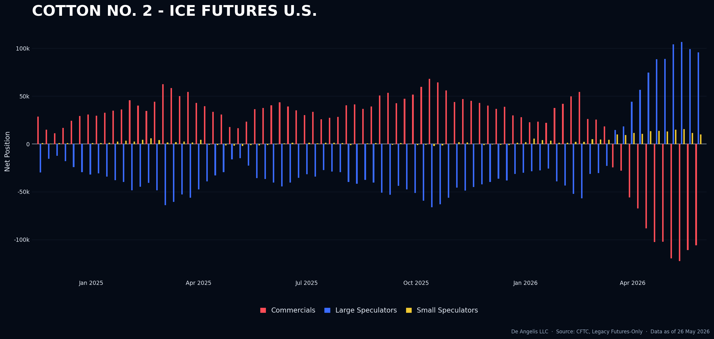
Orange Juice is a set up short. I will need to investigate what could be a news failure for Orange Juice because I have no idea.
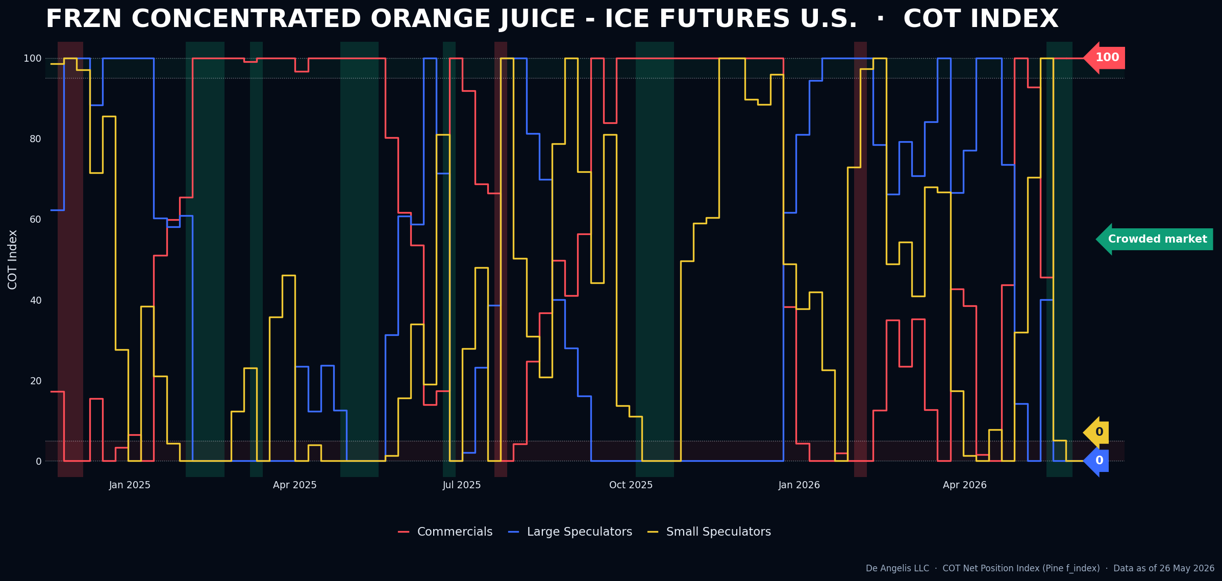

Livestock
Nothing happening here other than general selling and same pattern of small spec moving with commercials
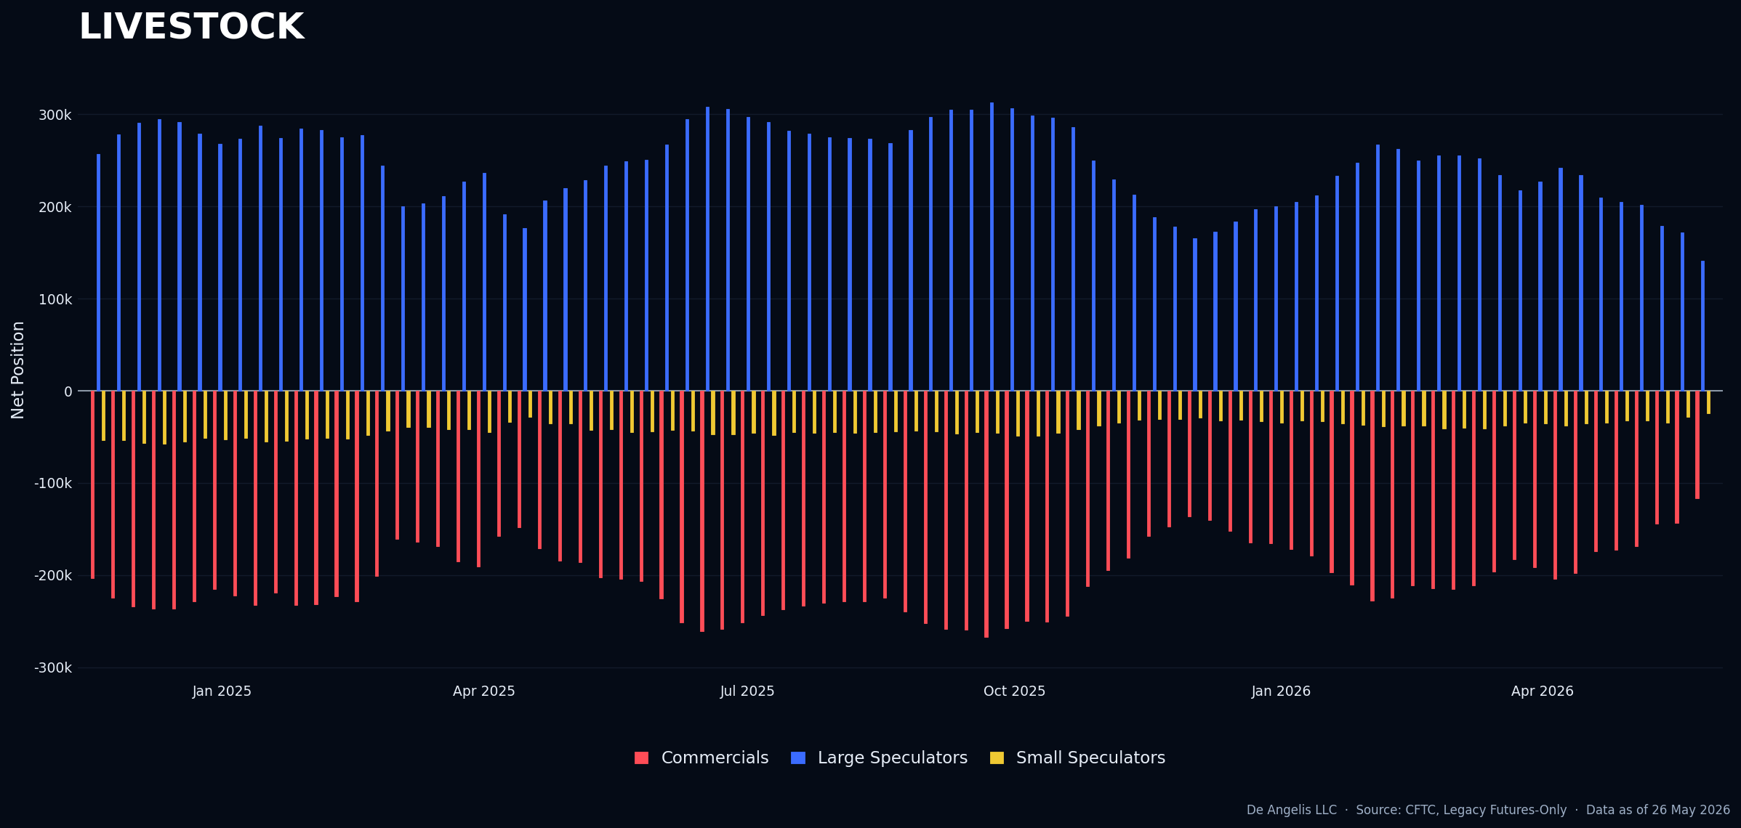

Grains
Soybean Meal Is a Short set up, the Next WASDE Report is in 2 weeks from now on June 11th.
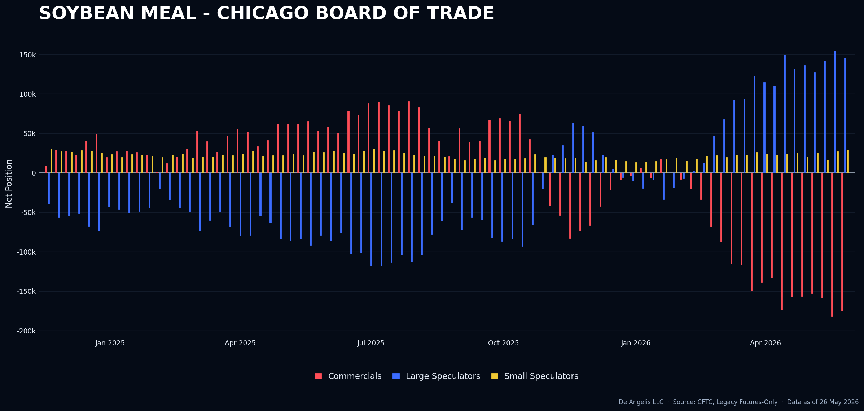
Increase in longs for the small speculators is the driver for the set up
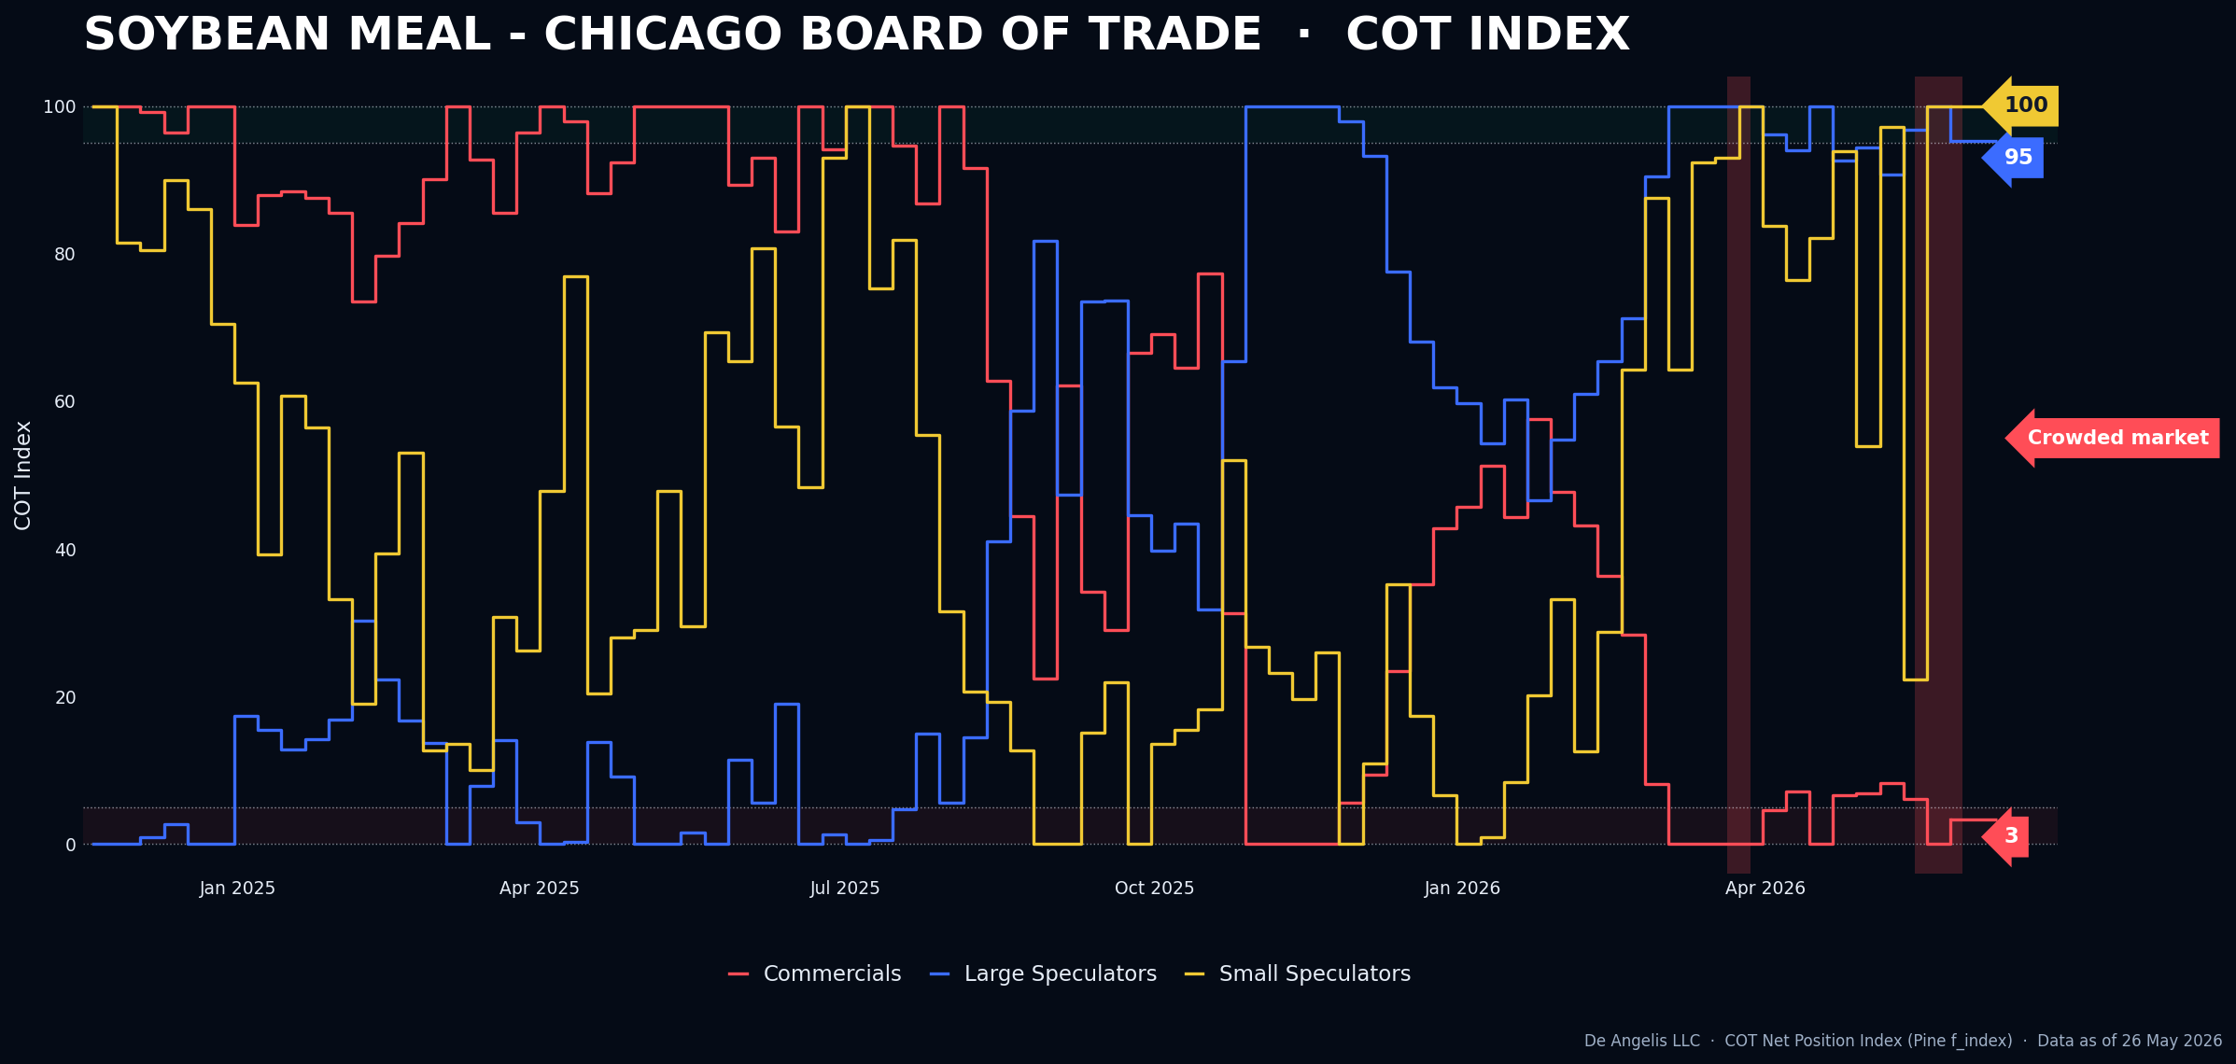

Combining | Positioning, Sentiment, Price Action…
In the last week report I was mentioning for a possible correlation failure where we could see gold closing up on a stronger than expected news about inflation that would push prices of gold down and then close up or breaking the metals/energies correlation where we would see energies closing up with Gold closing up. On Thursday we had Gold closing up with Energies up and Bonds down; However, during the day we had a weaker than expected PCE number and from which gold rallied immediately, as I mentioned in the last report, I wanted to see a clear news failure to get into this trade and this to me looks more like a news confirmation and not a news failure event; Correlation failures don’t have a good track record for working both from the past and also this year, most of the times they look more like impulsive emotional trades to me rather than based on a real observable fact. What I am going to do is that I will sit and wait. Until I see clarity, which will come with a tangible news failure, I decided that I will practice my patience and observation skills.
Getting into equities, the rally is being fueled mainly by the hyperscale’s AI related names. It is now obvious that keeping the short exposure in equities like many are doing is not paying off. For this reason, we have seen positioning data finally getting slightly longer especially from the small speculators which are the ones that are most likely to be unhedged in this rally. Large speculators being net short and increasing looks more like a Hedge exposure at this point rather than a bias. However, until they decide full net long and create a short set up for that I won’t execute any trade here. AAII numbers got more bullish after 3 weeks of market rallying and investors getting bearish and more bearish Week after week. We are definitely not to a short set up but I like to think that people can become more rational at times and accept that this is a bull market.
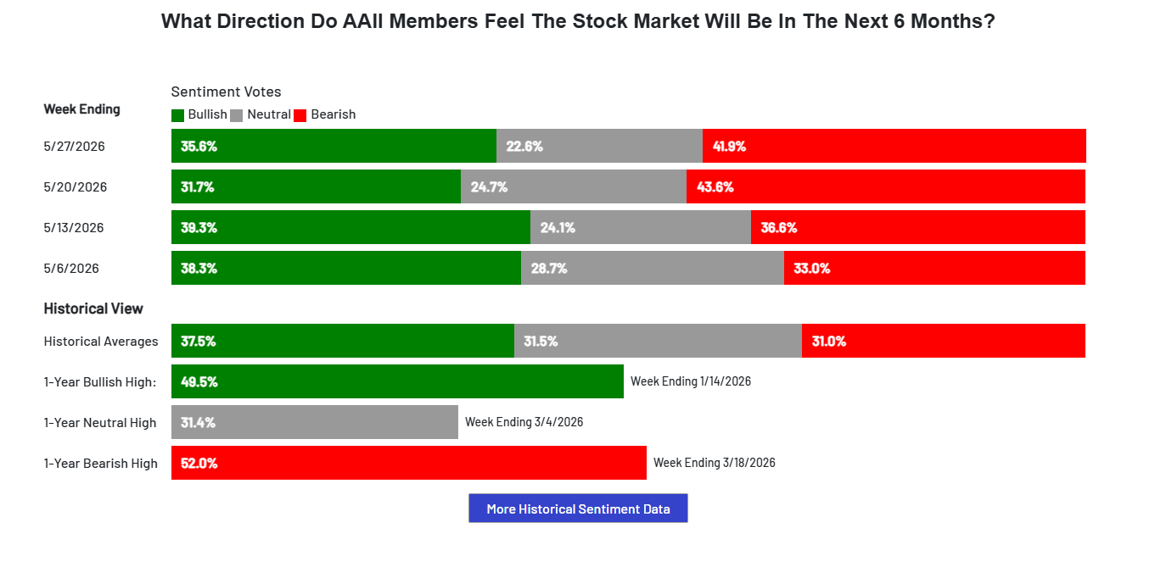

Aussie dollar was an asset I was having a look from the report of last week. Inflation numbers were reported lower than expected and the price immediately collapsed, making it a news confirmation rather than a news failure. Again, I can clearly recall November 2024 where I was Long the euro and New Zealand dollar on a news confirmation with big size and being completely destroyed after a CPI report came out. Later on, I would analyze my track record and found that if only executed the trades that were fully in process, I would be up triple digit on the year. It took me all 2025 to really calm down and stop certain bad habits and only now I can say that I am starting to really learn this craft and making sure trades like this one are not executed. Also, in this case executing a trade like the Aussie would have got me fully stopped out on Friday Close. I can recall that feeling of executing a trade that is outside process and then feeling that shame and guilt coming up after I would then go back, look at my record and see that If I just sticked to news failures trades, I’d be up monster amounts. So not going there this time and I’m also glad to see the market rewarding me for that. I literally have 3.5% in form of capital protection in my account now.
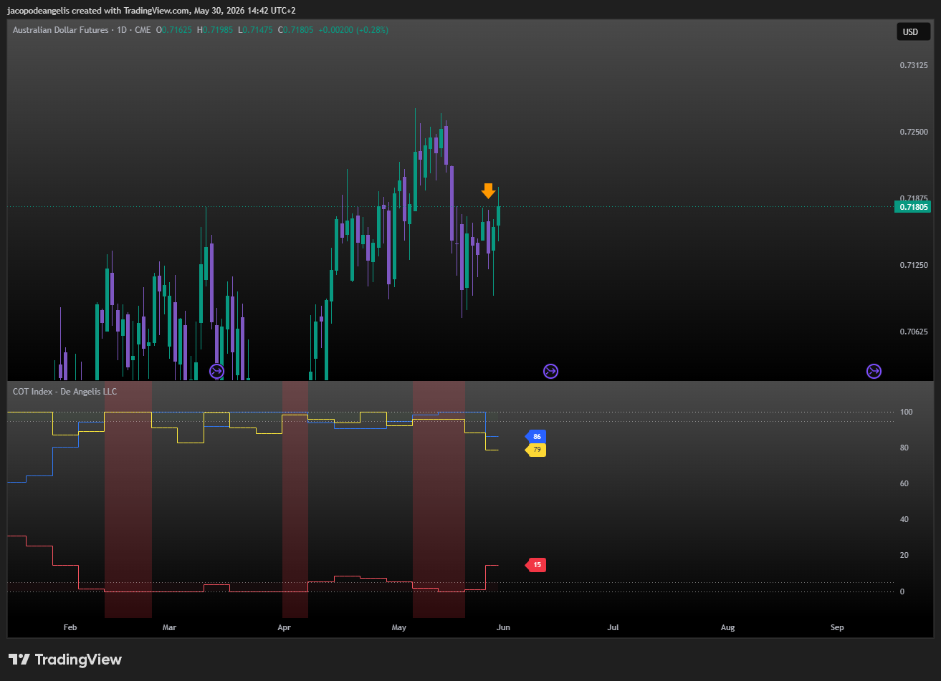
For Soybean Meal, I have already executed couple of trades in the grains this year. I will wait for the official WASDE report next week, hopefully the set up will still be there.
Getting more into the psychological side of this week. I think the maturity as a trader comes in different ways. I will write down whatever comes to my mind in the moment and revise it later so you know it came from a natural thinking.
I have been using Claude ai to create models that I then can deploy in tracking financial metrics for my track Record

Next week Calendar | What I expect?
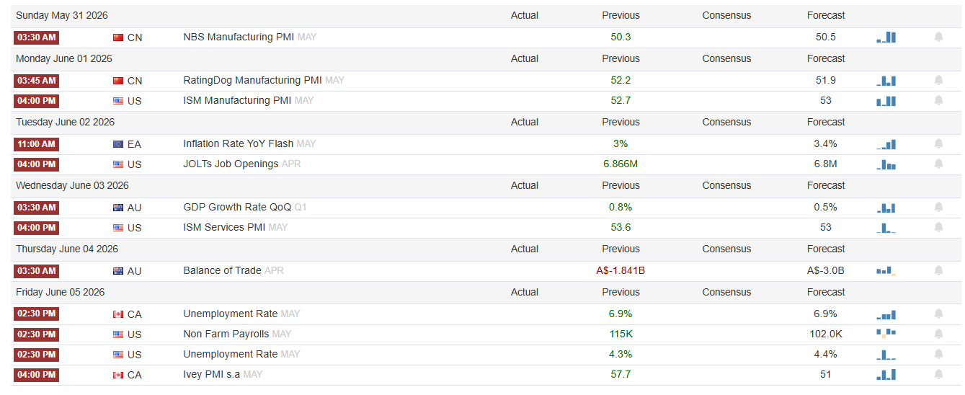
- ISM Manufacturing: I don’t think any reaction will come out of this report because historically does not do much
- Jolts Opening: a stronger than expected number should drive interest rate expectations higher, higher dollar, lower Gold, see the close.
- Non-Farm Payrolls: Important event for the week, I don’t know what to say theoretically a stronger than expected number will lead to stronger dollar because of less need to cut rates, therefore lower gold and then if it closes up it’s a news failure. However, a lot depends on what the market was pricing though.

Current set ups and how I want to execute them?
- SHORT SOYBEAN MEAL: At this time, I think the only trade available for grains and softs are the WASDE reports, I don’t think there is anything to do this week about these trades. I will repeat in this report what I’ve reported also in the last report and it is that I’ve been burned in the past with anything that is not very CLEAR with softs and Grains.
- LONG GOLD: This week I think we might get a good chance to go long Gold on Friday with NFP. I think that a better-than-expected number will drive interest rate expectations higher, USD Up, Gold down and to get a news failure we see the close. I might be wrong as usual, but what matters is clarity in these situations and interpretations. The clearer the better. Clarity comes at a price and it’s that sometimes I will lose some good trades and sometimes amazing ones as well. What matters is that clarity overtime pays off.

Open trades
- SHORT COTTON: Since the 12th of May close with news failure on WASDE Report

