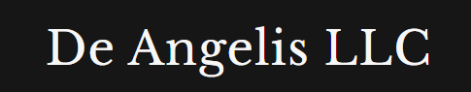

Weekly Market Report

24th May 2026
Contents

Equities 3
Energies 5
Metals 6
Fixed Income 8
Crypto 9
Currencies 10
Softs 11
Livestock 12
Grains 13
Combining | Positioning, Sentiment, Price Action… 14
Next week Calendar | What I expect? 17
Current set ups and how I want to execute them? 17
Open trades 17
Closed trades 17

Equities
Over the past month and a half, we have seen this continuous increase in short exposure on equities despite the market rallying. This week very little has changed from the past week as a group
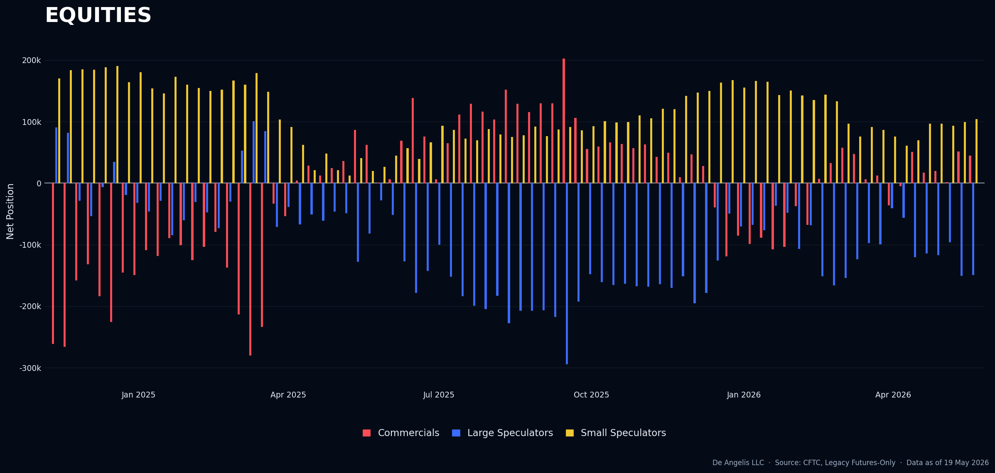
We’re now seeing DOW getting close to being a long set up. As reported from previous report of the 16th of May, it was not long time ago since we were thinking it could be the most probable short. “When the market change I change my mind”
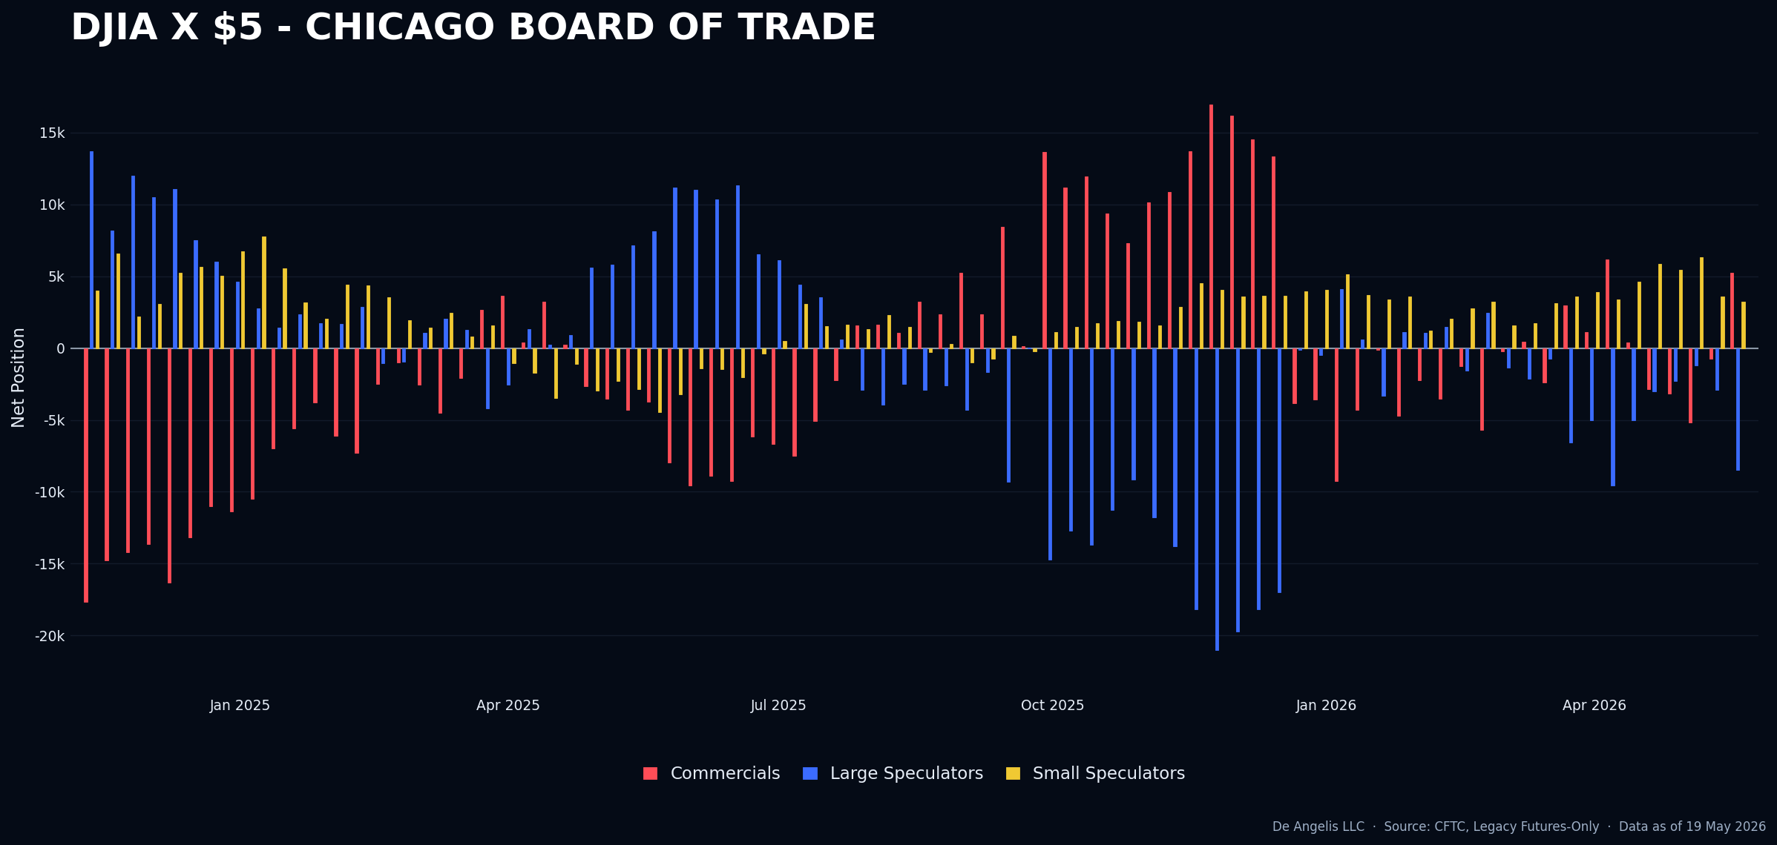

Index is just not there yet. Won’t get it into my watchlist either.
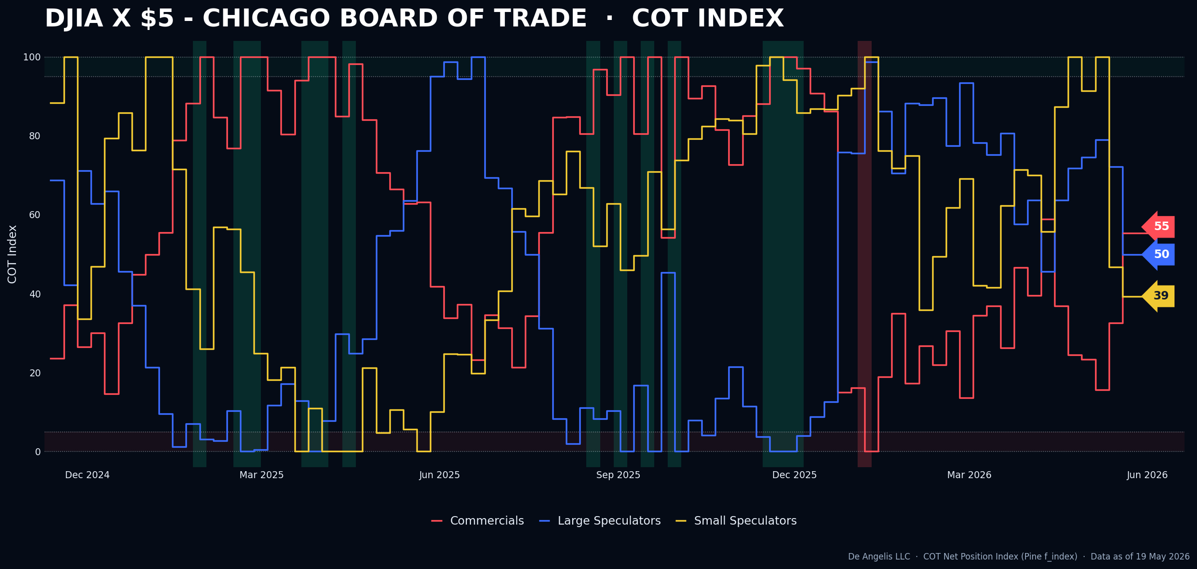
Nasdaq is not shorted as it was a week ago anymore. It’s not on my watchlist anymore.
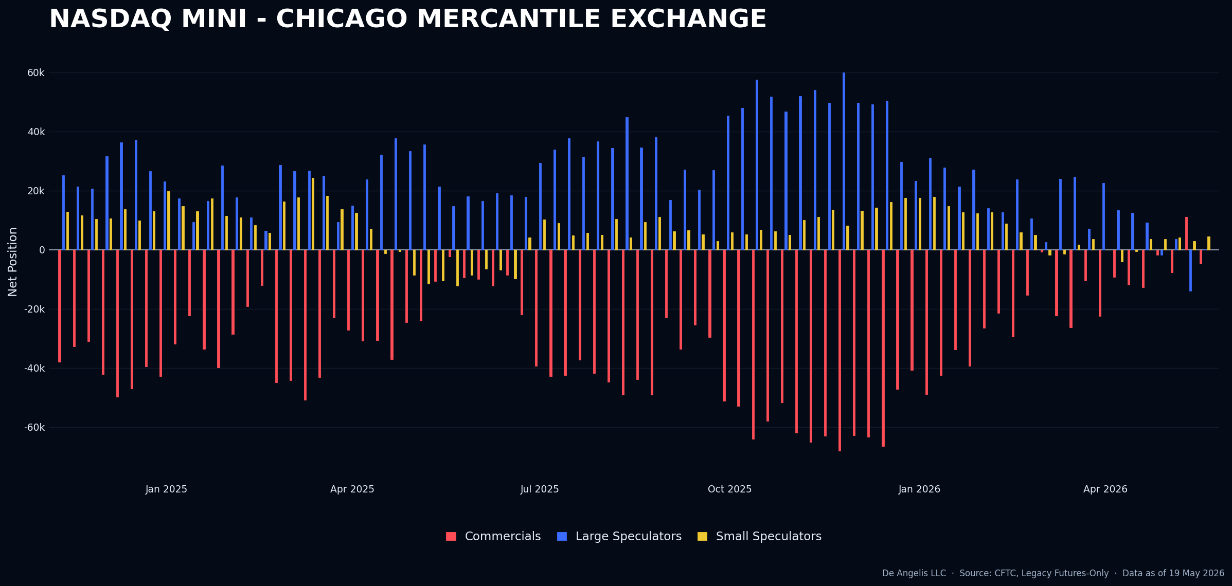

Energies
So many people are talking about Energies, yet these markets do not seem to have any edge at this time from a positioning perspective. Such a high number of people talking about “making a war trade” while markets are just STALLING since March. As I said last week. Lots of commissions for the broker, very little profit for those who are trading this around. At this time there is no edge for our process to be into this.
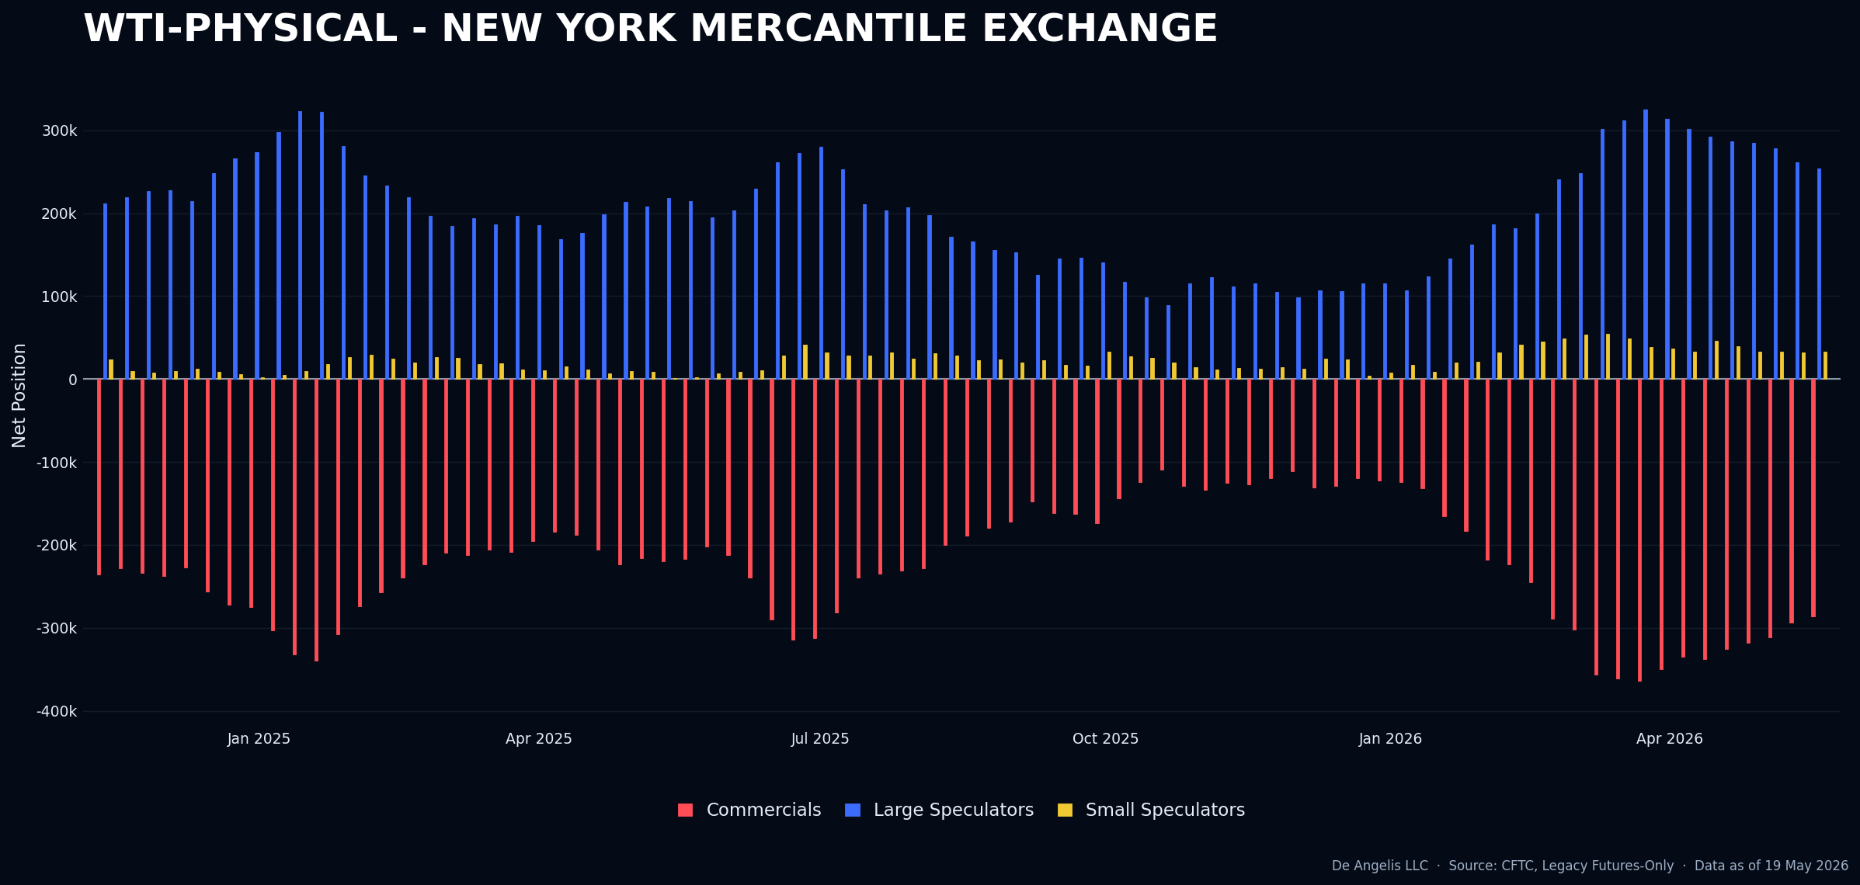
Also Nat gas, nothing there either
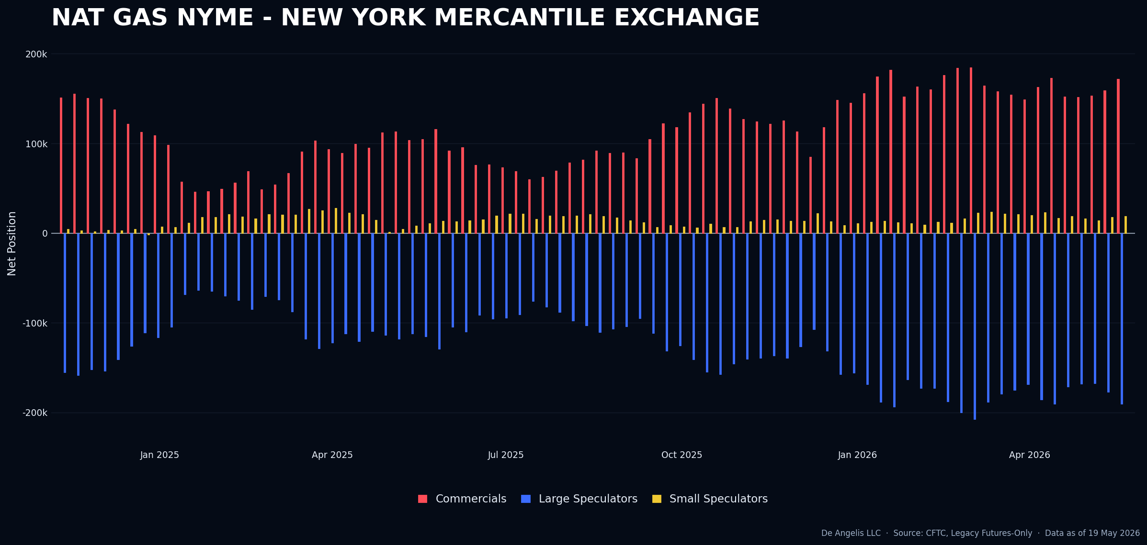

Metals
Metals as a group are not showing any sign of crowdedness. However, looking at single markets, we have a new long set up…
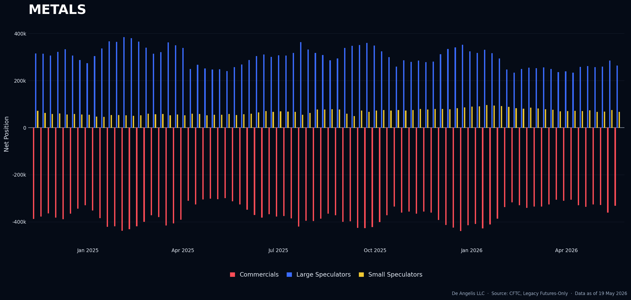
Gold is now a Long set up.
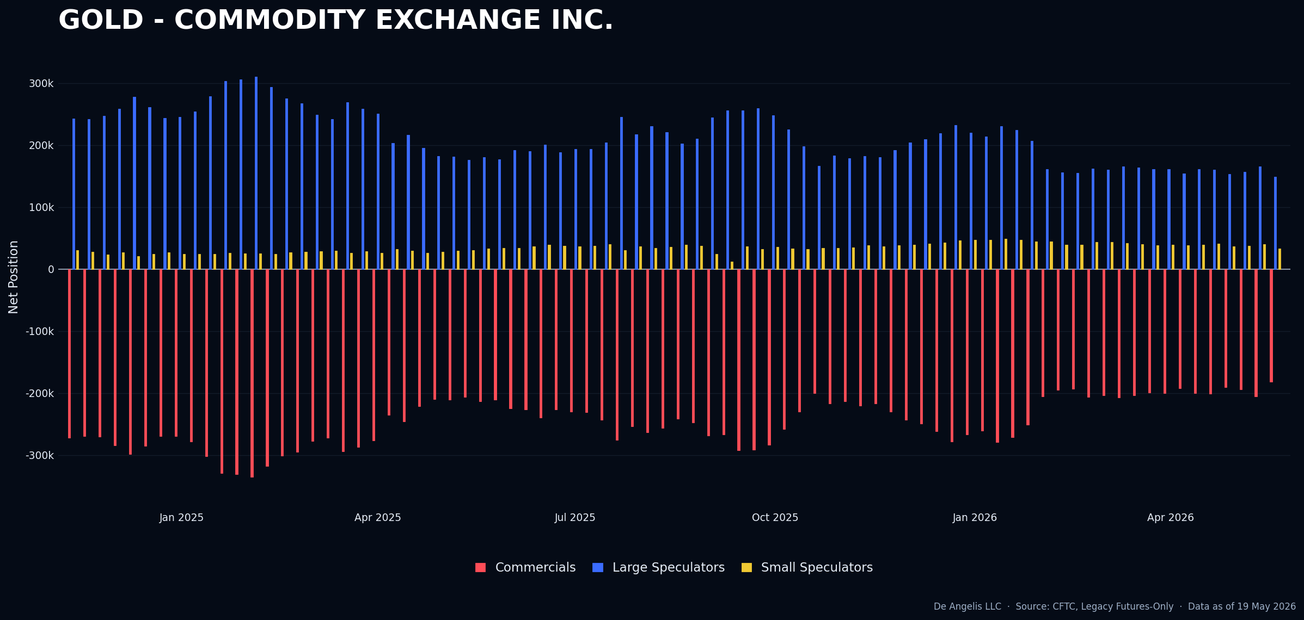
Index is now at 100, 0, 0…
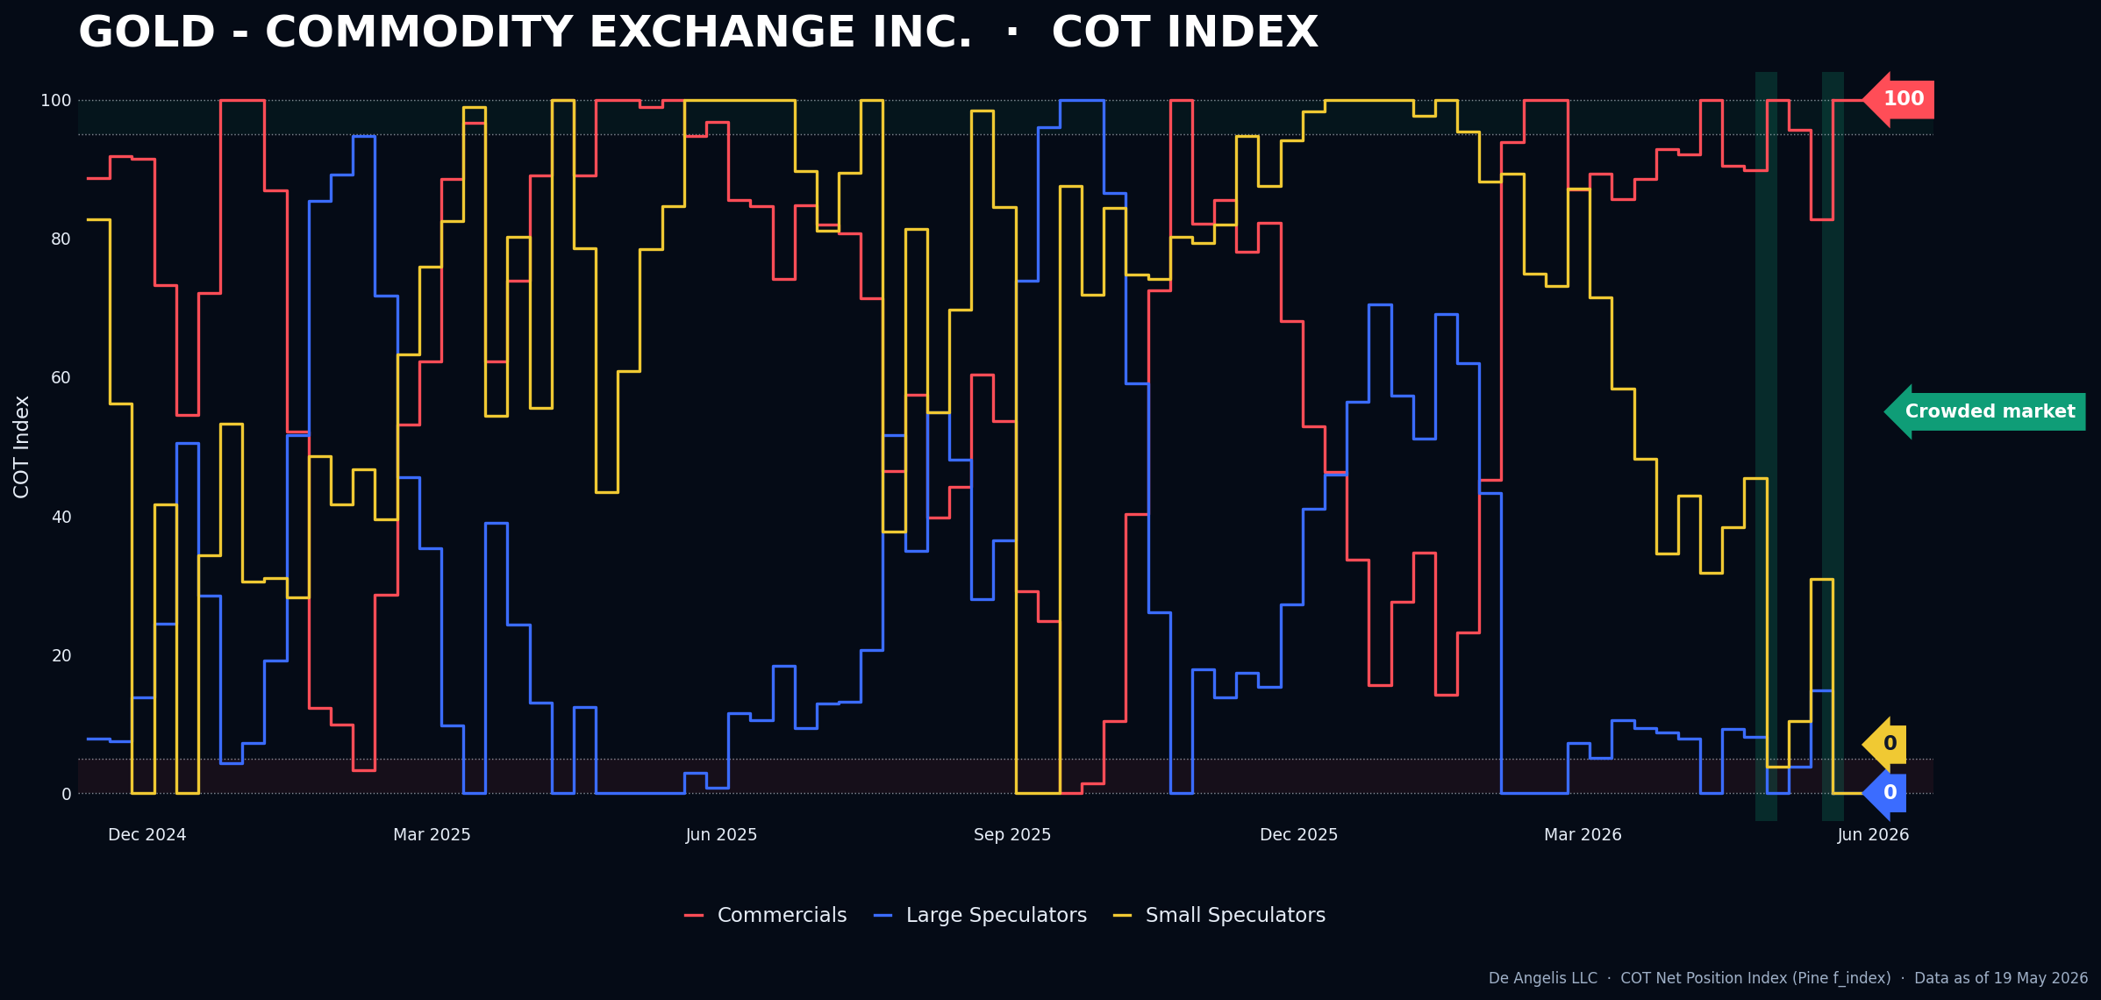
I will better explain what I am looking for to get long gold in the next commentary section.
Copper is also getting pretty interesting as a potential short with large speculators being at a multi-year high long positioning level since 2020. Index is not there yet for small spec. Consensus is on the long side with some people calling it for a “multiyear, commodity Supercycle”.
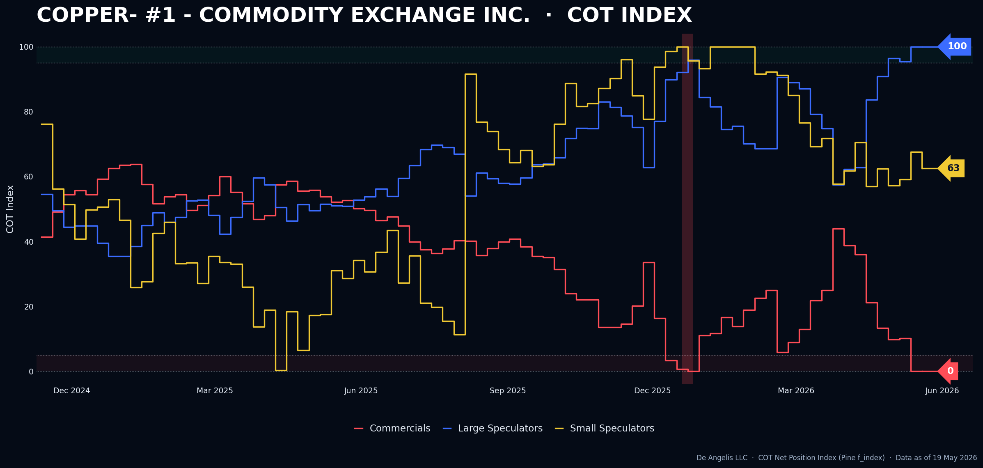

Fixed Income
30 years is now shorter and shorter with commercials starting to get really interesting for a long trade. Consensus is short bonds and CTA’s and Hedge funds are profiting from it.
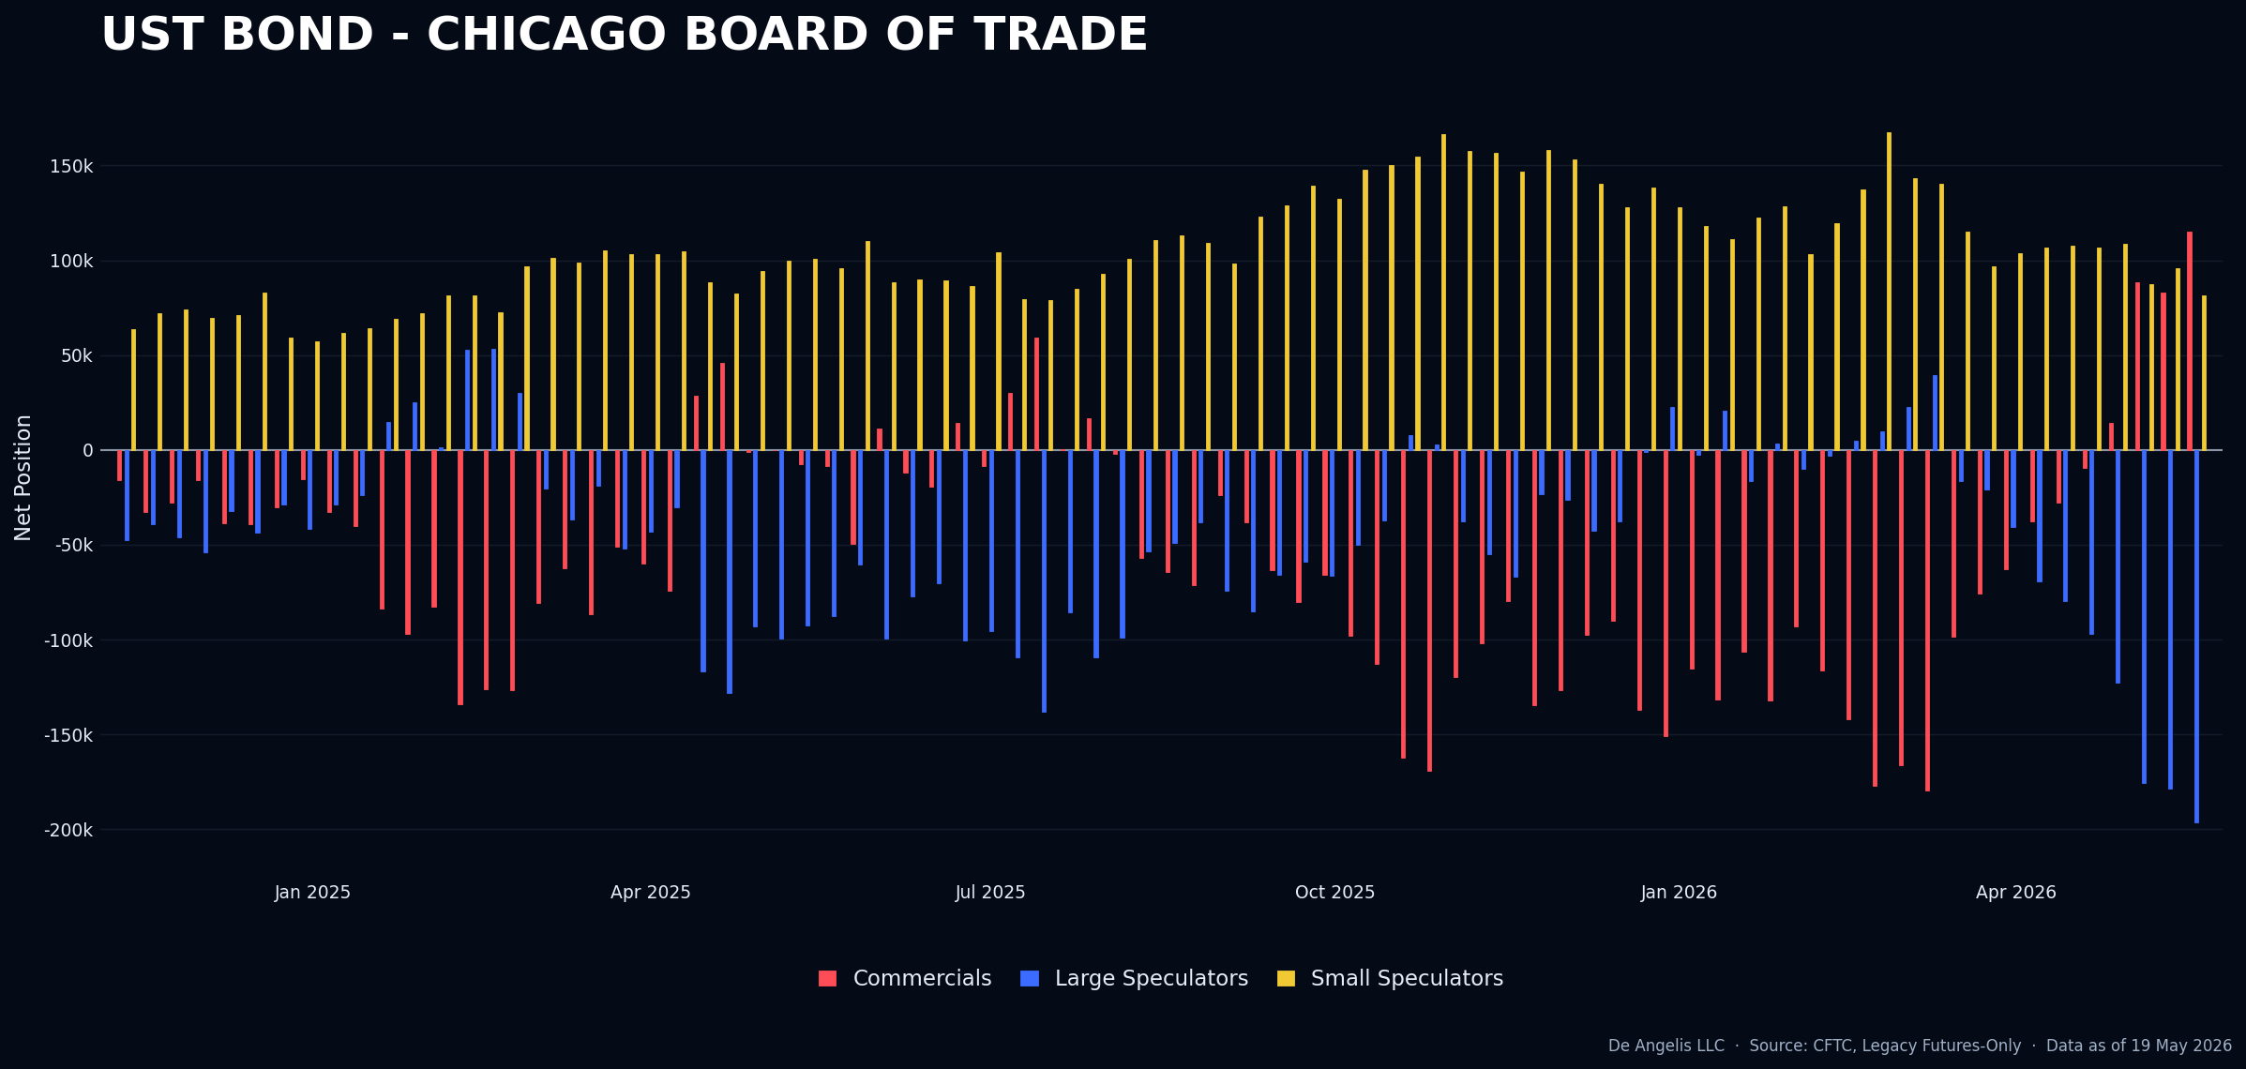
Fixed income as a group is not there though
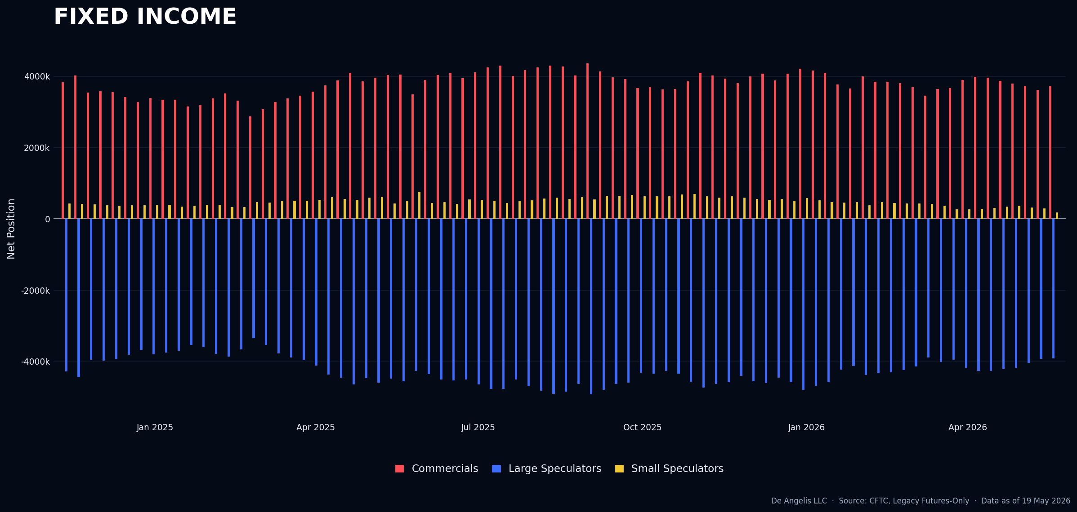

Crypto
Small spec seems to have turned into large spec now, positioning for small from last week came off a lot
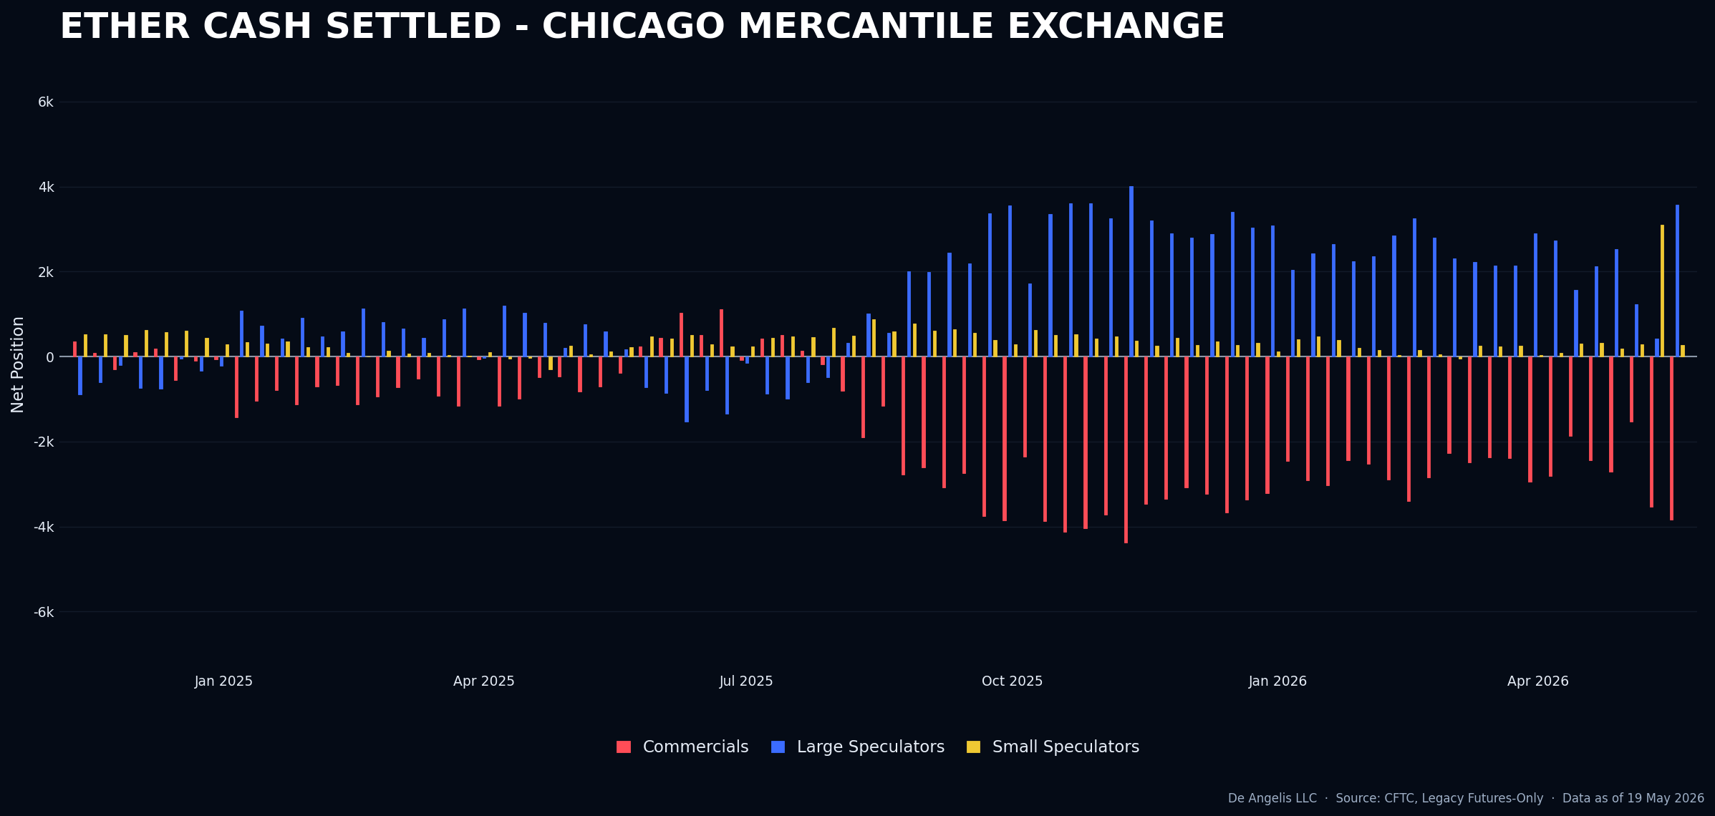
Also as a group, large spec going ballistic, small spec reduced a lot. Something is going on there.
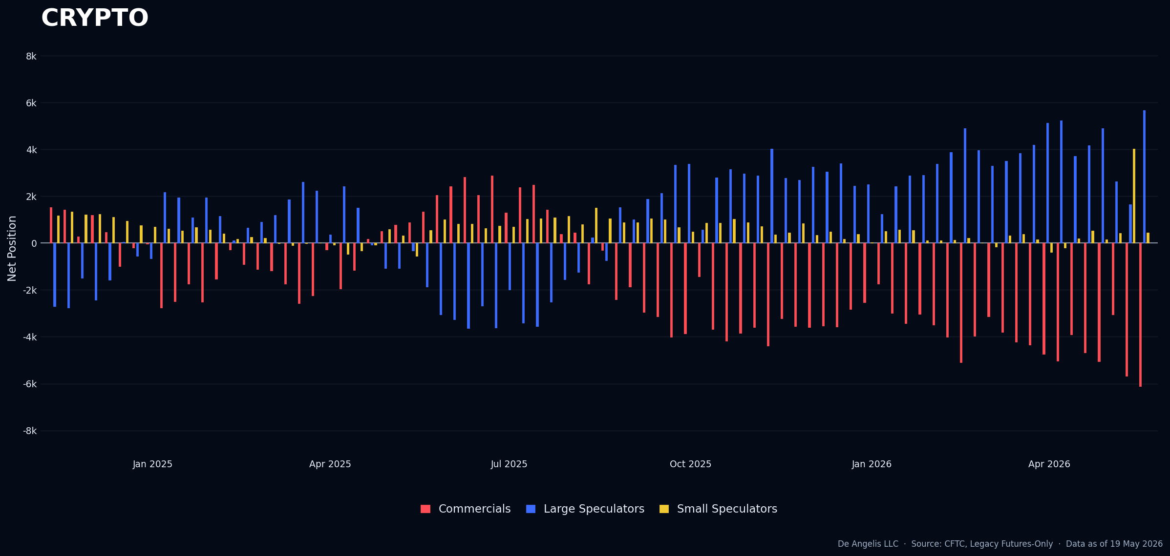

Currencies
Lots of people talking about YEN in various chats, while Large and Commercials are set up for a long, small specs are not there yet.
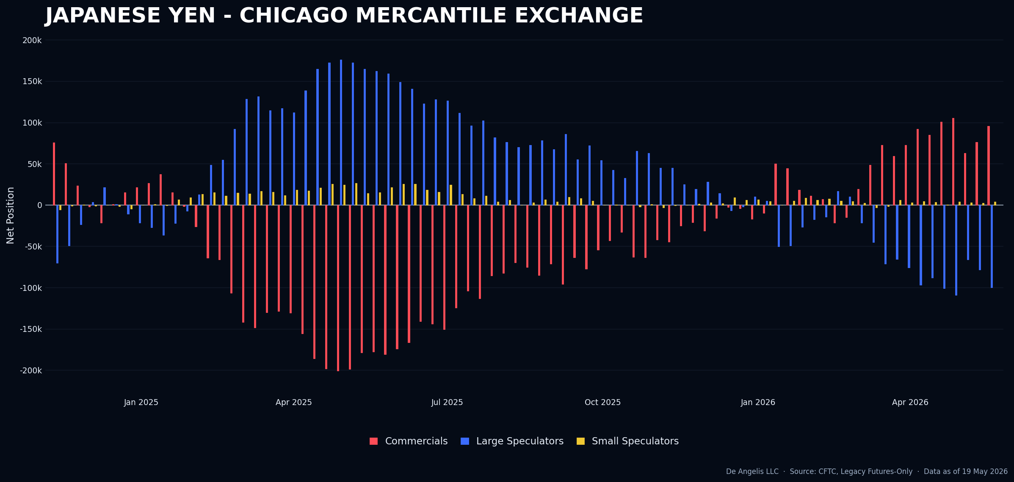
Australian dollar has a general long positioning but not a set up anymore.
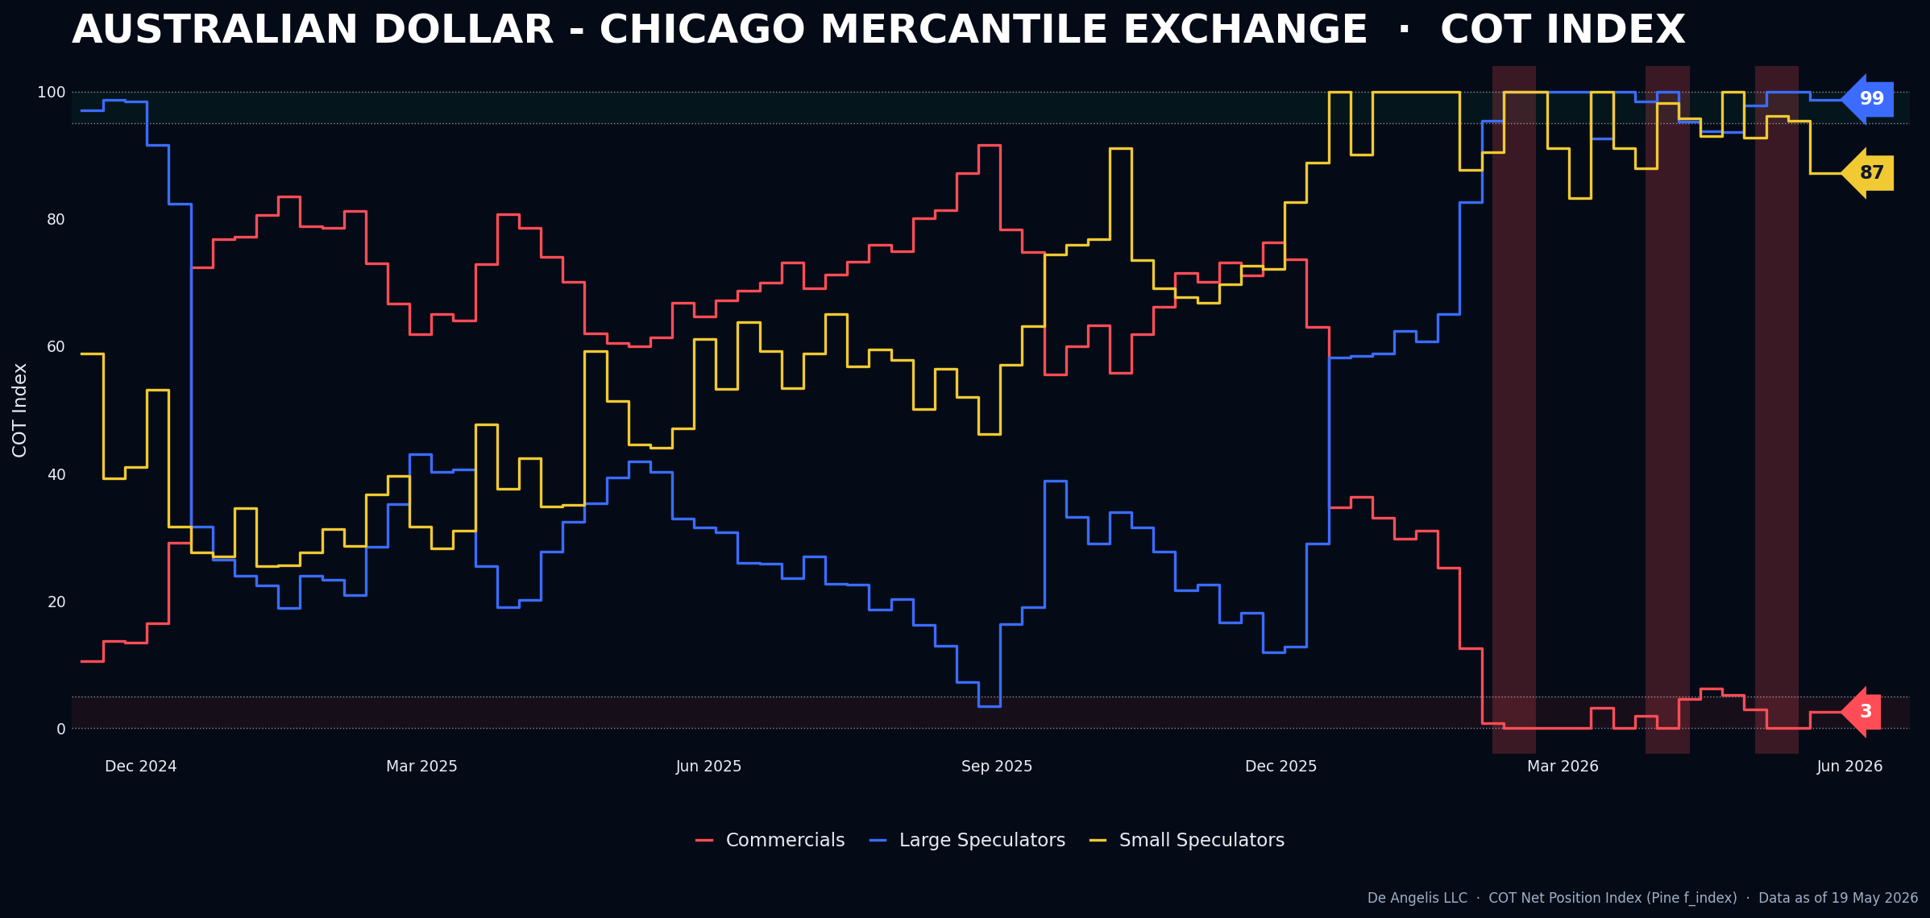

Softs
Cotton coming off a little bit, but it’s understandable as prices are now down for over 2 weeks since it was a short set up. Large and small spec fought with the tape for a week but I think that with the recent down moves they capitulated and they are now selling their net long holdings.
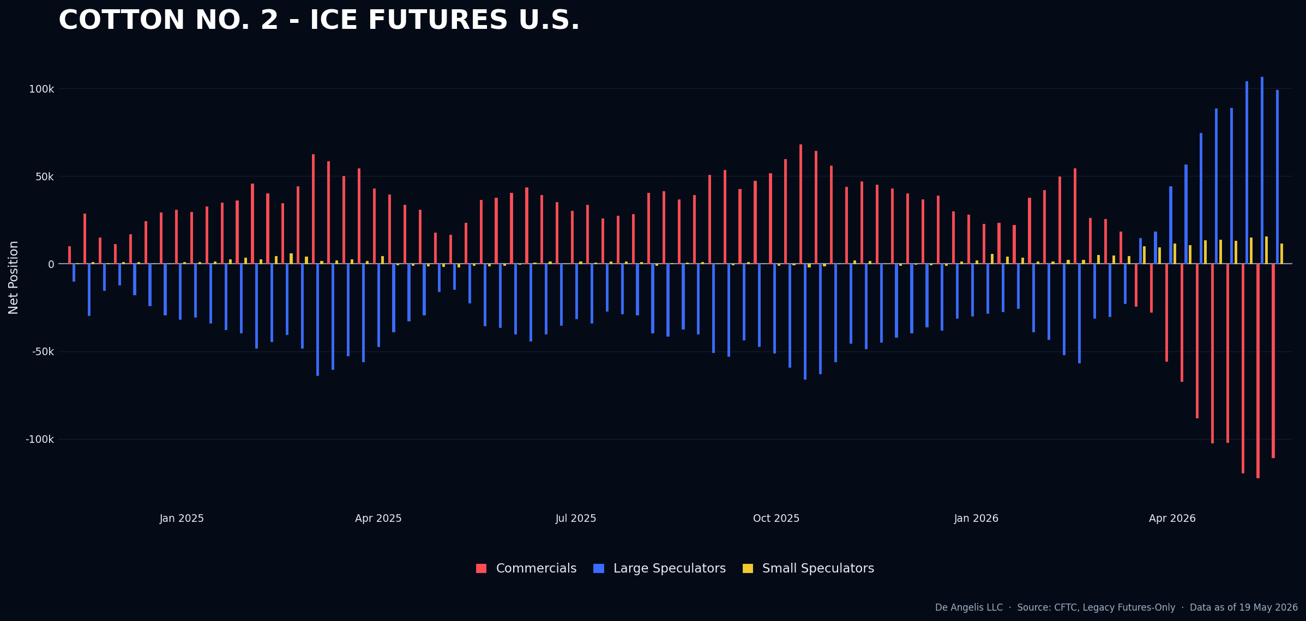
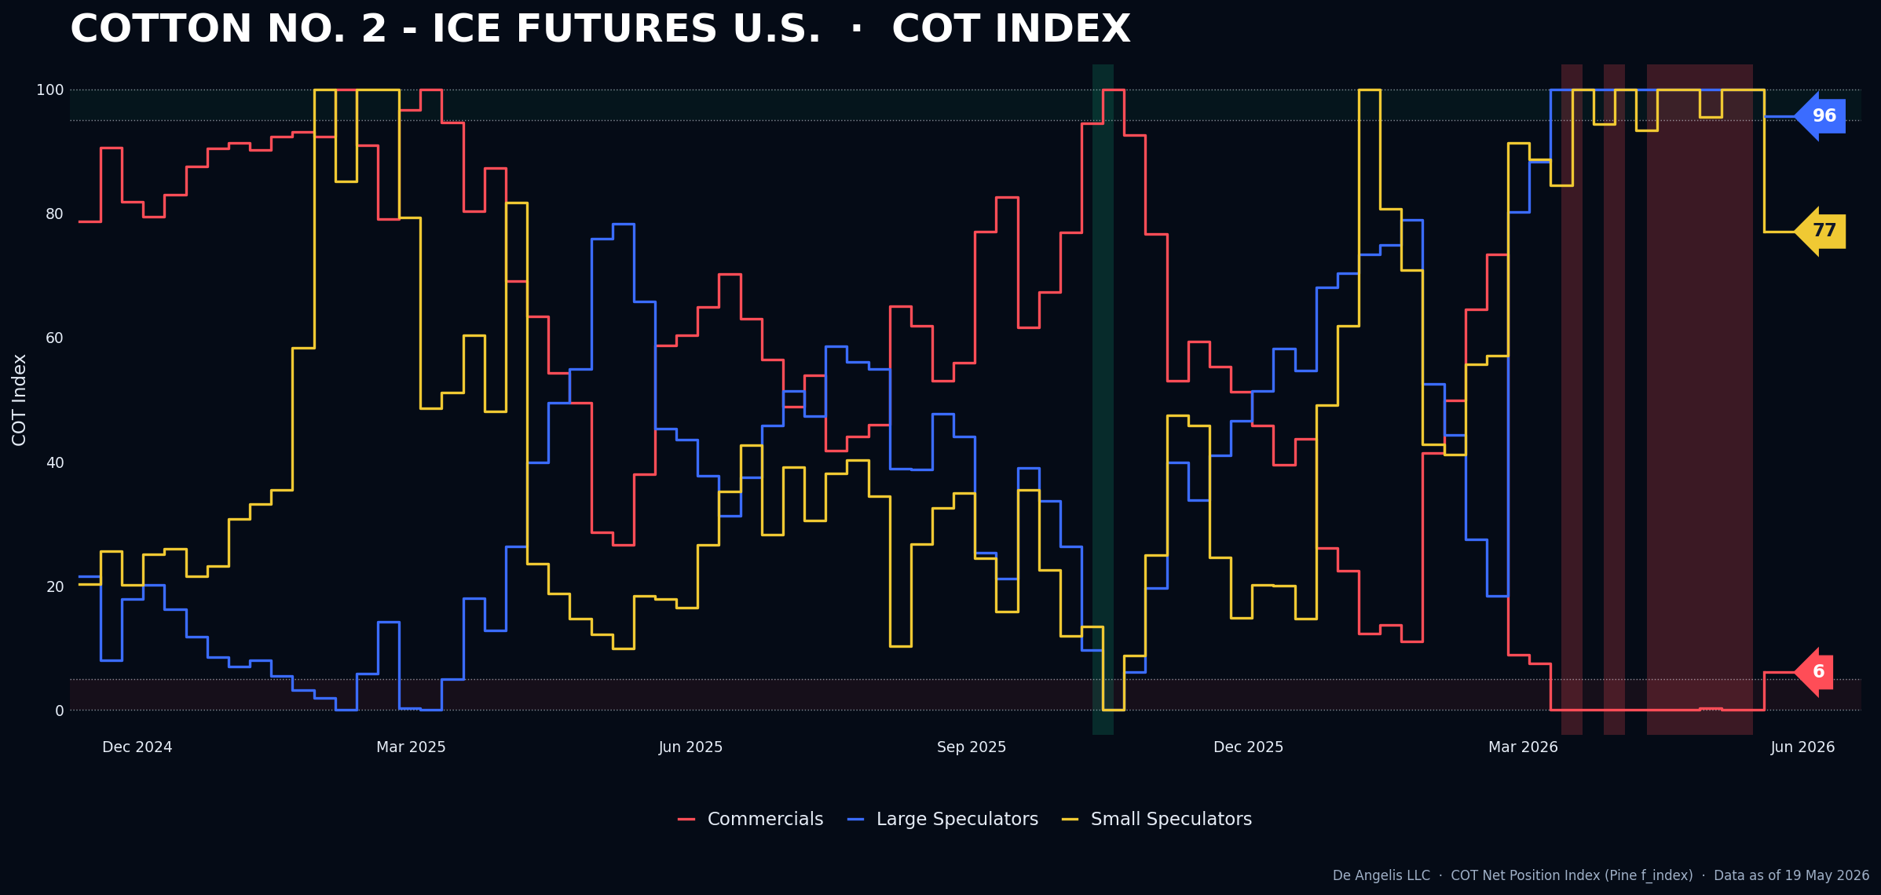

Livestock
A world of nothingness here.
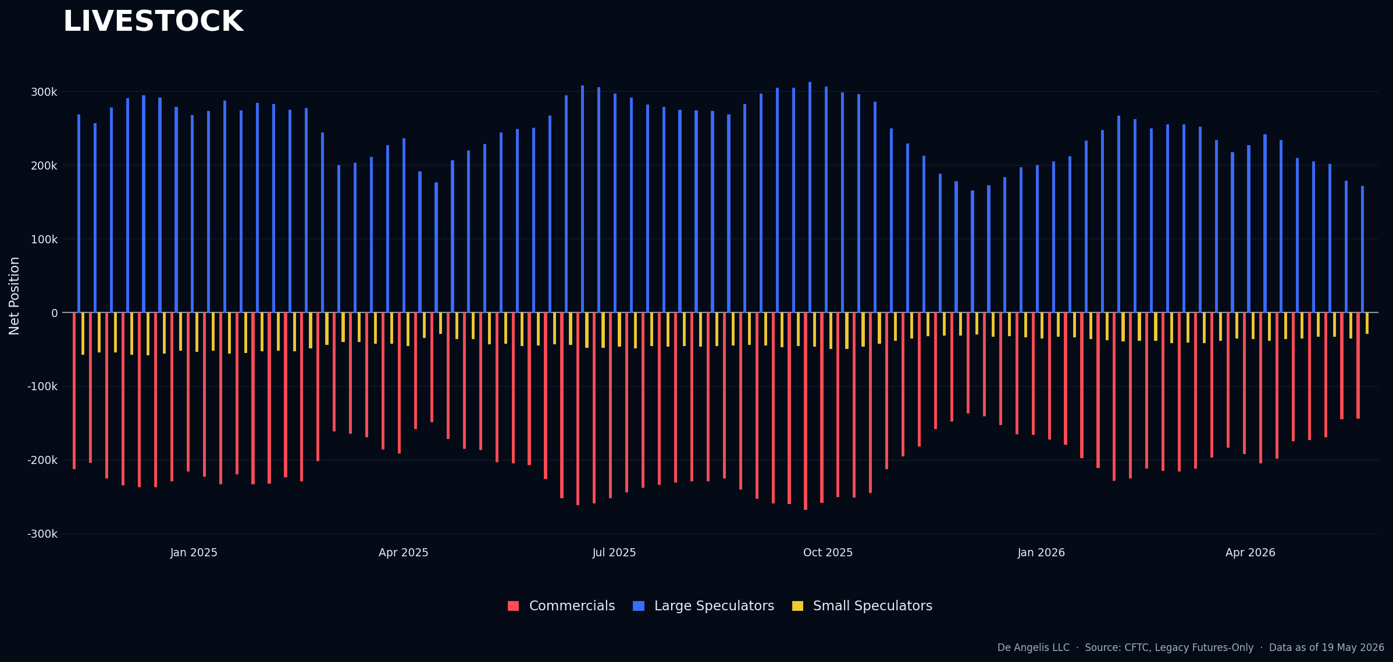

Grains
Finally, Grains getting interesting again, Soybean Meal is a short set up.
What I like about the Soybean Meal set up is the speed of change week over week both in large spec and small spec. I have noticed that it’s usually a sign of reversal incoming.
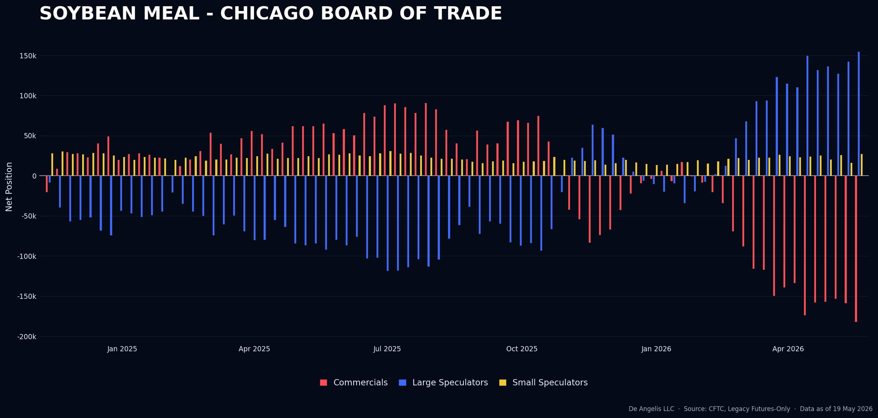
Still, we need to find a reason to get the short going, Next WASDE report is going to be in 3 weeks from now
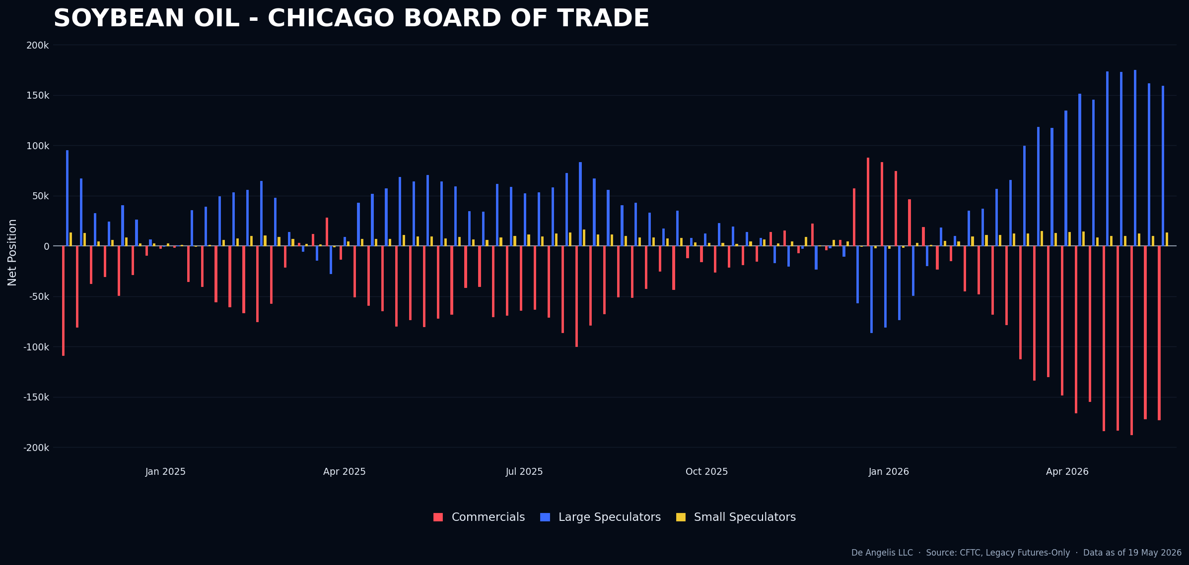

Combining | Positioning, Sentiment, Price Action…
After consolidating all the information, I will reiterate my previous point that I mentioned in the report of the 16th of May. “Typically, markets do not decline when most investors expect them to”. This pattern has been evident in the equities market, especially with Nasdaq and the tech sector until last week. I believe this trend may become clearer in the coming weeks with the Dow and Russell indices “catching up” since they were shorted the past week. A breakout or significant news event could trigger an upward movement, and I see the risk-reward ratio to the upside at this time.
Additionally, the AAII survey indicates an increased bearish sentiment, given the high number of persistent bears, I take this survey as a sign that we can go up even more from here.
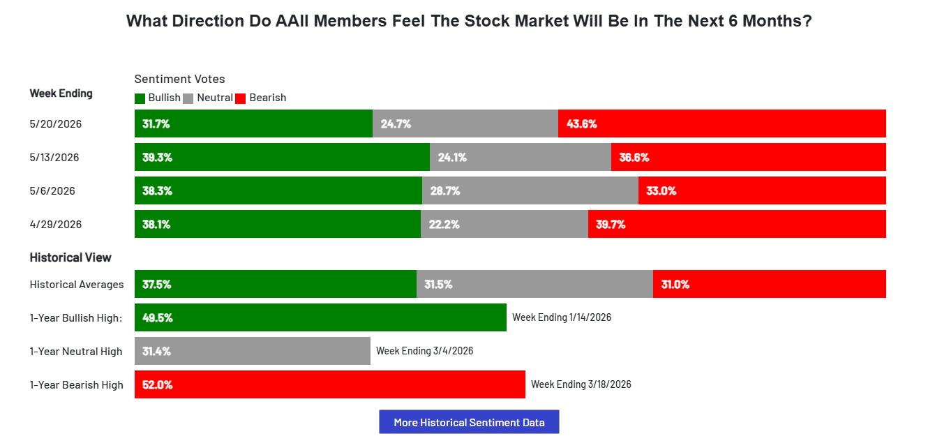
After missing the opportunity with long silver, I now consider gold a potential hedge against the short cotton position. Recently, gold has outperformed equities amid US-Iran peace news. However, negative news, especially related to inflation, could trigger a decline in gold prices. Gold was heavily discussed during its upward surge last year, but since September 2025, activity has slowed, and volatility has decreased since January 2026. This reduced volatility makes gold an attractive asset for hedging a short position in cotton. The Australian dollar, cotton, and grains are positioned as risk-on trades, which could support a long gold position hence a general reversal of markets. Nonetheless, waiting for a very clear and specific news failure is crucial before executing the trade. If such a catalyst does not materialize, I will refrain from entering the market.
Getting into what happened this week relative to my expectations from last week, I would say most of the events mentioned previously unfolded pretty much as anticipated.
- The RBA minutes had no impact on the Australian dollar, aligning with expectations, and the current risk-on/risk-off scenarios remain intact.
- In a risk-on environment, equities and bonds are rising, energies are declining, metals and currencies are appreciating, the dollar is weakening, soft are down, and grains are also declining. As long as this trend persists, there is little significant comments to make in the markets.
- Another point I might have overlooked last week is Nvidia's earnings report. All attention was on Nvidia, while the FOMC minutes received little to no reaction from the markets. This indicates that the market has fully priced in the higher inflation expectations. The Federal Reserve appears cautious, likely to keep interest rates steady, and seems prepared for various scenarios, according to an AI report I generated this past week. The exact implications of this are still uncertain.
Now getting more into the psychology side and reflections of this week…
Every time I say something I always need to remember that I could be wrong, as statistics show I am incorrect about 65% of the time. However, when I am wrong, I want to make sure that losses are small so I can easily move forward. What I need to remember and also, I’d say the primary focus of a fund manager is on ensuring that when I am correct, I offset the previous small losses as quickly as possible, so that I can demonstrate positive skewness in my track record. For example, this year I executed nine trades: seven resulted in losses of 1R each, one gained 5R, and cotton is currently up 6R. Currently, I am up 12% for the year, which I consider satisfactory given my targets. My approach involves small losses followed by significant wins. What I also need to remember related to that is that there is no high win rate in the contrarian trading world, only a positive risk-reward ratio. These are the rules I accepted 2 years ago when I started trading this way and I would never change them, I love them; Also ignoring them would come at a very high price. Which I already paid couple of times and not planning to get there anymore.
Recently, I have been working on developing greater patience and finding satisfaction in waiting for opportunities to arise. Trading has evolved a lot for me compared to when I first started. For example, I reviewed my trading records from 2021-2022, where I executed over 200 trades annually. During that period, I made virtually no profit, primarily due to high commissions associated with such volume and my own weaknesses; The need to be RIGHT, the desire to WIN, and an obsession with doing extensive work—such as creating reports of over 40 pages for a single trade idea based on fundamental analysis. This approach was unsustainable and unprofitable. As I continue to develop as a trader, I observe an inverse correlation between trade volume and profitability. In 2022, I executed over 200 trades; in 2023, which was my worst trading year, I made 210 trades. However, in 2024, with only 42 trades, I achieved a 27% gain, and in 2025, with just 14 trades, I gained over 60%+, with a maximum drawdown below 15%. Currently, in 2026, I am at my 9th trade, up 12%, and feeling more relaxed than ever.
Additionally, I analyzed a trader claiming to have earned over $250,000 in seven months through more than 400 trades, incurring $6,000 in additional commissions. What he overlooks is his unrealized losses, which total over -$136,000—a remarkable figure relative to his account size. This unrealized losses primarily results from traders engaging in options trading without regard for unrealized profits or losses, believing these do not matter until they are realized. This misconception is quite amusing, as I believe such trading is driven by hope and fear mismanagement. Traders often feel compelled to book profits to satisfy their need to win, while simultaneously fearing the realization of losses. Consequently, they keep losing trades open, hoping they will turn profitable before expiry. I have experienced this behavior myself, and it has not led to good results—neither in terms of profits nor mental well-being.
It is also important to recognize that some traders truly understand how to use options effectively. They focus on minimizing losses, remaining nimble and patient with profitable positions, and exploiting the capped loss potential of options while managing time constraints. I am not that guy and have yet to meet one, nor do I wish to be; I would tend to overthink, over model, and overcomplicate everything. To me, options seem like a more complex form of trading. The only question that arises in my mind is “why?” Why bother? Why impose time constraints on something that is already so difficult and mentally draining? Why create structures such as buying an at-the-money (ATM) option while selling half of it slightly out-of-the-money (OTM) with two different time structures, hoping that the market will go against you so you can collect a credit, and then hoping it will go in your favor afterward? It looks to me I’m trading hope rather than a process in that case. Why? because the truth in the market always finds a way to reveal itself, and I soon realized that when trading like this, if it doesn’t work, it will just result in a loss, just a smaller one; and if it does work, the win will be smaller than it could have been. Why not simply open half of the position, such as a long call or long put and fully exploit the upside potential if there? Does this process suit my personality? Or am I just blindly following instructions from someone else? I already face a time constraint, yet I am overcomplicating matters further by creating price structure constraints where I must be right to fully exploit the upside. Most of the time with this framework, I’ve seen traders refuse to accept losses on the long leg, similar to the trader mentioned earlier. Instead, they try to maximize “credits,” by getting out of their short legs, sit on losing long leg positions, and hope for a miracle to save them before expiry—an outcome that rarely materializes. Anyway, “observation- rant “ of the week is over and back to the real work.

Next week Calendar | What I expect?
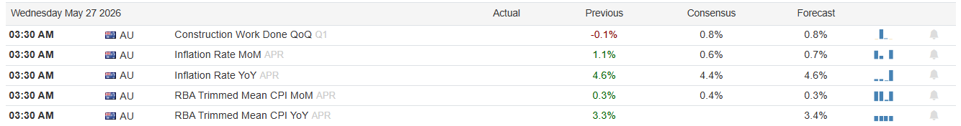
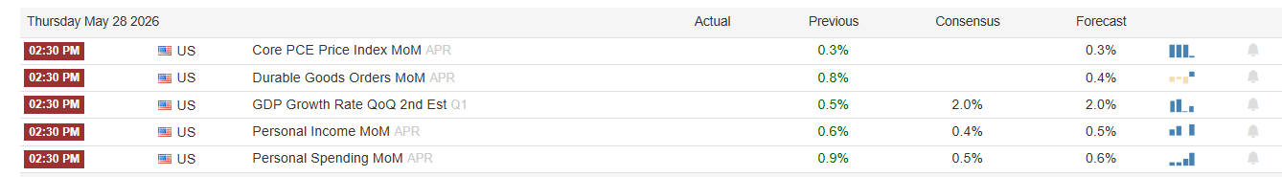
- Inflation rate in Aussie could create some interesting opportunities there, the currency is not a full set up and it will be highly unlikely that I will execute a trade unless what I see is something like this. Monday and Tuesday prices reclaim previous levels (implying more net long positioning) and then on Wednesday a very CLEAR news failure comes out. However, it needs to look like the news failure of WASDE report on cotton.
- GDP & PCE is the next following news failure I will look for over the next week and that is for gold. This is the scenario I’d like to see. A higher-than-expected CPI number would drive expectations of future inflation higher, so Interest rates probabilities would go up which is negative for an asset like gold because gold works much better in times where expectations for interest rates are lower and inflation expectations are higher. It’s all about the expectations not the actual numbers.

Current set ups and how I want to execute them?
- SHORT SOYBEAN MEAL: At this time, I think the only trade available for grains and softs are the WASDE reports, I don’t think there is anything to do this week about these trades. I’ve been burned in the past with anything that is not very CLEAR with softs and Grains.
- LONG GOLD: What I said above is true for gold especially, higher than expected inflation, lower gold on the day closing up. Again, it needs to be SUPER CLEAR here because mistakes can be done easily if not. Thankfully I don’t have to predict anything, I need to observe.

Open trades
- SHORT COTTON: Since the 12th of May close I’ve been short Cotton and until it goes neutral or get stopped out I will stay into this position. Currently it’s up almost 6R

Closed trades
- n/a

