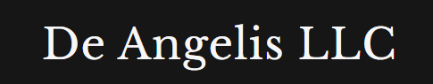
Weekly Market Report

May 9th, 2026

Equities
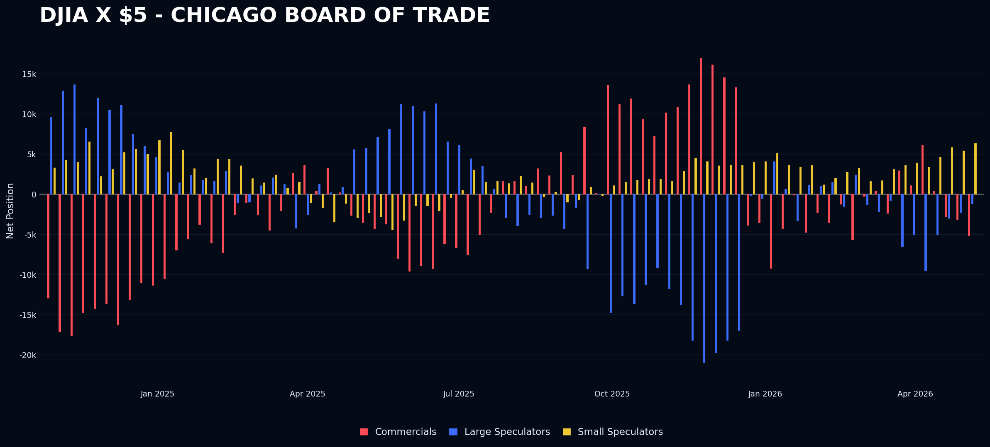
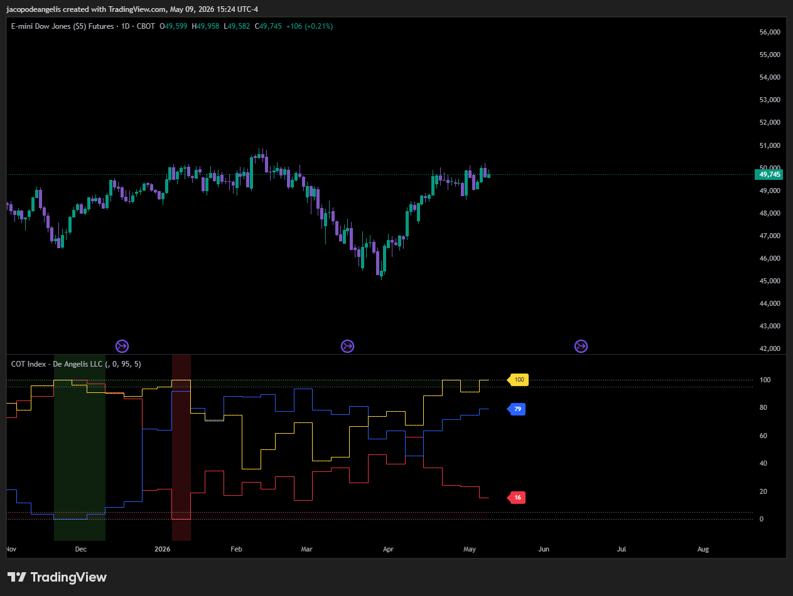
Dow is shifting from neutral toward a crowded long positioning among large spec and small specs. With small speculators at 100 and commercials at 16, there is a significant potential for a short position in this index in the near future. Over recent weeks, the Dow has exhibited the weakest price action compared to other indexes. Since March 30th, the index's performances have been steadily up but the relative performances between them have been highly dispersed.
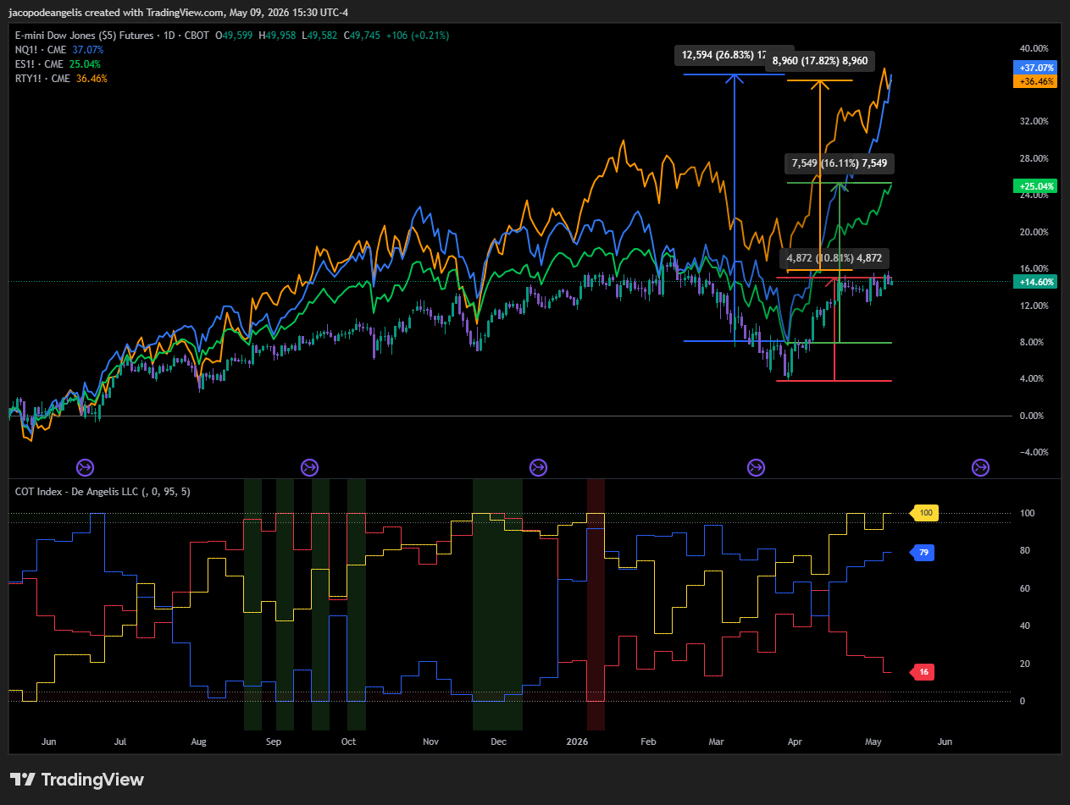
- YM: +10.81%
- NQ: +26.83%
- ES: +16.11%
- RTY: +17.82%
This analysis suggests that at the onset of the war, investors shifted their strategies, shorting the Nasdaq and the broader tech sector while buying Dow stocks. This move was driven by the expectation that inflation-resistant assets would outperform technology stocks. The influx of capital into the Dow indicates both large and small investors anticipated a market rotation in favor of the classical “Hard asset “theory by which during an inflationary time the assets with the best returns are physical ones. Conversely, the Nasdaq experienced significant outflows and short positions from various investor groups. It appears that the prevailing trade in terms of positioning since the market bottom has been long Dow and short Nasdaq. Despite widespread bearish sentiment, this positioning has contributed to the outperformances of the Nasdaq compared to the DOW

This is the current positioning in Nasdaq
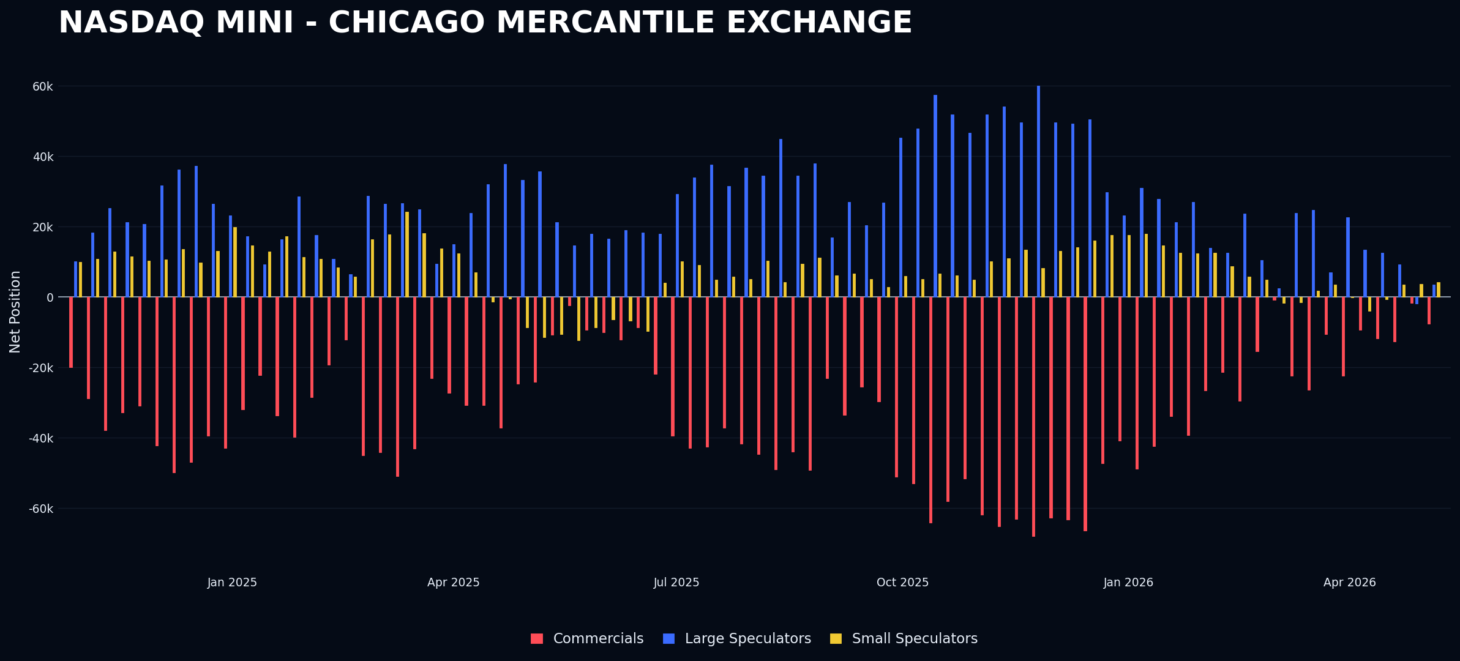
Large speculators have decreased and shorted their exposure to the index, despite the fact that the price action has been the strongest observed.
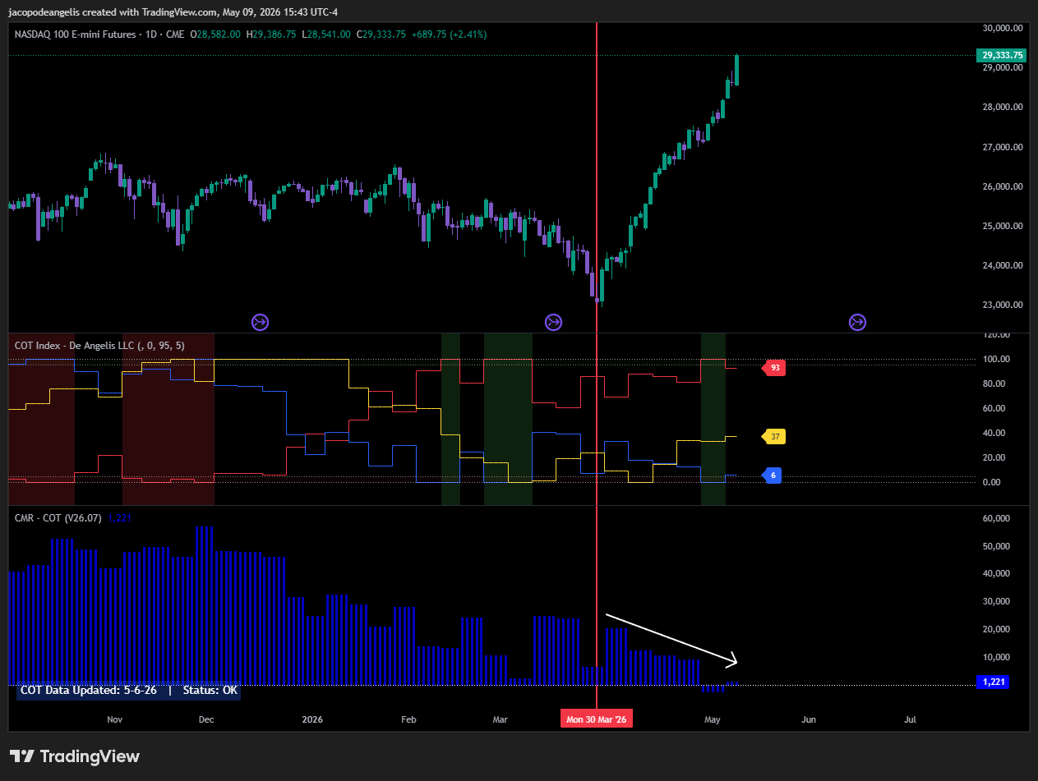
Large speculators in Nasdaq have been heavily shorting during the recent upward trend and have actively fought against the market movement over the past month and a half.
In contrast, looking at the Dow, they followed the trend downward, reducing long positions and increasing shorts. They fought against the market until April 9th, intensifying short positions, then resumed trend-following behavior over the past month. The presence of trend followers contributed to market efficiency and therefore to the underperformance (“crowding into the market”). Conversely, Nasdaq's behavior exhibited an irrational pattern of shorting while the market steadily advanced, highlighting the “need to be right” pattern of market participants, which as I have showed in my back testing of last year is the worst pattern that traders can get in and the best to exploit for us.
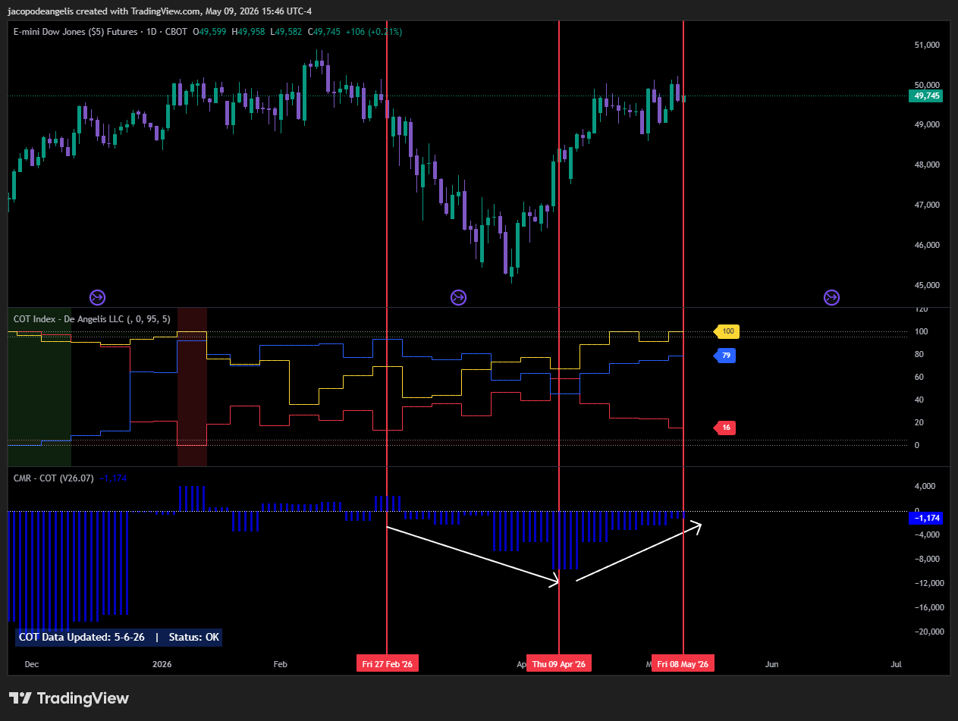
We have observed that assets exhibiting the highest levels of irrational behavior in their positioning patterns tend to generate the best performance. The Nasdaq exemplifies this, with such behavior clearly visible well before today made it exploitable in various ways, confirming the presence of an edge utilizing positioning dynamics. Recognizing these behaviors can enhance decision-making and improve trading outcomes.

Energy
There is nothing interesting in Energies at this time. Positioning has gone down as price did together with it.
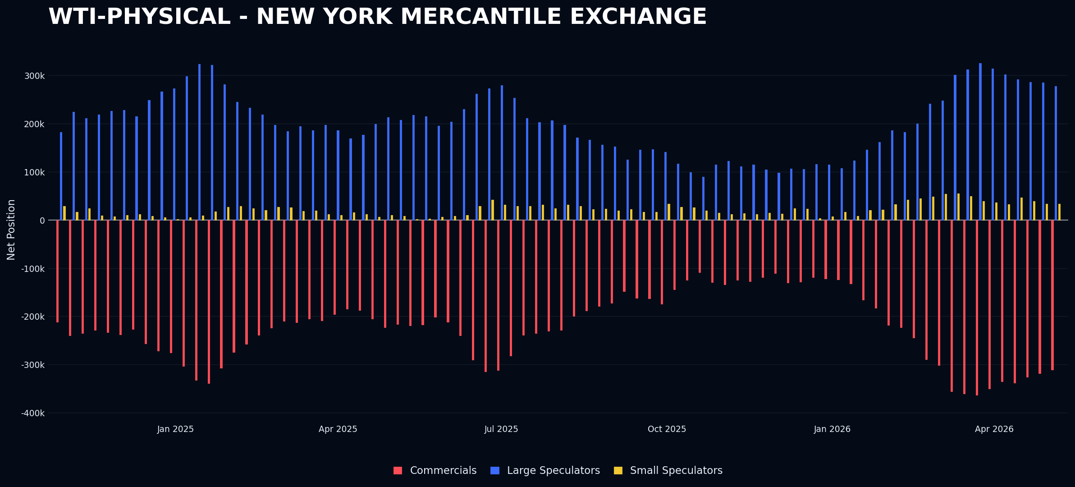
Nat gas doing nothing, positioning still very short. Not followed by any price action though.
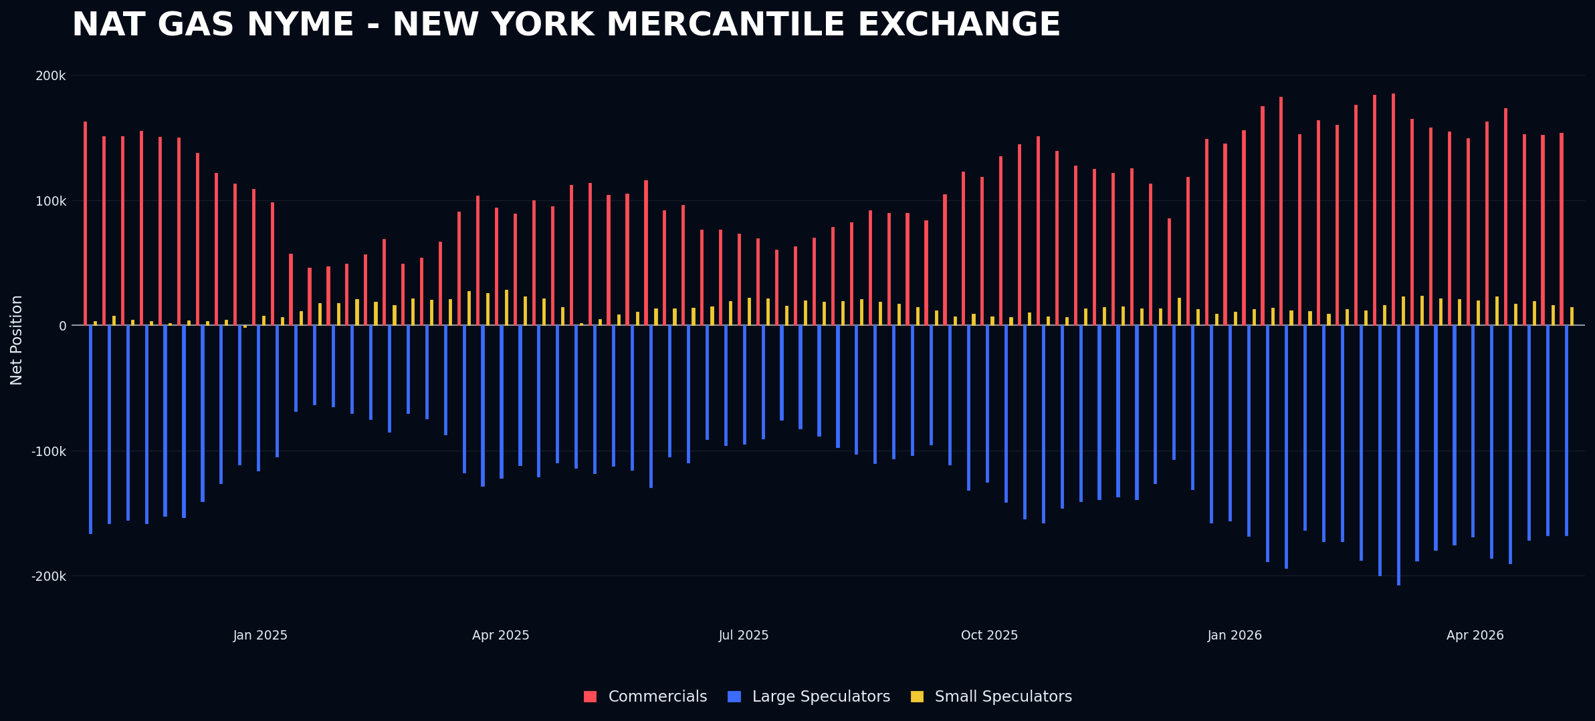

Fixed Income
Fixed income has seen a large short increase in the UST Bond (30 years)
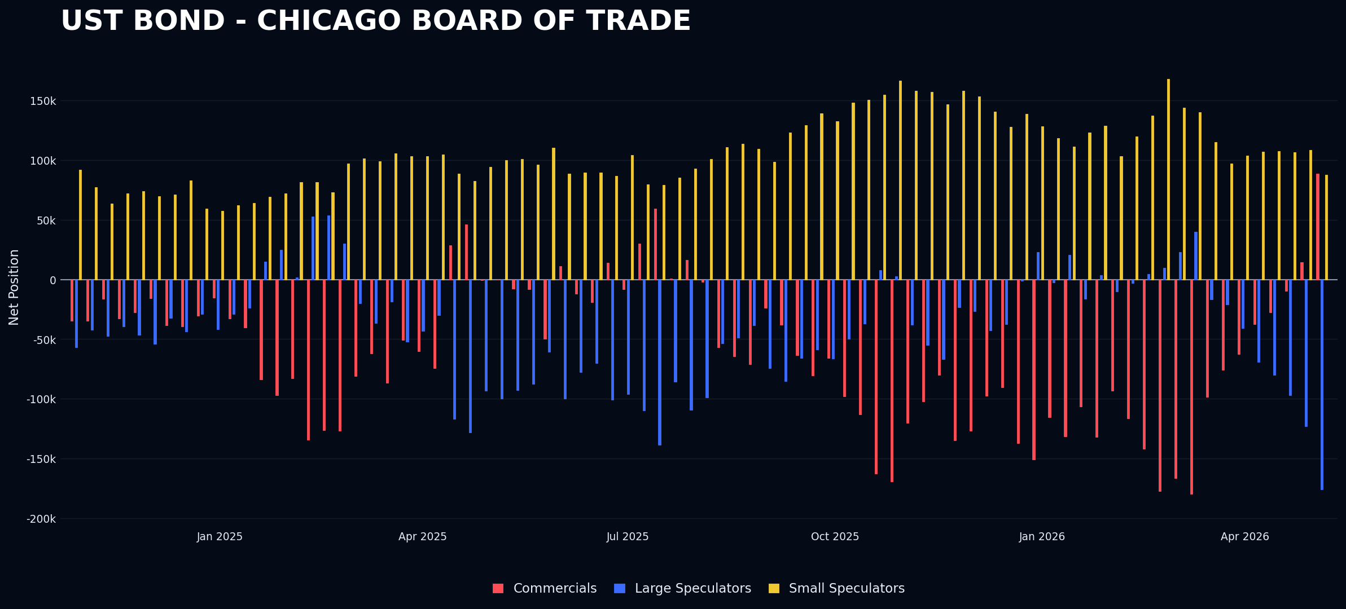
Short positioning in long-duration bonds can be explained by a repricing of long-term inflation expectations, which are now trending higher and exerting upward pressure on long-end yields. The 30-year Treasury yield has recently revisited the 5% threshold, supported in part by persistently elevated energy prices. This environment reduces the attractiveness of holding long-duration bonds, as inflation uncertainty has re-emerged. At the same time, geopolitical expectations have shifted: the previously held assumption of a near-term resolution to the conflict is now being replaced by a “higher-for-longer” war scenario. This repricing is increasingly visible across fixed income markets.
The 5% level in long-end yields has also taken on signaling importance in recent market discourse, effectively acting as a psychological threshold for both equities and bonds.
My interpretation is that market consensus has transitioned into a hedging posture, with positioning increasingly aligned toward a continued steepening of the yield curve.
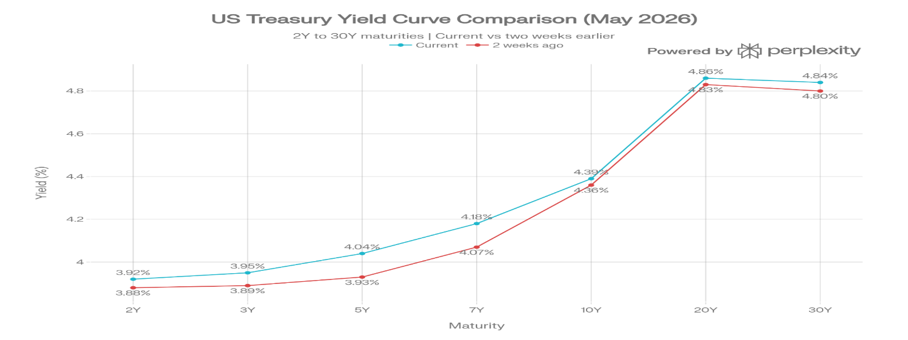
Currencies
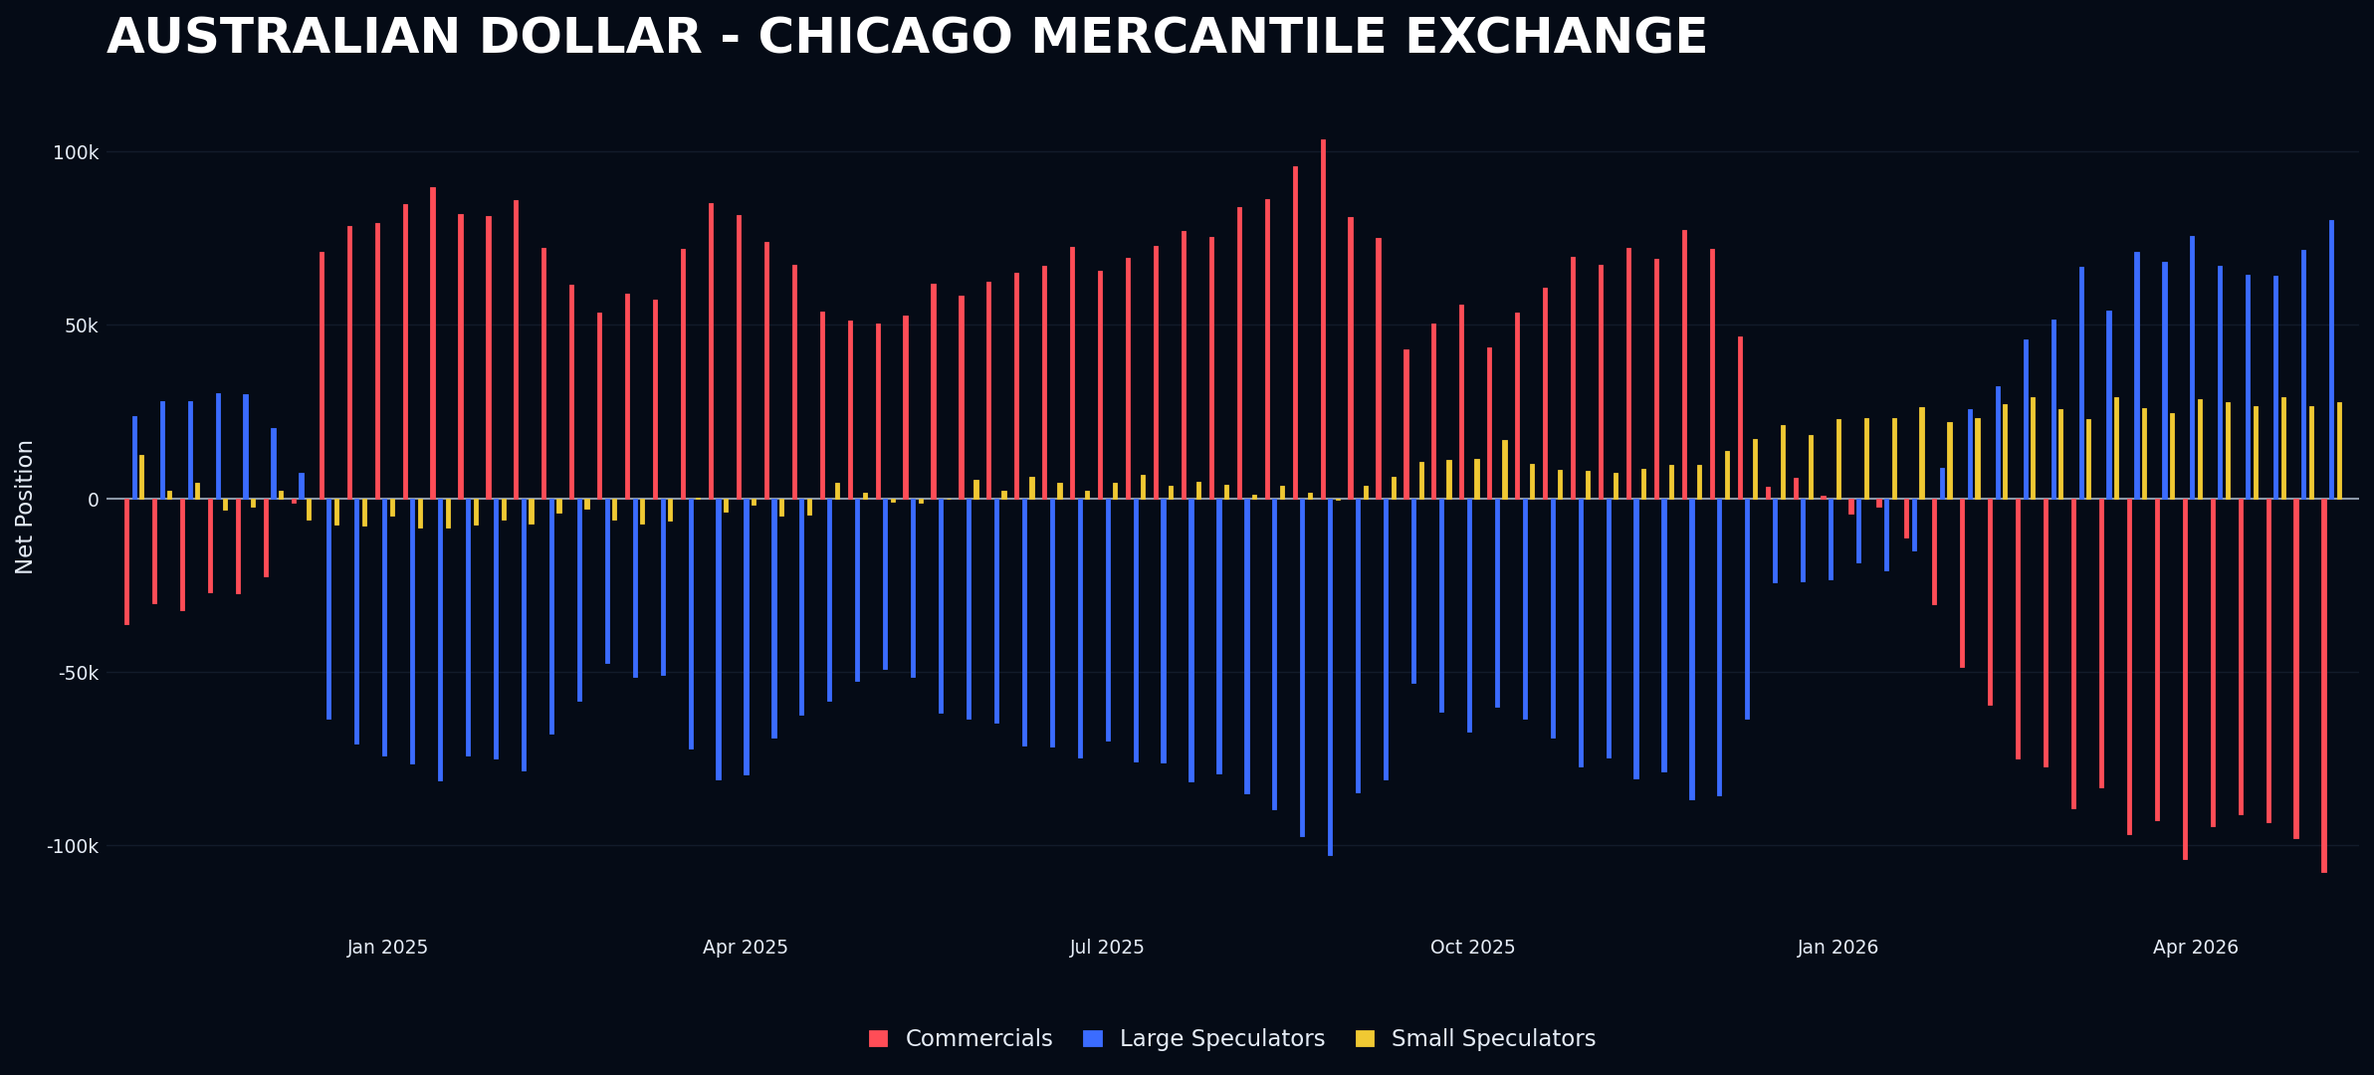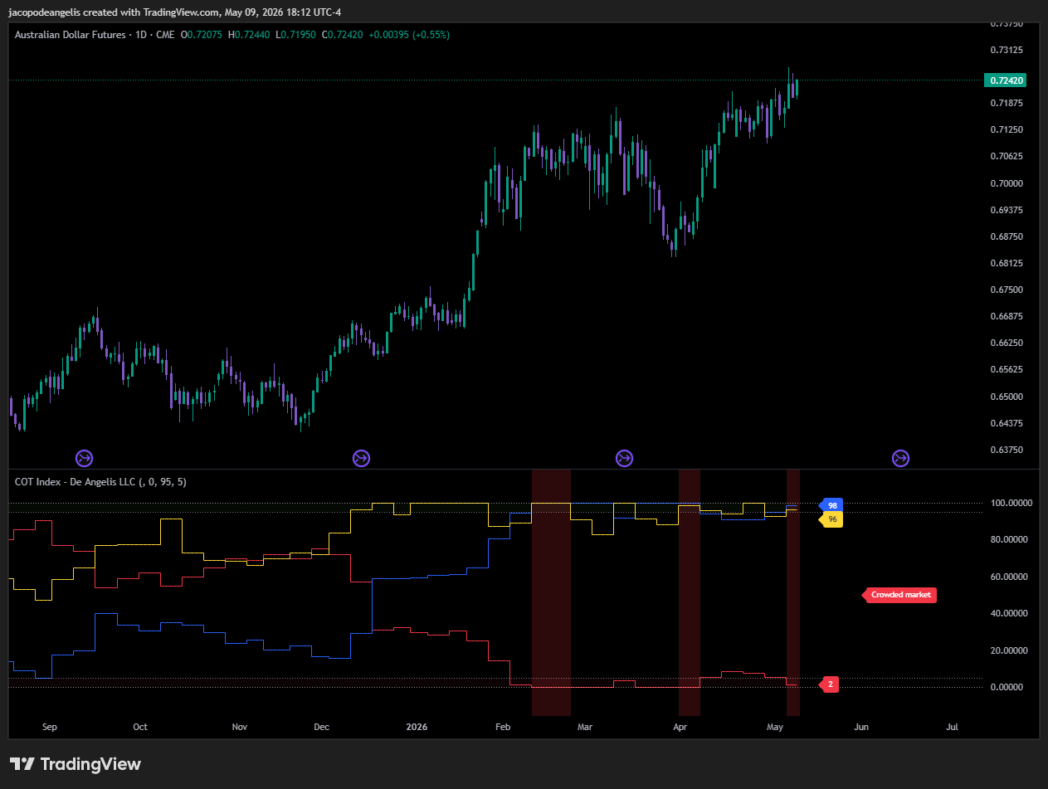
Currencies have the Australian Dollar being set up again for the third time since the beginning of the year. I already executed the trade on 2 news failures this year and both trades got stopped out. Since this is a process trade, I will be looking for a news failure this week. Last week I also highlighted how NFP could have been a good news failure for the Australian Dollar. However, on Friday numbers came out much stronger than expected and the Australian dollar just closed up on the day, so no news failure there.
Softs
The next interesting asset that is set up for the week is Cotton, and I will go into the WASDE Report with Cotton Being set up as a short officially. If I can get a good news failure and supply is short with a down close on the day it could be a good trade to get with a long on Nasdaq or some other risk asset.
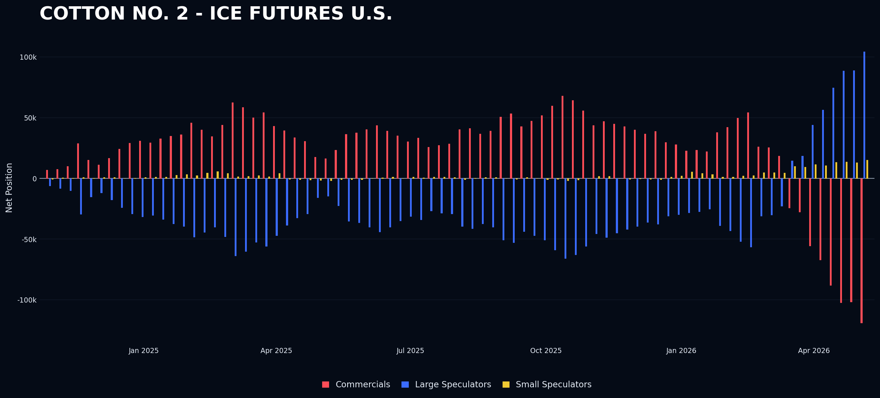
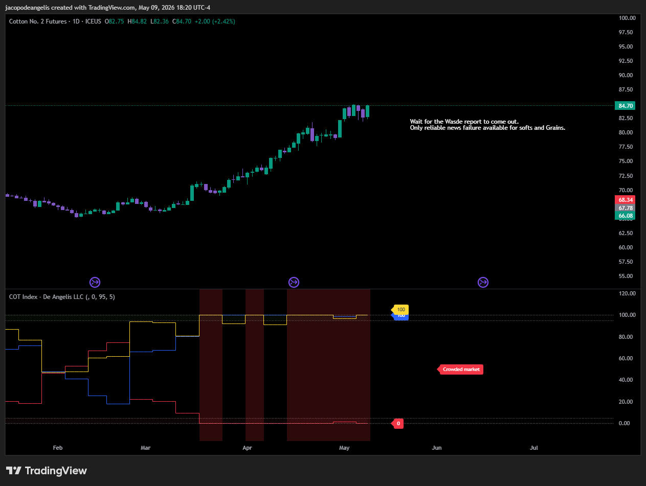

The Next week
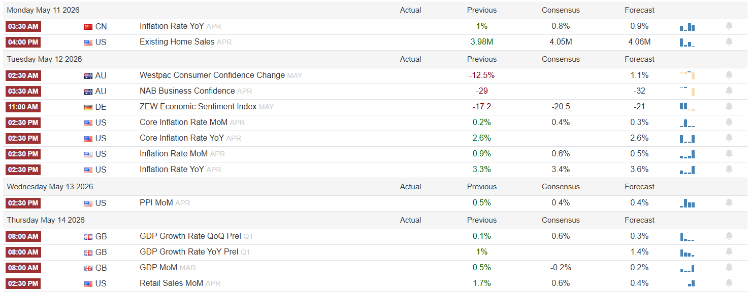
Official Set ups: SHORT COTTON, SHORT AUD
Cotton
I will be looking to short cotton on the 12th of May next week at the end of the day if we get a positive news on the WASDE Report and the prices of Cotton close down on the day after an initial price reaction to the upside.
AUD
I will short the Australian dollar most probably on Tuesday as well the 12th If we can get a news failure on CPI where it’s weaker than expected, the Dollar goes down, AUD goes up initially and then they both close the other way.
Or in any other scenario where there is CLARITY. This is the most important part. Clarity in the news.
Jacopo

