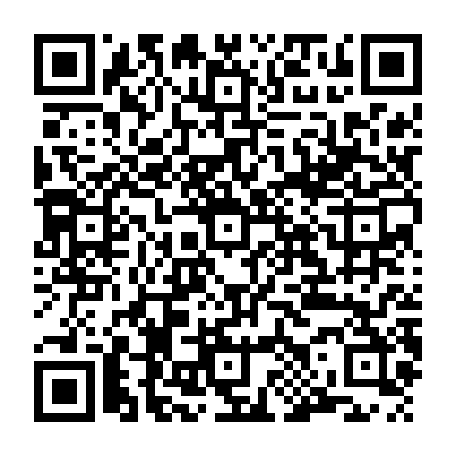
(Please Print all information) Date: ____________________________

Family Last Name: ____________________________ Phone: ___________________________________
Address: _____________________________________________________________________________
Email: _______________________________________________________________________________
If Married: Date of Wedding: ___________________ Wife’s Family Name: ________________________
Ministries members of your Family would like to be involved in (ex: music ministry, altar serving, People Helping People, Food Pantry, Fellowship group, Youth Group, Ushers, Lectors, etc.)
_______________________________________________________________________________________________________________________________________________________________________________________________________________________________________________________________
How would you like to contribute to the mission of the parish:
( ) envelopes ( ) online giving through WeShare ( ) anonymous
You can access WeShare at saintpatricksmilford.churchgiving.com or with the QR code at the top.
Name of members in household | Date of Birth | Sex  (M-F) | Religion (Catholic/other) | Baptism (Date) | First Communion (Date) | Confirmation (Date)

