Purdue Global University
HW320 Contemporary Diet and Nutrition
Nutrition Education Guide

purdue global University

Nutrition Education Guide
By

Felicia Simpson

Purdue Global University
HW320: Contemporary Diet and Nutrition

Aug 9

Table of Contents

Introduction
Unit 1 Dietary Trends and Nutrition
Professionalism in the workplace.
Unit 2 Food Choices
Psychological factors that impact a person’s food choices and eating habits.
Unit 3 Food ChoiceS: Economics
Economic factors dictate the day-to-day life of every consumer
Unit 4 Food ChoiceS: fOODBORNE iLLNESSES
Foodborne illnesses will always be a concern for consumers as well as professionals in the field of health and wellness.
Unit 5 gENETICALLY eNGINEERED fOOD
Genetically engineered food has been a topic of discussion among consumers and major food companies.
Unit 6 tHE oRGANIC fOOD moVEMENT
As a professional in the health and wellness field, it would be beneficial for you to join an organization focused on organic food.
Unit 7 gLOBAL fOOD mARKETS
The United States’ fast-food industry has set its sights on overseas markets.
Unit 8 cONTEMPORARY weIGHT lOSS pROGRAMS
There are three FDA-approved weight loss medications and there are many weight loss clinics
Unit 9 dIVERSITY OF fOOD chOICES
A nutrition-based certification that would benefit the local community is the Certified Nutrition Specialist (CNS) designation.

Unit
1
Dietary Trends and Nutrition
Unit 1 Dietary Trends and Nutrition

Information to Remember:

Professionalism in the workplace, especially in the field of nutrition, health, and wellness, is essential. If you do not appear fit and healthy, you will have difficulty earning the trust of your target market. This principle also applies when applying for jobs in the health and wellness sector. Dressing professionally in this environment should be a top priority. By doing so, you will not only earn respect but also build trust.

Resource:
- Showing professionalism in the health and wellness field is not discussed enough. Many people in the field do not necessarily know that dressing the part will and being the model for the brand that you work for is also important. The article discusses ways that you can build rapport and trust with the consumers by the way that you present yourself.
- “10 Ways to Show Professionalism in the Health Care Field.” Professionalism in Health Care | U of M CCAPS HSM, 14 June 2023, ccaps.umn.edu/story/10-ways-show-professionalism-health-care-field.

Unit
2
Dietary Trends and Nutrition
Unit 2 Dietary Trends and Nutrition

Information to Remember:

There are many psychological factors that impact a person’s food choices and eating habits. Some examples that may influence how one views food, nutrition, and diets include emotions, beliefs, and stress, which are significant factors. A person’s mental state can easily lead them to make healthy or less healthy food choices.

Resource:
- Food choices and nutrition addressed on a psychological level are addressed with this source. Themes that were primarily identified were social and environmental influences, psychological influences, and eating behavior. Throughout this article, the main topic being discussed is behaviors surrounding eating patterns.
- Hardcastle, Sarah J, et al. “Food Choice and Nutrition: A Social Psychological Perspective.” Nutrients, U.S. National Library of Medicine, Oct. 2015, pmc.ncbi.nlm.nih.gov/articles/PMC4632444/.

Unit
3
Dietary Trends and Nutrition
Unit 3 Dietary Trends and Nutrition

Information to Remember:

Economic factors dictate the day-to-day life of every consumer. Some factors that may impact food needs and choices include the cost and ability to purchase food that is considered healthy. Many consumers buy food not for its health benefits, but because it is what they can afford. This is important because the dietary quality and nutritional value of the selected food and drinks are impacted.

Resource:
- This website discusses the economy and how nutrition is impacted day to day. It talks about the prices of food versus the quality of food are outlined and discussed. Federal food and nutrition programs are also briefly discussed on this website. The quality if diet in the United States is addressed as well.
- “Diet Quality & Nutrition - Background.” Diet Quality & Nutrition - Background | Economic Research Service, www.ers.usda.gov/topics/food-choices-health/diet-quality-nutrition/background#:~:text=Food%20choices%20and%20diet%20quality%20are%20influenced,and%20Federal%20food%20and%20nutrition%20assistance%20programs. Accessed 9 Aug. 2025.

Unit
4
Dietary Trends and Nutrition
Unit 4 Dietary Trends and Nutrition

Information to Remember:

Foodborne illnesses will always be a concern for consumers as well as professionals in the field of health and wellness. Proper food handling and the manufacturing process are crucial for food safety and health. The importance of food labels is significant, as they provide consumers with essential information. Consumers need to know what has been added to their food or drinks, especially in case of medical issues. They should also be informed if the food is organic. Additionally, food labels should indicate whether the food contains GMOs or any other preservatives.

Resource:
- The labeling of food is very important, and the USDA has made vast improvements when it came to labeling as well as food handling. This website discusses everything for the labeling standards, quality food dates. Where to find the information on the proper handling of food is also found on this website.
- “Food Safety and Inspection Service.” Food Product Dating | Food Safety and Inspection Service, www.fsis.usda.gov/food-safety/safe-food-handling-and-preparation/food-safety-basics/food-product-dating#:~:text=To%20reduce%20food%20waste%2C%20it,don’t%20practice%20good%20sanitation. Accessed 9 Aug. 2025.

Unit
5
Dietary Trends and Nutrition
Unit 5 Dietary Trends and Nutrition

Information to Remember:

Genetically engineered food has been a topic of discussion among consumers. Many companies agree that genetically modified foods are beneficial. However, several countries do not allow genetically modified foods. While there are cons to consuming genetically engineered foods, there are also benefits. These foods can supplement nutrients that consumers may need, but since they are scientifically made, there is no guarantee that the amount consumed meets an individual’s specific needs.

Resource:
- The USDA made this site to inform the population about basic facts about agricultural biotechnology. It does go into detail about how it is being used, what it is, and some of the benefits. Safety considerations are also discussed on the website as well as well as the risk that may be associated. How the government is involved with biotechnology is also discussed.
- “Biotechnology Faqs.” Home, www.usda.gov/farming-and-ranching/plants-and-crops/biotechnology/biotechnology-faqs#:~:text=1.,microorganisms%20for%20specific%20agricultural%20uses. Accessed 9 Aug. 2025.

Unit
6
Dietary Trends and Nutrition
Unit 6 Dietary Trends and Nutrition

Information to Remember:

Many companies have begun to invest in organic foods. As a professional in the health and wellness field, it would be beneficial for you to join an organization focused on this for several reasons. The Organic Trade Association ensures that the public receives accurate information about organic food. If you are a practitioner in the field involved with a group like this and specialize in organic foods, you will gain more credibility within your community. Additionally, being a member of such organizations aids in networking and connecting with peers in your field.

Resource:
- The Organic Trade Association is an organization that spreads awareness about organic foods. There is a membership associated with it, but if you navigate throughout the website, you will still be able to learn about important information regarding the organic food industry. They also advocate for the organic industry on Capitol Hill.
- “Home.” OTA, ota.com/. Accessed 9 Aug. 2025.

Unit
7
Dietary Trends and Nutrition
Unit 7 Dietary Trends and Nutrition

Information to Remember:

There are multiple reasons why the United States’ fast-food industry has set its sights on overseas markets. One significant factor is the intense competition within the U.S. market. Many companies offer similar options, and healthier alternatives can make it challenging for others to compete. In some instances, businesses can expand overseas and earn more money for the same offerings. By using the same inexpensive ingredients and packaging, they can increase their profit margins.

Resource:
- The global fast food chain is a topic that is gaining popularity in the health and wellness industry. Globalization of fast food is a trending topic for many reasons. The quality of the food that is being produced. The cost of labor and the significant profit margins with fast food chains that are opening oversees.
- “Globalization of American Fast-Food Chains: The Pinnacle of Effective Management and Adaptability.” The Yale Globalist, 8 Apr. 2019, globalist.yale.edu/in-the-magazine/globalization-of-american-fast-food-chains-the-pinnacle-of-effective-management-and-adaptability/.

Unit
8
Dietary Trends and Nutrition
Unit 8 Dietary Trends and Nutrition

Information to Remember:

There are three FDA-approved weight loss medications and there are many weight loss clinics. One advantage I’ve noticed is that these medications can assist with quick weight loss, as they help with appetite suppression. However, some drawbacks include the fact that they are not meant for long-term use. Once you stop taking the medication, if you don’t maintain good eating habits and a robust exercise routine, the weight tends to return, and often more is gained. Many people view these medications as a solution for weight loss, but they shouldn’t be relied upon solely, as the medication industry is ultimately a business. If someone decides to use these medications, they should seek guidance from a professional and a nutritionist as well.

Resource:
- This website talks about the difference between overweight and obesity. It also discusses weight loss medication and how they can impact an individual who is interested in going that route. The financial aspect ant if it is covered by insurance is also covered.
- “Prescription Medications to Treat Overweight & Obesity - NIDDK.” National Institute of Diabetes and Digestive and Kidney Diseases, U.S. Department of Health and Human Services, www.niddk.nih.gov/health-information/weight-management/prescription-medications-treat-overweight-obesity#:~:text=The%20table%20below%20lists%20prescription,be%20confirmed%20by%20genetic%20testing. Accessed 9 Aug. 2025.

Unit
9
Dietary Trends and Nutrition
Unit 9 Dietary Trends and Nutrition

Information to Remember:

A nutrition-based certification that would benefit the local community is the Certified Nutrition Specialist (CNS) designation. This certification is particularly advantageous because many areas are culturally diverse. Expertise in this field would enable professionals to assist a broader range of people within the community. With the CNS certification, professionals can build rapport with the local population in their chosen country. By fostering relationships with the community and holding various relevant certifications, they can create opportunities for individuals to learn about improving their eating habits and overall nutrition.

Resource:
- This website describes the details on how to acquire this certification. This is also a website that gives you other resources to obtain other certification in the health and wellness field. It breaks down every class that is needed as well as the supervised practice experience hours that are needed as well. The certification examination information is also listed as well as the cost.
- “Nutritionists & Health Professionals.” American Nutrition Association, www.theana.org/certify/become-a-cns/nutritionists-health-professionals/. Accessed 9 Aug. 2025.

Part 2: Cultural Food Choice Explanation and Screenshot

The cultural food option I chose is spaghetti. While it may sound simple, I love incorporating my Jamaican heritage into everything I cook for my family. I prepare spaghetti with Jamaican spices, often using jerk sauce, and sometimes I add a small sliver of scotch bonnet, which is a hot pepper. Depending on my kids' moods, I might make it as a seafood spaghetti. This meal has become a staple in our home, blending my Jamaican culture with my American upbringing. We usually pair it with a light salad, and on this occasion, we had a Caesar salad. In our household, we don’t drink much juice or soda, so dinner is typically accompanied by flavored water. Both of my parents are Jamaican, so a lot of the American dishes I prepare are infused with Jamaican ingredients, or the meal itself is Jamaican/ American. My kids have gotten used to the spiciness of the meals, and if it to hot, they drink milk. I was always given milk as a child if the food was too spicy. I am not sure if that is a Jamaican tradition but it is something that I was raised with. After dinner, my kids usually get a bowl of fruit if they have a sugar craving.

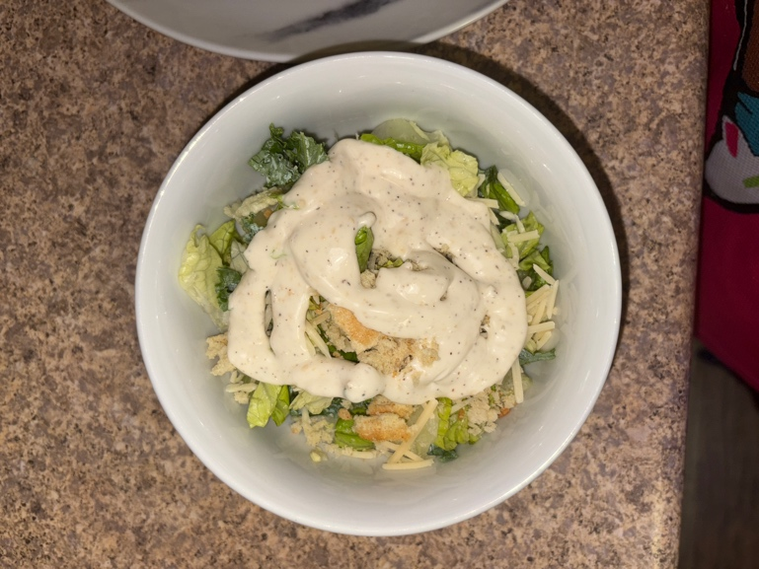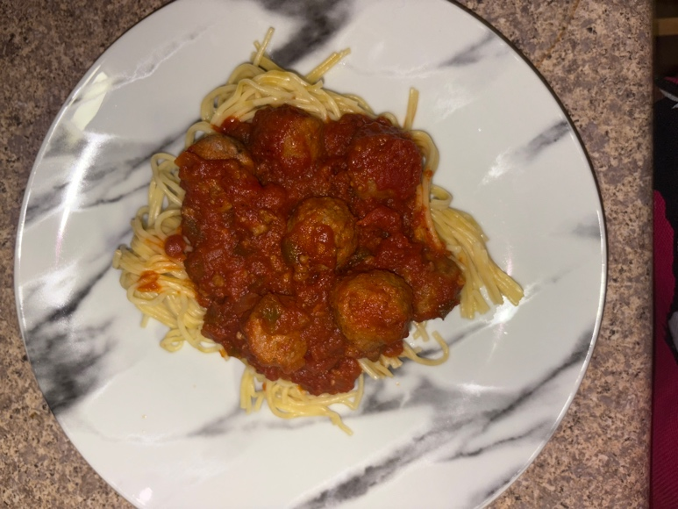

References:
- “Biotechnology Faqs.” Home, www.usda.gov/farming-and-ranching/plants-and-crops/biotechnology/biotechnology-faqs#:~:text=1.,microorganisms%20for%20specific%20agricultural%20uses. Accessed 9Aug. 2025.
- “Diet Quality & Nutrition - Background.” Diet Quality & Nutrition - Background | Economic Research Service, www.ers.usda.gov/topics/food-choices-health/diet-quality-nutrition/background#:~:text=Food%20choices%20and%20diet%20quality%20are%20influenced,and%20Federal%20food%20and%20nutrition%20assistance%20programs. Accessed 9 Aug. 2025.
- “Food Safety and Inspection Service.” Food Product Dating | Food Safety and Inspection Service, www.fsis.usda.gov/food-safety/safe-food-handling-and-preparation/food-safety-basics/food-product-dating#:~:text=To%20reduce%20food%20waste%2C%20it,don’ t%20practice%20good%20sanitation. Accessed 9 Aug. 2025.
- “Globalization of American Fast-Food Chains: The Pinnacle of Effective Management and Adaptability.” The Yale Globalist, 8 Apr. 2019, globalist.yale.edu/in-the-magazine/globalization-of-american-fast-food-chains-the-pinnacle-of-effective management-and-adaptability/.
- Hardcastle, Sarah J, et al. “Food Choice and Nutrition: A Social Psychological Perspective.” Nutrients, U.S. National Library of Medicine, Oct. 2015,pmc.ncbi.nlm.nih.gov/articles/PMC4632444/.
- “Home.” OTA, ota.com/. Accessed 9 Aug. 2025.
- “Nutritionists & Health Professionals.” American Nutrition Association, www.theana.org/certify/become-a-cns/nutritionists-health-professionals/. Accessed 9 Aug. 2025
- “Prescription Medications to Treat Overweight & Obesity - NIDDK.” National Institute of Diabetes and Digestive and Kidney Diseases, U.S. Department of Health and Human Services, www.niddk.nih.gov/health-information/weight-management/prescription-medications-treat-overweight-obesity#:~:text=The%20table%20below%20lists%20prescription,be%20confirmed%2by%20genetic%20testing. Accessed 9 Aug. 2025. Aug. 2025.
- “10 Ways to Show Professionalism in the Health Care Field.” Professionalism in Health Care | U of M CCAPS HSM, 14 June 2023, ccaps.umn.edu/story/10-ways-show-professionalism-health-care-field.

