Suffolk Stables presents: Jumping Clinic with:

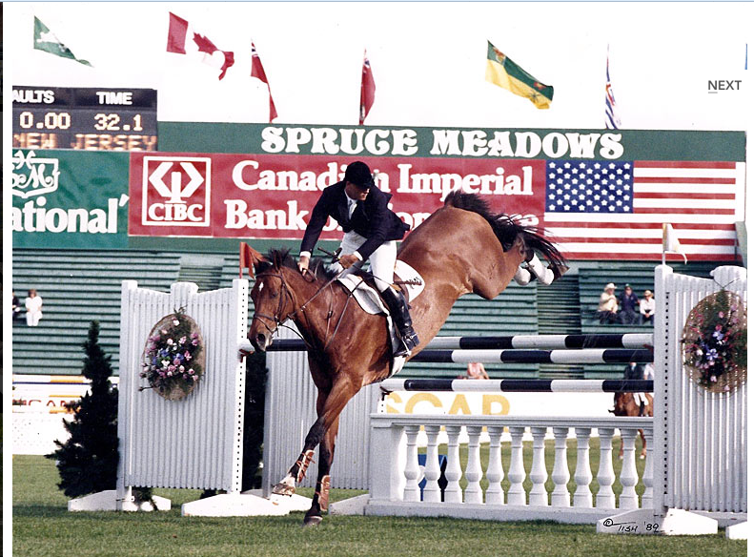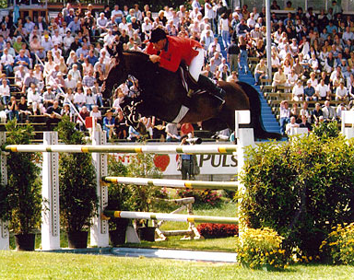

former Olympic Rider - Mark Leone

Mark Leone has more than 30 years of experience as both a winning international show jumping rider and leading trainer. His name is synonymous with excellence in the equestrian world. Mark is a Zone 2 Jumper Chairman, sits on several USEF committees, and has served as “athlete representative” for the United States Olympic Committee. In 2010, he was named as a member of the 2010 World Equestrian Games Show Jumping Team Selection Committee. His knowledge and expertise has also landed him in front of the camera as an on-air commentator for broadcasts on ESPN and Fox Sports.

Don’t miss out on the chance to learn from one of the best!

Cost: $150 for 1.5 hour Group lesson (lessons will be grouped by jump height, ex.: crossrails, 2’, 2’6”, 3’, etc.)

Date: OCT 07th, 2018

Start: 9am

Contact: Deborah Greer to register by 10/6/2018 – 609.346.7093

Where: Suffolk Stables-1418 Old Indian Mills Rd. Shamong, NJ

**0900 am – Crossrails**

**1030 am – 3’ and over (please let Mark know height you want)**

**1230 pm – 2’3 – 2’6**

**200pm – small verticals up to 2’**