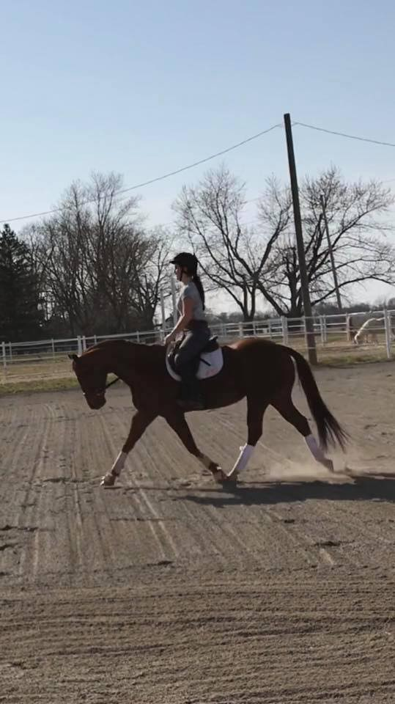

***OPEN DRESSAGE RING *** AT SUFFOLK STABLES HORSE SHOW FROM 10 AM TILL NOON . BRING A COPY OF THE TEST YOU WANT TO RIDE , HAND IT TO OUR JUDGE AND RIDE YOUR TEST. RIBBONS AS FOLLOWS : SCORES 70 AND ABOVE 1ST PLACE RIBBON , SCORES IN THE 60'S SECOND PLACE RIBBON AND SCORES IN THE 50'S 3RD PLACE RIBBON . OUR JUDGE WILL ALSO GIVE YOU SOME TIPS TO IMPROVE YOUR TESTS. * FUN * , * CASUAL * , AND * EDUCATIONAL – SEASON END TEAM POINTS AT OUR BANQUET* ,
BETWEEN 10 AM AND NOON , EVERYONE IS WELCOME 🙂

