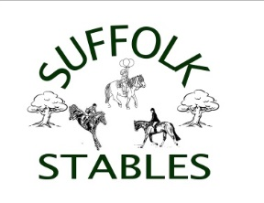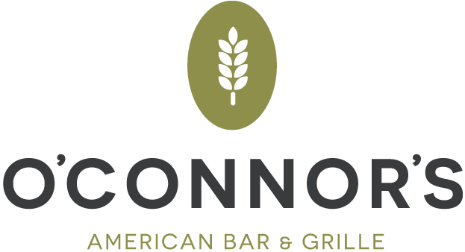

Suffolk Stables Christmas Party and YEAR END Show Banquet Jan 4th, 2018 7pm to 11pm

BUFFET MENU

Salads included are Tossed and Caesar, choice of roast potato and mixed vegetables, rolls and butter, coffee and tea. We will have a cash bar.

**Entrées**

Steak with mushrooms and onion

Chicken Marsala

Stuffed flounder

Angel Hair with broccoli

**Dessert.**

Red Velvet cake and Carrot cake.

∞∞

***This year we have a DJ so bring your dancing shoes and dance until 11pm.***

***We will also be having a Chinese auction and would love if you could bring items for the auction.***

∞∞

Name:_________________________________Phone Number_____________________

Adult dinners:________*$55.00. Child (12 and under):__________*$25.00 (3 and Under are free)

Total due: ____________________

Christmas Party Gift swap at 7:20pm – Awards at 8pm. (bring a wrapped gift for the kids to do a ‘Poly-Anna’ gift swap/steal for a fun activity)

email to: [Deborah@suffolkstables.com](mailto:Deborah@suffolkstables.com) Paypal to: [Deborah@suffolkstables.com](mailto:Deborah@suffolkstables.com)

Return form with payment by DECEMBER 20th. Make checks payable to SUFFOLK STABLES LLC

If you are mailing payment please send it to: **Suffolk Stables LLC**

1418 Old Indian Mills Rd

Shamong NJ 08088