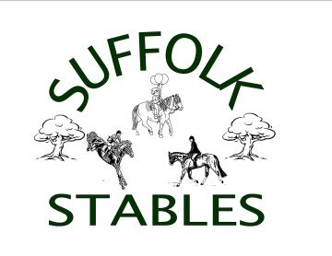
Spring: Apr 25*, May 2, May 16,Jun 13. July 11 and July 18, Sep 26 and Oct 24, 2021

Suffolk Stables, 1418 Old Indian Mills Rd, Shamong NJ. Show Day Phone (609) 346-7093

*** Year End Awards Banquet***

$25 use-of-grounds fee for each horse not showing. Use of grounds in driving field only.
Show Attire must be worn as per the ADS rule book. $15/class Ribbons 1st – 6th
12pm Start SHARP
*double points show dates.

DRIVING DIVISION:

Class 77: Working Pleasure.

A Pleasure Driving class in which entries are judged primarily on the suitability of the horse to provide a pleasant drive. To be shown both ways of the arena at a walk, slow trot, working trot and strong trot. To stand quietly, both on the rail and while lined up, and to rein back. All entries chosen for a workout may be worked both ways of the arena at any gait requested by the judge and may be asked to execute appropriate tests.

To be judged:
• 70% on performance, manners and way of going of the horse(s).
• 20% on the condition and fit of harness and vehicle.
• 10% on neatness of attire.

Class 78: Reinsmanship

A Pleasure Driving class in which entries are judged primarily on the ability and skill of the driver. To be shown both ways of the ring at a walk, slow trot, working trot and strong trot. Drivers are required to rein back. All drivers chosen for a workout may be worked at any gait requested by the judge and may be asked to execute appropriate tests. The driver should be seated comfortably on the box so as to be relaxed and effective. Either the one- or two-handed method of driving is acceptable. Common to both methods, the elbows and arms should be close to the body with an allowing but steady hand enabling a consistent “feel” with the horse’s mouth. Drivers should not be penalized or rewarded for using one general style over another.

To be judged:
• 75% on handling of reins and whip, control, posture, and overall impression of driver.
• 25% on the condition of harness and vehicle and neatness of attire

Class 79: Cones
This is an OPTIMUM time class.

Class 80: Dressage test A (other tests will be added in the future)

