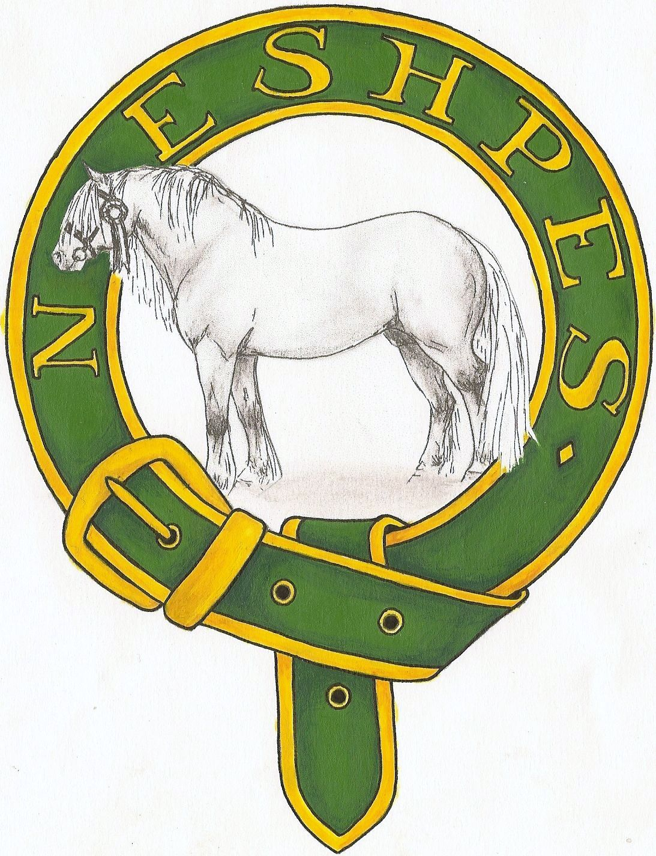
North East of Scotland Highland Pony Enthusiast Society

Membership Form 2025

Name ………………………………………………………………
Address ………………………………………………………………
………………………………………………………………
………………………………………………………………
Postcode ………………………………….
Telephone ………………………………….
Email ………………………………………………………………

Membership Fees:

- Adult - £15
- Junior (under 18yrs) - £7

- Cheque
- Bank Transfer (Acc 00108828 / Sort Code 80-73-30)

Membership paid by 30th April 2025 ensures points accumulated for NESHPES awards between end of prior year’s scheme and current membership period are valid. For new or lapsed members, points will be valid from date membership is received by NESHPES membership secretary.

Data Protection: The detail you have supplied will be used for processing your subscription and for emailing or posting other information about North East of Scotland Highland Pony Enthusiast Society and will never be passed to a third party. Your information will be kept on the NESHPES membership database for two years. To agree to be kept up to date with NESHPES news and information please tick this box

Please make cheques payable to NESHPES and return to
Susanne Shepherd, East Brachmont, Durris, Banchory, AB31 6DY
sr.shepherd@btopenworld.com

