Pearland High School
3775 S Main St, Pearland, TX 77581
Approach the campus from 35 (Main St./Telephone Rd.) or Pearland Parkway, and turn onto Oiler Drive. PLEASE NOTE THERE IS CONSTRUCTION AT THE PEARLAND PKWY AND 35 INTERSECTION WHICH IS CAUSING SIGNIFICANT TRAFFIC DELAYS. Buses and Trailers should enter as shown, check-in, unload, and proceed to the holding area.
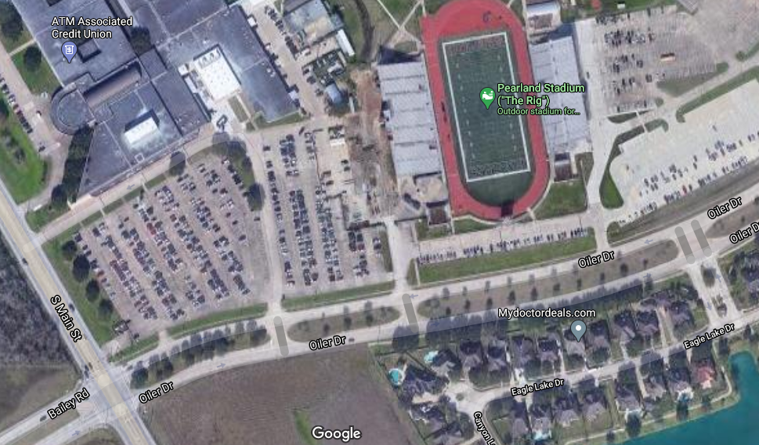
Percussion Load-in/
Visitor Entrance
Fine Arts Gym
Band Halls and Auditorium
Bus and Trailer Entrance
Bus and Trailer Parking – move here after unloading
VISITOR PARKING
35

