Pearland High School:
High School SNV & NV UIL Concert & Sight-Reading Evaluation
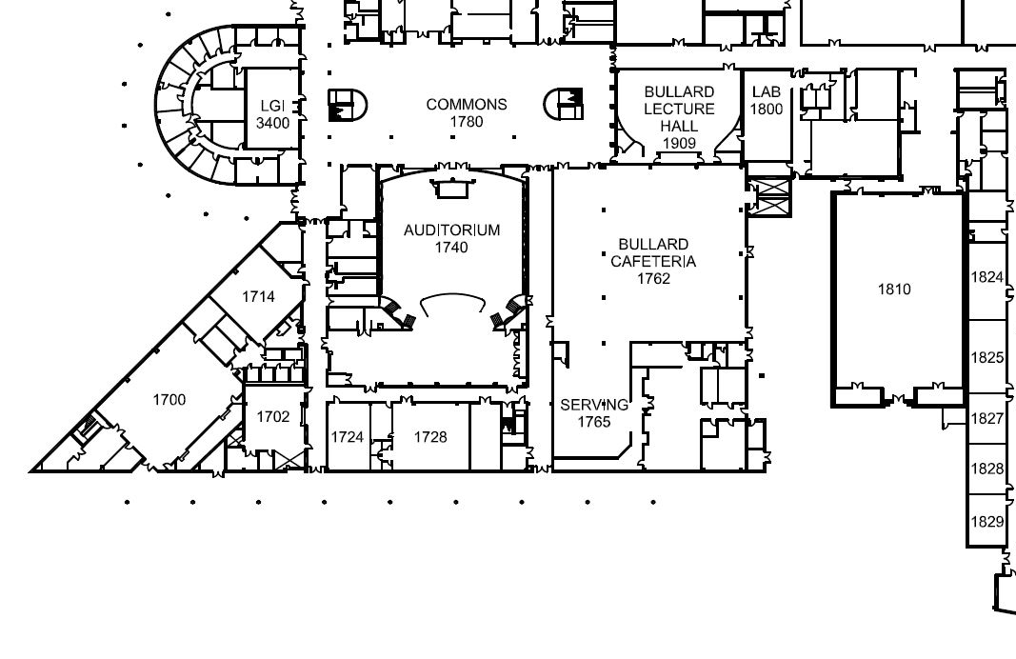
Contest Office
Percussion load-in/ VISITOR ENTRANCE – Please check in here
Bus Lane: load students and equipment

Warmup
Performance

Bus Lane: unload students (Leave cases on bus)
Restrooms
Restrooms
SMALL BAND HALL
Sight Reading

LARGE BAND HALL
STAGE
Student holding area
FINE ARTS GYM
Temporary percussion storage in hallway

