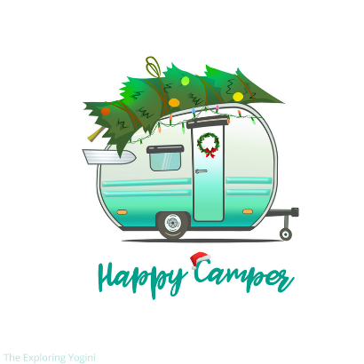
Christmas in July
Saturday, July 25th
Christmas Site Decorating Contest- Make sure your site looks jolly, is all decked with holly and ready to be judged Saturday night while the Christmas movie plays. The winner will be announced at the 11am Sleigh Ride on Sunday. The prize is a FREE night of camping with us!
11am – Sleigh Ride @office
1pm – “Snowball” Fight and Other Outdoor Fun @rec. field
2:30pm – Story Time with Santa
3pm – Pictures with Santa (Bring your own camera to snap your pictures. Masks are not required, but it can be requested that Santa wears one during your photo. You will also have to option on where to sit or stand.)
We will have Christmas crafts to do while waiting for your turn for pictures! @clubhouse

5pm – Sleigh Ride @office
6:30pm – Tree Decorating @clubhouse
7pm – Adult Pool Party (TBD)
8:40pm – Outdoor Christmas Movie (Movie TBD) Bring your lawn chairs and/or blankets for front row seating, or your golf cart for back row seating. @pavilion

Sunday, July 26th – 11am Sleigh Ride @office

All activities are subject to last minute change or cancellation based on weather and attendance.

